AEC MEDIA
D&D Carpentry
Website: d-dcarpentry.ie | Industry: Kitchen Design & Installation | Location: Meath, Ireland
WHAT WE NOTICED

D&D Carpentry has a strong visual portfolio and a clear range of bespoke services, with high-quality project imagery helping demonstrate the standard of their work. However, the current website experience has several areas where small improvements could make the business feel more polished, strengthen trust and make it easier for potential customers to move from viewing the work to making an enquiry.

● HIGH 01- GOOGLE MAPS EMBED IS NOT FULLY CONFIGURED
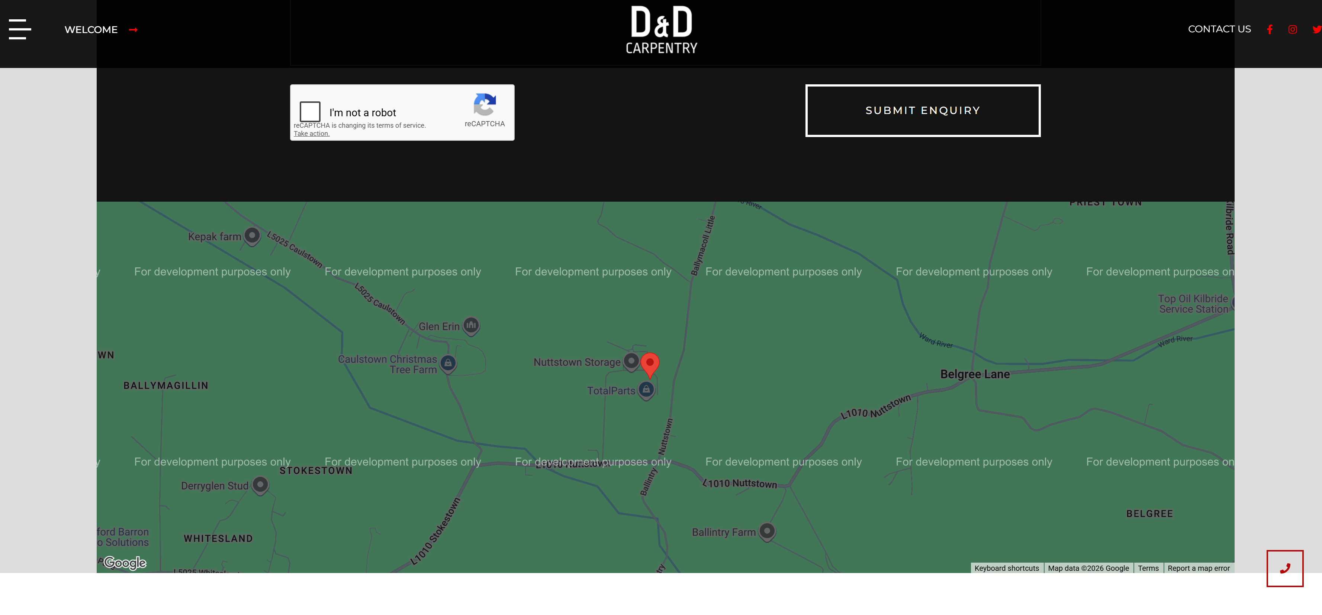

WHAT WE NOTICED
The Contact Us page includes an embedded Google Maps section, but the map displays a “For development purposes only” overlay and initially shows a Google Maps warning. The map remains usable after dismissing the warning, but the development overlay is still visible across the map.
WHY IT MATTERS
The contact page should give visitors a polished and trustworthy final impression of the business. A development overlay on a customer-facing page can make the website appear unfinished and may reduce confidence when visitors are checking the company's location.
WHAT WE'D CHANGE
Review the Google Maps integration and configure the embed correctly so the development overlay and warning no longer appear on the live website.
Priority: HIGH | Effort: LOW
● HIGH 02- SOCIAL MEDIA LINKS AREN'T WORKING CONSISTENTLY

WHAT WE NOTICED
The website displays Facebook, Instagram and Twitter/X icons in the header. The Facebook and Instagram accounts appear active and relevant, but their links load within the current website page rather than opening separately. The Twitter/X icon does not appear to open a working account and appears to reference an outdated social presence.
WHY IT MATTERS
Social profiles can provide additional proof of recent work, activity and customer engagement. Broken or outdated links create unnecessary friction and can make the website feel less actively maintained.
WHAT WE'D CHANGE
Update the Twitter/X link or remove it if the account is no longer used. Configure the Facebook and Instagram links to open the relevant profiles in a new browser tab while keeping visitors on the website.
Priority: HIGH | Effort: LOW

THE OPPORTUNITY
CURRENT JOURNEY | RECOMMENDED JOURNEY
LAND  ↓  BROWSE  ↓  VIEW PROJECTS  ↓  FIND CONTACT DETAILS  ↓  SUBMIT ENQUIRY | LAND  ↓  UNDERSTAND THE OFFER  ↓  SEE THE WORK  ↓  BUILD TRUST  ↓  DISCUSS YOUR PROJECT
● HIGH 03- PROJECT PAGES COULD DO MORE TO DRIVE ENQUIRIES
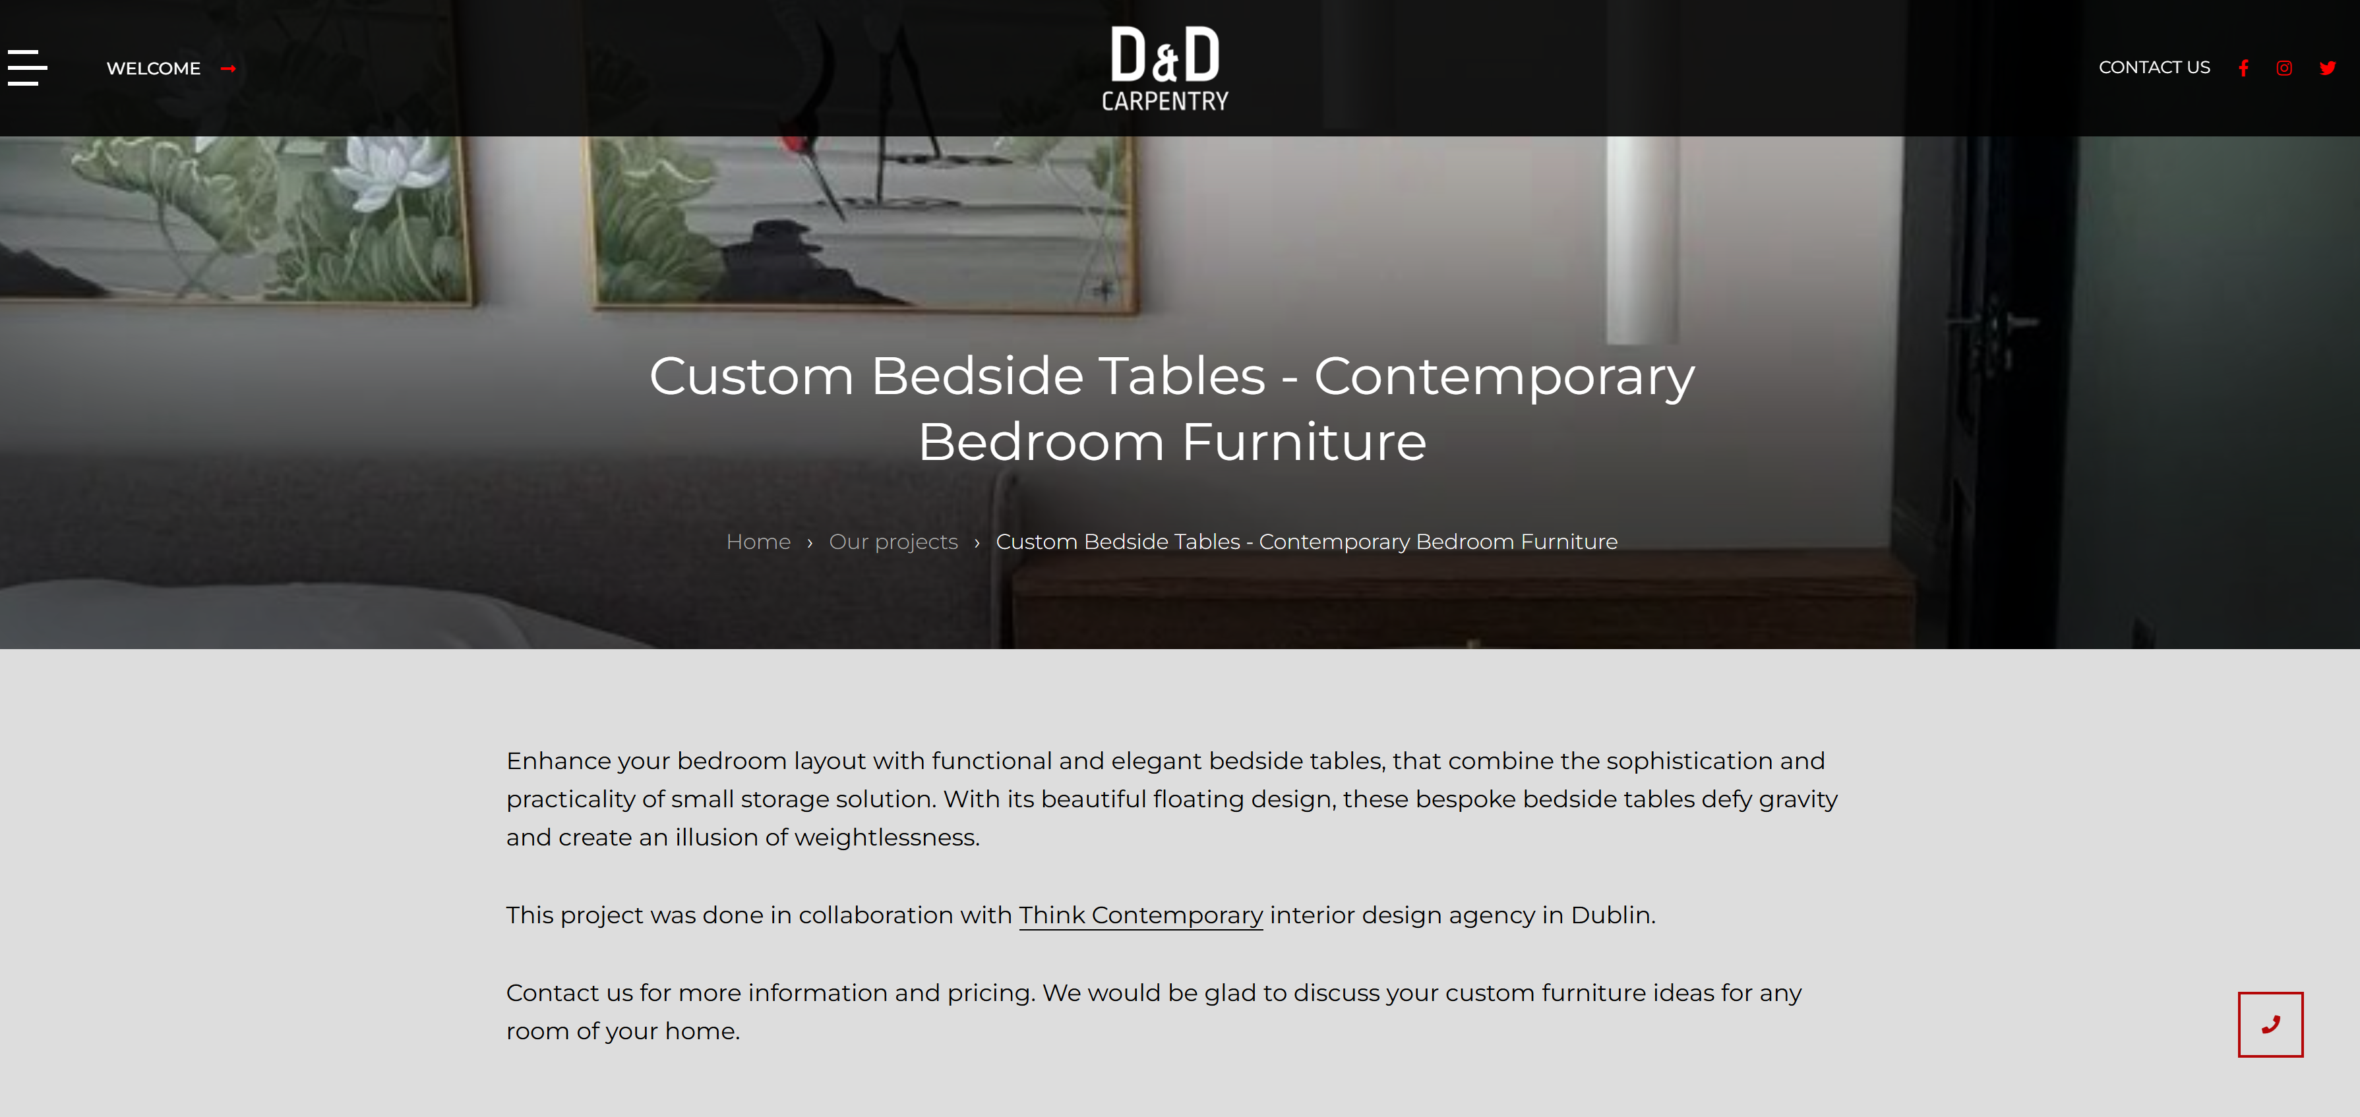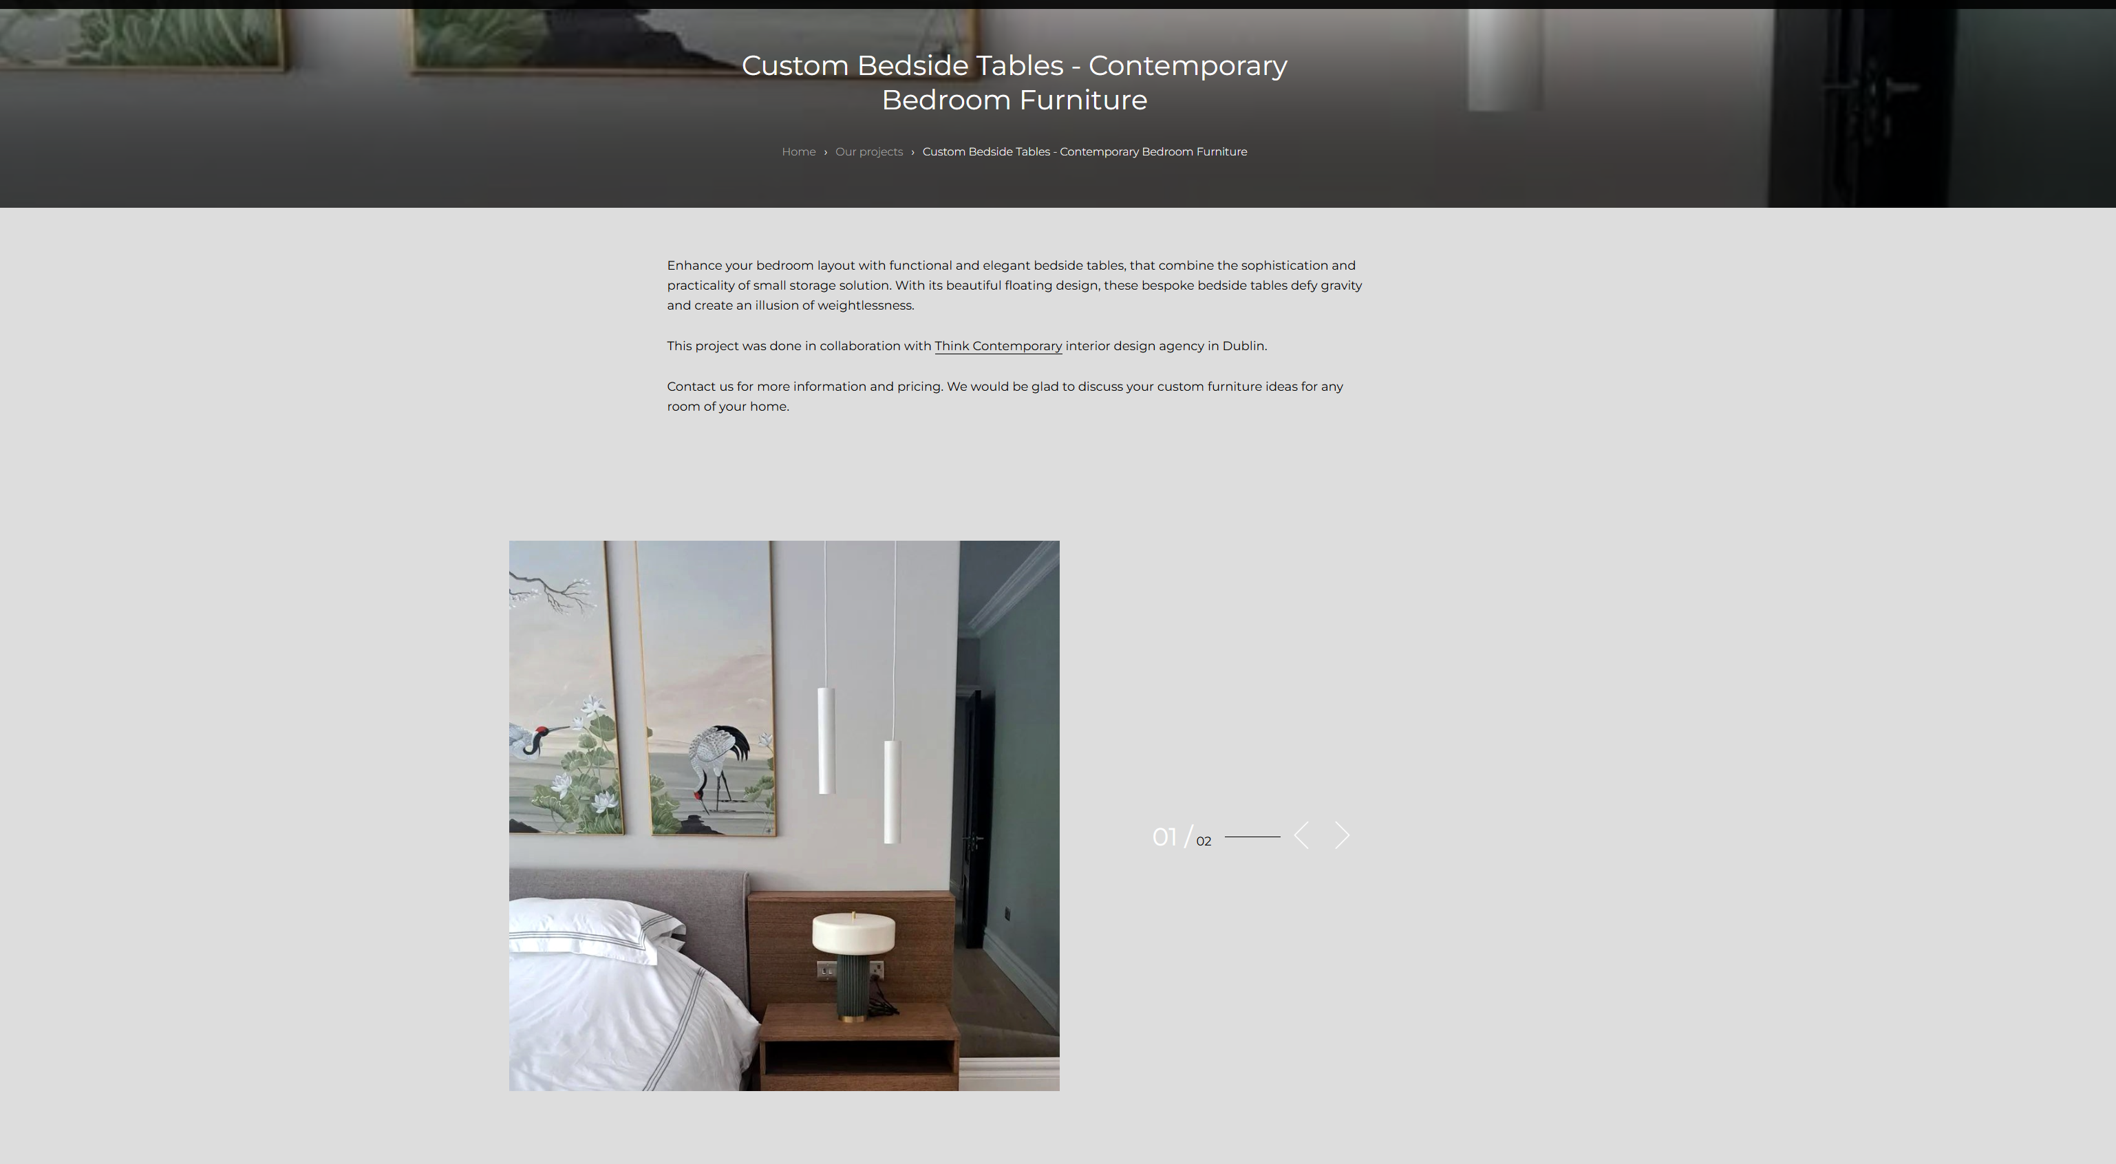

WHAT WE NOTICED
D&D Carpentry has a strong portfolio of bespoke projects, including kitchens, wardrobes, living rooms and custom furniture. However, “individual project pages give substantial space to imagery and description, but provide limited opportunities for visitors to take the next step.
WHY IT MATTERS
The project portfolio is one of the strongest parts of the website because it demonstrates the quality and range of the company's work. Visitors viewing a project are already showing interest in the service, making this an important opportunity to move them towards an enquiry.
WHAT WE'D CHANGE
Rework project pages around stronger imagery, clearer project information and more prominent enquiry opportunities, such as “Discuss Your Project” or “Request a Consultation” CTAs.
Priority: HIGH | Effort: MEDIUM
OTHER OBSERVATIONS
OBSERVATION | OPPORTUNITY
Primary homepage CTA focuses on the product range | Introduce a clearer route towards consultation or enquiry.
Large areas of unused space across several pages | Create a more efficient page structure that brings key information into view sooner.
Strong customer testimonials | Bring selected testimonials closer to project galleries and enquiry CTAs

WANT US TO TAKE A CLOSER LOOK?
This is a short preliminary review. A full AEC Media Growth Audit explores Conversion • UX • Messaging • Trust • SEO • Local Visibility • Competitors
Full Growth Audit — €79 introductory price • aecmedia.ie

Preliminary review based on the publicly visible website experience. Not a full technical SEO, analytics or accessibility audit. Recommendations are not guarantees of increased enquiries.

