AEC MEDIA
Kitchenfix.ie
Website: kitchenfix.ie | Industry: Kitchen Design & Installation | Location: Dublin, Ireland
WHAT WE NOTICED

Kitchen Fix has strong visual project content, clear service offerings and multiple ways for visitors to enquire. However, the current website experience leaves some opportunities to build trust and make the path from discovering the service to requesting a quote more seamless.

● HIGH 01- THE QUOTE FORM CREATES UNNECESSARY FRICTION
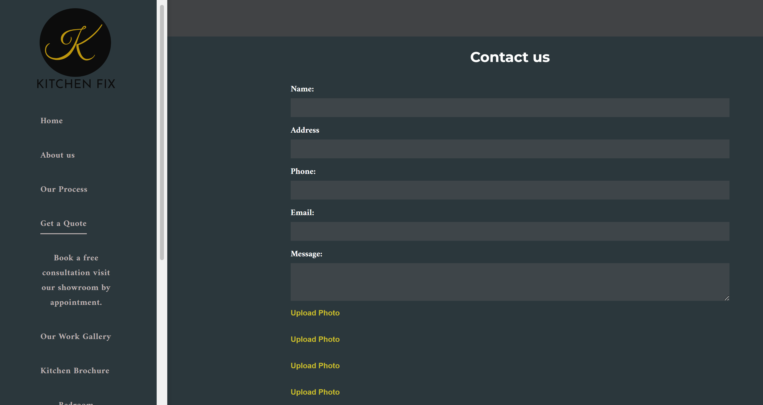

WHAT WE NOTICED
The quote form asks visitors for name, address, phone, email and a message, followed by multiple photo-upload fields and several project-type selections.
WHY IT MATTERS
The number of steps and fields can make the quote process feel more demanding than necessary, particularly for visitors making an initial enquiry.
WHAT WE'D CHANGE
Simplify the first-stage form around essential contact details and project type, with optional photo uploads rather than making the process feel like a full consultation form.
Priority: HIGH | Effort: MEDIUM
● HIGH 02- REVIEWS AREN'T BEING USED ON THE WEBSITE
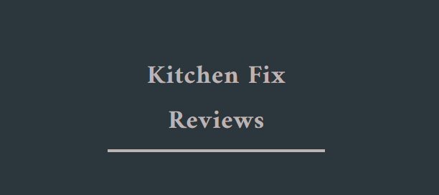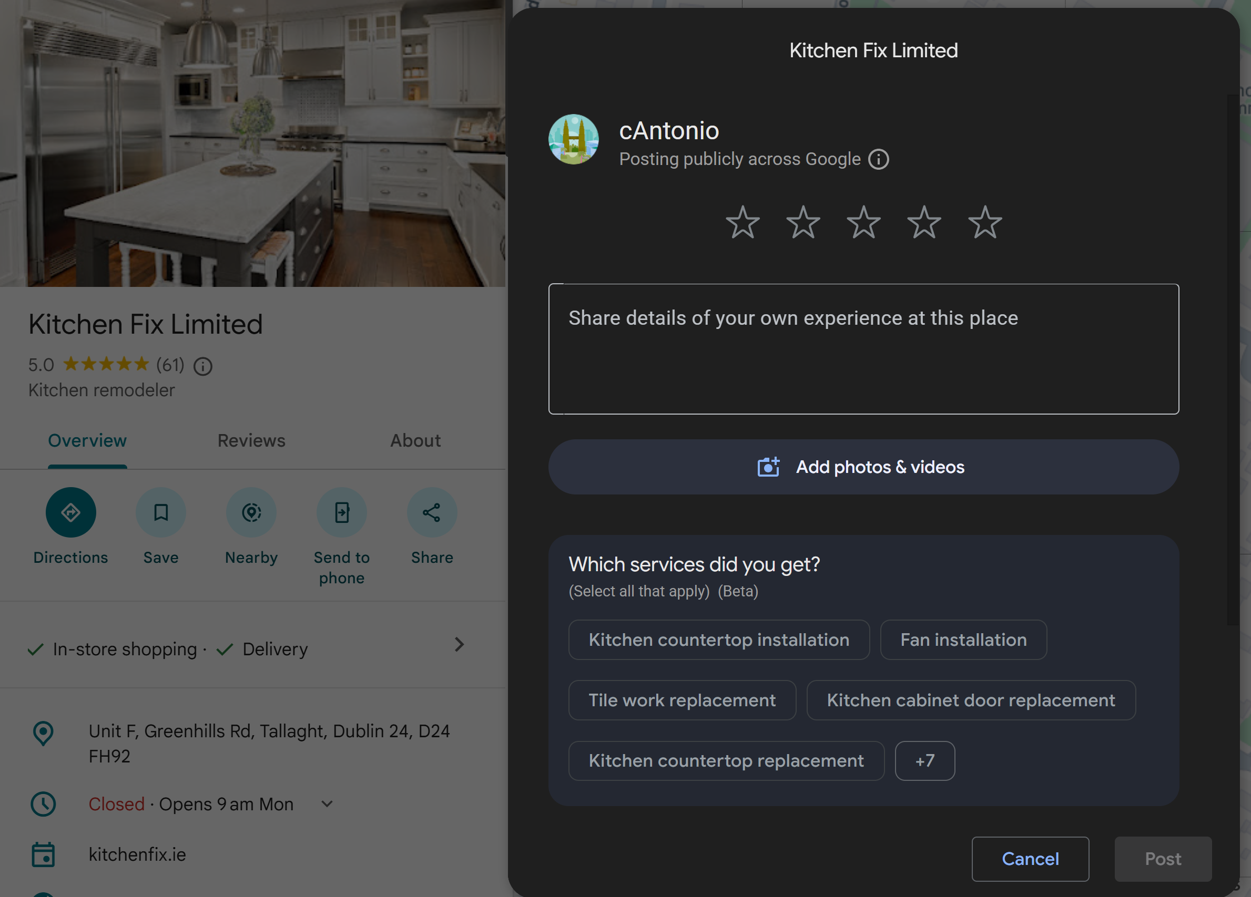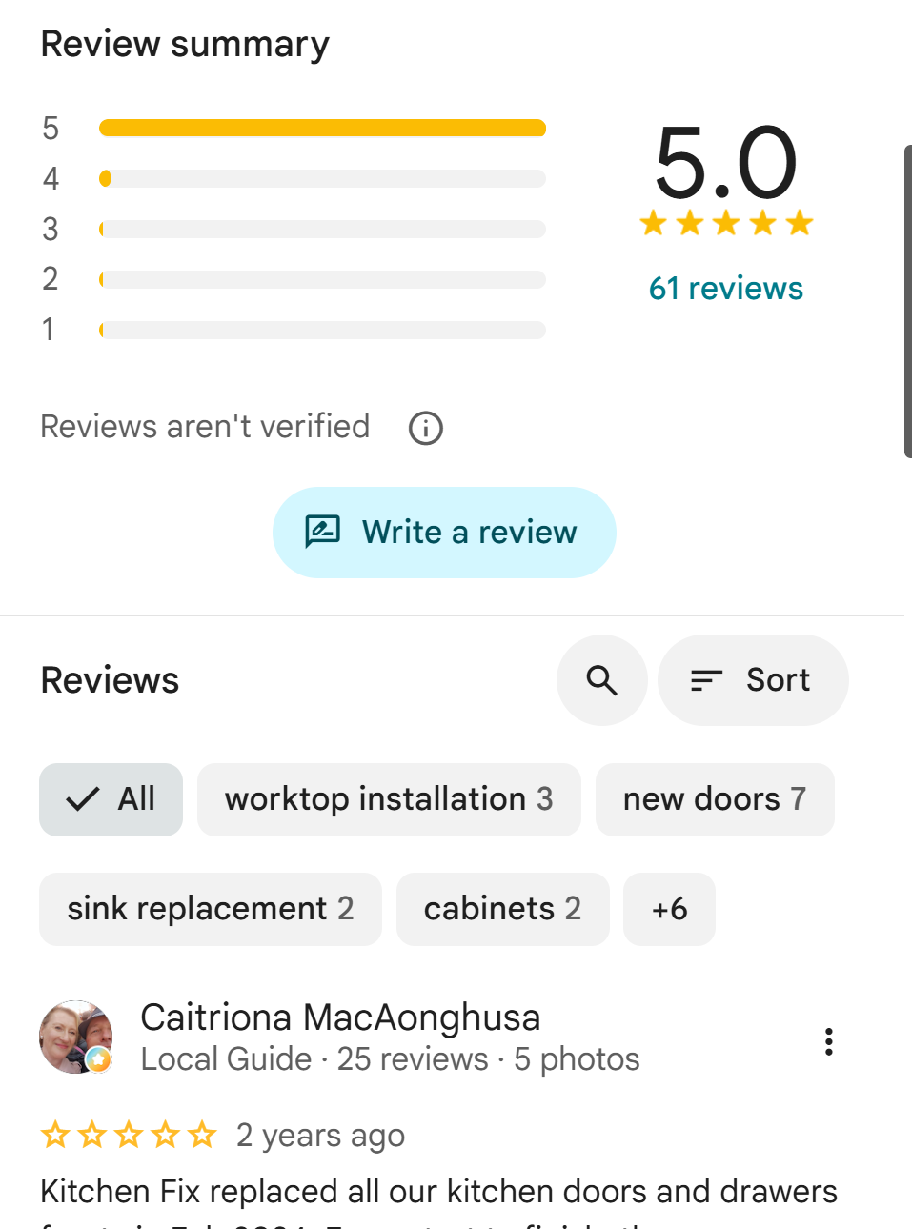

WHAT WE NOTICED
The website directs visitors to Google for reviews rather than displaying customer testimonials directly within the website experience.
WHY IT MATTERS
Strong customer reviews can build trust at the point visitors are deciding whether to enquire. Sending visitors elsewhere adds an unnecessary step.
WHAT WE'D CHANGE
Bring selected Google reviews onto key pages and place them near project galleries and enquiry CTAs.
Priority: HIGH | Effort: LOW

THE OPPORTUNITY
CURRENT JOURNEY | RECOMMENDED JOURNEY
LAND  ↓  BROWSE  ↓  VIEW PROJECTS  ↓  FIND REVIEWS  ↓  COMPLETE FORM  ↓  CONTACT | LAND  ↓  UNDERSTAND THE OFFER  ↓  SEE THE WORK  ↓  BUILD TRUST  ↓  REQUEST QUOTE  ↓  BOOK DESIGN
● HIGH 03- THE WEBSITE JOURNEY IS HEAVY AND DISCONNECTED
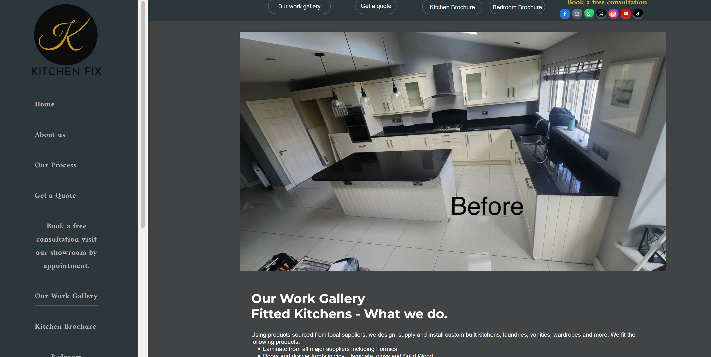

WHAT WE NOTICED
The website uses several different layouts, CTA styles and large areas of unused space, creating a less consistent journey between pages.
WHY IT MATTERS
Visitors should be able to move naturally from seeing the work to understanding the service and taking the next step. A fragmented layout can make that journey less clear.
WHAT WE'D CHANGE
Simplify the page structure, create a more consistent visual hierarchy and repeat clear quote/consultation CTAs throughout the customer journey.
Priority: HIGH | Effort: HIGH
OTHER OBSERVATIONS
OBSERVATION | OPPORTUNITY
Multiple enquiry options | Create one clearer primary conversion path.
Large, persistent sidebar | Use screen space more efficiently.
Strong before/after project content | Make transformations more prominent.

WANT US TO TAKE A CLOSER LOOK?
This is a short preliminary review. A full AEC Media Growth Audit explores Conversion • UX • Messaging • Trust • SEO • Local Visibility • Competitors
Full Growth Audit — €79 introductory price
aecmedia.ie

Preliminary review based on the publicly visible website experience. Not a full technical SEO, analytics or accessibility audit. Recommendations are not guarantees of increased enquiries.

