AEC MEDIA
Kitchenwise.ie
Website: kitchenwise.ie | Industry: Kitchen Design & Installation | Location: Dublin, Ireland
WHAT WE NOTICED

Kitchenwise has a strong visual portfolio, clear service categories and a prominent design appointment CTA. However, several elements of the current website experience create unnecessary friction and distractions that may make it harder for potential customers to move from browsing to enquiry.

● HIGH 01- ENQUIRY FORM CREATES FRICTION
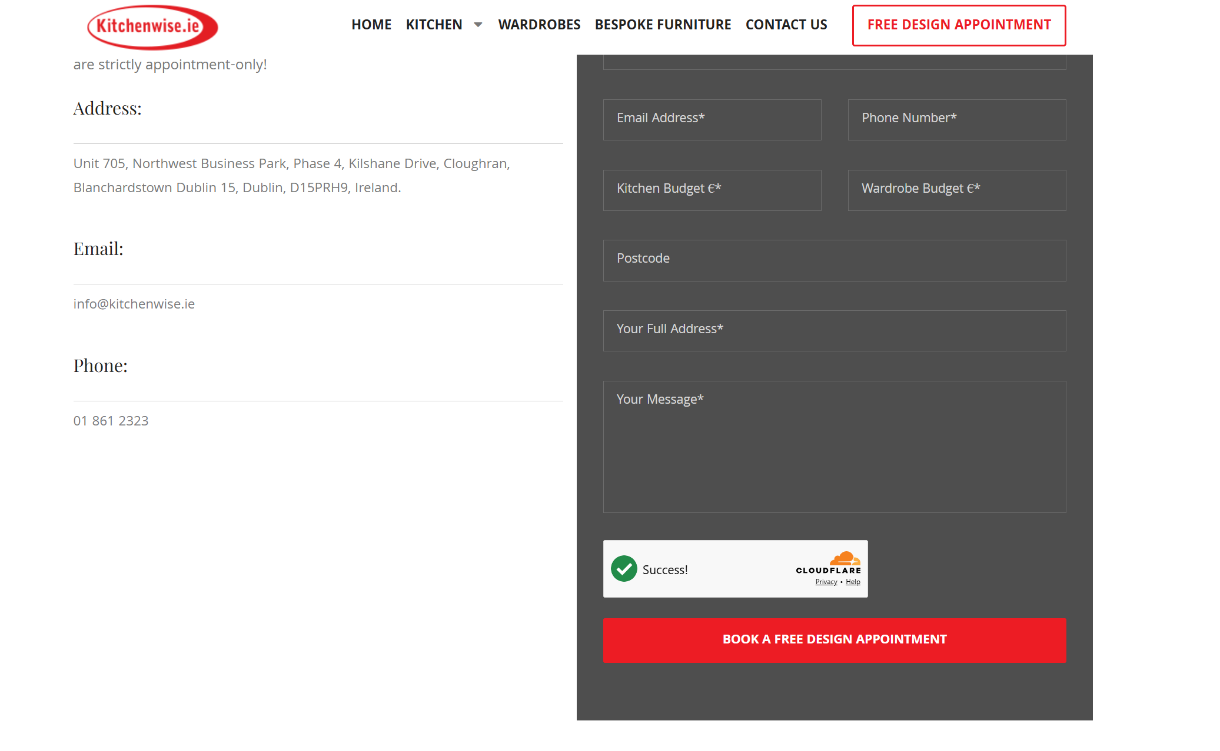

WHAT WE NOTICED
The appointment form asks visitors for several details, including kitchen budget, wardrobe budget, postcode and full address before submitting an enquiry.
WHY IT MATTERS
A longer form can discourage visitors who are interested but not yet ready to provide detailed information.
WHAT WE'D CHANGE
Simplify the initial form to essential details and collect additional information during the consultation.
Priority: HIGH | Effort: LOW
● HIGH 02- VISUAL DISTRACTIONS WEAKEN THE BRAND PRESENTATION
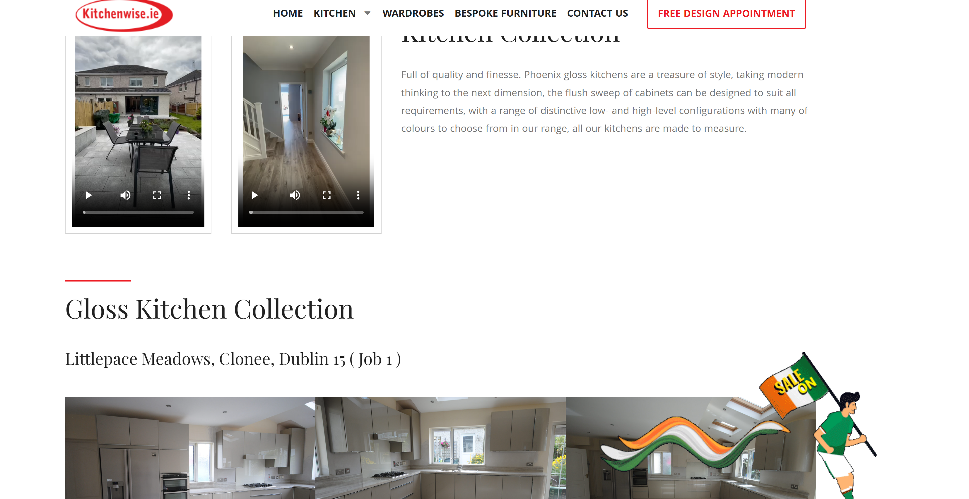

WHAT WE NOTICED
A recurring “SALE ON” graphic appears across the website and overlaps or competes with the main content and project imagery.
WHY IT MATTERS
For a visual, high-value purchase, the website should keep attention focused on the quality of the work and the customer journey.
WHAT WE'D CHANGE
Remove the distracting graphic and use a cleaner promotional element that supports rather than competes with the content.
Priority: HIGH | Effort: LOW

THE OPPORTUNITY
CURRENT JOURNEY | RECOMMENDED JOURNEY
LAND  ↓  BROWSE  ↓  VIEW PROJECTS  ↓  COMPLETE DETAILED FORM  ↓  CONTACT | LAND  ↓  UNDERSTAND THE OFFER  ↓  SEE THE WORK  ↓  BUILD TRUST  ↓  BOOK DESIGN
● HIGH 03- PROJECT PORTFOLIO COULD CONVERT BETTER
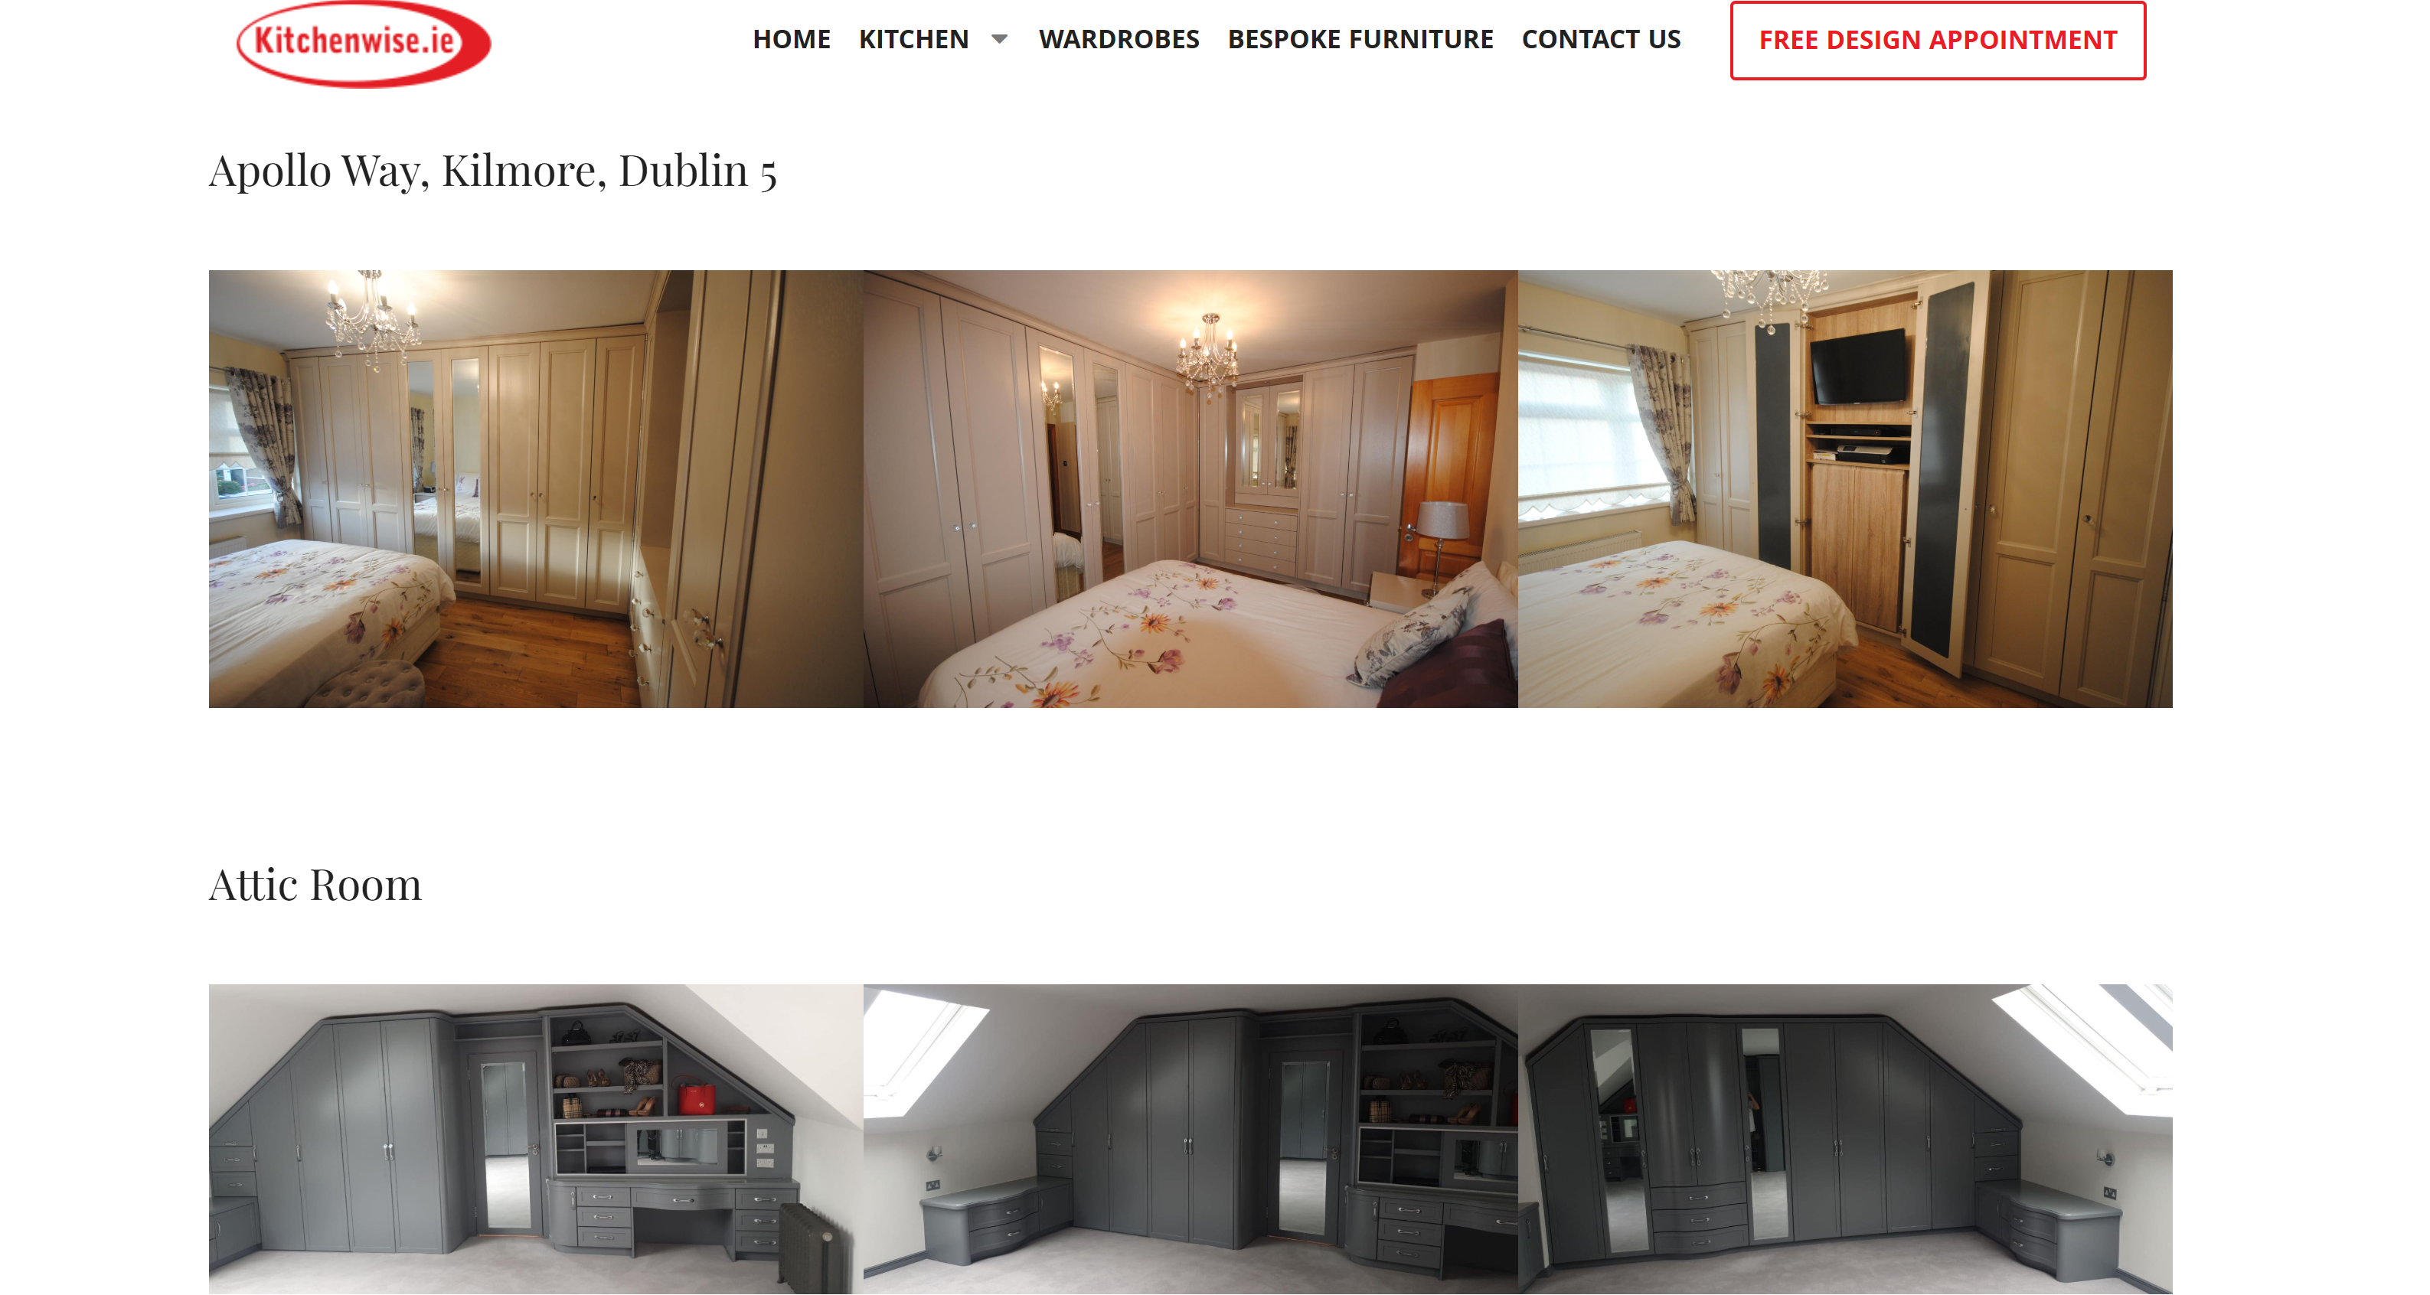

WHAT WE NOTICED
Kitchenwise has a strong collection of completed projects, but many are presented through image-heavy layouts with limited project context.
WHY IT MATTERS
The portfolio is one of the site's strongest assets and could do more to demonstrate quality, build confidence and encourage enquiries.
WHAT WE'D CHANGE
Rework project pages around stronger imagery, clearer project information and more prominent enquiry opportunities.
Priority: HIGH | Effort: HIGH
OTHER OBSERVATIONS
OBSERVATION | OPPORTUNITY
Large areas of unused space | Create a more efficient page structure that brings key information into view sooner.
Project imagery varies in presentation | Create a more consistent and premium gallery experience.
Strong appointment CTA | Bring the CTA more consistently into the customer journey.

WANT US TO TAKE A CLOSER LOOK?
This is a short preliminary review. A full AEC Media Growth Audit explores Conversion • UX • Messaging • Trust • SEO • Local Visibility • Competitors
Full Growth Audit — €79 introductory price
aecmedia.ie

Preliminary review based on the publicly visible website experience. Not a full technical SEO, analytics or accessibility audit. Recommendations are not guarantees of increased enquiries.

