AEC MEDIA
Micheal Cawley Design
Website: d-dcarpentry.ie | Industry: Kitchen Design & Installation | Location: Meath, Ireland
WHAT WE NOTICED

Michael Cawley Design has a strong visual portfolio and clearly communicates its bespoke kitchen, bedroom and furniture services. The website showcases a range of completed work and provides multiple ways to contact the business. However, several areas of the current experience could be improved to make the website feel more polished, communicate the offering more clearly and create a smoother path from browsing to enquiry.

● HIGH 01- MOBILE HEADER AND LOGO OVERLAP
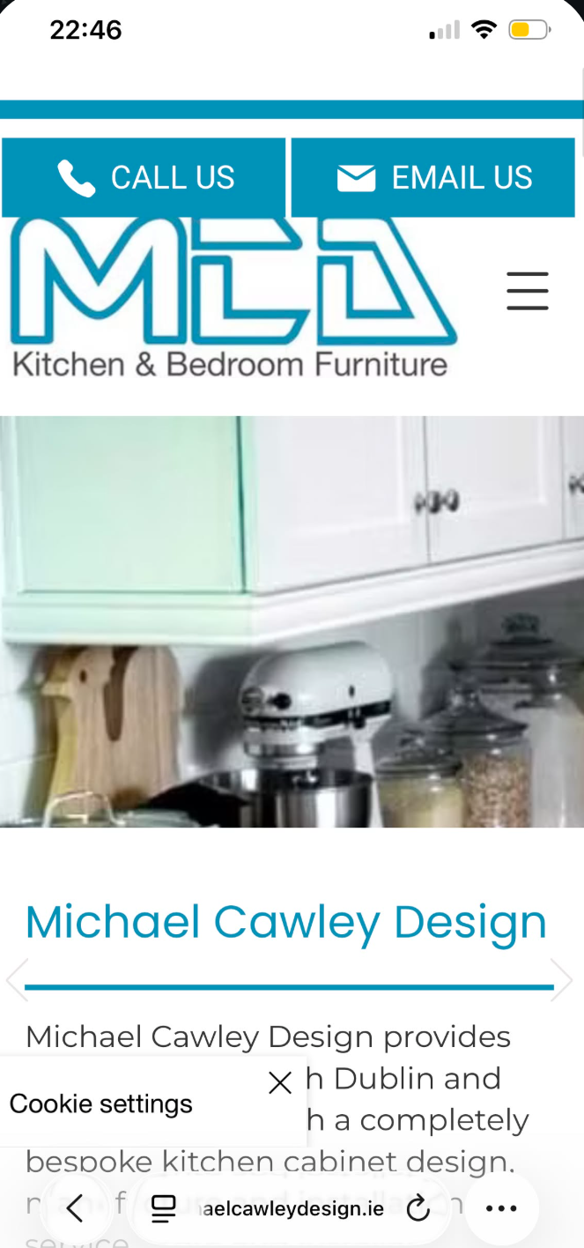

WHAT WE NOTICED
On mobile, the header elements compete for space and the logo overlaps with the navigation area. This creates a visually crowded first impression and makes the header feel less polished than the desktop experience.
WHY IT MATTERS
The mobile experience is often the first interaction for potential customers. Overlapping navigation and branding can make the website feel poorly optimised and can make important actions harder to access.
WHAT WE'D CHANGE
Rework the mobile header spacing and responsive layout so the logo, contact buttons and navigation remain clearly separated and usable across mobile screen sizes.
Priority: HIGH | Effort: MEDIUM
● HIGH 02- THE OFFER COULD BE COMMUNICATED MORE CLEARLY
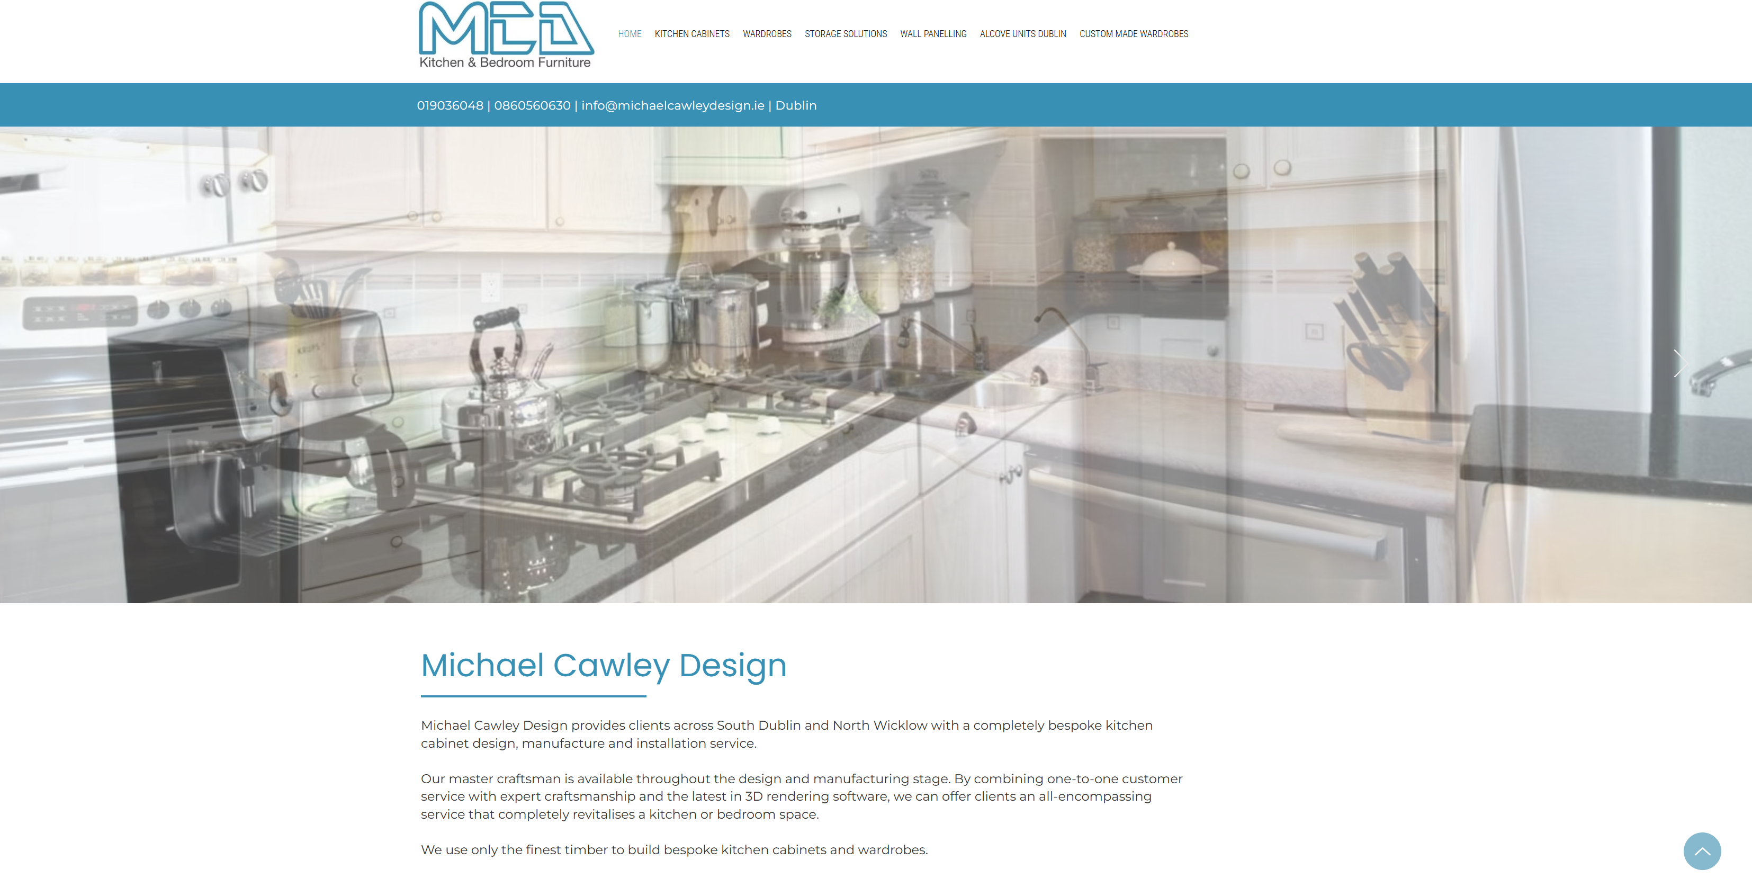

WHAT WE NOTICED
The homepage introduces Michael Cawley Design and showcases its work, but the core offering is not communicated as clearly or quickly as it could be. Visitors are presented with several service categories, while the main value proposition and next step could be more prominent.
WHY IT MATTERS
A visitor should be able to quickly understand what the business does, who it serves and what they should do next. Clearer messaging could reduce uncertainty and help move interested visitors towards an enquiry.
WHAT WE'D CHANGE
Strengthen the above-the-fold messaging with a clearer value proposition, supporting statement and more prominent enquiry or consultation CTA.
Priority: HIGH | Effort: LOW

THE OPPORTUNITY
CURRENT JOURNEY | RECOMMENDED JOURNEY
LAND  ↓  BROWSE  ↓  VIEW PROJECTS  ↓  FIND CONTACT DETAILS  ↓  SUBMIT ENQUIRY | LAND  ↓  UNDERSTAND THE OFFER  ↓  SEE THE WORK  ↓  BUILD TRUST  ↓  DISCUSS YOUR PROJECT

● HIGH 03 PROJECT/PORTFOLIO CONTENT COULD DRIVE MORE ENQUIRIES
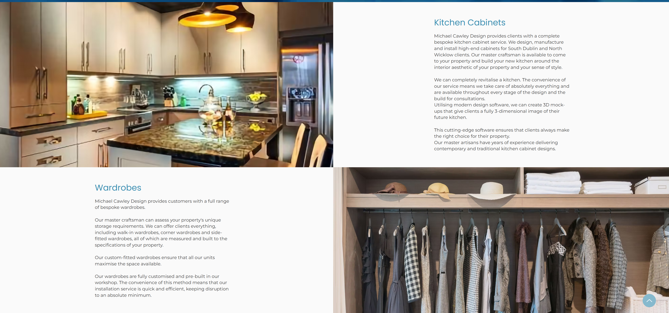

WHAT WE NOTICED
The website contains a strong range of kitchens, wardrobes, storage solutions and bespoke furniture projects. However, much of the portfolio experience focuses on displaying the work rather than giving visitors a clear next step after viewing it. WHY IT MATTERS
Someone browsing completed projects is already demonstrating interest in the type of work Michael Cawley Design provides. This creates an opportunity to connect inspiration directly with consultation or enquiry.
WHAT WE'D CHANGE
Add stronger project-level CTAs and supporting information, such as “Discuss Your Project”, “Request a Consultation” or “Get a Quote”, alongside relevant project imagery.
Priority: HIGH | Effort: MEDIUM
OTHER OBSERVATIONS
OBSERVATION | OPPORTUNITY
Contact information is available | Make enquiry CTAs more prominent throughout the site.
FAQ section exists | Use FAQs to address common buying questions and reinforce trust.
Main service offering requires more interpretation | Make the value proposition more immediate.

WANT US TO TAKE A CLOSER LOOK?
This is a short preliminary review. A full AEC Media Growth Audit explores Conversion • UX • Messaging • Trust • SEO • Local Visibility • Competitors
Full Growth Audit — €79 introductory price • aecmedia.ie

Preliminary review based on the publicly visible website experience. Not a full technical SEO, analytics or accessibility audit. Recommendations are not guarantees of increased enquiries.

