AEC MEDIA
Town & Country Kitchens
Website: townandcountrykitchens.ie | Industry: Kitchen Design & Installation | Location: Dublin, Ireland
WHAT WE NOTICED

Town & Country Kitchens has a strong foundation of experience, a substantial project gallery and clear contact information. However, the current website experience creates several points of friction that may affect visitor trust and make it harder for potential customers to move from browsing to enquiry.

● HIGH 01- WEBSITE CONNECTION IS NOT SECURE
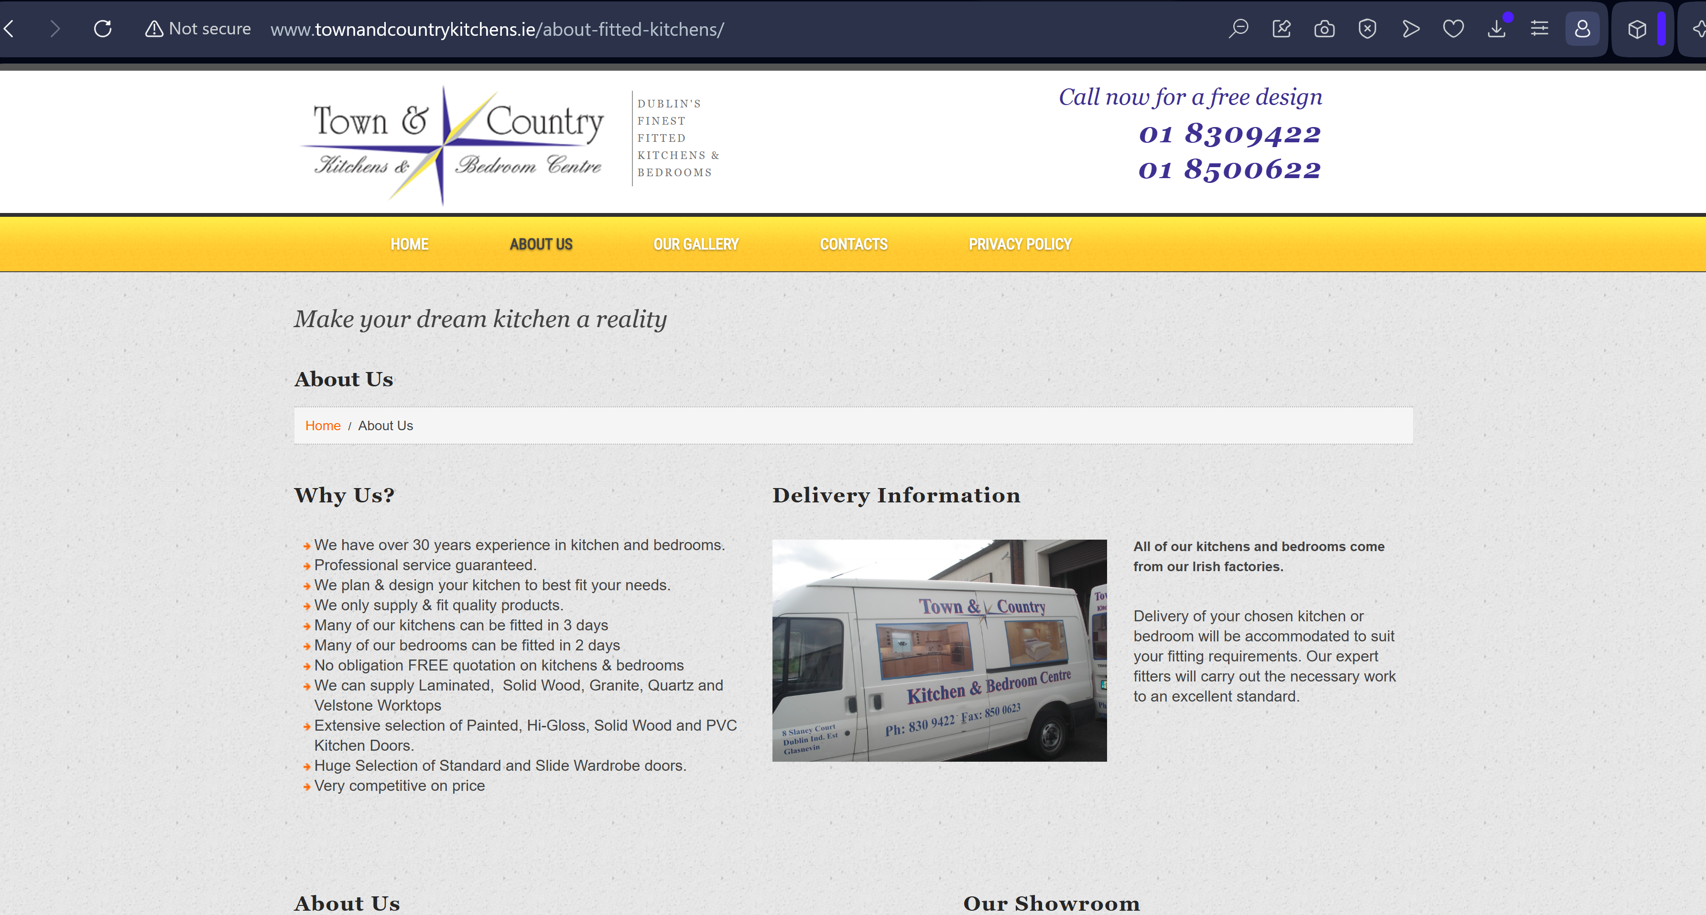

WHAT WE NOTICED
The website is currently being accessed over an insecure connection, with the browser displaying a security warning.
WHY IT MATTERS
Security warnings can immediately reduce visitor trust, particularly for a business asking customers to submit personal information through contact and quotation forms.
WHAT WE'D CHANGE
Install and correctly configure an SSL certificate so the entire website loads securely over HTTPS.
Priority: HIGH | Effort: LOW
● HIGH 02- THE WEBSITE DOES NOT MATCH THE QUALITY OF THE WORK
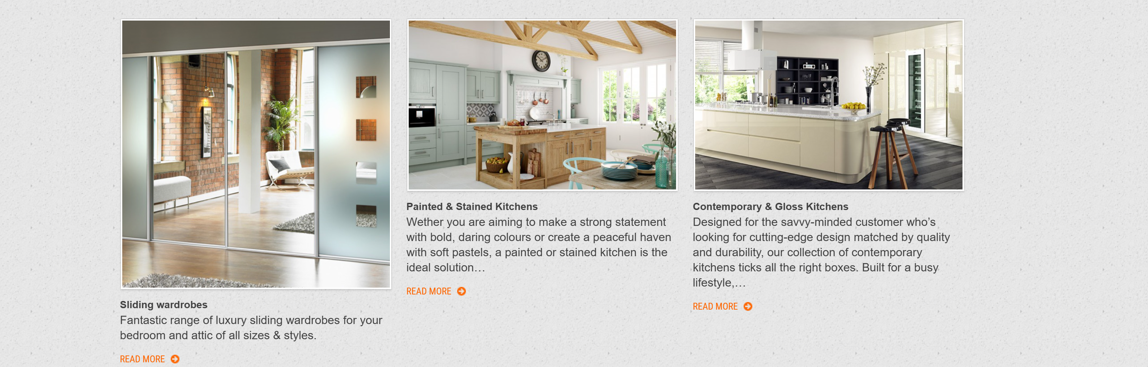

WHAT WE NOTICED
The website presents high-value kitchen projects through a dated and highly compressed layout, with large areas of unused space and important information displayed at a very small scale.
WHY IT MATTERS
Kitchen purchases are highly visual and often involve significant investment. Visitors need to quickly understand the quality of the work, services offered and why they should choose the company. The current presentation can make the business feel less established online than the quality of its work suggests.
WHAT WE'D CHANGE
Redesign the core page layouts around larger project imagery, clearer messaging, stronger hierarchy and more prominent enquiry opportunities.
Priority: HIGH | Effort: HIGH
THE OPPORTUNITY
CURRENT JOURNEY | RECOMMENDED JOURNEY
LAND  ↓  BROWSE OUTDATED CONTENT  ↓  SEARCH THROUGH GALLERY  ↓  CONTACT | LAND  ↓  UNDERSTAND THE OFFER  ↓  SEE THE WORK  ↓  BUILD TRUST  ↓  GET A QUOTE/ BOOK DESIGN
● HIGH 03- BROKEN / UNAVAILABLE PROJECT CONTENT
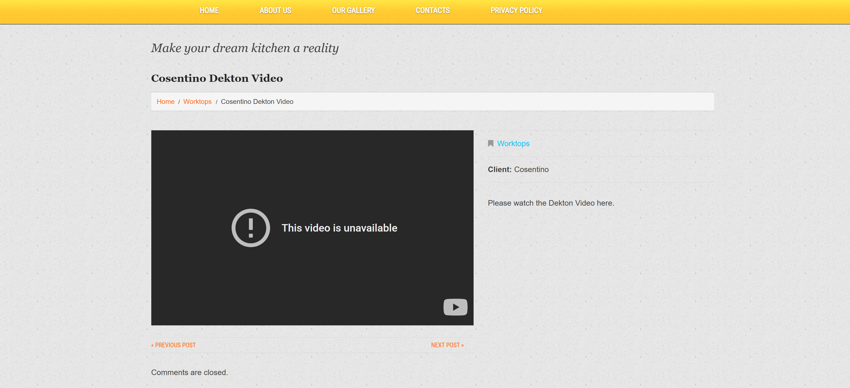

WHAT WE NOTICED
Several pieces of older project content remain accessible through the website, including a dedicated video page where the embedded video is currently unavailable.
WHY IT MATTERS
Broken or outdated content can weaken trust and makes the website feel less actively maintained. For a customer evaluating a kitchen company, project content should reinforce confidence rather than introduce doubt.
WHAT WE'D CHANGE
Audit existing gallery and project content, remove broken assets and replace outdated pages with current project showcases featuring strong imagery, descriptions and clear enquiry CTAs.
Priority: HIGH | Effort: MEDIUM
OTHER OBSERVATIONS
OBSERVATION | OPPORTUNITY
Very large areas of unused space | Create a more efficient page structure that brings key information and CTAs into view sooner.
Gallery relies heavily on older-style layouts | Rebuild the gallery around larger imagery, categories and project details.
Homepage messaging is quite limited | Make the value proposition, experience and differentiators clearer immediately.

WANT US TO TAKE A CLOSER LOOK?
This is a short preliminary review. A full AEC Media Growth Audit explores Conversion • UX • Messaging • Trust • SEO • Local Visibility • Competitors
Full Growth Audit — €79 introductory price
aecmedia.ie

Preliminary review based on the publicly visible website experience. Not a full technical SEO, analytics or accessibility audit. Recommendations are not guarantees of increased enquiries.

