S11 Reduced Security Portfolio CORS and CSRF
Version 1.2.1 CANDIDATE / WIP/PREVIEW_NOT_FINAL. Individual required two-class route.
Complete this required two-class portfolio after the short classroom transfer. It belongs in the same individual S11 PDF as P02, the bounded Gemini critique and reflection. The source requires two classes; CORS and CSRF are the documented local curriculum choice. P02 remains the central implementation.

Open the exact assessed file
From the extracted package root, locate portfolio/p03-reduced/student/src/security-boundary.js. Preserve its export signatures. This is the only assessed edit in this project. Preserve support.js, the tests, package metadata and baseline declaration. Do not import or launch the historical deliberately insecure all-five exercise.

Predict two protective decisions
For CORS, trace a normal exact allowed-origin category and a benign non-member origin to the decision. Record the complete origin tuple, HTTP status, sharing headers, credentials and Vary: Origin separately. An application refusal and withheld browser-sharing permission are different results. A pure helper does not establish browser or cache enforcement.
For CSRF, separate the exercise’s safe methods from the cookie-authenticated unsafe-method path. Use benign matching, missing and nonmatching categories. Record the comparison owner and outcome, omitting all token values. A deterministic fixture is not a production secret, and a constant-time comparison helper does not make the complete path timing-safe.

Implement and retain your evidence
Implement your own two-class decisions inside the permitted file, retaining fail-closed behaviour while work is incomplete. When your separately qualified environment accepts, use TEST_P03_REDUCED.cmd on Windows or run sh ./TEST_P03_REDUCED.sh from the root on macOS/Linux to retain the actual named portfolio checks. Use the package-root boundary command node tools/verify-boundary.mjs p03 to check changed paths. Boundary acceptance is not correctness. Use node tools/verify-work-result.mjs only in the separately provisioned strict environment after the mandatory P02 and reduced P03 work is complete.
Record source-to-decision traces, your initial predictions, actual named controls or NOT_EXECUTED, expected and observed results, a narrow diff, a locator and a limitation. Keep the normal positive control; refusing everything cannot demonstrate a correct protective implementation. Do not modify support/tests, weaken guards or test an external target.

Read the frozen suite contract
The canonical reduced P03 contract has baseline 2 PASS and regression 2 PASS; its objective 4 begins with 1 PASS and 3 exact intended assertion failures. Additional required suites are infrastructure 6 PASS and successorInputs 12 beginning with 6 PASS and 6 exact intended assertion failures. Completed work requires every named test to PASS. These are expected contract counts, not observations. Read tools/PROJECT_SUITE_CONTRACT.json for the names and signatures. A parser error, TypeError, timeout, skip or crash is an infrastructure incident, not an accepted starter assertion.

Complete the portfolio fields
Use portfolio_route, cors_trace, cors_controls, csrf_trace, csrf_controls, portfolio_patch, portfolio_retained, portfolio_limits and portfolio_completion. Record COMPLETE_RECORDED only from your actual required results. A source/model fallback preserves a draft; it does not fulfil the normal actual-execution gate. A genuine prior teacher-authorised alternative has its own recorded assessment route.
Explicitly state that this selected evidence does not establish query safety, destination-specific output handling or configuration-secret controls. The result must not be called a pass of the historical all-five suite. If prerequisites are blocked, preserve an honest draft and the real block before the teacher-set deadline; do not invent that deadline.
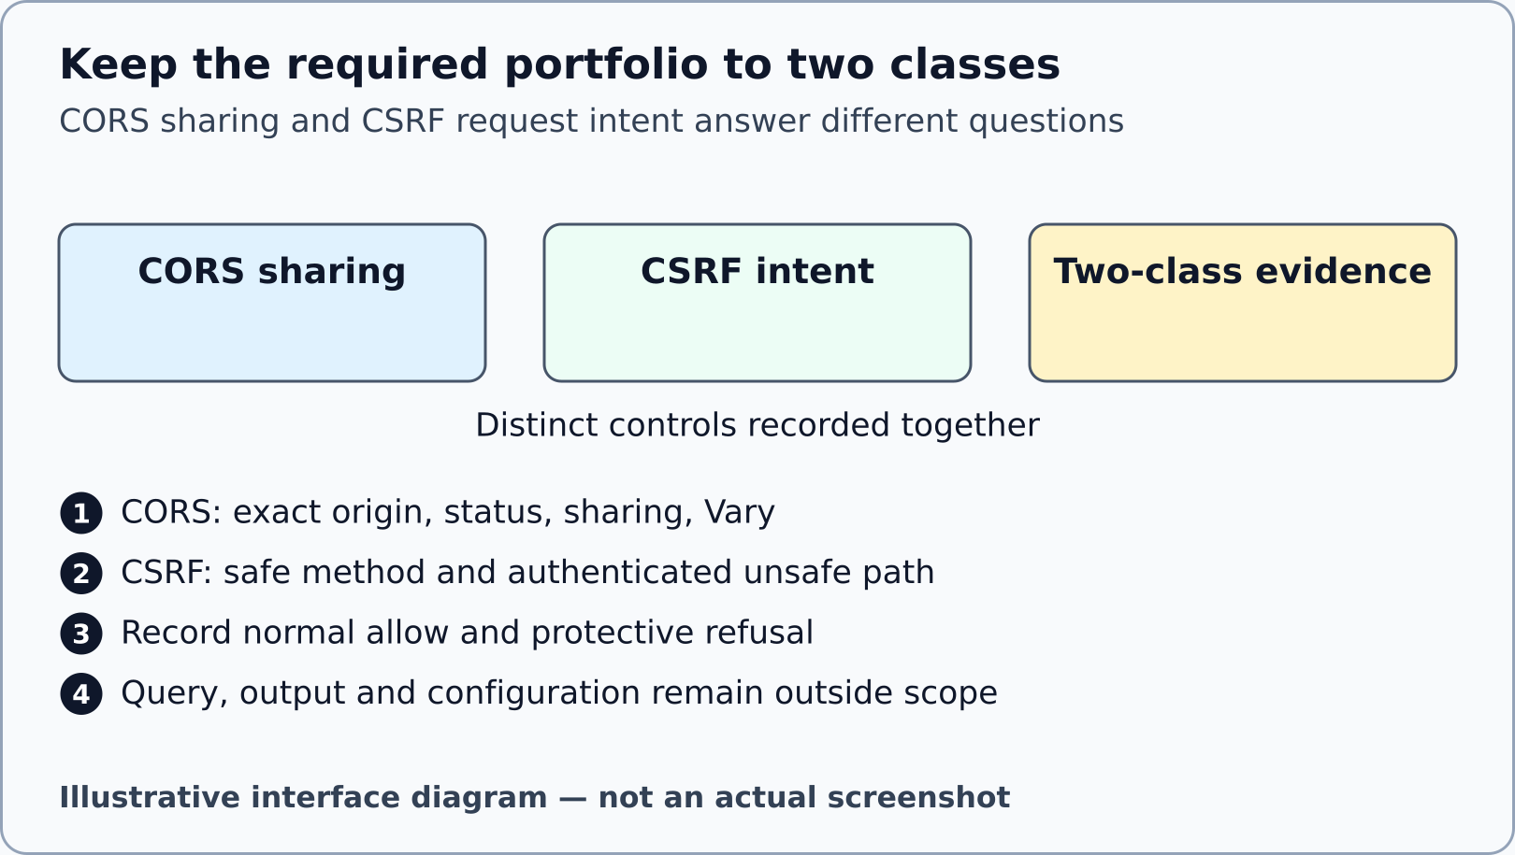
Illustrative interface diagram. No exploit trace, browser/cache result or all-five PASS is depicted.

