Decision trees are a fundamental tool in machine learning and data analysis, widely used for classification and regression tasks. They're a supervised learning method used for both categorical and continuous input and output variables. Let's delve into the theory behind decision trees:

Basics:
- Tree Structure: A decision tree is a flowchart-like structure where an internal node represents a "test" on an attribute (e.g., whether a coin flip comes up heads or tails), each branch represents the outcome of the test, and each leaf node represents a class label (decision taken after computing all attributes).
- Decision Node: These are used to make decisions based on different attributes. It splits the data into smaller subsets.
- Leaf Node: These are the terminal nodes that predict the outcome. They don't split any further.
- Root Node: It represents the entire dataset and gets split into two or more homogeneous sets by the feature that best splits the data.

Building Process:
- Splitting: The process of partitioning the data into subsets based on the value of a particular attribute. The algorithm chooses the best attribute that splits the data into most homogeneous subsets.
- Stopping Criteria: The process of deciding when to stop splitting a node. It could be when all records belong to the same class or when there are no more attributes to split or when a predefined depth of the tree is reached.
- Pruning: The process of removing the parts of the tree that are non-informative or unnecessary. It helps in avoiding overfitting.

Splitting Criteria:
- Gini Impurity: It measures the probability of misclassifying an observation if it is randomly labeled according to the distribution of labels in the branch. Lower Gini impurity indicates higher homogeneity.
- Entropy: Entropy measures the randomness or uncertainty in the dataset. A lower entropy indicates less uncertainty.
- Information Gain: It measures the reduction in entropy or impurity after splitting the dataset. The attribute with the highest information gain is chosen as the splitting attribute.

In more detail:

1. Gini Impurity:
Gini impurity measures the probability of incorrectly classifying a randomly chosen element in the dataset if it were labeled according to the distribution of labels in the subset. It ranges from 0 to 1, where 0 indicates perfect homogeneity (all elements belong to a single class) and 1 indicates maximum heterogeneity (equal distribution across all classes).
For a node t with K classes and p(i∣t) denoting the probability of an element in t being classified as class i, Gini impurity is calculated as:
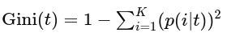

The attribute that minimizes the weighted sum of Gini impurities across all child nodes is selected as the splitting criterion.

2. Entropy:
Entropy measures the randomness or uncertainty in the dataset. In the context of decision trees, it quantifies the impurity of a set of examples. Similar to Gini impurity, it ranges from 0 to 1, with 0 representing perfect homogeneity and 1 representing maximum heterogeneity.
For a node t with K classes and p(i∣t) denoting the probability of an element in t being classified as class i, the entropy H(t) is calculated as:
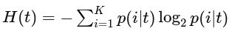

As with Gini impurity, the attribute that minimizes the weighted sum of entropies across all child nodes is chosen for splitting.

3. Information Gain:
Information gain measures the reduction in entropy or impurity achieved by splitting the dataset based on a particular attribute. The attribute with the highest information gain is selected as the splitting criterion at each node.
For a dataset D with K classes, and A representing an attribute to split on, information gain is calculated as:
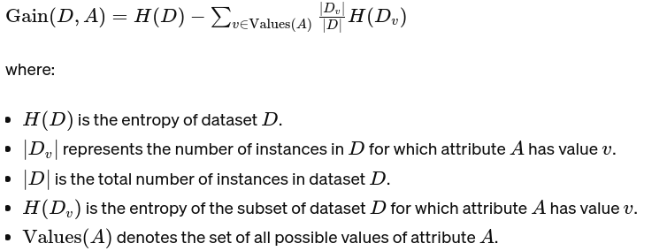
Information gain selects the attribute that maximizes the difference between the entropy of the original dataset and the weighted sum of entropies of its subsets.
In practice, both Gini impurity and entropy are commonly used, and they often lead to similar results. Information gain is particularly popular in decision tree algorithms like ID3 (Iterative Dichotomiser 3) and C4.5.

Advantages:
- Interpretability: Decision trees are easy to understand and interpret. They mimic human decision-making processes.
- Handles Non-linearity: They can handle both numerical and categorical data and also non-linear relationships between parameters.
- Feature Selection: Decision trees automatically select the most important features, making them robust to irrelevant features.

Disadvantages:
- Overfitting: Decision trees tend to overfit the data if not pruned properly. This can be mitigated using techniques like pruning and setting a maximum depth for the tree.
- High Variance: Small variations in the data can result in a completely different tree structure, making them unstable.
- Bias Towards Dominant Classes: When one class dominates the dataset, decision trees tend to bias towards that class.
Decision trees serve as the basis for more complex ensemble methods like Random Forests and Gradient Boosting Machines, which aim to overcome their limitations while retaining their strengths.

