A.V.E.A* Screen User Manual
Oct 26, 2026 · @Antonio

Warnings
- AVEA is not a certified aviation instrument: it is an aid to VFR flying and does not replace the onboard instruments, aeronautical charts or visual lookout.
- Icing, fog and haze risks are estimates based on temperature and humidity; always check the actual visibility in the METAR.
- Fuel is a time-based estimate: always check the tank before flight.
- Set the QNH before take-off and reset the QFE if needed.

Introduction
AVEA is a panel-mounted flight instrument for ultralights, 58 mm diameter, threaded screw holes at standard spacing: altimeter, variometer, QFE, GPS speed, compass, return to home, weather with icing and fog risk, estimated haze likelihood, estimated fuel, flight timer and flight log. It can work together with up to 2 other instruments via Bluetooth (1 master and 2 slaves).
Basic controls
Gesture | What it does
Swipe right or left | Next or previous page; from secondary pages it goes back
Tap | Described for each page in this manual
Swipe up or down on the compass | Changes the color theme: white/black → color → yellow/black
Drag on a roller | Changes the value (settings pages); scrolling fast makes the roller accelerate
Drag on an arc | Adjusts thresholds or liters (on the ground only)
The selected theme applies to the whole instrument. Some pages (AIR DATA, WIFI LOG, alerts) are always in color. With DISABLE VERTICAL SWIPE (PAGES 2/2 page) the vertical swipe no longer changes the theme, not even on the compass.
In flight, once the timer starts, many options are disabled to prevent accidental touches.
Power-up
- The AVEA logo appears for 5 seconds. Tapping its center within those 5 seconds opens FIRMWARE VERSION.
- If there are risks (carburetor icing, fog, reduced visibility or haze) a full-screen alert appears; with several risks the pages alternate every 3 seconds.
- A tap closes the alert and goes to the saved page, i.e. the last page of the loop used before switching off.

The page loop
Swiping right or left moves from one page to the next in this order; the last one returns to the first. Pages switched off in PAGES are skipped.

# | Page | Purpose | Default
1 | COMPASS | GPS track and heading | On
2 | GO TO HOME | Arrow, distance and corridor to the airfield | On
3 | SENSOR DASHBOARD (METEO) | Outside temperature and humidity | On
4 | VARIO | Climb and sink in m/s, altitude | On
5 | ALTIMETER | Altitude, bar variometer, GS speed | On
6 | QFE | Height above the airfield | On
7 | GPS SPEED | Ground speed with colored thresholds | On
8 | GPS CLOCK | GPS time and UTC offset | On
9 | AUTO TIMER | Automatic flight timer | On
10 | ICT | Instrument check reminder | On
11 | SETUP | Vario threshold, DUAL | On
12 | WIFI LOG | Flight logs and firmware update via phone | On
13 | GPS INFO | Satellites, constellations, enabling and connecting Bluetooth slaves | On
14 | MANUAL FLIGHT TIMER | Manual stopwatch | On
15 | G-METER (TEST) | Vertical acceleration (disabled) | Off
16 | FUEL ESTIMATE | Estimated fuel (indicative only; it may not match actual consumption, which depends on engine RPM. Calibration was done at cruise speed in straight and level flight). | On

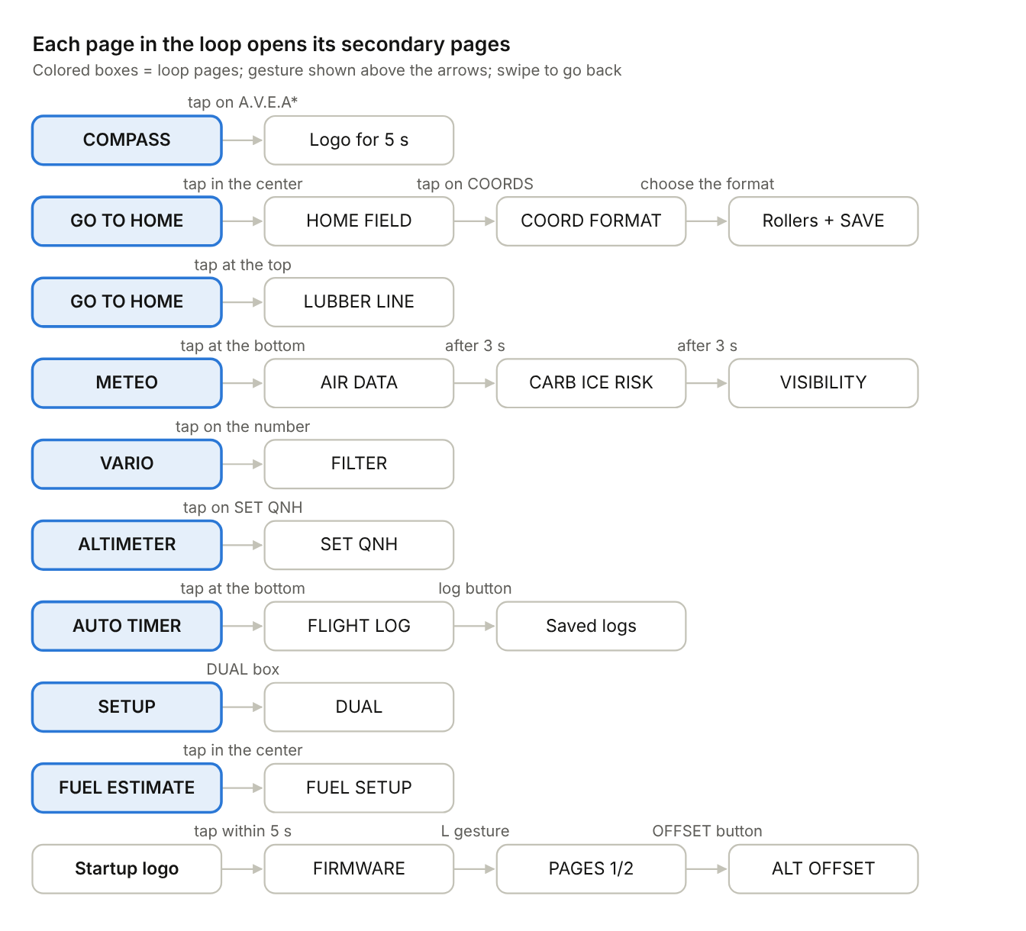
From any secondary page, a swipe right or left takes you back to the page you started from.

Flight pages
Four pages show altitude, climb and speed; on the three with an arc, an orange needle with a yellow outline moves along the scale.
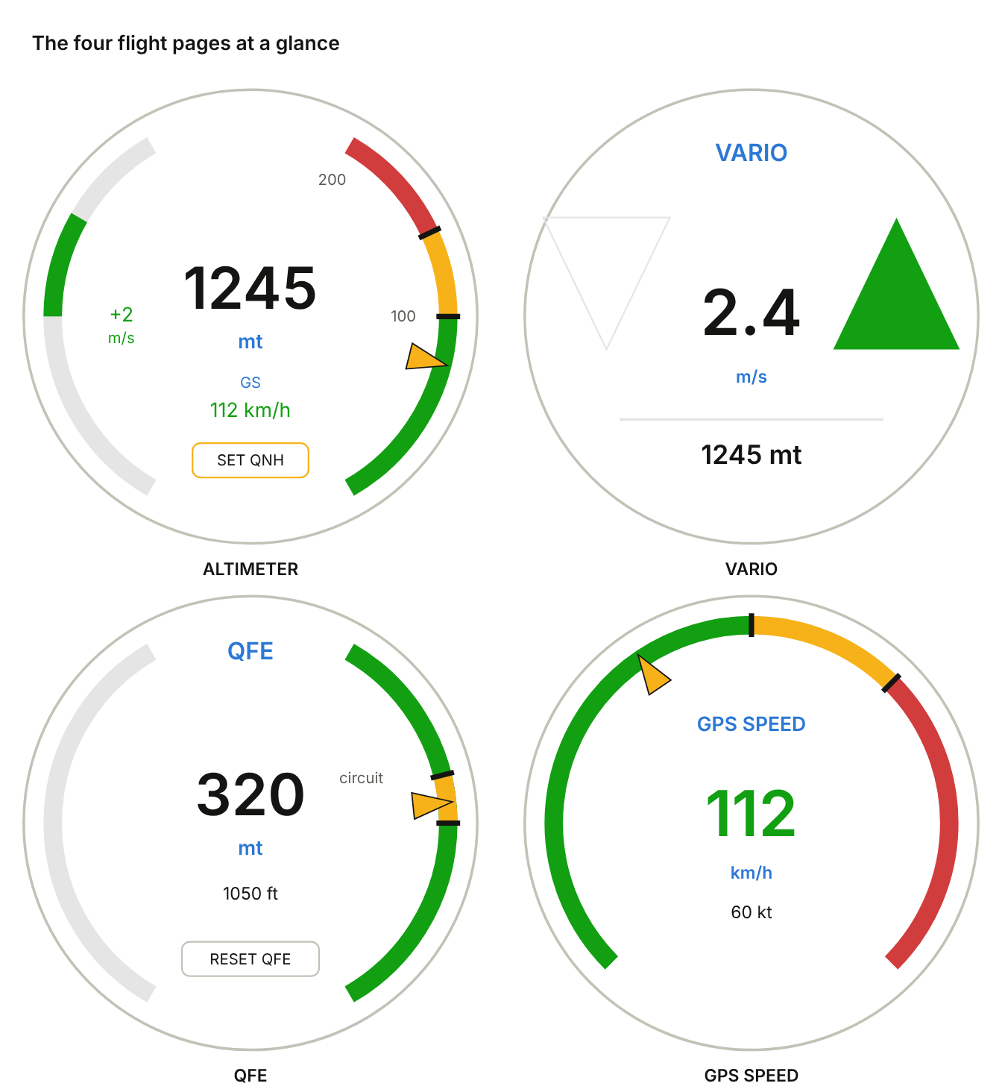
ALTIMETER, VARIO, QFE and GPS SPEED · schematic drawings
Arc colors: green below the yellow threshold, yellow up to the red one, red beyond; black tick marks separate the yellow section. Values are examples.

ALTIMETER
- Center: altitude in meters or feet (mt/ft below the number).
- Left: variometer bars, one per m/s, green when climbing and red when sinking; the m/s value is shown next to them.
- Right: green / yellow / red GS speed arc with needle, numbers every 50 km/h. Full scale starts at 200 km/h (110 kt) and automatically extends to 250, 300… km/h if the speed exceeds it.
- Bottom: "GS" and numeric speed, then the SET QNH button.
Tap | Effect
On the GS value | km/h ↔ knots (scale too)
Swipe along the right arc (on the ground only) | Moves the yellow or red threshold closest to your finger, in steps of 5
SET QNH at the bottom | Opens SET QNH

VARIO
- Large m/s value in the center, with "m/s" below and a thin gray line separating it from the altitude.
- Green triangle on the right when climbing, red on the left when sinking; the inactive triangle remains as a gray outline.
- Tap on the number: FILTER page (vario filter). Tap on the altitude: SET QNH.

QFE
- Height above the airfield (since RESET QFE), with variometer bars on the left.
- Green right arc with the yellow circuit altitude band (default 250–350 m) bounded by black tick marks. Automatic full scale in steps of 500 m (1500 ft).
- Tap on the value: meters ↔ feet. RESET QFE: zeroes the height above the airfield. Swipe on the arc (on the ground only): moves the edge of the circuit band.
- At device power-up it automatically sets itself to 0 after 15 seconds.

GPS SPEED
- Large ground speed in the center, colored according to the band it falls in, with the value in the other unit below.
- 270° green / yellow / red arc with needle and a small triangle marking the maximum speed of the flight. Same automatic full scale as the ALTIMETER.
- Tap in the center: km/h ↔ knots. Swipe on the arc (on the ground only): yellow and red thresholds (the same as the ALTIMETER).

LOW GS
An orange reminder, not a stall warning, that appears when ground speed drops too low in flight.
- Arming: only after take-off (automatic timer running), as soon as ground speed reaches 100 km/h (54 kt). It disarms on landing, so it never appears while taxiing or during the take-off run.
- Active: when ground speed drops below 65 km/h (35 kt); it goes off as soon as you are above it again. In knots the same thresholds apply, converted.
- ALTIMETER: the word "GS" becomes LOW GS, orange and blinking; the speed value turns orange.
- GPS SPEED: the title becomes LOW GS, orange and blinking; the large number turns orange.
- Important: ground speed is not airspeed. With a tailwind you can be slow relative to the air even with a higher GS: LOW GS is a reminder to check the airspeed indicator.

Navigation and return to home
Home (the departure airfield) is set in HOME FIELD, manually or with the GPS, and from there GO TO HOME guides you back.
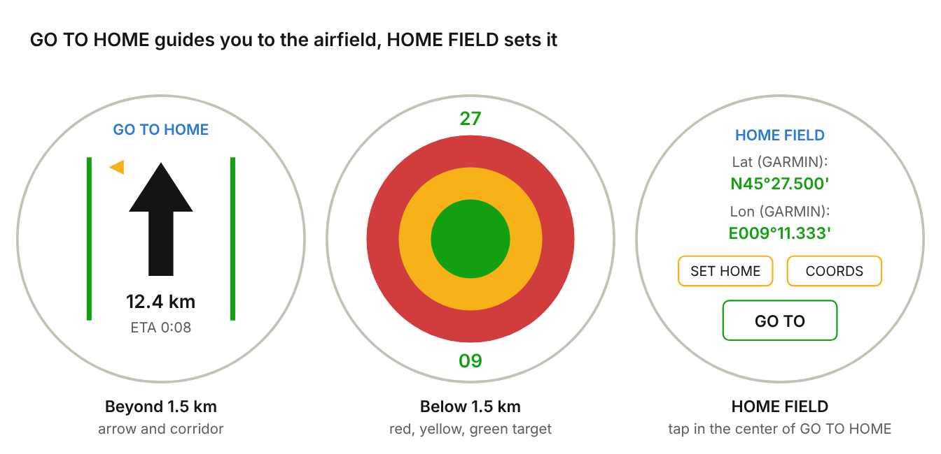
GO TO HOME (far and near) and HOME FIELD · schematic drawings
Far from the airfield you see the arrow between the two corridor lines; near the airfield the arrow becomes the target, with the course below and the reciprocal course above.

COMPASS
- Aircraft in the center with the GPS track in degrees; "N" and aircraft.
- The A.V.E.A* box at the bottom: a tap shows the logo for 5 seconds.
- Swipe up or down: changes the color theme (the only page where this is possible; it also changes on the other pages).
- Without a GPS fix, "NO GPS FIX" is shown.

GO TO HOME
- Arrow to the airfield, distance in km and ETA. Beyond 2 km the arrow is steady; between 2 and 1.5 km it flashes.
- Below 1.5 km a target of circles appears: red down to 900 m, then yellow down to 500 m, flashing green down to 400 m, steady green below that; above and below the target are the reciprocal course and the course in tens of degrees (09 = 90°).
- Corridor (lubber line): two side lines, green within the set width, yellow within the tolerance, red beyond; a small arrow shows which way to correct. Below 10 km the corridor narrows in proportion to the distance. If you deviate by more than 100° the corridor switches off and comes back on below 80°; if you point back toward home within 20°, the leg restarts from your current position.
- Tap in the center: HOME FIELD. Tap in the upper center: LUBBER LINE.

LUBBER LINE
Sets the corridor width (green, default 1 km each side) and the yellow tolerance (default +1 km). Swipe to return to GO TO HOME.

HOME FIELD
- Shows the latitude and longitude of home in the selected format.
- SET HOME: tap twice (SET HOME, then CONFIRM) to save the current GPS position.
- COORDS: opens the format selection and then the rollers to enter coordinates manually.
- GO TO: returns to GO TO HOME. Swipe: back to the compass.

COORD FORMAT and coordinate rollers
- Choose the format: XCSOAR (N45°27'30"), GARMIN (N45°27.500'), SKY DEMON (N452730) or GOOGLE MAPS (45.458333).
- Three rollers adapted to the format open: drag up or down, or tap above or below the band for a single step.
- At the top: N/S (or E/W, or +/−) switches the hemisphere, LON ▸ / LAT ▸ switches to the other coordinate. Above SAVE there is a preview as written by the selected app.
- SAVE saves and returns to HOME FIELD. Swipe exits without saving.
With two instruments connected, home is always the same on master and slave.

Weather and risks
From its sensors the instrument estimates the risk of carburetor icing and of reduced visibility; these are indicative estimates, and the actual visibility must be checked in the METAR.
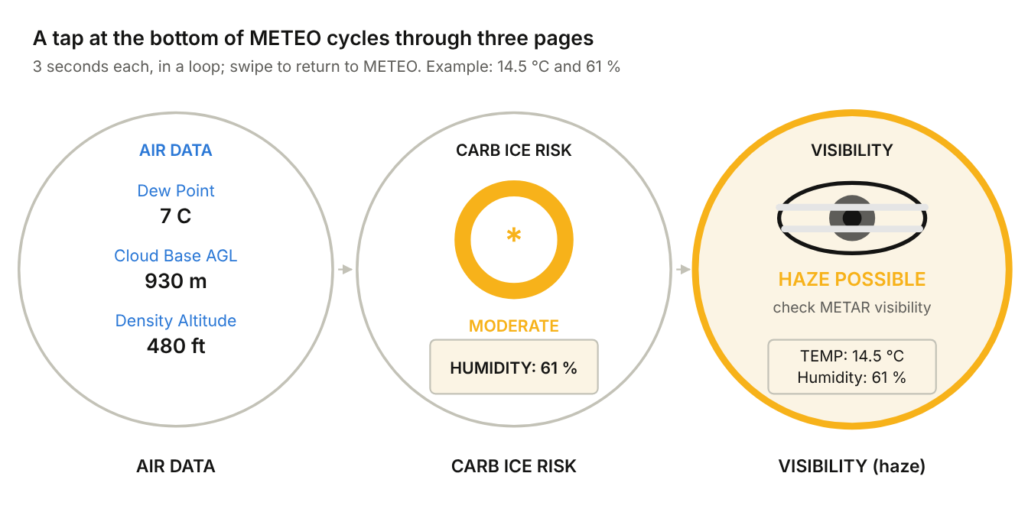
AIR DATA, CARB ICE RISK and VISIBILITY · schematic drawings
The VISIBILITY page changes appearance with the status: sun and cloud (GOOD), cloud with a crossed-out eye (LOW VISIBILITY), fog (FOG) or, for haze, a veiled eye on a cream background with an orange border.

SENSOR DASHBOARD (METEO)
Large outside temperature in the center and humidity below, already corrected for sensor self-heating; however, in the cockpit the reading is affected by heat from the engine, the sun, people on board and other instruments. When the aircraft is powered up "cold", the readings are fairly accurate, though they may read a few degrees high. Always check a weather service for your flying area.
A tap in the lower part starts the AIR DATA → CARB ICE RISK → VISIBILITY loop, 3 seconds per page; a swipe stops the loop and returns to the sensor dashboard.
For greater reliability, the sensor can be requested with an extension cable so it can be mounted outside the aircraft.

AIR DATA
Three centered values, each with its name above: Dew Point (°C), Cloud Base AGL (cloud base above ground level, m) and Density Altitude (ft). This page is always in color.

CARB ICE RISK
Green, orange or red ring according to the carburetor icing risk, with the snowflake in the center in the risk color. The needle follows the temperature and the small window at the bottom shows the humidity.

VISIBILITY (based on temperature, humidity and dew point)
Status | When (spread T − dew point) | In-flight alert
GOOD VISIBILITY | above 8 °C | No
HAZE POSSIBLE (veiled eye, cream background, "check METAR visibility") | between 4 and 8 °C | Only if it worsens by 2 °C
LOW VISIBILITY WARNING | between 2 and 4 °C | Every 10 minutes
FOG | 2 °C or less | Every 10 minutes
At the bottom, a box shows temperature and humidity.

Full-screen alerts
- At power-up: if there is at least one risk, the alert appears; with several risks CARB ICE and VISIBILITY alternate every 3 seconds. A tap goes to the saved page.
- In flight: the instrument re-checks every 10 minutes; the alert closes by itself after 5 seconds (6 if it alternates two pages) or with a tap. Haze reappears only if the spread has dropped by at least 2 °C.
- CHECK INSTRUMENTS (ICT): when the ICT timer expires, from any page, for 8 seconds.
- SUNSET: sunset alert, once a day; a tap closes it.

Fuel
FUEL ESTIMATE does not read the tank and is only a purely indicative estimate: it calculates liters from flight time × hourly consumption plus ground consumption (warm-up and taxiing), so it must be set at every refueling and visually checked before flight.
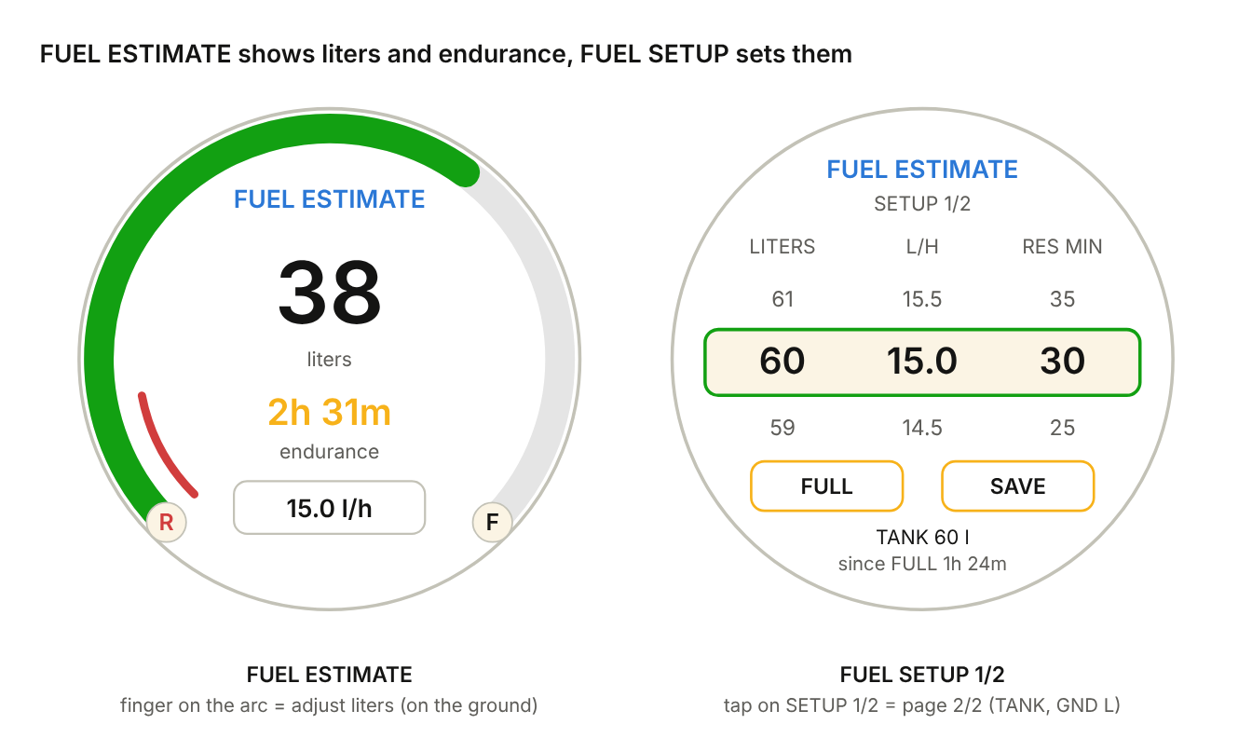
FUEL ESTIMATE and FUEL SETUP · schematic drawings
In the example the 60 l tank contains 38 l: at 15 l/h there are 2 hours and 31 minutes left, and the 30-minute reserve (7.5 l) is the inner red mark.

FUEL ESTIMATE
- Green arc on the edge of the display: tank level from R (reserve) to F (full); the inner red mark shows where the reserve begins. In reserve the arc turns red.
- Center: estimated liters (red in reserve), below them the endurance in hours and minutes (red in reserve) and the consumption in l/h.
- Dragging your finger along the arc (on the ground only) adjusts the liters in steps of 0.5 l.
- Tap in the center: FUEL SETUP.
- Liters decrease only while the automatic timer is running in flight; at take-off the ground liters (GND L) are subtracted once.

FUEL SETUP
Tap "SETUP 1/2" to switch to 2/2 and back. A swipe exits without saving.
Page | Roller | Values | Notes
1/2 | LITERS | 0–200 l | If you exceed 200 l the value is updated
1/2 | L/H | 2–60 l/h, steps of 0.5 | Hourly consumption (set 2/2 first)
1/2 | RES MIN | 0–90 min, steps of 5 | Reserve in minutes at the set consumption
2/2 | TANK | 5–200 l | Tank capacity
2/2 | GND L | 0–5 l, steps of 0.5 (default 1.5) | Taxiing and engine run-up
FULL sets the liters to a full tank and resets "since FULL" (flight hours since the last fill-up, useful for calculating actual consumption). SAVE saves.

RESERVE alert
When the estimate enters the reserve during flight, the FUEL ESTIMATE page appears from any page, with a red border, the word RESERVE and the distance and time to HOME. A tap closes it. It only works if FUEL ESTIMATE is enabled in PAGES 2/2.
In demo mode fuel is simulated and the real values do not change. Master and slave share settings and liters; the master is in charge.

Timer and flight logs
The flight is detected automatically from GPS speed: the automatic timer starts at take-off, stops at landing and saves the log; a loss of GPS in flight does not end the flight.

AUTO TIMER
Large flight time in the center, with START and STOP times (UTC). At the end of the flight the end-of-flight screen appears: a tap closes it (on the slave it also closes it on the master). Tap in the lower part: FLIGHT LOG.

FLIGHT LOG and saved logs
Summary of the current or last flight: Flight Time, Km travelled, Approx Fuel (estimated liters used), Max GPS GS, Max Altitude, Max Climb rate, Temp, Humidity and times. The log button lets you browse the last 10 flights by swiping; a tap exits.

MANUAL FLIGHT TIMER
Stopwatch with Start, Stop and Reset boxes, independent of the automatic timer.

ICT (Instrument Check Timer)
Set how often (in minutes) you receive the CHECK INSTRUMENTS alert with − and +, and switch it on or off with TIMER: ON / OFF. The alert lasts 8 seconds or until you tap the screen.

WIFI LOG
- Turn on your phone hotspot / PC mobile hotspot (2.4 GHz) with name: avea and password: aveaavea (all lowercase).
- Open the page: "Connecting to / Router/Hotspot WIFI: / avea" appears, followed by the IP address.
- Open that address in your phone browser to view or download the logs (web page and CSV) and to upload firmware.
- If new firmware is available in the repository, "FW: new! Tap to update" appears: tap the lower part of the page to update.
WiFi is off in flight and when you leave the page.

Settings and tools
Settings are made on the ground; those that affect the flight remain saved even after switching off.
Page | How to open | What you set
SET QNH | SET QNH at the bottom of the ALTIMETER, or tap on the altitude in the VARIO | QNH pressure with DOWN − / UP +, unit METERS or FEET (the selected one is green, the other yellow), BACK / SAVE
FILTER | Tap on the number in the VARIO | Variometer responsiveness: from smoother to more reactive
SETUP |  | Vario activation threshold (default 1.0 m/s) and DUAL box
DUAL | DUAL box in SETUP | Two pages at once on the display (SELECT 2 PAGES)
GPS INFO |  | Fix, quality, satellites, locked constellations; tap in the lower part: Bluetooth role OFF → MASTER → SLAVE
FIRMWARE VERSION | Tap on the logo within 5 s of power-up | Version, MAC, DEMO MODE, Reset preferences

DEMO MODE (FIRMWARE VERSION) starts a complete simulation: first the risk sequence (visibility, haze, icing, sunset), then a simulated flight with speed, vario, altitude, approach to home and fuel. The same button, now labeled STOP DEMO, stops it. With two instruments connected, the demo starts and stops on both.
Reset preferences restores the factory settings and deletes the logs; it does not affect PAGES, DISABLE VERTICAL SWIPE, ALT OFFSET and FUEL.

In flight, two instruments and warnings
During an actual flight (automatic timer running, not in demo) the instrument locks the settings to prevent accidental changes.
- Pages hidden from the loop: GPS INFO, WIFI LOG, SETUP (with DUAL) and ICT; if you were on one of these at take-off, it moves to the next page.
- Locked: FUEL SETUP, liter adjustment on the FUEL arc, colored thresholds of the GS arcs and the QFE circuit band.
- Always active: km/h ↔ knots and m ↔ ft switching, page change, SET QNH, alerts.
- LOW GS: after reaching 100 km/h, ground speed below 65 km/h shows an orange blinking LOW GS on ALTIMETER and GPS SPEED (see LOW GS).

Master and slave
In GPS INFO select MASTER on the instrument with the sensors and GPS, and SLAVE on the second one. The slave receives GPS, altitude, vario, weather and timer from the master, and shares in both directions QNH, UTC offset, home, fuel, demo and end-of-flight closing. Each instrument keeps its own page selection, theme and coordinate format. Always update master and slave to the same firmware version.

