Analog Portable Graphic Equalizer

Nicole LoGiudice

Antonio Cardona

Nathan Finley

**Concept of Operations**

REVISION – Draft

08 September 2022

Concept of Operations

for

Analog Portable Graphic Equalizer

Team GrAPE

Approved by:

_____________________________

Project Leader Date

_____________________________

Prof. Kalafatis Date

_____________________________

T/A Date

**Change Record**

| **Rev.** | **Date** | **Originator** | **Approvals** | **Description** |
| --- | --- | --- | --- | --- |
| **-** | [date here] | [person’s name] |  | Draft Release |

**Table of Contents**

**List of Tables** **4**

**List of Figures** **5**

**Executive Summary** **6**

**Introduction** **7**

Background 7

Overview 7

Referenced Documents and Standards 7

**Operating Concept** **8**

Scope 8

Operational Description and Constraints 8

System Description 8

Modes of Operations 8

Users 8

Support 8

**Scenario(s)** **9**

Power Sourcing 9

Main Signal Processing 9

User Interface, Housing, Bluetooth 9

**Analysis** **9**

Summary of Proposed Improvements 9

Disadvantages and Limitations 9

Alternatives 9

Impact 9

# List of Tables

No table of table entries found.

# List of Figures

No table of figures entries found.

# Executive Summary

During events or large gatherings, the use of audio processing devices such as equalizers is typically used to provide quality audio entertainment. Frequently, equalizers have installed applications and often receive and deliver audio signals through wires. The GrAPE differs from typical equalizers with the main features being audio signal processing via Bluetooth and its portability. The GrAPE will be a graphic analog portable equalizer that will consist of ten frequency bands between the audio band (0Hz to 20kHz). The gain of these frequency bands will be adjustable with the help of physical sliders on the device. LEDs will also form part of the device displaying the different gain levels of each frequency band on the equalizer. The I/O for the GrAPE will operate via Bluetooth with the additional ability to use an auxiliary connection at the output. The size of the GrAPE will be designed to be small enough to fit into small carriers such as backpacks. The goal of the GrAPE is to provide its users with a low-budget quality audio processor that is more readily portable and accessible than regular equalizers.

# Introduction

This document is an introduction to the GrAPE, a graphic analog portable equalizer that will provide its users with a low-budget quality audio processing system. The graphic equalizer will serve as a tool to correct or enhance the performance of an audio system by controlling the gain of various frequency bands which are physically displayed on the device with sliders, hence the name “graphic equalizer” [1]. The I/O of the graphic equalizer will function via Bluetooth with the additional feature of having an auxiliary connection at the output stage of the device.

## Background

Equalizers are audio processing devices that are widely used in audio systems. The use of equalizers has become standard in modern audio applications whereas before, equalizers were used mostly in telephones to enhance the intelligibility of the speech signal in the 1930s [1]. Equalizers are used today to enhance or correct the performance of the system rather than flattening out the response of an audio system.

There are two main types of equalizers: parametric equalizers and graphic equalizers. Parametric equalizers allow the user to control the gain, center frequency, and bandwidth of the equalizer filters separately. These equalizers are known for being flexible due to the number of factors a user can control. However, the knowledge level needed to efficiently utilize parametric equalizers is high, therefore mostly experts and engineers utilize these types of equalizers. Graphic equalizers, on the other hand, allow the user to control the gain of various frequency bands, while the center frequency and the bandwidth are fixed, leaving the user to only control the gain of a specific frequency band. This facilitates the use of graphic equalizers as little knowledge is needed to operate this type of equalizer.

Graphic equalizers in general are built to be used in installed applications and typically are not portable. In addition, the I/O of the most common graphic equalizers are completely analog instead of wireless. This is where the GrAPE differs from typical equalizers as the GrAPE will be built to be portable, and the I/O will operate via Bluetooth with the option of an auxiliary connection for the output of the device. The GrAPE is set to provide its users with a relatively low-budget quality audio processing device that is portable and accessible.

## Overview

….

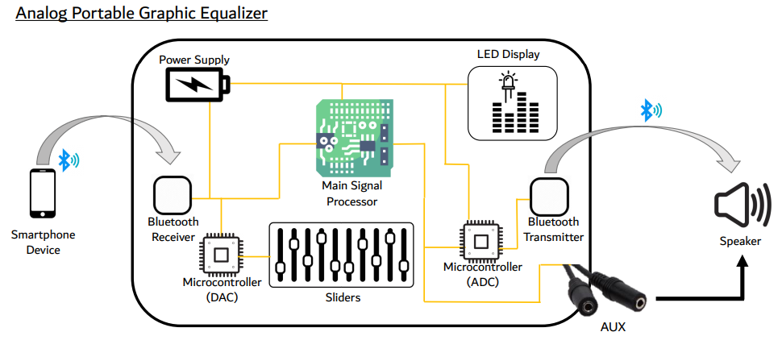

Figure 1: Analog Portable Graphic Equalizer Block Diagram

…

## Referenced Documents and Standards

## [1] J. Rämö, V. Välimäki and B. Bank, "High-Precision Parallel Graphic Equalizer," in IEEE/ACM Transactions on Audio, Speech, and Language Processing, vol. 22, no. 12, pp. 1894-1904, Dec. 2014, doi: 10.1109/TASLP.2014.2354241.

## [2] V. Välimäki and J. Rämö, "Neurally Controlled Graphic Equalizer," in IEEE/ACM Transactions on Audio, Speech, and Language Processing, vol. 27, no. 12, pp. 2140-2149, Dec. 2019, doi: 10.1109/TASLP.2019.2935809.

# Operating Concept

## Scope

The Graphic Analog Portable Equalizer (GrAPE) will operate as a standard analog equalizer with ten frequency-tuning sliders, an attached LED display to visually communicate frequency strengths to the user, and bluetooth input and output connectivity, and a rechargeable internal power source. The above functionality will fit inside a metal enclosure no larger than the capacity of a backpack. A continuous phone-transmitted bluetooth signal containing audio data will be received, manipulated as per the settings of the frequency sliders, and then transmitted to any bluetooth-receiving device for playback. Signal processing and transmission will be designed to occur concurrently with signal reception and latency will be minimized so that the GrAPE can tune “live” music and a user needn’t wait a significant time for playback. Though the current market has plenty of analog equalizer equipment to choose from, the additional LED and bluetooth features distinguish the GrAPE as a device that could benefit users who desire frequency-tuned audio but require wireless transmission and perception as per the “Users” section of this report.

## Operational Description and Constraints

The GrAPE is purely an audio modification and transmission device. The bluetooth connectivity allows for one transmission device: a phone. It allows for one reception device: any speaker that has Bluetooth capabilities. When a song is played on a device with a Bluetooth connection to the GrAPE configured, a powered-on speaker that is also connected to the GrAPE will begin to produce the audio that the GrAPE has altered. Thus, in order for the system to operate correctly, the user must manually ensure two connections via phone, GrAPE, and speaker software settings:

1. A Bluetooth connection from the phone to the GrAPE
2. A Bluetooth connection from the GrAPE to the desired speaker.

The connection from the GrAPE will be ensured via an esp32 Bluetooth microcontroller, which establishes a connection using the phone, but is able to transmit its audio signal directly to the speaker without the use of the phone.

The constraints of our proposed design are as follows:

* The bluetooth connectivity features will prohibit long-distance signal transmission; The phone, GrAPE, and speaker *all* need to adhere to the well-known proximity and environment conditions expected of Bluetooth devices.
* Since the original signal needs to be transmitted *twice* as well as processed within the GrAPE, higher-than-normal latency is to be expected. This system *will* have a higher latency than other devices of its kind.
* Since the original signal needs to be transmitted *twice*, higher-than-normal interference/noise is likely to make the signal more muddy. The ultimate audio quality will not likely compare to optimized devices with line-in connections.

## System Description

The architecture of the system is as follows:

* Signals
  + A bluetooth receiver (inside metal casing)
    - On/off modes of operation controlled by input microcontroller
    - When on, the receiver sends the received bluetooth signal to the input microcontroller.
  + Input microcontroller
    - Receives data from: sliders, on/off button, bluetooth receiver
    - Sends data to: main signal processor
  + Main signal processor
    - Receives data from: input microcontroller
    - Sends data to: output microcontroller
  + Output microcontroller
    - Receives data from: main signal processor
    - Sends data to: LED display, bluetooth transmitter, auxiliary port
* Power
  + Battery
    - Connects to all internal components that require their own power source

## Modes of Operation

There are only two modes of operation of the GrAPE: on and off. When off, no power is delivered to the internal components by the battery and there is no flow of data within the device. When on, the GrAPE operates in the fashion described by “Operation description and constraints.”

## Users

The GrAPE’s capabilities are designed to fit the needs of people who want to experience the performance of a standard equalizer, but desire wireless connection for maneuverability. The GrAPE is meant to demonstrate how such a device would work for the potential expansion of multiple-speaker connectivity. This expansion would open up the possibility for many practical applications of the GrAPE including:

* Allowing DJs at silent disco events to tune audio for multiple listeners listening to the same tracks simultaneously.
* Allowing concert attendees at venues with poor acoustics have headphones with tuned audio frequencies connected to the GrAPE.

## Support

A user manual will be provided as a component of each GrAPE. The manual will describe the basic operations of the GrAPE so that any minor malfunctions can be repaired by the user or a third party. Additionally, the user manual will explain the process to connect the phone to the GrAPE and the GrAPE to the speaker.

# Scenario(s)

## Power Sourcing

Describe the use case scenario for your project. Use a separate subsection for each scenario.

…

…

## Main Signal Processing

Describe the use case scenario for your project. Use a separate subsection for each scenario.

## On House User Interface and Bluetooth Input/ Output Connectivity

The analog graphic equalizer will be portable, therefore small enough to carry in a backpack because of its potential to be used in so many different settings and make for easy transportation. Furthermore, because the device could be used in a wide variety of locations, it needs to be easily adaptable to the technology that is available in each setting. Therefore, the equalizer will be bluetooth compatible for input and output while also having an auxiliary output option for wired sound systems. Furthermore, because of the different locations the equalizer could be used, and the ability to be used by many, the interface will be on the housing itself in order to keep all components together and prevent users from having to download an app every time. The interface will tell the user what amplification certain frequency ranges are at, bluetooth connectivity for input and output, and whether the output is on bluetooth or auxiliary.

# Analysis

## Summary of Proposed Improvements

* The equalizer will be portable, therefore small enough to carry inside a backpack and will have its own power supply.
* The different frequencies will be identified through at least 10 different groupings from 0-20kH.
* The adjustments of each frequency group’s gain will be manually set by the person using the equalizer.
* The user will be able to connect the equalizer to their phone and any sound equipment through bluetooth.
* The equalizer will also allow for auxiliary connection for wired output in order to allow for a greater range of sound equipment capabilities and less noise in the music.
* The selection of desired output connection type, bluetooth or auxiliary, will be a manual input from the user.

## Disadvantages and Limitations

* Due to budget constraints, the equalizer will not be designed to be waterproof.
* With the only input for signal to the equalizer being digital (bluetooth) the output sound quality through auxiliary will never be as clean as a completely analog design.
* The devices connected to the equalizer need to be in close proximity when connected by bluetooth in order to preserve sound quality and connection.
* Because data needs to be received *and* transmitted, latency will be higher than an auxiliary connection.

## Alternatives

* Store bought analog equalizers.
* Input to the equalizer could also include auxiliary input to allow for a completely analog design and better sound quality.
* Non-wired connection between devices could be achieved through Wi-Fi connection.
* Digital equalizers through computers or phones.

## Impact

* Batteries are used to power the equalizer and create landfill waste when they are thrown away.
* The device will not track/record what frequencies are being altered or what songs are played.
* Bluetooth connectivity is wireless and therefore has a risk of being hacked.