# MatchGPX2OSM

The MatchGPX2OSM utility matches GPX track logs to the map. It takes a routable OSM map (from the OSM2Routing utility), GPS track log and finds a path from the map, that matches the best to the GPS track log.

## Usage

matchgpx2osm [OPTIONS]+  
Options:  
 --osm=VALUE path to the routable map file   
 --gpx=VALUE path to the GPX file to process or to the  
 directory to process  
-o, --output=VALUE path to the output directory  
-p, --period=VALUE sampling period of the GPX file (in seconds)  
-f, --filter enables output post processing  
-h, -?, --help

Value of the --gpx parameter can be either path to the single GPX file or path to the directory – in that case, all GPX files in the directory are processed.

Matched paths are saved in the output directory. Default value for the --output parameter is ‘.’ which means the current working directory. An output file is created for every GPS track segment. Naming conversion is gpxFilename_[trackName|trackIndex]_segmentIndex.osm

The --period parameter set minimal sampling period of the GPS track log. It can be used to reduce sampling period of the GPS track log. GPS track logs with higher sampling period are processed faster and sometimes even more precisely.

The--filter parameter enables matched track post processing. Post processing removes short U-turns that can occur when processing logs with worse accuracy or in the places, where a GPS unit wasn’t moving (points from the log oscillates around center position and it makes result path going back and forth). Example of a U-turn before and after filtering is on the picture 3 and 4.

## Speed

Speed of the utility depends on the density of the road network, size of the map and sampling period of the GPS log and length of the GPS.

Utility running times (Core 2 Duo @GHz, 2GB RAM)

Track length 5km, 700 points; map size 28MB, large city with high density road network

|  |  |
| --- | --- |
| Sampling period | Time |
| 30s | 1.4s |
| 10s | 1.45s |
| 5s | 2.1s |
| 1s | 9.4s |

Track length 5km, 700 points; map size 290MB, whole Czech republic

|  |  |
| --- | --- |
| Sampling period | Time |
| 30s | 13.1s |
| 10s | 12.6s |
| 5s | 20.1s |
| 1s | 91.4s |

Track length 300km, 17000 points; map size 30MB, whole Lithuania

|  |  |
| --- | --- |
| Sampling period | Time |
| 30s | 3.8s |
| 10s | 8.2s |
| 5s | 15.2s |
| 1s | 79.3s |

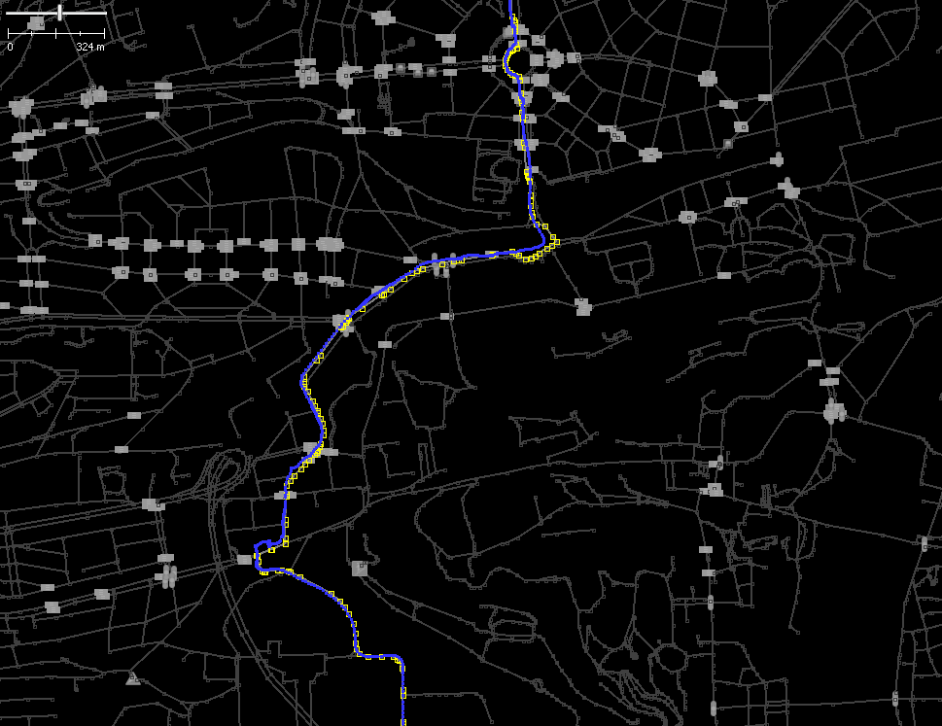

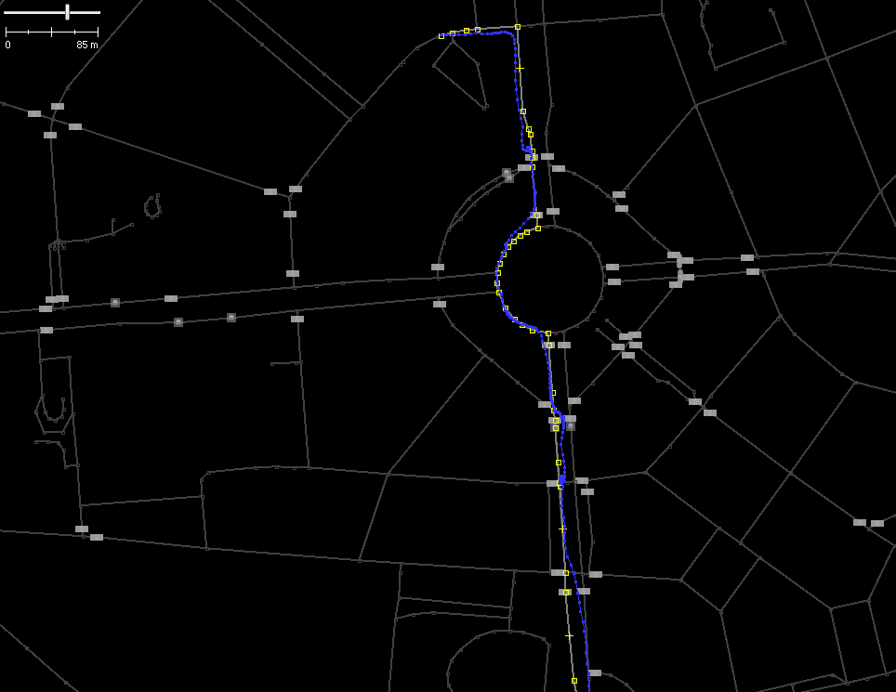

Pictures 1 and 2 – Examples of matched GPS track logs

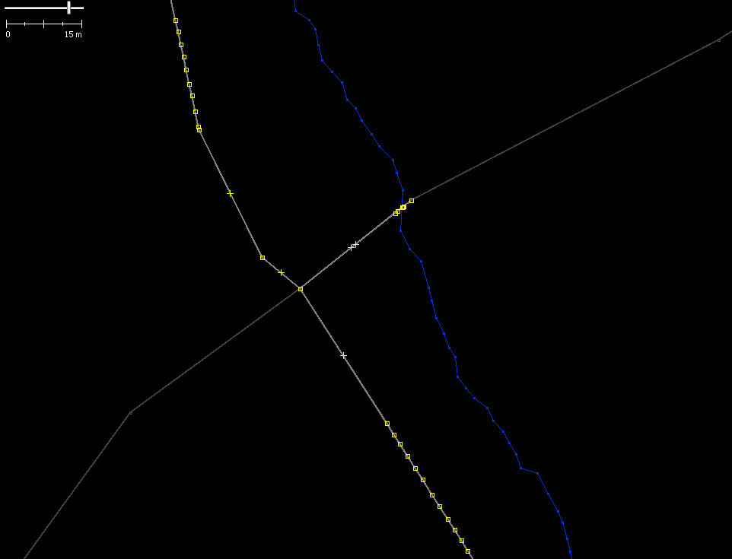 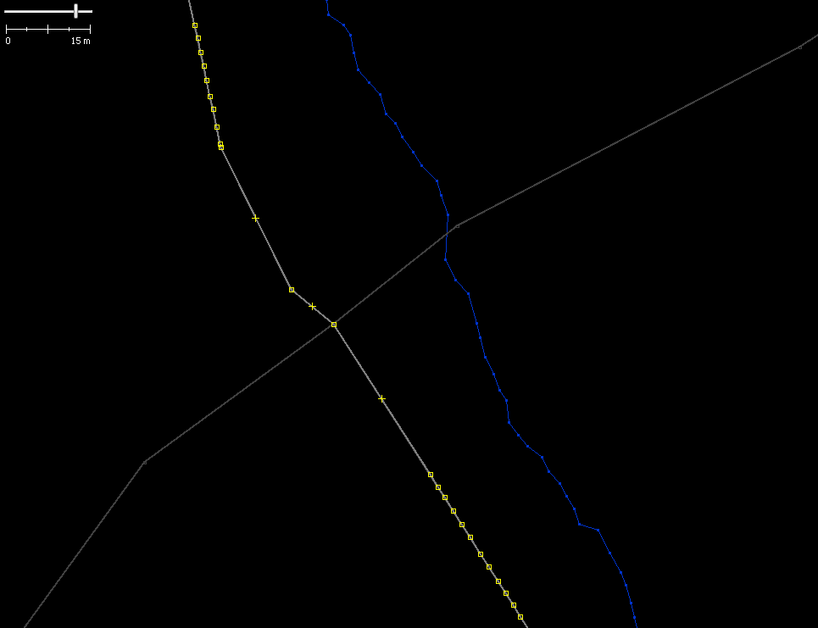

Pictures 3 and 4 – U-turn before and after filtering