fiaas -> infrastructure as a service (VM you can control up to os)
paas -> platform as a service (Azure App Service you manage App code)
saas -> software as a service (Microsoft 365 you manage userSettingsf)
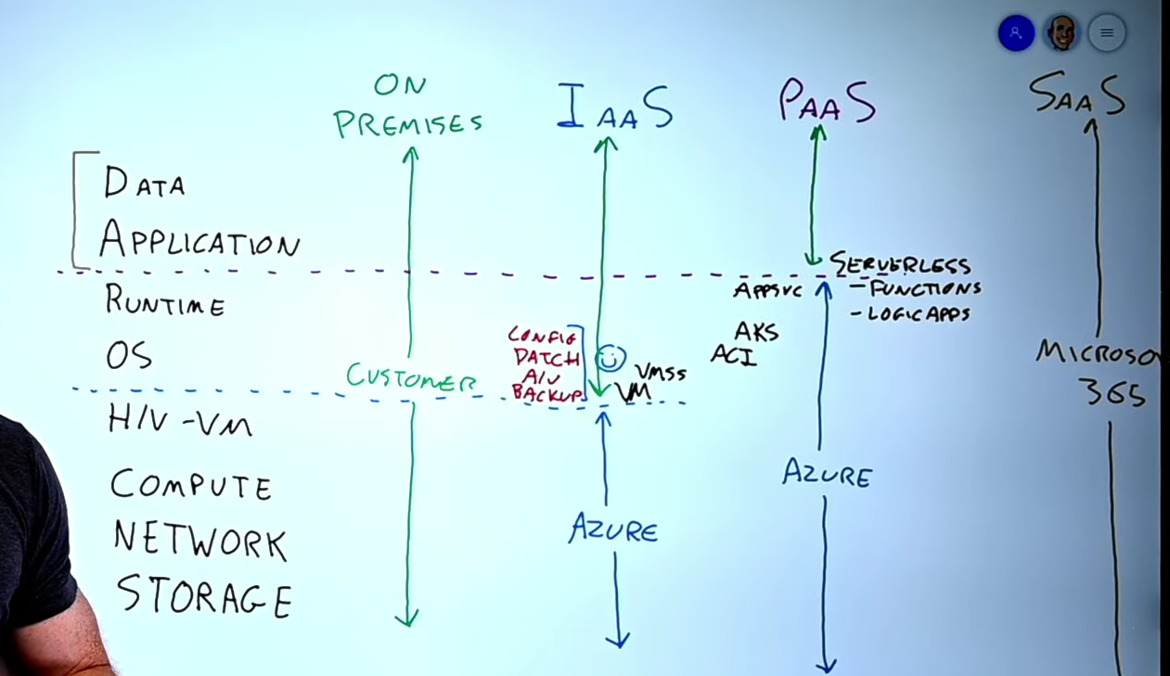

**CLOUD MODEL**
private cloud -> most of the time on premises but tools like Azure Arc help
public cloud -> services like vm server
hybrid cloud -> combination of private + public cloud. Some resources stay on-premises, while others run in the public cloud (like Microsoft Azure) and both environments are connected.

expenditure model
(CapEx) Capital expenditure -> initial cost of buying something (buying inferstructure like computers or licence initially)
operational expenditure (OpEx) -> more like cloud ->spending money on services or products over time as you use it –
the more you use it more you spend ->consumption based (Serverless)
the usage does not matter but you pay for how long you rent it → pay as you go model (iaas)

--------------------------------

SCAILING
Vertical scaling is focused on increasing or decreasing the capabilities of resources (more ram, more cpu power).
Horizontal scaling is adding or subtracting the number of resources (more vm’s).
--------------------------------

RELIABILITY
-auto healing
-storage (min 3 copies of data)
-auto scale
-SLA (99.99..%)
-Design for failure
-AZURE MONITOR -collects, analyzes, and acts on telemetry data from Azure, hybrid, and on-premises environments

PREDICTABILITY
-SKU (example azure compute unit acu for VM which tell amount of process power it uses, certain amount of memory, certain iops & throughput limit for storage)
-Behaviour exmple: api, certain tools, prodictable price based on region
-use template like terraform
-automation (take out human buttons) like mantinace activites
-devops ci/cd

----------------
Management of the cloud -> scale resource deployment based on need...monitor...Deploy resources..etc (azure does it automatically for me)
Management in the cloud-> api, powershell, through webportal (my manual control in the resources)

------------------------------

REASON FOR REGION PAIRS
-Performance
-Regulatory
-DR resiliency (disaster recovery and IT resilience)

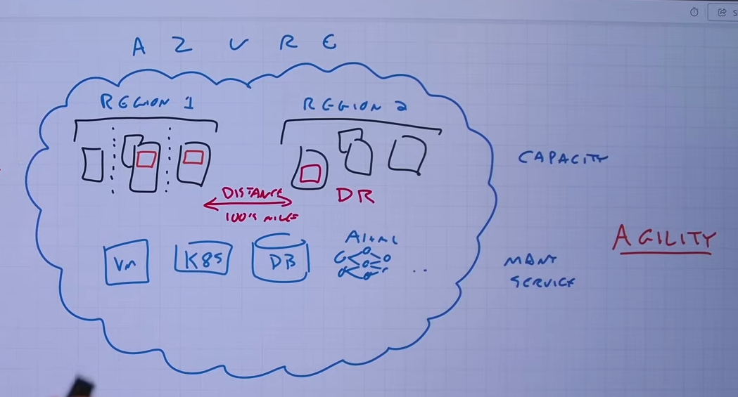
-----------------------------
Zonal services: You pin the resource to a specific zone (for example, VMs, managed disks, IP addresses).
Zone-redundant services: The platform replicates automatically across zones (for example, zone-redundant storage, SQL Database).
Non-regional services: always available, survives even full region outages

----------------------------

Benefits of availability zones
FIRSTLY there are 3 availability zones per region
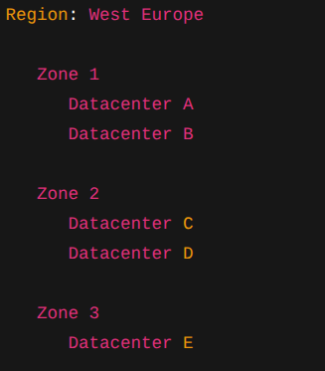
Availability Zone->If Datacenter A catches fire → your app is still running in Datacenter B or C.
Now imagine the entire city floods. All 3 zones go down.
**SOLUTION**
Region Pair:
West US ◄──────────► East US
(if this dies) (this takes over)
If a single server rack loses power or a single switch dies -> Availability Sets protect you. (This ensures your virtual machines are spread across different physical racks within the same datacenter).

Most pairs are bidirectional and in their geopolitical zone(each backs the other up)
Brazil South is *unique* — paired with South Central US, which does NOT pair back to Brazil South
West India is also one-directional

BENEFITS AND USAGE OF SUBSCRIPTIONS
AZURE ACTIVE DIRECTORY -> (AZURE AD) ”secure instance of Microsoft Entra ID which serves as a master container for users, apps, and resources, ensuring isolation from other customers”
AZURE AD
└─USERS
└─GROUPS
└─DEVICES
Each subscription trusts one and only one azure ad tenant
azure ad tenant does not live inside subscription but is separate
IN subscription I can apply
-BUDGET
-Billings
-TAGS
-RBAC
-POLICY
EVERYTHING APPLYING TO SUBSCRIPTIONS GET APPLIED TO RESOURCES GROUP AND THEN INTO ACTUAL RESOURCES

Management Groups
Tenant
└── Management Groups
└── Subscriptions
└── Resource Groups
└── Resources
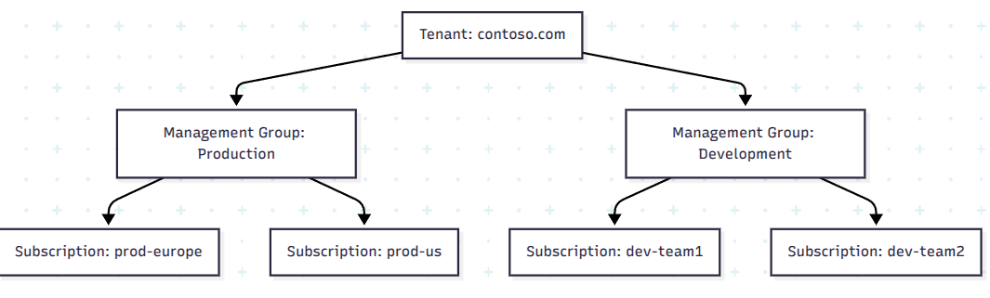
what can I DO in management groups??
-BUGET
-RBAC
-POLICY
----
Management Groups
└── Subscriptions
└── Resource Groups
└── Resources (VMs, DBs, App Services...)

TechCorp Azure Account
├── Subscription: Development
├── Subscription: Production
└── Subscription: Finance

Billing:Separate invoices per subscription, track costs
Access control: Different policies per subscription

managment groups example
GlobalCorp operates in multiple countries with multiple departments. They have tons of subscriptions.

AZURE RESOURCE MANAGER
ARM is the actual deployment and management service for Azure.
A single interface (via Portal, PowerShell, CLI, or API) to manage all Azure resources.
so when i manually try to add a vm from azure website this will be translated into a json format and go through arm!
1. The Unified API Gateway
when you are interacting with azure your request is sent to the Azure Resource Manager API. ARM authenticates and authorizes the request, and then routes it to the correct underlying service (like Compute, Storage, or Network)
2. Infrastructure as Code : json files ->ARM Templates
3.ARM introduces the concept of Resource Groups.
4.ARM allows you to apply metadata tags (key-value pairs) to your resources. For example, you could tag resources with Environment: Production or Department: Finance.

TAGS → tags are not automatically inherited

Azure arc
-
what it does: Azure Arc extends Azure Resource Manager (ARM) to resources that do not live in Azure.
It allows you to project your external infrastructure into the Azure portal so you can manage, govern, and secure everything from a single control plane, exactly as if those external resources were native Azure resources.

>>Describe Azure storage services
types of data
>structured data -> like rational db
>semi-structured data -> like non rational db
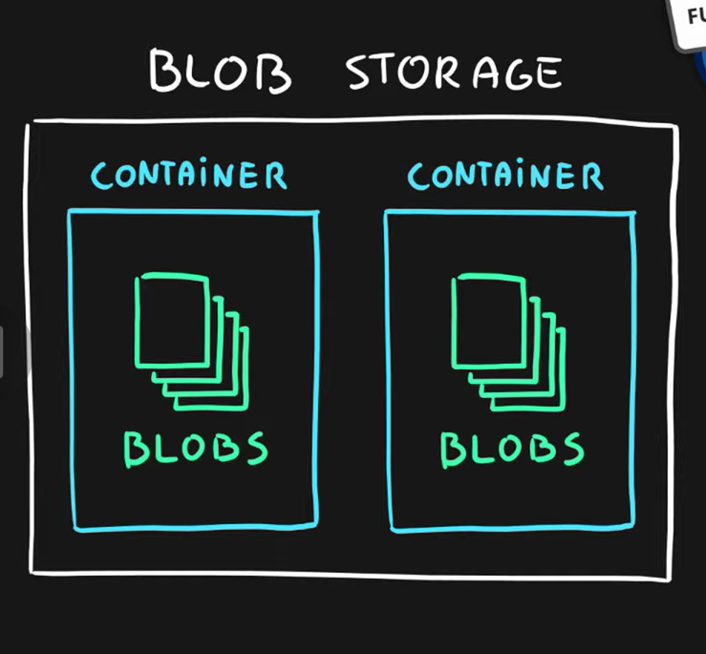
>unstructured data -> photo video text, exe... they dont follow structure that can represent any kind of data (azure blob storage)

Blob mean for binary large object
blob storage
└blob container
└blobs

three storing tiers
hot-> frequent asked data *fastest* (images for website)
cool tiers -> less frequent example usage: backups of app database
archive -> store here if you rarely need those files
- LRS (Locally Redundant Storage) → copies in one datacenter
- ZRS (Zone-Redundant Storage) → across availability zones
- GRS (Geo-Redundant Storage) → to another region
- RA-GRS / RA-GZRS → same as above but with read access to backup region
You will pay for the data you save for this duration:
- Hot → no commitment
- Cool → 1 month commitment
- Cold → ~3 months commitment
- Archive → 6 months commitment

Azure Migrate
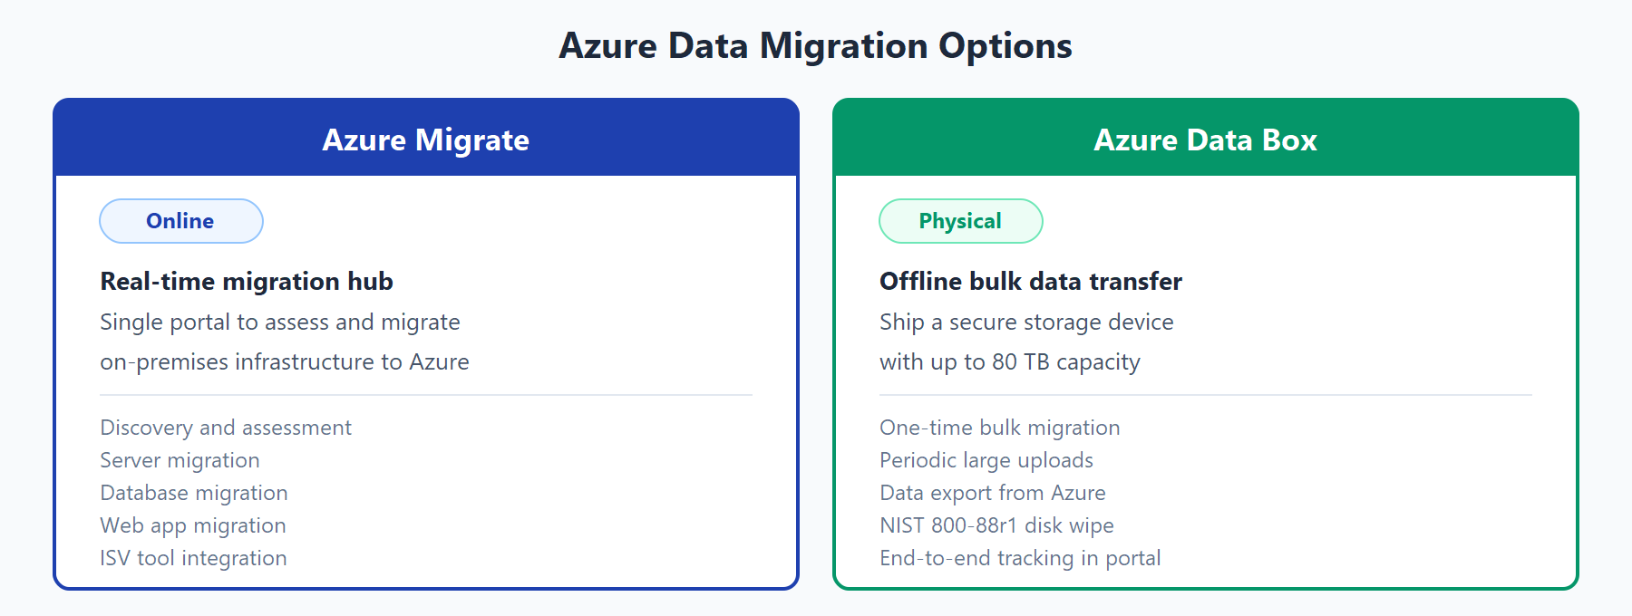
-----------------
Azure Queue Stroage (small service) if you have apps that has several tasks to be completed and each free task might need some time to complete. You can put those to azure queue as separate messages. This will allow background services to pick those messages from the queue at they own pace, and let the proccess those async.
So its job is to store small pieces of data so you can build scalable async proccessing

VPN
An Azure VPN securely connects networks over the internet using encrypted tunnels.
It allows safe communication between:
- On-premises networks
- Azure virtual networks (VNets)
- Individual devices

VPN Gateway (Core Component)
Uses secure IPsec/IKE VPN tunnel
A VPN Gateway is deployed in a VNet and enables 3 connection types:
- Site-to-Site (S2S): On-premises ↔ Azure
- Point-to-Site (P2S): Individual device ↔ Azure
- VNet-to-VNet: Azure network ↔ Azure network
Key facts:
- Only 1 gateway per VNet
- Can connect to multiple locations
- All traffic is encrypted

ExpressRoute
need private cable installed by internet companies specifically for this purpuse,private, dedicated, and highly secure physical connection between your company's on-premises datacenter and the Azure cloud.
Is mainly for large enterprise compaines

Azure RBAC
Role assignments are the way you control access to Azure resources.
The Contributor role grants you full access to manage all resources but does not allow you to assign roles in Azure RBAC.
The Owner role lets you manage everything, including access to resources and the contributor’s role. It grants you full access to manage all resources, including the ability to assign roles in Azure RBAC.
Virtual Machine Contributor role lets you manage virtual machines, but not access to them, and not the virtual network or storage account they’re connected to.
The Reader role lets you view everything, but not make any changes.
Microsoft Defender for Cloud ->evaluate regulatory compliance and improve the security
TO LEARN
network security group- (nsg) filter network traffic to and from Azure resources in an Azure virtual network. For each rule, you can specify source and destination, port, and protocol.
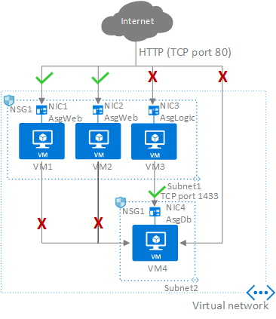
Application security group- configure network security as a natural extension of an application’s structure, allowing you to group virtual machines and define network security policies based on those groups

subnet- divide the vnet into smaller pieces, Vnet is the building while the subnet is the rooms

Azure service release stages
- Private Preview → invitation-only
- Public Preview → generally available to try, but still may have limitations
- General Availability (GA) → is officially released, stable, and fully supported for production workloads, backed by formal Service Level Agreements (SLAs).
Microsoft artifact→ an Azure DevOps service used to create, host, and share package feeds (NuGet, npm, Maven, Python, Universal Packages) securely across teams and pipelines

Azure Key Vault → is a cloud service for securely storing and accessing secrets, key,secret, certeficate metadata

explaining words

Azure Service Health:
Alerts on the health of Azure infrastructure

resiliency
is simply a system's ability to handle unexpected failures—like a server crashing, a datacenter losing power, or a sudden massive spike in traffic—and bounce back automatically without your users ever noticing

azure policy
used to dictate rules (e.g., "All servers must have port 22 closed" or "All databases must be encrypted")

Elasticity
in Azure is the ability of a cloud system to automatically and dynamically increase or decrease resources—such as CPU, RAM, or storage—in real-time based on fluctuating workload demands

High Availability
apps to be operation and accessible with minimal downtime reasons: hardware failures, software issues, or data center outages

Entra Id
A cloud-based identity and access management service that your employees can use to access external resources

Advisor
A service that provides personalized best practices and recommendations to help optimize your Azure resources for cost, security, performance, and reliability.

Microsoft Purview
governs your data
weMicrosoft Purview is a comprehensive, unified data governance, risk, and compliance platform designed to help organizations manage, protect, and govern their entire data estate

Peering
It is a feature that connects two VNets in Azure, allowing resources to communicate securely and with low latency.

Azure Information Protection
enables organizations to discover, classify, label, and protect sensitive documents and emails
It uses uses Azure Rights Management (encryption service).
So the chain is:
Purview Information Protection → uses Azure Rights Management → provided by Azure Information Protection

Recovery Services vault
A service used to manage backup and disaster recovery operations in Azure. It stores recovery points and configurations for Azure-based backups and disaster recovery setups.
- “stores recovery points”
- “manages backup and disaster recovery”
→ that is almost always Recovery Services vault in Azure exam questions.

Application Insights
An application performance management service that provides real-time monitoring and telemetry for applications.
Telemetry just means data collected automatically from a system while it’s running.

Azure Arc
governs your infrastructure
- Azure Arc allows you to manage resources outside Azure—like on-prem servers, other cloud VMs, Kubernetes clusters—from a single, unified platform.
- It helps with governance, policy enforcement, and management across hybrid and multicloud environments.

