Business rules

Order status and Payment status
In order entity there are two columns order_status and payment_status both with constraint character check. Also in service layer (spring boot) the OrderStatus and PaymentStatus are represented as enums.
The naming is not the best since orderStatus is broader and paymentStatus is specific but thing of order status as the status of delivery and the payment as the name suggest the status of the payment.
OrderStatus and PaymentStatus although having different instances (delivered mean finished order but completed mean finished payment), they are linked togather. Roles
- If the payment status is failed the order status must also be failed.
- If the status changes to failed there must be a reasonOfFailure represented as column in Orders.
- An order cannot be marked as DELIVERED unless the payment has been successfully completed.
For example, when the delivery person meets the receiver, the product must not be delivered before the payment transaction is finalized.
- If the payment method is CASH_ON_DELIVERY, the delivery person must first receive the cash and then update the payment status to COMPLETED before marking the order as DELIVERED.
- If the payment method is POK (card payment), the delivery person cannot deliver the order if the p ayment is not already completed, because they cannot collect the money and do not have the authority to change the payment status.
This rule ensures that order delivery is strictly dependent on successful payment, preventing unpaid deliveries and enforcing correct responsibility boundaries in the system.

User-Roles

MANAGER
The delivery user has a sidebar with nav links that show pages such as
First let go with WEBSOCKET pages
ALL ORDERS FETCHED FROM BACKEND ARE are related to the branch manager.
Incoming- orders : Orders with status initialized
GET →http://localhost:8080/api/orders/all?orderStatus=INITIALIZED&page=0&size=20

Preparation Queue : Both statuses confirmed and preparing
GET →http://localhost:8080/api/orders/allorderStatus=CONFIRMED&orderStatus=PREPARING&page=0&size=20

Dispatch Board: Status ready for pickup
GET → http://localhost:8080/api/orders/all?orderStatus=READY_FOR_PICKUP&page=0&size=20

DELIVERY

Big picture
The delivery user has a sidebar with nav links that show pages such as
Unassigned orders – are orders unassigned that are confirmed by the venue restaurant,
ready for pickup – are orders which are assigned to the user and only have status “READY_FOR_PICKUP”,
On the way – orders with status “ON_THE_WAY”.
The above three pages only display orders with a valid payment status — orders with a FAILED payment status are excluded. All three pages use WebSocket for real-time updates, which will be covered in later chapters.
Dashboard — displays statistics for the user's assigned orders, including total deliveries, active orders, and a full list of their assigned orders.
My Orders — shows all orders assigned to the user, regardless of their status (including failed).
Earnings — displays the user's earnings.
Note: The Incoming Orders, Preparation Queue, and Dispatch Board are updated in real-time via WebSockets. For technical details on the /topic/branch/{branchId}/manager channel, see the WebSocket Architecture chapter.

Changing order and payment status Business Rules
There are strong applied business rules from the backend, such rules are:
The user can only change the order status to these three:
“ON_THE_WAY”, “DELIVERED”, “FAILED”.
And payment status to those two:
“FAILED” and “COMPLETED”
If the user decides to switch to other not allowed statuses they get ForbiddenException
Also the order matter:
ON_THE_WAY — you can only mark an order as "on the way" if it's currently READY_FOR_PICKUP. Example: the driver picks it up, then goes on their way.
DELIVERED or FAILED — both of these can only happen if the order is currently ON_THE_WAY. You can't deliver or fail an order that hasn't been picked up yet.
default -> false — any other status transition (e.g. trying to set it back to READY_FOR_PICKUP, or applying some unrecognized status) is automatically invalid. Should it though???Let say a user clicked failed he got an accident but than he feels good and want to continue but can’t undue it.Still uncertain what to do. Overall Im enforcing this rule.
If the payment method is card or better say POK than the delivery has no authority to change the payment method.
The validations are located in this class
```java
public void validateDeliveryUpdate(Order order, OrderDTO orderDTO){...}
// `order` represents the current entity stored in the database,
// while `orderDto` contains the updated data received from the frontend.
```
Note: The Incoming Orders, Preparation Queue, and Dispatch Board are updated in real-time via WebSockets. For technical details on the /topic/branch/{branchId}/manager channel, see the WebSocket Architecture chapter.

Unassigned Orders
The initial fetch is this endpoint
GET → http://localhost:8080/api/orders/unassigned-orders?page=0&size=50
The process of getting the orders is simple, Im not using the “GOD” endpoint: getAll and pass the arguments because I have to write a lot of logic for the unassigned and better of create new one.
The controller endpoint is getConfirmedUnassignedOrders(...)
It returns a paginated list of orders, with the page size controlled by the frontend's request parameters.
The service is straightforward — it delegates filtering entirely to the database layer, returning only orders that have no assigned delivery person and have a status of CONFIRMED, PREPARING, or READY_FOR_PICKUP.
Mapping is done through modelmapper and I manually remove reviews and set payment method to the orderDTO class because the model mapper fail to do it automatically.

Ready For Pickup
Two get endpoints here one to get the orders with status READY_FOR_PICKUP and
countAssignedOrdersInPreparation() to get the assigned orders that are being prepared or are not ready to delivery specifically with status PREPERING or CONFIRMED.

Earnings
To calculate the earnings of the delivery person I simply add up the 50% of the delivery cost per order if the delivery is more than 100lek, but if is less than 80lek than is 100% all the driver profit because he would not consider to take the ride.
Example
- delivery cost is 300Lek and tip 50lek the delivery profit is 150+50=200 lek for that
- 70lek Delivery cost and 20lek tip than total profit is 90lek.
The driver_earnings are located in the table orders and is initially calculated just after the user clicks to place the order. To enforce the business rules I implemented this function to calculate it “BigDecimal calculateDriverEarnings(..)..”

Helper Methods

IsIncomplete(Order order)
This method is used primarily by the delivery user to filter orders that are still actionable. It returns true if the order has a status of CONFIRMED, PREPARING, or READY_FOR_PICKUP, making it eligible to be assigned to a delivery person.

WebSocket Architecture

Event-Driven Notification System
Instead of the "God Method" directly triggering WebSocket updates, the system uses an event-driven approach to decouple business logic from real-time notifications.
When an order is created or updated in the OrderService, the system publishes an internal Spring Event called OrderSavedEvent. This event carries the updated OrderDTO, the branchId, and a flag wasPreviouslyUnassigned to help track state transitions.
The WebSocketController listens for this event and acts as a router, deciding exactly who needs to receive the update based on the order's status and assignment.

Branch Manager Channels
The branch manager needs to see orders moving through the Kanban board (Incoming, Preparation, Dispatch) in real-time.
Topic: /topic/branch/{branchId}/manager
Logic: The controller checks if the order belongs to a branch. If it does, the full OrderDTO is broadcast to this topic.
Behavior:
If status is INITIALIZED → Adds to "Incoming Orders".
If status is PREPARING → Adds to "Preparation Queue".
If status is READY_FOR_PICKUP → Adds to "Dispatch Board".

Delivery Channels
The delivery logic is split into two distinct channels to handle the "Unassigned Pool" and "Personal Assignments" securely and efficiently.

1. Global Unassigned Pool
This channel drives the "Unassigned Orders" page. Since delivery drivers can accept orders from any branch they are authorized for, a global topic is used.
Topic: /topic/delivery/global/unassigned
Payload logic (wsAction): The backend appends a wsAction field to the DTO to tell the client how to react.
ADD: Sent if the order matches the isUnassignedCriteriaMet() check (Status is CONFIRMED, PREPARING, or READY_FOR_PICKUP, and deliveryPerson is null).
REMOVE: Sent if the order was unassigned before the update, but is not anymore (e.g., a driver accepted it, or it was cancelled).
This ensures that as soon as a manager marks an order as "CONFIRMED", it appears instantly on all drivers' screens. Conversely, if Driver A accepts it, it disappears instantly from Driver B's screen via the REMOVE action.

2. Driver Queue
This channel drives the "My Orders", "Ready for Pickup", and "On The Way" pages.
Topic: /user/queue/updates
Security: This uses convertAndSendToUser. The update is sent only to the specific driver assigned to the order. Driver A cannot listen to Driver B's updates.
Logic:
If the delivery person is not null, the update is sent here.
This handles the lifecycle of the active delivery (e.g., changing status to ON_THE_WAY updates the driver's own dashboard).

Helper Methods

isUnassignedCriteriaMet(OrderDTO order)
This method inside the WebSocket Controller replicates the logic of the getConfirmedUnassignedOrders endpoint. It returns true only if:
The deliveryPerson is null.
The status is one of: CONFIRMED, PREPARING, or READY_FOR_PICKUP.
The payment status is NOT FAILED.
Integration Points
The OrderSavedEvent is triggered in two specific places in the OrderService:
updateStatus: After a status change (e.g., Manager confirms order, Driver picks up order).
createOrder: Immediately after a customer places a new order. This ensures the Branch Manager sees the "Incoming" order instantly without refreshing.

Managing duplicate orders and payments in checkout flow
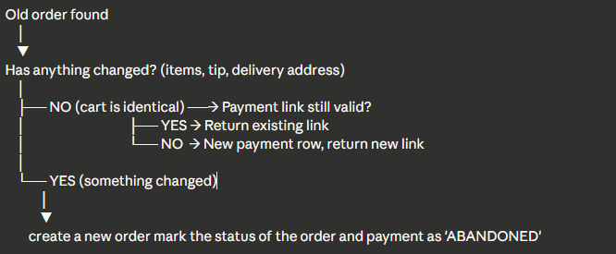

How to know if my previous order has nothing changed

The things that can change are:
- Cart items + quantities + variants
- Tip amount
- Delivery location
- Payment method\
My solution is to store a cart hash on the order.

Schedulers

processExpiredPayments()

Card Payment Checkout Flow & Webhook Handling

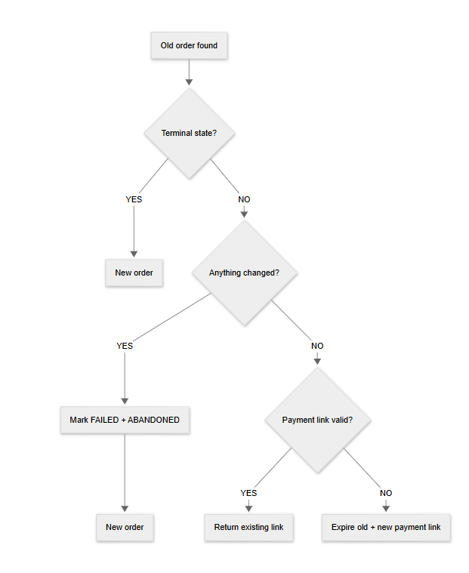

1. Overview
Here is the logic for handling online card payments (via Pok), order placements, and asynchronous payment webhooks. It specifically addresses how we handle user drop-offs, cart modifications, and race conditions between our internal expiration cron jobs and the payment gateway's success callbacks.

2. Order Placement Flow (placeOrder)
When a user attempts to place an order using a card payment, the system checks if they already have an existing, unpaid order for the same restaurant branch. We do this to prevent spamming the database with new orders if the user simply refreshed the page or backed out of the payment provider's screen.

Logic Flow for Existing Orders:
- Check for Terminal States:
  - If the existing order is marked as FAILED or the payment is ABANDONED, it is considered a terminal state.
  - Action: We ignore this order entirely and proceed to create a new one.
- Check for Cart Modifications:
  - We compare the cartHash of the current cart against the existing order's cartHash.
  - If the cart HAS changed: We mark the old order as FAILED and its payments as ABANDONED. We then fall through to create a brand new order.
- Check Payment Link Validity (If cart is identical):
  - If the existing card payment link expires in more than 5 minutes, we return the existing payment link. (This ensures a good UX, giving the user plenty of time to enter their card details).
  - If the link is expired (or expiring in < 5 minutes), we mark that specific payment row as EXPIRED, request a new payment link from the payment gateway, and attach it to the existing order.

3. The Expiration Cron Job
A scheduled task runs regularly to clean up stale orders that users abandoned at the card checkout screen.
- What it does: It looks for orders in the INITIALIZED state where the card payment's expires_at timestamp has passed.
- Action: It updates the order status to FAILED and the payment status to ABANDONED / EXPIRED.
- Buffer Strategy: To account for network latency and delayed webhooks from the payment provider, the cron job should ideally look for payments that expired a few minutes ago (e.g., NOW() - INTERVAL '5 minutes') rather than expiring them the exact second the clock runs out.

4. Webhook Handling & "The Race Condition"
Because card payment completion happens asynchronously off-platform, there is a known edge case: The Race Condition.
The Scenario: A user completes their card payment at the absolute last second. The cron job runs and marks the order as FAILED just milliseconds before the success webhook arrives at our server.

The "Resurrecting Webhook" Strategy
To solve this, we treat the payment gateway as the ultimate source of truth. If the gateway says the card was charged successfully, we honor the order, even if the cron job already killed it.
When the processSuccessfulPayment webhook fires, it must enforce the following rules:
- Idempotency Guard:
  - Webhooks can be delivered multiple times by the payment provider.
  - Action: Check if the order's PaymentStatus is already COMPLETED. If yes, log it as a duplicate and halt execution to prevent double-counting analytics or sending duplicate tickets to the kitchen.
- Order Resurrection:
  - Check if the cron job already marked the OrderStatus as FAILED.
  - Action: If FAILED, overwrite it back to INITIALIZED (or your standard pre-kitchen state). Update the PaymentStatus to COMPLETED.
- Kitchen Notification:
  - Resurrecting the database rows isn't enough; the restaurant needs to cook the food.
  - Action: Fire the OrderSavedEvent (or your equivalent notification service) to ensure the restaurant tablet rings and prints the ticket. Clear the user's cart and increment daily metrics.

