Special Issue of the journal "Computational and Mathematical Methods in Medicine": Advances in Radiation Microdosimetry and Nanodosimetry through Monte Carlo Calculation

**Integration of the Low-Energy Particle Track Simulation code in GEANT4**

P. Arce1, A. Muñoz2, M. Moraleda3, J.M. Gómez Ros3,F. Blanco4, J. M. Perez6, G. García6,7

1 Medical Applications Unit, CIEMAT, Av. Complutense 40, E-28040-Madrid, Spain

2 Scientific Computing Unit, CIEMAT, Av. Complutense 40, E-28040-Madrid, Spain

3 Dosimetry of Ionizing Radiations Unit, CIEMAT, Av. Complutense 40, E-28040-Madrid, Spain

4 Departament. of Atomic, Molecular and Nuclear Physics, Universidad Complutense de Madrid, Ciudad Universitaria, 28040 Madrid

5 Technology Department, CIEMAT, Av. Complutense 40, E-28040-Madrid, Spain

6 Instituto de Física Fundamental, Consejo Superior de Investigaciones Científicas, Serrano 113-bis, 28006 Madrid

7 Centre for Medical Radiation Physics, University of Wollongong, Wollongong, NSW 2522, Australia

# Abstract

The Low Energy Particle Track Simulation code (LEPTS) is a Monte Carlo code developed to simulate the damage caused by radiation at molecular level. The code is based on the experimental data of scattering cross sections, both differential and integral, and energy loss data, complemented with theoretical calculations. It covers the interactions of electrons and positrons from energies of 10 keV down to 0.1 eV. In this article we briefly mention the main characteristics of this code and we present its integration within the GEANT4 Monte Carlo toolkit.

# INTRODUCTION

The simulation of the radiation effects in living organisms needs a deep understanding of the interaction of the radiation with biological tissues. The study of those interactions is a big concern, especially in medical applications such as radiotherapy and diagnosis, which need an accurate characterization of the radiation field in order to evaluate the effect of the treatment as well as its associated risk.

The conventional description of the irradiation in terms of the absorbed dose is not adequate to infer the cellular response and a more precise description of the microscopic energy deposition pattern is needed. It has been generally assumed that the energy deposition in a volume is directly proportional to the number of ionization processes. But the considerable amount of low-energy electrons produced in the matter cannot be neglected in the transport, hence they are responsible of a large portion of the deposited energy and are an important source of radiation damage in the tissues. These low-energy electrons will suffer multiple collisions with the atoms and molecules and can provoke strand breaks in DNA and molecular fragmentations with the subsequent formation of reactive species, which can diffuse and react in the media leading to structural changes in the biomolecular systems, the so-called “indirect effects”.

The Low-Energy Particle Track Simulation (LEPTS) code [Muñoz 2005] has been developed to provide interaction details at lengths compatible with the biological targets, that is, nano-size scale, as an attempt to address the damage mechanisms at the molecular level.

A Monte Carlo approach of application in this domain must rely on the detailed simulation of the trajectories of single particles in a medium, i.e. the whole particle track structure of the primary particle and all the secondary particles generated. That means that the position, direction and energy of individual particles are simulated at each interaction event and until their thermalization. Therefore, a good quantification of electron interaction parameters in the whole energy range is required. This includes appropriate integral and differential cross sections, energy loss spectra and scattering cross sections for all kinds of inelastic events, in particular those mechanisms leading to molecular dissociations, chemical alterations and radical formation.

This paper describes how LEPTS has been recently included in the Geant4 package [Agostinelli 2003, Allison 2006] as a new physics model for the simulation of low-energy electrons and positrons in relevant biological systems

# 2 .LEPTS

The Monte Carlo code LEPTS aims to model electrons and positrons down to the electronvolt scale and it is based on reliable and self-consistent databases of interaction cross-sections and energy loss distributions compiled from both new and existing experimental data, complemented with theoretical input data.

These databases include the required processes for a molecular-level simulation: elastic scattering, ionization, electronic, vibrational and rotational excitations, dissociative electron attachment, neutral dissociation for electrons and positrons, and positronium formation and annihilation for positrons.

Different experiments have been carried out to get a complete input data set valid below 10 keV. Energy loss information, total scattering cross sections, partial ionization cross sections and positronium formation have been experimentally calculated, ([Muñoz 2007], [Muñoz 2008], [Fuss 2009], [Fuss 2010], [Sullivan 2008]) and complemented with theoretical calculations, based on an optical potential method in the framework of the independent atoms models (IAM) with additional corrections for the treatment of molecular targets applying the screening-corrected additivity rule (SCAR), [Blanco 2002], [Blanco 2003 a,b], [Blanco 2004], [Blanco 2009]. These IAM-SCAR calculations consider the geometry of the molecule (atomic positions and bond lengths) and have produced reliable elastic and inelastic cross sections in a wide range of incident energies for several molecular targets (water, methane, ethylene, tetrahydrofuran, pyrimidine and pyrazine), thus complementing experimentally obtained data. Remaining scattering information, such as vibrational and rotational excitation and electron attachment has been taken from literature [Fuss 2013].

When both experimental and calculated data are available, experimental sources are preferred. The consistency of the data is checked with the total scattering cross section values, hence it represents the sum of the integral cross sections for all the processes and it is generally the parameter known with the highest accuracy.

The Monte Carlo calculation is based on an event-by-event modeling of each particle interaction where each particle is tracked during the whole slowdown process until its final thermalization down to about 1 eV.

The partial cross sections of each process determine the type of the next collision and its location. If the collision is elastic, the outgoing particle’s angle is sampled according to an angular probability function derived from the differential elastic cross sections. If an inelastic collision takes place, different processes can occur according to their relative frequency: ionization, electronic excitation, vibrational and rotational excitation, electron attachment or neutral dissociation. For inelastic processes involving the complete absorption of the incident particle, the total remaining energy is deposited at the interaction site. For all other inelastic channels, the energy transferred and the particle’s outgoing direction are determined according to the corresponding distribution functions (differential cross sections and energy loss spectra).

Secondary electrons are generated after an ionization event with the energy lost by the primary electron minus the ionization energy, and the direction is obtained according to the linear momentum conservation. They are fully simulated afterwards in the same way as the primary electrons.

The alterations produced in the material, such as the energy deposition, rotational or vibrational excitations, molecular dissociations, or the generation of secondary electrons and ions, are registered at its exact location within the volume and are then available for further analysis at the end of the calculation.

# 3. IMPLEMENTATION IN GEANT4

The LEPTS code has been fully integrated in Geant4 by including it, as a set of alternative physics models. This set of models can be easily identified by the first letters in their name: G4LEPTS. New physics processes have been introduced: G4DNARotExcitation to simulate rotational excitation, G4DNADissociation to simulate neutral dissociation and G4DNAPositronium to simulate positronium formation. A physics constructor has also been provided in the Geant4 “physics_lists” directory as an example of the use of this physics for electrons and positrons. While Geant4 allows mixing seamlessly different models for each process, due to the nature of how the cross sections have been built to provide a coherent set, it is strongly recommended not to mix a LEPTS model for a physics process with another type of model for another process of the same particle at the same energy. Nevertheless, it is possible, as for all other Geant4 models, to select different sets of models for different energy intervals, for example using standard, Livermore or Penelope for high energies and LEPTS for low energies.

All the data needed to run LEPTS can be found in the directory defined by the environmental variable G4LEDATA, in the subdirectory named “lepts”. This data includes the microscopic cross sections for each of the physics models, the double differential cross to sample the angle as a function of energy for the elastic model and the energy loss distributions for the ionization, electronic excitation and neutral dissociation models. Currently only data for liquid and gaseous water are provided with the Geant4 release, while data for other materials are in preparation: pyrimidine, pyrazine, HCN and gold.

# 4. EXAMPLE OF APPLICATION

As an illustration of the integration of the LEPTS code in Geant4 we have made a simulation of the secondary electrons emitted by a 1 MeV proton in water. The ionization and the subsequent production of delta rays caused by the proton have been simulated using the standard electromagnetic physics, while the propagation of electrons has been simulated with the LEPTS physics. The production cut for the emission of electrons by protons has been lowered to 100 eV. Figure 1 shows the different interactions of the electrons created by one proton along its path. A triple zoom allows seeing in more detail the many interactions of electrons at very short distances. One can appreciate that even with very small energy deposited, as low as 111 eV in the fourth area, the LEPTS code is able to reproduce the interactions that may cause biological damage.

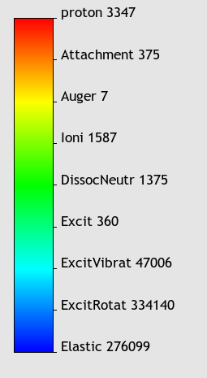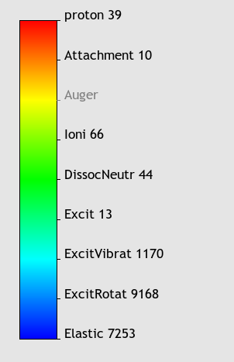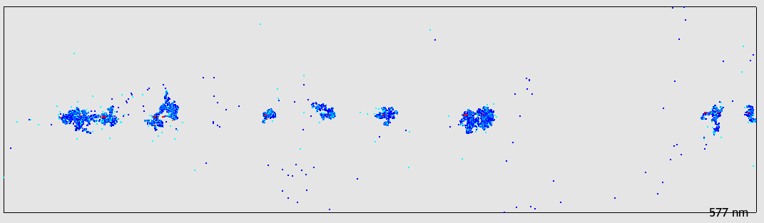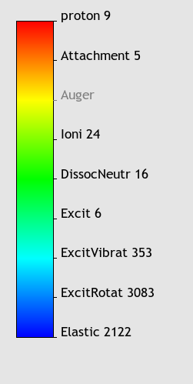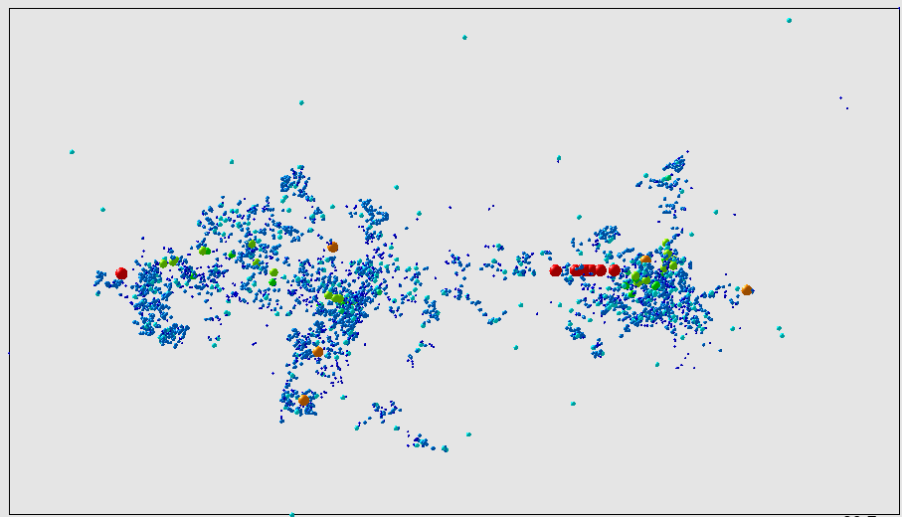

**a)**

**b)**

**c)**

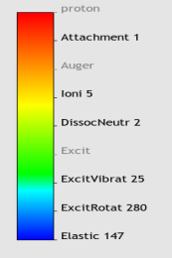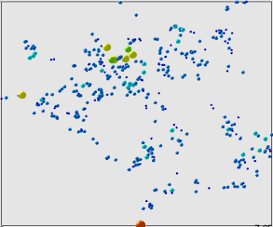

**d)**

**E dep: 999.2 keV**

**E dep: 36.63 keV**

**E dep: 9.16 keV**

**E dep: 111 eV**

Fig. 1. Proton and electron interactions from a 1 MeV proton in water. Fig a) shows full proton path length; Fig. b), c) and d) show three successive zooms. In the left zone of each of the four figures it can be seen the colour assigned to each interaction type with the corresponding number of interactions. The total energy deposited by all interactions included in each figure is indicated.

# 5. CONCLUSIONS

The Low-Energy Particle Track Simulation code has been integrated within GEANT4. This allows to make a full multi-scale simulation starting with a high energy particle down to sub-eV energy. In this way it is possible to develop an effective nanodosimetry based not on energy deposited but in the real damage caused by the radiation at molecular level.

**Acknowledgements**: This work is partially supported by the Ministerio de Economia y Competitividad  (FIS2012-31230), COST Actions (MP1002, CM1301) and the Australian Research Council  (DP140102854).

# REFERENCES

[Agostinellil 2003] S. Agostinelli, et al. GEANT4 - A simulation toolkit. Nuclear Instruments and Methods in Physics Research A, 506, 250-303, 2003.

[Allison 2006] [J. Allison, et al. Geant4 developements and applications. IEEE Trans. Nucl. Sci., NS-53, p. 270, 2006

[Blanco 2002] F. Blanco, G. Garcia, Improvements on the imaginary part of a nonempirical model potential for electron scattering (30 to 10000 eV energies), Phys. Lett. A 295 178–184, 2002.

[Blanco 2003 a] F.Blanco, G.Garcia. Inprovements on the quasifree absorption model for electron scattering. Phys. Rev. A 67, 022701, 2003.

[Blanco 2003 b] F.Blanco, G.Garcia. Screening corrections for calculation of electron scattering from polyatomic molecules. Phys. Lett. A 317, 458-462, 2003.

[Blanco 2004] F.Blanco, G.Garcia. Screening corrections for calculation of electron scattering differential cross sections from polyatomic molecules. Phys. Lett. A 330, 230-237, 2004.

## [Blanco 2009] F.Blanco, G.Garcia. A screening-corrected additivity rule for the calculation of electron scattering from macro-molecules. J.Phys B 42, 145203, 2009.

[Fuss 2009] M.C.Fuss, A.Muñoz, J.C.Oller, F.Blanco, D.Almeida, P. Limao-Vieira, T.P.D. Do, M.J. Brunger, G.Garcia. Electron-scattering cross sections for collisions with tetrahydrofuran from 50 to 5000 eV. Phys. Rev. A 80, 052709, 2009.

[Fuss 2010] M.C.Fuss, A.Muñoz, J.C.Oller, F.Blanco, M.J. Hubin-Franskin, D.Almeida, P. Limao-Vieira, G.Garcia. Electron-methane interaction model for the energy range 0.1-10 000 eV. Chem. Phys. Lett. 486, 110, 2010.

[Fuss 2013] M.C.Fuss, A.G.Sanz, A.Muñoz, T.P.D. Do, K.Nixon, M.J.Brunger, M.J. Hubin-Franskin, J.C.Oller, F.Blanco, G.Garcia. Interaction model for electron scattering from ethylene in the energy range 1–10 000 eV. Chem. Phys. Lett. 560, 22, 2013

[Muñoz 2005] A. Muñoz, J.M. Perez, G.Garcia, F.Blanco. An approach to Monte Carlo simulation of low-energy electron and photon interactions in air. Nuclear Instruments and Methods in Physics Research A, 536, 176-188, 2005

[Muñoz 2007] A. Muñoz, F. Blanco, J.C. Oller, J.M.Pérez, G. Garcia. Energy deposition models at the molecular level in biological systems. Adv. Quantum Chem. 52, 21-57, 2007.

[Muñoz 2008] A.Muñoz, F.Blanco, G.Garcia, P.A. Thorn, M.J.Brunger, J.P.Sullivan, S.J. Buckman. Single electron tracks in water vapour for energies below 100 eV. Int. J. Mass Spectrom. 277, 175, 2008.

[Sullivan 2008] J.P.Sullivan, A. Jones, P.Caradonna, C.Makochekanwa, S.J. Buckman. A positron trap and beam apparatus for atomic and molecular scattering experiments Rev. Scient. Instrum. 79, 113105, 2008.