ARTest D4 Python Manual Test Report
D4.2 Python host and SDK acceptance
Use this report to verify the prepared Python environment, generated metadata, mixed C++ and Python execution, measurement verdicts, error handling and cleanup. All devices in these cases are simulated. Do not connect physical equipment.
Automated execution does not complete this report. Record the actual behavior, attach screenshots or logs, and assign PASS or FAIL only after comparing every expected result.
Field | Tester entry
Tester and execution date | Juan Antonio Roman 08/09/2026
Git commit or working tree identifier | main
Windows version and architecture | Windows 10 x64
Visual Studio version and build configuration | Visual Studio Insiders
Python path and version | ________________________________________
Generated manual case directory | ________________________________________
Overall verdict and open defect references | EXECUTED

Acceptance rules
A negative scenario passes when ARTest reports the expected failure accurately. For example, MT03 requires a failed measurement and process exit code 5. Do not mark MT03 failed merely because the test sequence correctly ends FAILED.
Never treat a killed worker as proof that physical hardware was cleaned up. The fault-injection case requires an indeterminate result, one attempt and an explicit cleanup warning.
Before signing acceptance, complete MT01 through MT10 and reference the automated XML/HTML reports. Record any deviation as a defect rather than editing the expected results.

Preparation and shared variables
Use a normal PowerShell terminal, not the Visual Studio Package Manager Console. Keep the same terminal open for all cases. If using another repository/interpreter path, record that change on the first page and update the commands consistently.
Set-Location 'D:\GitHub\main\ARTestCLI'
$python = 'C:\Users\anton\AppData\Local\Programs\Python\Python313\python.exe'
& $python -I -c "import sys; print(sys.version)"
.\scripts\build.ps1 -Configuration Release -Platform x64
.\scripts\prepare-python-example.ps1 -Python $python -IncludeFaultTests
$cli = '.\artifacts\bin\x64\Release\ARTestCLI.exe'
$mapping = '.\artifacts\python\environments\python-environments.json'
$cases = .\scripts\manual-tests\prepare-stage-d4-2.ps1 -Configuration Release
$catalog = Join-Path $cases 'catalog'
$cases
Expected prerequisites: standard CPython 3.13 x64; successful Release build; prepared environment mapping; a new case directory. Preparation uses pinned protobuf 6.33.4 and pywin32 311 in isolated venvs. No global pip installation is required. If changed inputs cause a preparation mismatch, stop and prepare a new output root as described in the Python guide; do not edit receipts.

Evidence capture
For each execution case, run the command shown and then $LASTEXITCODE immediately. Capture the terminal with the final JSON and exit code. The JSON is printed to the terminal; it is not automatically saved to a report file. Use screenshots or explicitly redirect/copy output.
All generated plans and copied catalogs are under $cases. The preparation script creates a unique directory and does not overwrite previous manual evidence.
Reference: docs/sdk/python-extension-authoring.md. Architecture and deferred planning findings: docs/architecture/stage-d4-2-python-runtime.md.

MT01 Generated metadata and offline compilation
Prerequisite: complete the preparation page and retain its PowerShell variables.

Procedure
Get-ChildItem '.\artifacts\python\extensions\ARTestPySimulated'
Get-Content '.\artifacts\python\extensions\ARTestPySimulated\artest-extension.json'
& $cli compile "$cases\PythonPassed.json" --extensions $catalog
$LASTEXITCODE

Expected results
1. The package contains code, schemas, requirements.lock and generated artest-extension.json.
2. The manifest declares schemaVersion 3, runtime kind python, outOfProcess, runtimeVersion 3.13 and a file inventory.
3. Compilation succeeds with exit code 0 and states that no instruments were initialized.
4. No PYTHON_WORKER_READY or PY_DRIVER_INITIALIZE message appears during compilation.

Actual results and evidence
Verdict | PASS
Actual result and exit code | Exit code = 0
Evidence file or screenshot | 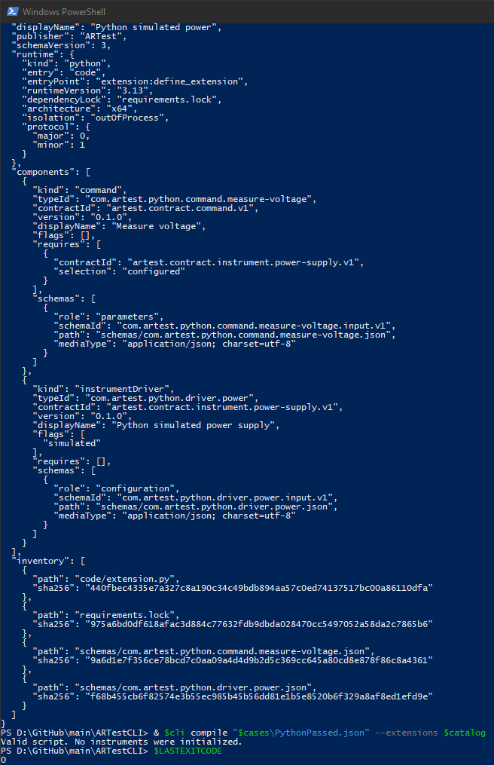
Defect reference and notes
Tester and date | Juan Antonio Roman 08/09/2026

MT02 Python command and Python driver
Prerequisite: complete the preparation page and retain its PowerShell variables.

Procedure
& $cli extension-run "$cases\PythonPassed.json" $catalog --python-environments $mapping
$LASTEXITCODE

Expected results
1. Exit code 0; overall status and step status are passed.
2. Events include PYTHON_WORKER_READY, PY_DRIVER_INITIALIZE, PY_MEASUREMENT_COMPLETED and PY_DRIVER_SHUTDOWN.
3. Final schema is artest.schema.run-result.v2. The first step outcome contains value 5.0, unit V and minimum 4.8.
4. Summary reports one planned, executed and passed step.

Actual results and evidence
Verdict | PASS
Actual result and exit code | Exit code = 0
Evidence file or screenshot | 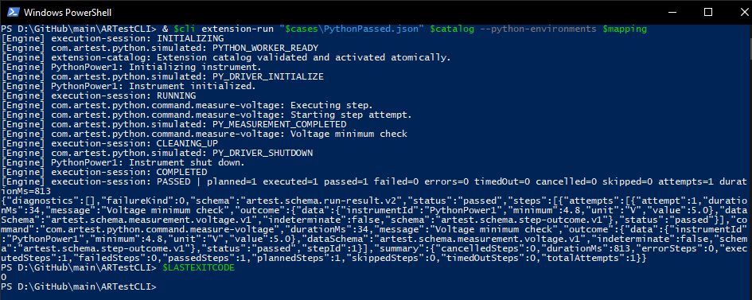
Defect reference and notes
Tester and date | Juan Antonio Roman 08/09/2026

MT03 Failed measurement remains a failed verdict
Prerequisite: complete the preparation page and retain its PowerShell variables.

Procedure
& $cli extension-run "$cases\PythonFailed.json" $catalog --python-environments $mapping
$LASTEXITCODE

Expected results
1. Exit code 5; overall and step status are failed, not passed or error.
2. Summary has failedSteps 1 and errorSteps 0.
3. Step and attempt outcome data retain value 4.2, minimum 4.8 and unit V.
4. PY_DRIVER_SHUTDOWN appears before the terminal state.

Actual results and evidence
Verdict | PASS
Actual result and exit code | Exit code = 5
Evidence file or screenshot | 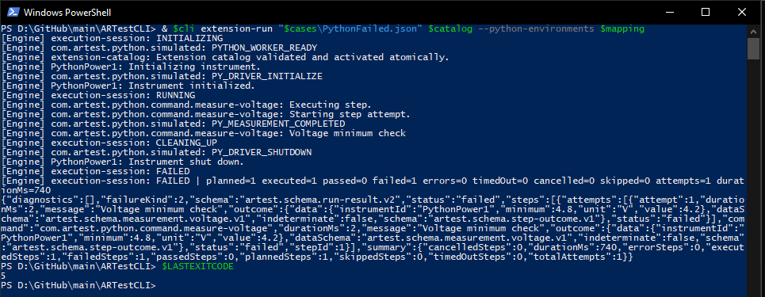
Defect reference and notes
Tester and date | Juan Antonio Roman 08/09/2026

MT04 Native command calls Python driver
Prerequisite: complete the preparation page and retain its PowerShell variables.

Procedure
& $cli extension-run "$cases\NativeToPython.json" $catalog --python-environments $mapping
$LASTEXITCODE

Expected results
1. Exit code 0; overall and step status are passed.
2. The command is com.artest.command.sample.power-cycle and it uses the configured Python driver.
3. PY_DRIVER_INITIALIZE and PY_DRIVER_SHUTDOWN appear. The native sample command reports service completion.
4. No direct command-to-driver DLL dependency or manual JSON metadata edit is needed.

Actual results and evidence
Verdict | PASS
Actual result and exit code | Exit code = 0
Evidence file or screenshot | 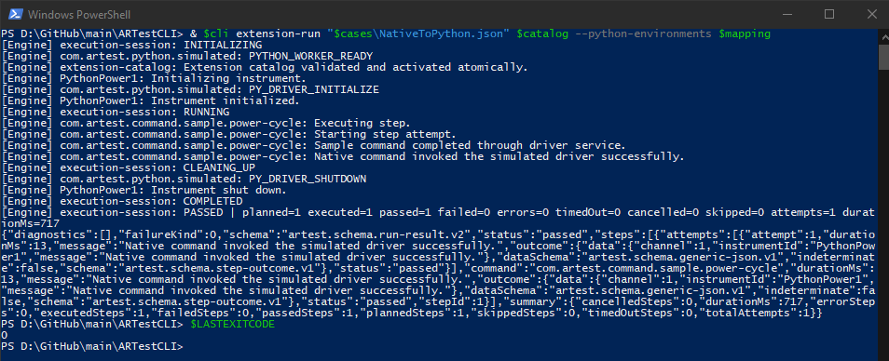
Defect reference and notes
Tester and date | Juan Antonio Roman 08/09/2026

MT05 Python command calls native driver
Prerequisite: complete the preparation page and retain its PowerShell variables.

Procedure
& $cli extension-run "$cases\PythonToNative.json" $catalog --python-environments $mapping
$LASTEXITCODE

Expected results
1. Exit code 0; overall and step status are passed.
2. The native simulated power driver reports initialization and shutdown.
3. PY_MEASUREMENT_COMPLETED appears; the outcome retains measured value 5.0 and unit V.
4. The Python command implementation is unchanged from MT02.

Actual results and evidence
Verdict | PASS
Actual result and exit code | exit code = 0
Evidence file or screenshot | 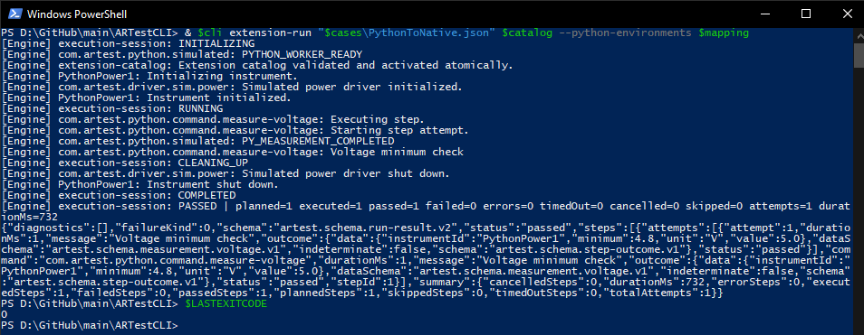
Defect reference and notes
Tester and date | Juan Antonio Roman 08/09/2026

MT06 Python exception becomes an execution error
Prerequisite: complete the preparation page and retain its PowerShell variables.

Procedure
& $cli extension-run "$cases\PythonError.json" $catalog --python-environments $mapping
$LASTEXITCODE

Expected results
1. Exit code 5; overall status is error and summary errorSteps is 1.
2. The diagnostic includes Simulated command error.
3. The exception does not terminate ARTestCLI abnormally.
4. PY_DRIVER_SHUTDOWN appears and the next independent run of MT02 can pass.

Actual results and evidence
Verdict | PASS
Actual result and exit code | Exit code = 5
Evidence file or screenshot | 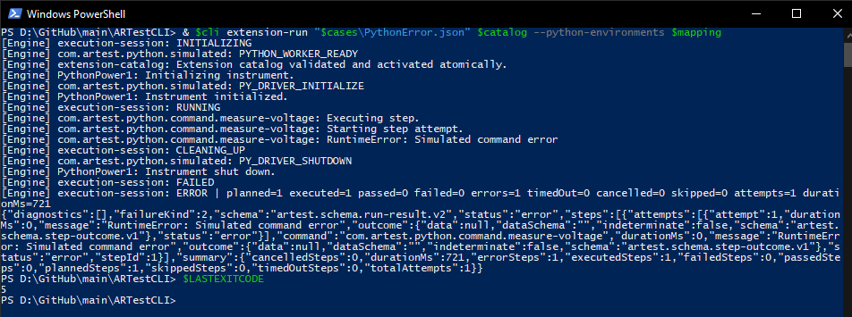
Defect reference and notes
Tester and date | Juan Antonio Roman 08/09/2026

MT07 Deadline and cooperative cleanup
Prerequisite: complete the preparation page and retain its PowerShell variables.

Procedure
& $cli extension-run "$cases\PythonTimeout.json" $catalog --python-environments $mapping
$LASTEXITCODE

Expected results
1. Exit code 5; overall and step status are timedOut.
2. The 100 ms step deadline interrupts a requested 2000 ms hold.
3. PY_DRIVER_SHUTDOWN appears. The step outcome indeterminate flag is false.
4. Do not use total process duration as the step latency; startup/environment validation are separate.

Actual results and evidence
Verdict | PASS
Actual result and exit code | Exit Code = 5
Evidence file or screenshot | 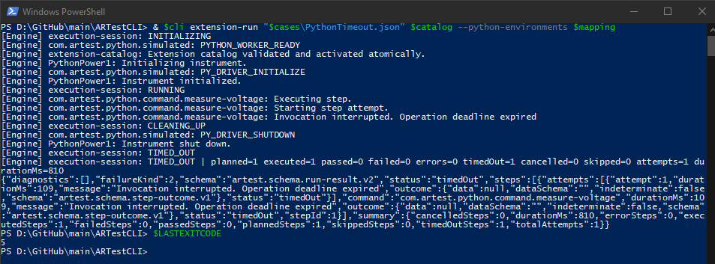
Defect reference and notes
Tester and date | Juan Antonio Roman 08/09/2026

MT08 User cancellation and cleanup
Prerequisite: complete the preparation page and retain its PowerShell variables.

Procedure
Run the command below. After Executing step 1 appears, press Ctrl+C once within 5 seconds. Wait for ARTest to finish cleanup, then run $LASTEXITCODE.
& $cli extension-run "$cases\PythonCancel.json" $catalog --python-environments $mapping
$LASTEXITCODE

Expected results
1. Wait until the terminal prints Executing step 1, then press Ctrl+C once within 5 seconds.
2. ARTest handles cancellation and returns exit code 5; overall status is cancelled.
3. PY_DRIVER_SHUTDOWN appears and the step outcome indeterminate flag is false.
4. The terminal remains usable. Repeating MT02 in the same terminal succeeds.

Actual results and evidence
Verdict | PASS
Actual result and exit code | - Exit code = 5  - Exit code = 0
Evidence file or screenshot | 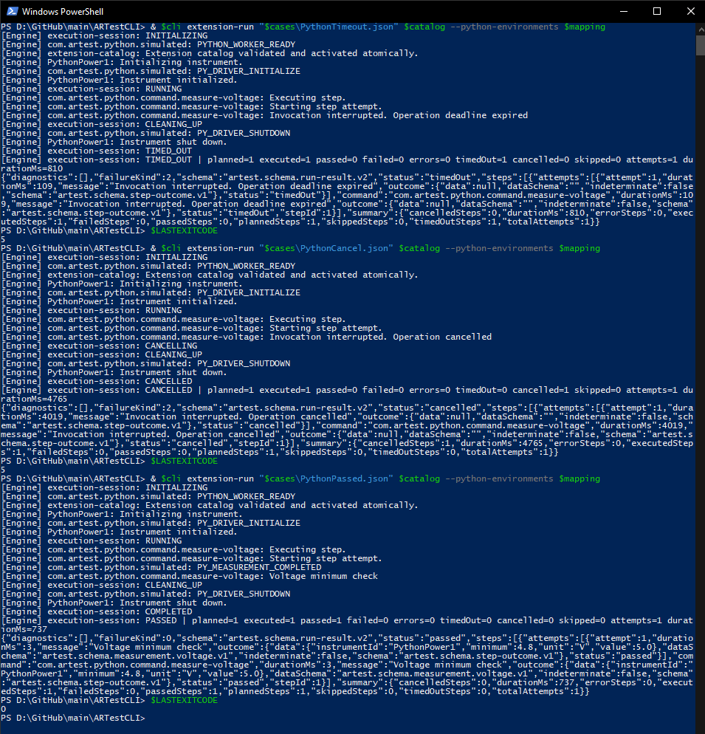
Defect reference and notes
Tester and date | Juan Antonio Roman 08/09/2026

MT09 Cleanup failure overrides successful measurement
Prerequisite: complete the preparation page and retain its PowerShell variables.

Procedure
& $cli extension-run "$cases\PythonCleanupError.json" $catalog --python-environments $mapping
$LASTEXITCODE

Expected results
1. The step measurement passes, but the overall run status is error and exit code is 5.
2. The diagnostic includes Simulated cleanup failure.
3. The run must not report overall PASSED merely because the measurement passed.
4. PY_DRIVER_SHUTDOWN confirms the cleanup attempt, not its successful completion.

Actual results and evidence
Verdict | PASS
Actual result and exit code | Exit code = 5
Evidence file or screenshot | 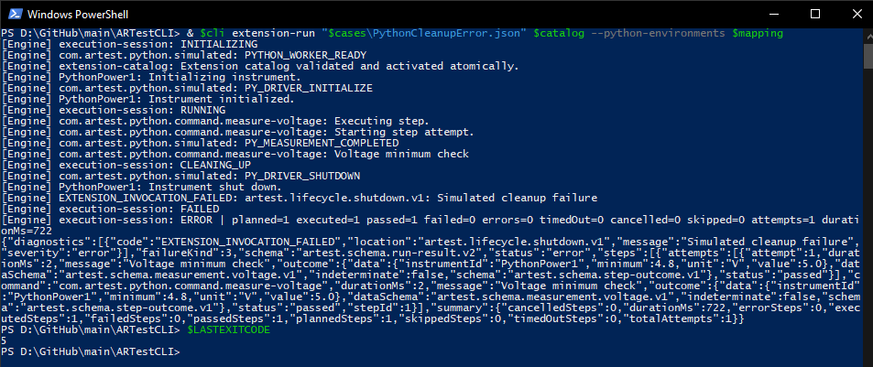
Defect reference and notes
Tester and date | Juan Antonio Roman 08/09/2026

MT10 Controlled process faults and no replay
Prerequisite: complete the preparation page and retain its PowerShell variables.

Procedure
.\scripts\test-python-runtime.ps1 -Configuration Release
Get-ChildItem '.\artifacts\test-results\x64\Release\ARTestPython.Integration.*'

Expected results
1. The script succeeds and reports all Python integration cases passed.
2. Open ARTestPython.Integration.html and verify CrashAfterEffectIsNeverRetriedOrContinued, BlockingIoThatIgnoresTimeoutIsTerminatedWithoutReplay and BlockingIoFinishesBeforeDriverCleanupBegins are PASSED.
3. The fault tests verify one persisted simulated effect, no retry/continuation, explicit indeterminate state and unconfirmed cleanup after worker termination.
4. Attach the HTML/XML report references and a screenshot. No real device or Task Manager kill is required.

Actual results and evidence
Verdict | PASS
Actual result and exit code
Evidence file or screenshot | 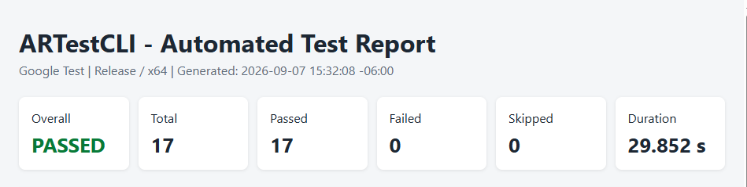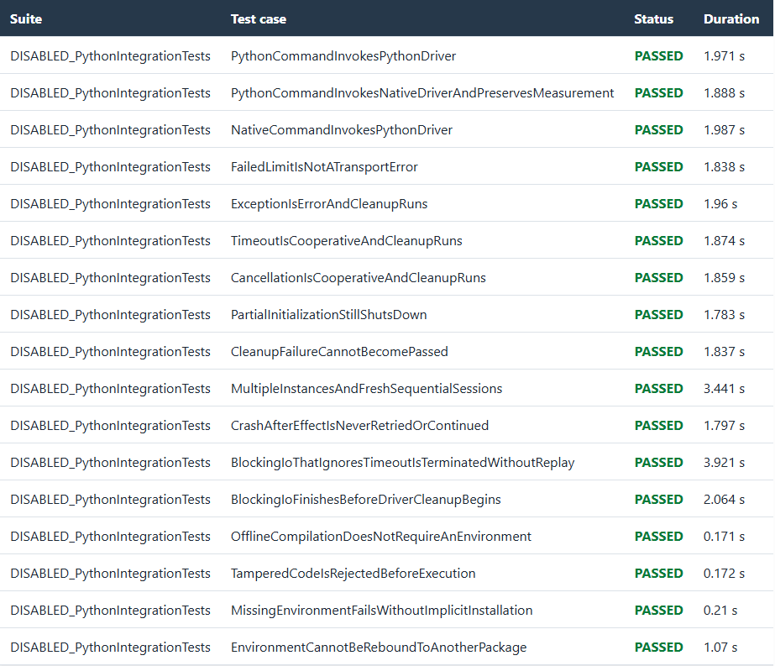
Defect reference and notes
Tester and date | Juan Antonio Roman 08/09/2026

