QUALITY ASSURANCE
ARTestCLI Manual Test Report
Stage D2 - Thin-Host Migration
Document ID | ARTEST-QA-D2-MANUAL-001
Version | 1.0
Status | Completed
Prepared for | ARTestCLI / ARTestEngine Stage D2 acceptance
Tester | Juan Antonio Roman Alarcon
Execution date | 01/09/2026
Commit / branch | main

Purpose and acceptance scope
This report captures repeatable manual evidence for the Stage D2 thin-host migration. It validates the public Engine API 0.2 boundary, legacy CLI compatibility, controlled debug sessions, structured compilation, cancellation, cleanup, and D1 extension regression.
Acceptance rule: All nine manual cases must be Passed, and the Debug and Release automated reports must each show 61 passed, 0 failed, and 0 skipped.

Execution environment
Operating system | Windows:
Visual Studio | 18 Insiders / v145
Platform | x64
Configurations | Debug and Release
Repository | D:\GitHub\main\ARTestCLI
PowerShell version | 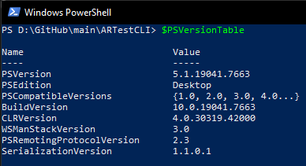
Machine / tester | Juan Antonio Roman Alarcon

Test summary
ID | Scenario | Expected verdict | Actual verdict
MT-D2-001 | Official Debug and Release regression workflow | Passed | Passed
MT-D2-002 | Thin-host architectural boundary enforcement | Passed | Passed
MT-D2-003 | Offline compilation and structured diagnostics | Passed | Passed
MT-D2-004 | Run command compatibility through ARTestEngine.dll | Passed | Passed
MT-D2-005 | Debug control callback and continue behavior | Passed | Passed
MT-D2-006 | Zero-based breakpoint compatibility | Passed | Passed
MT-D2-007 | Cooperative Ctrl+C cancellation through EngineClient | Passed | Passed
MT-D2-008 | Initialization-failure exit-code compatibility | Passed | Passed
MT-D2-009 | Native extension vertical-slice regression | Passed | Passed

MT-D2-001 | Official Debug and Release regression workflow
Objective | Confirm the complete solution, ABI layout, thin-host rule, Google Test suite, and validated reports pass in both supported configurations.
Preconditions | Visual Studio 18 Insiders is installed at the documented path. Run from the repository root.
Expected verdict | Passed

Procedure and expected results
Step | Action | Expected result
1 | Run .\scripts\build.ps1 -Configuration Debug -Platform x64. | Build succeeds; thin-host verification passes; ABI contract returns 0; Google Test reports 61 passed and 0 failed.
2 | Open artifacts\test-results\x64\Debug\ARTestCLI.UnitTests.html. | Overall is PASSED; Total and Passed are 61; Failed and Skipped are 0; every test-case verdict is consistent.
3 | Run .\scripts\build.ps1 -Configuration Release -Platform x64. | Release produces the same 61/61 passed baseline and a validated HTML report.
4 | Record both HTML reports and console output as evidence. | Evidence identifies configuration, platform, suite count, test count, and final verdict.

Execution evidence
Actual result | PASSED
Evidence references
Verdict | Passed
Defect ID / Notes

MT-D2-002 | Thin-host architectural boundary enforcement
Objective | Verify ARTestCLI compiles only against ARTest.SDK and ARTestEngine.dll, never ARTestEngine.Core.
Preconditions | Repository is on the D2 implementation under test.
Expected verdict | Passed

Procedure and expected results
Step | Action | Expected result
1 | Run .\scripts\verify-thin-host.ps1 -ProjectDirectory .\source\ARTestCLI. | The script prints Thin-host architecture verification: PASSED and returns 0.
2 | Open source\ARTestCLI\ARTestCLI.vcxproj in a text editor. | It references ARTestEngine.vcxproj and the ARTest.SDK include directory; it does not reference ARTestEngine.Core.vcxproj.
3 | Search source\ARTestCLI for ARTestEngine.Core. | No .cpp, .h, .hpp, or .vcxproj match is found.
4 | In the automated HTML report, locate StageDThinHostArchitectureTests. | CliDependsOnlyOnThePublicSdkAndEngineDll is PASSED.

Execution evidence
Actual result | PASSED
Evidence references
Verdict | Passed
Defect ID / Notes

MT-D2-003 | Offline compilation and structured diagnostics
Objective | Confirm compile uses ARTestEngine.dll, never initializes hardware, and preserves exit code 3 for an invalid plan.
Preconditions | Release build from MT-D2-001 completed successfully.
Expected verdict | Passed

Procedure and expected results
Step | Action | Expected result
1 | Set $cli = '.\artifacts\bin\x64\Release\ARTestCLI.exe'. | Test-Path $cli returns True.
2 | Run & $cli compile '.\source\Scripts\TestScript.json'; $LASTEXITCODE. | The CLI prints Valid script. No instruments were initialized. and returns 0; no Initialize or Shutdown text appears.
3 | Run & $cli compile '.\quality\manual-tests\stage-a\data\unknown-command.json'; $LASTEXITCODE. | The CLI reports COMMAND_TYPE_UNKNOWN with location steps[0] and returns 3.
4 | Run & $cli compile '.\quality\manual-tests\stage-a\data\malformed-json.json'; $LASTEXITCODE. | The CLI reports SCRIPT_JSON_INVALID, identifies the original file path, does not expose engine-api as the location, and returns 3.

Execution evidence
Actual result | PASSED
Evidence references | 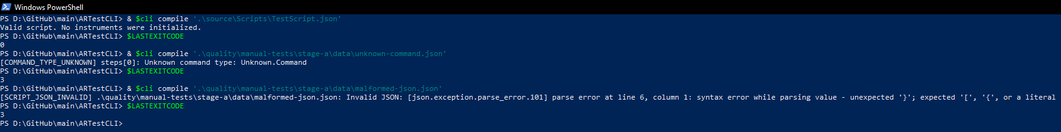
Verdict | Passed
Defect ID / Notes

MT-D2-004 | Run command compatibility through ARTestEngine.dll
Objective | Verify the legacy run contract is preserved while execution is owned by the public Engine boundary.
Preconditions | $cli is defined as in MT-D2-003.
Expected verdict | Passed

Procedure and expected results
Step | Action | Expected result
1 | Run & $cli run '.\source\Scripts\TestScript.json'. | The process returns exit code 0.
2 | Inspect state and instrument output. | Output shows INITIALIZING, fake CAN and power-supply initialization, RUNNING, four step records, CLEANING_UP, reverse-order shutdown, and COMPLETED.
3 | Inspect the final execution summary. | It reports PASSED with planned=4, executed=4, passed=4, failed=0, skipped=0, and attempts=4.

Execution evidence
Actual result | PASSED
Evidence references | 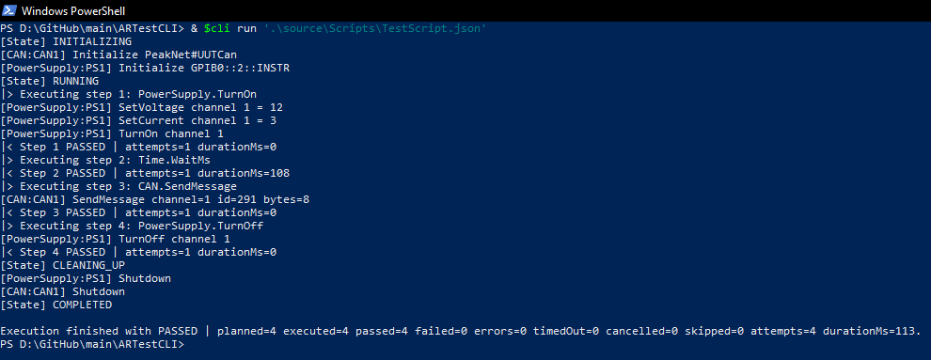
Verdict | Passed
Defect ID / Notes

MT-D2-005 | Debug control callback and continue behavior
Objective | Confirm debug pauses through the API 0.2 before-step callback and the host remains responsible for user interaction.
Preconditions | $cli is defined. Use an interactive PowerShell console.
Expected verdict | Passed

Procedure and expected results
Step | Action | Expected result
1 | Run & $cli debug '.\source\Scripts\TestScript.json'. | The Engine initializes instruments and the CLI pauses before script step 1.
2 | At Options: (n)ext, (c)ontinue, (q)uit > enter c and press Enter. | Execution continues without another debug prompt.
3 | Inspect completion and $LASTEXITCODE. | All four steps pass, cleanup completes, terminal state is COMPLETED, and exit code is 0.

Execution evidence
Actual result | PASSED
Evidence references | 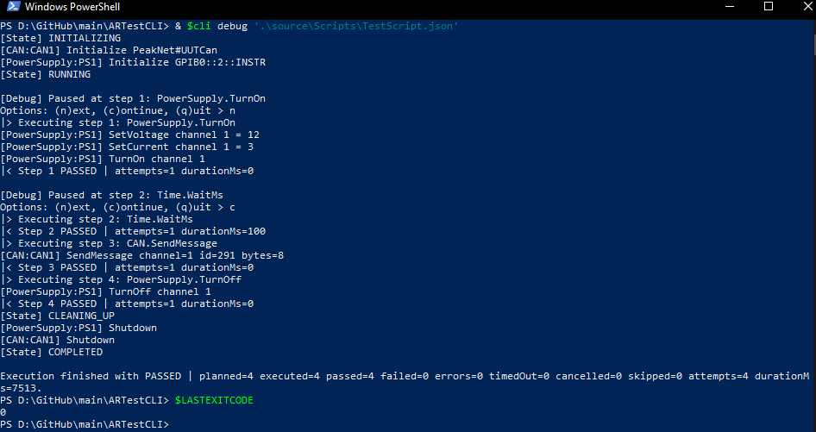
Verdict | Passed
Defect ID / Notes

MT-D2-006 | Zero-based breakpoint compatibility
Objective | Verify break retains zero-based command-index semantics through the controlled-session callback.
Preconditions | $cli is defined. Use an interactive PowerShell console.
Expected verdict | Passed

Procedure and expected results
Step | Action | Expected result
1 | Run & $cli break '.\source\Scripts\TestScript.json' 1. | Script step 1 executes without a debug prompt.
2 | Confirm the prompt identifies step 2: Time.WaitMs. | The callback receives command index 1 and displays the stable script stepId 2.
3 | Enter c and press Enter; then inspect $LASTEXITCODE. | Remaining steps execute, cleanup completes, and exit code is 0.

Execution evidence
Actual result | PASSED
Evidence references | 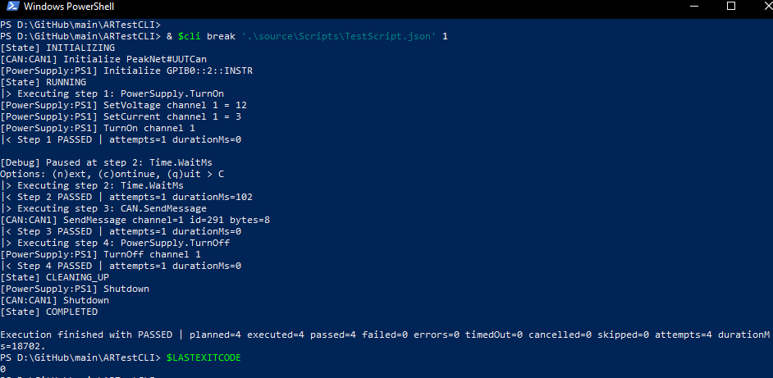
Verdict | Passed
Defect ID / Notes

MT-D2-007 | Cooperative Ctrl+C cancellation through EngineClient
Objective | Verify Ctrl+C reaches the public session, wakes a long command, and preserves guaranteed cleanup.
Preconditions | $cli is defined. Use an interactive PowerShell console.
Expected verdict | Passed

Procedure and expected results
Step | Action | Expected result
1 | Run & $cli run '.\quality\manual-tests\stage-c\data\cancel-cleanup.json'. | Execution reaches RUNNING and starts the long Time.WaitMs step.
2 | Press Ctrl+C once while Time.WaitMs is active. | The process does not terminate abruptly; it requests cooperative cancellation.
3 | Inspect state and instrument output. | Output shows CANCELLING, CLEANING_UP, power-supply Shutdown, and terminal CANCELLED in that order.
4 | Run $LASTEXITCODE immediately after completion. | The process exit code is 5.

Execution evidence
Actual result | PASSED
Evidence references | 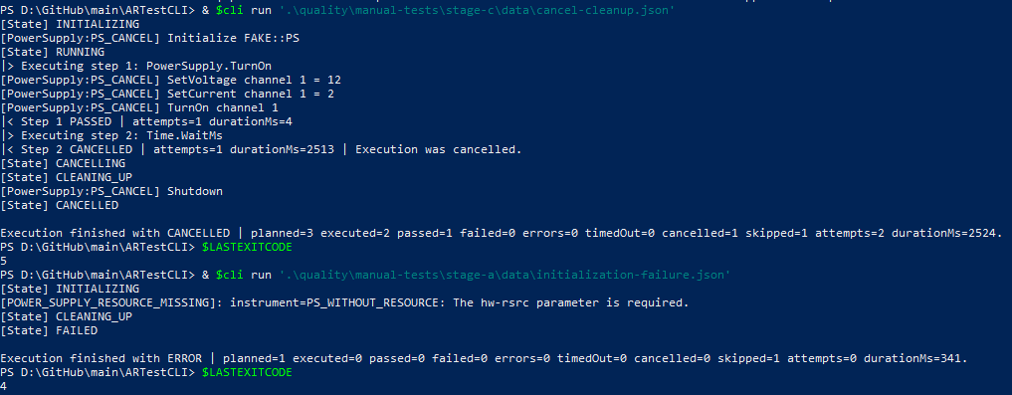
Verdict | Passed
Defect ID / Notes

MT-D2-008 | Initialization-failure exit-code compatibility
Objective | Confirm an initialization failure remains distinguishable from validation and execution failures after migration.
Preconditions | $cli is defined.
Expected verdict | Passed

Procedure and expected results
Step | Action | Expected result
1 | Run & $cli run '.\quality\manual-tests\stage-a\data\initialization-failure.json'. | The Engine enters INITIALIZING and reports POWER_SUPPLY_RESOURCE_MISSING.
2 | Inspect cleanup and terminal state. | CLEANING_UP and FAILED are emitted; no test step executes.
3 | Run $LASTEXITCODE immediately after completion. | The process exit code is 4.

Execution evidence
Actual result | PASSED
Evidence references | 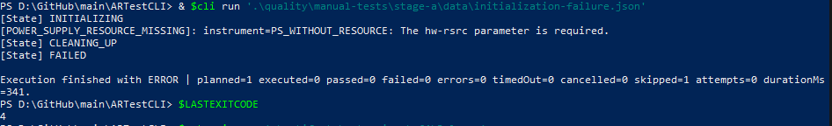
Verdict | Passed
Defect ID / Notes

MT-D2-009 | Native extension vertical-slice regression
Objective | Confirm the D1 Command Plugin to Instrument Driver flow remains functional after API 0.2 and thin-host migration.
Preconditions | Release build completed and packaged extensions exist.
Expected verdict | Passed

Procedure and expected results
Step | Action | Expected result
1 | Set $extensions = '.\artifacts\extensions\x64\Release'; confirm Test-Path $extensions returns True. | The approved extension root exists.
2 | Run & $cli extension-run '.\source\Scripts\ExtensionScript.json' $extensions. | The catalog loads, the sample Command Plugin invokes SimPower1, cleanup shuts down the driver, and the process returns 0.
3 | Inspect the final JSON line. | status is passed; failureKind is 0; plannedSteps, executedSteps, and passedSteps are 1.
4 | In the HTML report, locate StageDEngineApiCompatibilityTests. | NegotiatesMinorOneWithoutWritingPastItsTable is PASSED, proving API 0.1 table compatibility.

Execution evidence
Actual result | PASSED
Evidence references | 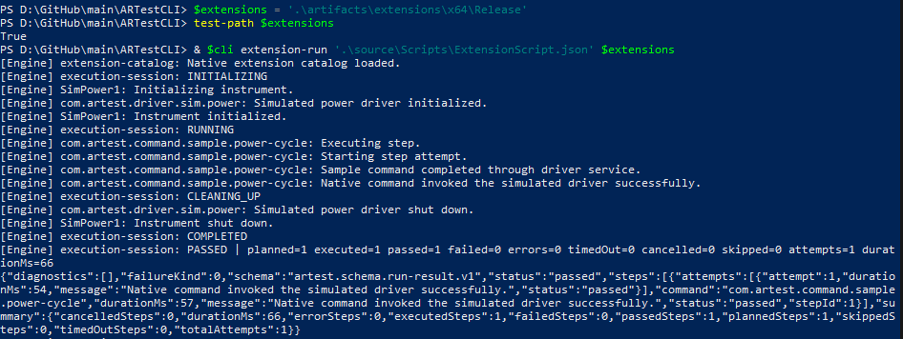
Verdict | Passed
Defect ID / Notes

Final acceptance
Total manual cases | 9
Passed | 9
Failed | 0
Blocked / Not run | 0
Automated Debug verdict | Passed
Automated Release verdict | Passed
Overall Stage D2 verdict | Passed

Approval
Role | Name / Signature | Date
Tester | Juan Antonio Roman Alarcon | 01/09/2026
Technical reviewer

