MANUAL TEST REPORT
ARTestStudio
Phase 2 - Persistence Hardening and Recovery

Document ID | ARTEST-QA-MTR-PH-001
Version | 1.0
Status | READY FOR MANUAL EXECUTION
Prepared | 2026-08-27
Base commit | 2cbce34 (feature under test is currently uncommitted)
Repository | D:\GitHub\main\ARTestStudio
Release executable | artifacts\bin\x64\Release\ARTestStudio.exe

Release gate
All seven manual cases must be PASS. Every executed case requires at least one referenced evidence item. Any failed High-priority case blocks closure of this persistence increment.

Document control
Version | Date | Author | Change
1.0 | 2026-08-27 | Codex / ARTestStudio | Initial controlled report for persistence hardening.

Scope and acceptance criteria
In scope | 16 MB file limit; 64 KB UTF-8 label limit; bounded parsing; transactional load; atomic save; stale .tmp cleanup; replacement-failure recovery; structured logs.
Out of scope | Project files .atprj, cloud synchronization, multi-user file locking and line editing interactions.
Pass rule | Observed behavior equals every expected result; the active or previous diagram remains intact after each negative test.
Evidence rule | Use the Evidence ID from each case in screenshot names, attachments and defect references.

Automated regression already executed
Configuration | Platform | Result | Date | Command
Debug | x64 | 29 / 29 PASS | 2026-08-27 | scripts\build.cmd -Configuration Debug
Release | x64 | 29 / 29 PASS | 2026-08-27 | scripts\build.cmd -Configuration Release

Manual execution environment
Tester | Juan Antonio Roman
Execution date | 28/08/2026
Windows version | Windows 10
Visual Studio | 18 Insiders - D:\Program Files\Microsoft Visual Studio\18\Insiders
Configuration | Release | x64
Repository root | D:\GitHub\main\ARTestStudio
Log path | %LOCALAPPDATA%\ARTestStudio\Logs\ARTestStudio.log

Preparation procedure
Step | Action | Expected result
1 | Open Command Prompt and run: cd /d D:\GitHub\main\ARTestStudio | The prompt changes to the repository root.
2 | Run: scripts\build.cmd -Configuration Release | Build completes and prints 29/29 tests passed.
3 | Run: scripts\manual-tests\generate_persistence_hardening_fixtures.cmd | A paused window lists four generated fixture paths.
4 | Start: artifacts\bin\x64\Release\ARTestStudio.exe | ARTestStudio opens without an error dialog.
5 | Keep File Explorer open at artifacts\manual-tests\persistence-hardening. | All fixtures are visible; file extensions are displayed.

Manual execution summary
Test case | Priority | Purpose | Status | Evidence | Defect
TC-PH-001 | High | Nominal save and load regression | NOT RUN
TC-PH-002 | High | Reject a diagram larger than 16 MB | NOT RUN
TC-PH-003 | High | Reject a label larger than 64 KB | NOT RUN
TC-PH-004 | High | Reject a truncated quoted label | NOT RUN
TC-PH-005 | High | Clean a stale .tmp during a successful save | NOT RUN
TC-PH-006 | Critical | Preserve the previous document when replacement fails | NOT RUN
TC-PH-007 | High | Recover normal saving after a replacement failure | NOT RUN

TC-PH-001 - Nominal save and load regression
Prioridad | High
Tipo | Functional / regression
Requisitos | PH-REQ-003, PH-REQ-005
Cobertura automatica | Yes - round-trip and stable identifiers

Objetivo
Confirm that normal .atd persistence remains functional after introducing limits and atomic writing.

Precondiciones y datos
Application | Release executable is running.
Test file | D:\GitHub\main\ARTestStudio\artifacts\manual-tests\persistence-hardening\PH-baseline.atd
Initial state | No document named PH-baseline.atd exists.

Procedimiento de ejecucion
Paso | Accion exacta | Resultado esperado
1 | Press Ctrl+N. Drag one Rectangle and one Diamond from Class View to the document. | A clean diagram contains exactly two visible blocks.
2 | Connect the Rectangle to the Diamond and visually confirm the orthogonal route. | One connection is visible and remains attached to both blocks.
3 | Use File > Save As and enter D:\GitHub\main\ARTestStudio\artifacts\manual-tests\persistence-hardening\PH-baseline.atd. | Save completes without a dialog; the title reflects PH-baseline.atd.
4 | Close only the document, then press Ctrl+O and select PH-baseline.atd. | The file opens without warnings.
5 | Compare the reopened diagram with the pre-save view. | Both blocks, their kinds, positions and the connection are preserved.

Registro de ejecucion
Estado | [ X] PASS [ ] FAIL [ ] BLOCKED [ ] NOT RUN
Ejecutor | Juan Antonio Roman
Fecha / hora | 28/08/2026 0:25
Resultado real | Application works as expected
Defecto asociado | ID: ____________________ Severidad: ____________________

Evidencia
Evidencia ID | Archivo / captura | Descripcion y punto verificado
EV-TC-PH-001-01 | 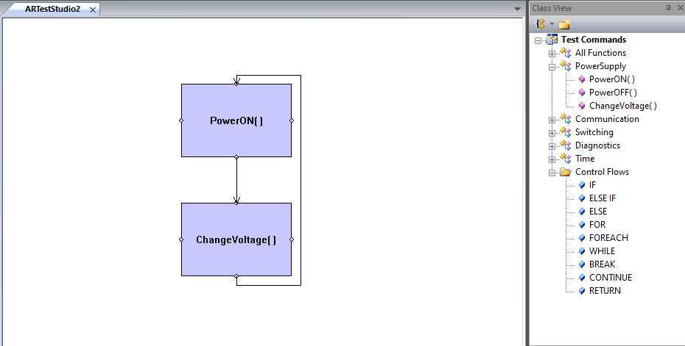 | Adding and connect two blocks in a new document.
EV-TC-PH-001-02 | 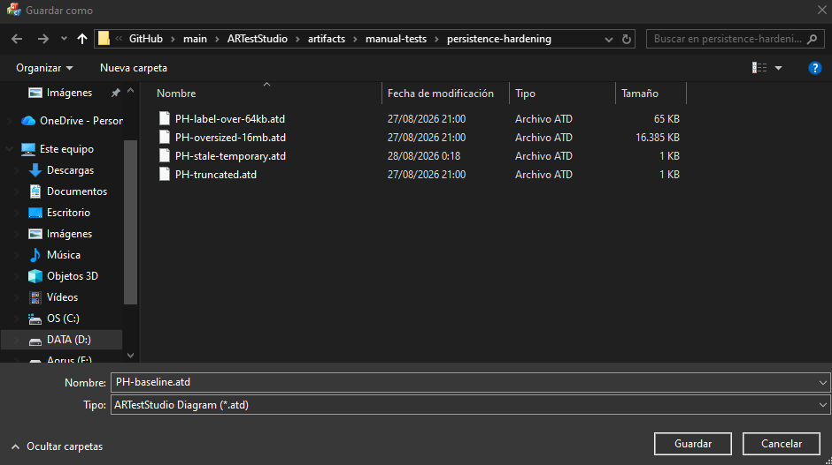 | Save as PH-baseline.atd without issue dialog.
EV-TC-PH-001-03 | 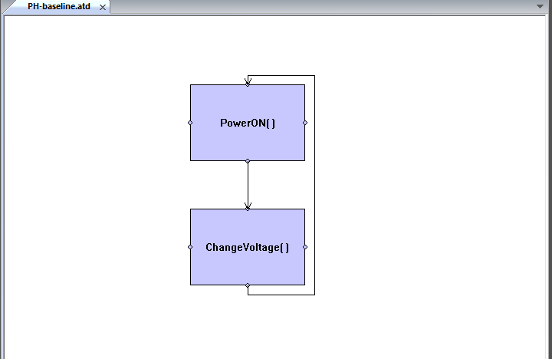 | Close and Reopen the PH-baseline.atd. Both blocks, their kinds and connections are preserved.

TC-PH-002 - Reject a diagram larger than 16 MB
Prioridad | High
Tipo | Security / negative
Requisitos | PH-REQ-001, PH-REQ-005, PH-REQ-006
Cobertura automatica | Yes - 16 MB + 1 byte boundary

Objetivo
Verify that total file size is rejected before parsing and that the current valid document is not replaced.

Precondiciones y datos
Active document | PH-baseline.atd is open and visibly contains two blocks.
Fixture | D:\GitHub\main\ARTestStudio\artifacts\manual-tests\persistence-hardening\PH-oversized-16mb.atd
Exact size | 16,777,217 bytes (16 MB + 1 byte).

Procedimiento de ejecucion
Paso | Accion exacta | Resultado esperado
1 | Capture the current PH-baseline.atd window as before-state evidence. | The capture clearly shows both blocks and their connection.
2 | Press Ctrl+O and select PH-oversized-16mb.atd. | An error dialog appears; ARTestStudio does not hang or close.
3 | Verify the dialog includes: El archivo excede el limite permitido de 16 MB. | The file-size-specific error is visible.
4 | Dismiss the dialog and inspect the open documents. | PH-baseline.atd remains open and unchanged; the oversized fixture is not opened.
5 | Open %LOCALAPPDATA%\ARTestStudio\Logs\ARTestStudio.log and search for STORAGE_10. | A Storage warning records operation abrir and the oversized fixture path.

Registro de ejecucion
Estado | [ X] PASS [ ] FAIL [ ] BLOCKED [ ] NOT RUN
Ejecutor | Juan Antonio Roman
Fecha / hora | 28/08/2026 – 0:35
Resultado real
Defecto asociado | ID: ____________________ Severidad: ____________________

Evidencia
Evidencia ID | Archivo / captura | Descripcion y punto verificado
EV-TC-PH-002-01 | 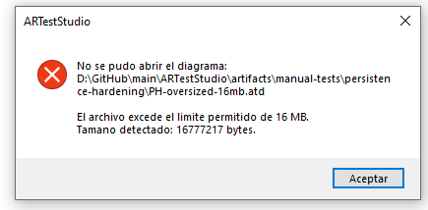 | Error dialog appears with the correct error description.
EV-TC-PH-002-02 | [2026-08-28T00:34:27.932] [WARNING] [STORAGE] [STORAGE_10] abrir | El archivo excede el limite permitido de 16 MB. | Detail: Ruta: D:\GitHub\main\ARTestStudio\artifacts\manual-tests\persistence-hardening\PH-oversized-16mb.atd | Tamano detectado: 16777217 bytes. | Error info saved correctly on log file.
EV-TC-PH-002-03

TC-PH-003 - Reject a label larger than 64 KB
Prioridad | High
Tipo | Security / boundary
Requisitos | PH-REQ-002, PH-REQ-005, PH-REQ-006
Cobertura automatica | Yes - bounded quoted-string parser

Objetivo
Verify bounded label parsing and transactional rejection of a valid-size file containing a label over the per-label limit.

Precondiciones y datos
Active document | PH-baseline.atd remains open and unchanged.
Fixture | D:\GitHub\main\ARTestStudio\artifacts\manual-tests\persistence-hardening\PH-label-over-64kb.atd
Label size | 65,537 UTF-8 bytes (64 KB + 1 byte).

Procedimiento de ejecucion
Paso | Accion exacta | Resultado esperado
1 | Press Ctrl+O and select PH-label-over-64kb.atd. | An error dialog appears promptly; the application remains responsive.
2 | Verify the dialog includes: El diagrama excede uno de los limites de seguridad permitidos. | The limit-specific category is shown.
3 | Verify the detail includes: Una etiqueta excede el limite de 64 KB. | The exact violated limit is identified.
4 | Dismiss the dialog and inspect PH-baseline.atd. | The baseline diagram is still open and unchanged.
5 | Search ARTestStudio.log for STORAGE_11 and PH-label-over-64kb.atd. | The rejected path and operation abrir are recorded.

Registro de ejecucion
Estado | [ X] PASS [ ] FAIL [ ] BLOCKED [ ] NOT RUN
Ejecutor | Juan Antonio Roman
Fecha / hora | 28/08/2026 – 0:41
Resultado real
Defecto asociado | ID: ____________________ Severidad: ____________________

Evidencia
Evidencia ID | Archivo / captura | Descripcion y punto verificado
EV-TC-PH-003-01 | 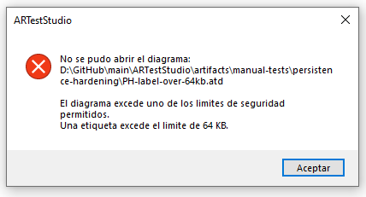 | Error dialog appears with the correct error description.
EV-TC-PH-003-02 | [2026-08-28T00:38:29.691] [WARNING] [STORAGE] [STORAGE_11] abrir | El diagrama excede uno de los limites de seguridad permitidos. | Detail: Ruta: D:\GitHub\main\ARTestStudio\artifacts\manual-tests\persistence-hardening\PH-label-over-64kb.atd | Una etiqueta excede el limite de 64 KB. | Error info saved correctly on log file.
EV-TC-PH-003-03

TC-PH-004 - Reject a truncated quoted label
Prioridad | High
Tipo | Robustness / negative
Requisitos | PH-REQ-002, PH-REQ-005, PH-REQ-006
Cobertura automatica | Yes - truncated label regression

Objetivo
Confirm that a truncated quoted field is detected without partially loading or damaging an existing document.

Precondiciones y datos
Active document | PH-baseline.atd remains open and unchanged.
Fixture | D:\GitHub\main\ARTestStudio\artifacts\manual-tests\persistence-hardening\PH-truncated.atd
Fixture condition | The NODE label starts with a quote but has no closing quote or END section.

Procedimiento de ejecucion
Paso | Accion exacta | Resultado esperado
1 | Press Ctrl+O and select PH-truncated.atd. | An invalid-data error dialog appears; no crash occurs.
2 | Verify the detail includes: La etiqueta de un bloque esta truncada o es invalida. | The truncated-label cause is explicit.
3 | Dismiss the dialog. | No document is created for PH-truncated.atd.
4 | Inspect PH-baseline.atd. | The baseline diagram remains intact and editable.
5 | Search ARTestStudio.log for STORAGE_8 and PH-truncated.atd. | A structured Storage warning records the failed open.

Registro de ejecucion
Estado | [X ] PASS [ ] FAIL [ ] BLOCKED [ ] NOT RUN
Ejecutor | Juan Antonio Roman
Fecha / hora | 28/08/2026 – 0:45
Resultado real
Defecto asociado | ID: ____________________ Severidad: ____________________

Evidencia
Evidencia ID | Archivo / captura | Descripcion y punto verificado
EV-TC-PH-004-01 | 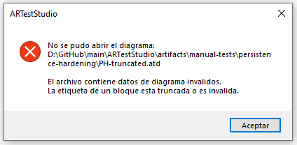 | Error dialog appears with the correct error description.
EV-TC-PH-004-02 | [2026-08-28T00:45:56.915] [WARNING] [STORAGE] [STORAGE_8] abrir | El archivo contiene datos de diagrama invalidos. | Detail: Ruta: D:\GitHub\main\ARTestStudio\artifacts\manual-tests\persistence-hardening\PH-truncated.atd | La etiqueta de un bloque esta truncada o es invalida. | Error info saved correctly on log file.
EV-TC-PH-004-03

TC-PH-005 - Clean a stale .tmp during a successful save
Prioridad | High
Tipo | Recovery / filesystem
Requisitos | PH-REQ-003, PH-REQ-004
Cobertura automatica | Yes - real Windows atomic writer

Objetivo
Verify deterministic cleanup of an abandoned temporary file before writing a new valid destination.

Precondiciones y datos
Temporary fixture | D:\GitHub\main\ARTestStudio\artifacts\manual-tests\persistence-hardening\PH-stale-temporary.atd.tmp
Expected content | The .tmp exists and contains STALE_TEMPORARY_CONTENT.
Destination | PH-stale-temporary.atd does not exist before execution.

Procedimiento de ejecucion
Paso | Accion exacta | Resultado esperado
1 | In File Explorer, confirm PH-stale-temporary.atd.tmp exists; capture its name and size. | The temporary file is 23 bytes and the final .atd is absent.
2 | In ARTestStudio press Ctrl+N and drag one Rectangle into the document. | A new diagram with one block is visible.
3 | Use File > Save As and save exactly as D:\GitHub\main\ARTestStudio\artifacts\manual-tests\persistence-hardening\PH-stale-temporary.atd. | Save completes without an error dialog.
4 | Refresh File Explorer. | PH-stale-temporary.atd exists and PH-stale-temporary.atd.tmp no longer exists.
5 | Close the document, press Ctrl+O and open PH-stale-temporary.atd. | The file opens and contains the saved Rectangle.

Registro de ejecucion
Estado | [ X] PASS [ ] FAIL [ ] BLOCKED [ ] NOT RUN
Ejecutor | Juan Antonio Roman
Fecha / hora | 28/08/2026 - 1:15
Resultado real
Defecto asociado | ID: ____________________ Severidad: ____________________

Evidencia
Evidencia ID | Archivo / captura | Descripcion y punto verificado
EV-TC-PH-005-01
EV-TC-PH-005-02
EV-TC-PH-005-03

TC-PH-006 - Preserve the previous document when replacement fails
Prioridad | Critical
Tipo | Recovery / destructive-failure prevention
Requisitos | PH-REQ-003, PH-REQ-006
Cobertura automatica | Yes - injected replacement failure and byte comparison

Objetivo
Prove that a failed destination replacement never corrupts or overwrites the last valid .atd.

Precondiciones y datos
Baseline file | D:\GitHub\main\ARTestStudio\artifacts\manual-tests\persistence-hardening\PH-lock-preservation.atd
Baseline content | Exactly two blocks and one connection; file is saved.
Lock helper | scripts\manual-tests\hold_file_lock.cmd

Procedimiento de ejecucion
Paso | Accion exacta | Resultado esperado
1 | Create the baseline diagram with exactly two blocks and one connection. Save it as PH-lock-preservation.atd. | The baseline saves and reopens successfully.
2 | In PowerShell record: Get-FileHash 'D:\GitHub\main\ARTestStudio\artifacts\manual-tests\persistence-hardening\PH-lock-preservation.atd' -Algorithm SHA256 | A SHA256 value is displayed; copy it to evidence.
3 | Run: scripts\manual-tests\hold_file_lock.cmd \"D:\GitHub\main\ARTestStudio\artifacts\manual-tests\persistence-hardening\PH-lock-preservation.atd\" | The helper reports Archivo bloqueado and waits for ENTER.
4 | Without closing the helper, add a third block in ARTestStudio and press Ctrl+S. | A replacement error appears; the dialog states that the previous content was preserved.
5 | Capture the error. Return to the helper window and press ENTER to release the lock. | The helper prints Bloqueo liberado.
6 | Close the modified document and choose No if prompted to save. Recompute SHA256. | The post-failure hash exactly matches the baseline hash.
7 | Open PH-lock-preservation.atd. | Only the original two blocks and one connection are present; no .tmp remains.
8 | Search ARTestStudio.log for STORAGE_13 and PH-lock-preservation.atd. | A ReplacementFailure warning records operation guardar.

Registro de ejecucion
Estado | [ X] PASS [ ] FAIL [ ] BLOCKED [ ] NOT RUN
Ejecutor | Juan Antonio Roman
Fecha / hora | 28/08/2026 – 1:20
Resultado real
Defecto asociado | ID: ____________________ Severidad: ____________________

Evidencia
Evidencia ID | Archivo / captura | Descripcion y punto verificado
EV-TC-PH-006-01 | 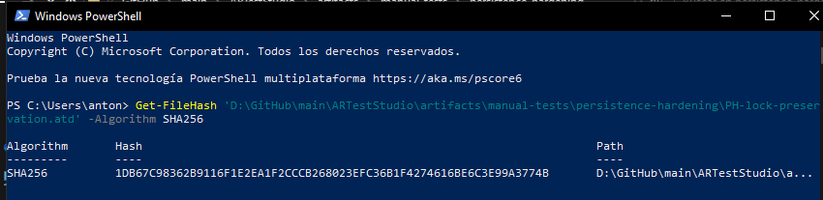  Hash SHA256: 1DB67C98362B9116F1E2EA1F2CCCB268023EFC36B1F4274616BE6C3E99A3774B | Generate successfully Hash SHA256 value
EV-TC-PH-006-02 | 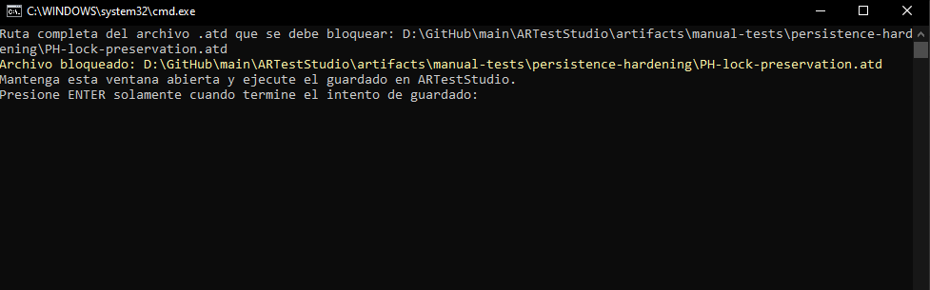 | Block successfully the .atd file with helper file.
EV-TC-PH-006-03 | 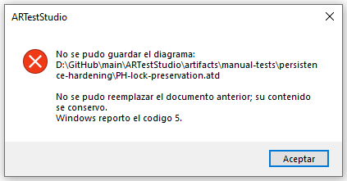 | Expected error dialog appears when try to save the changes on .atd file.
EV-TC-PH-006-04 | 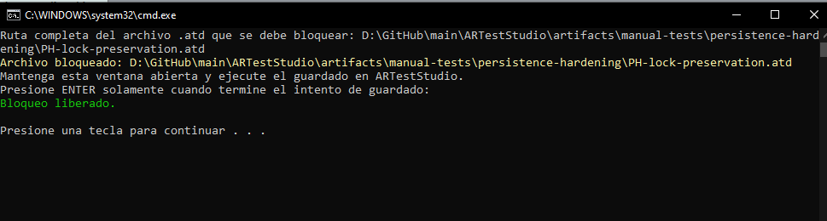 | Unlock the .atd file and close it without save the changes.
 | 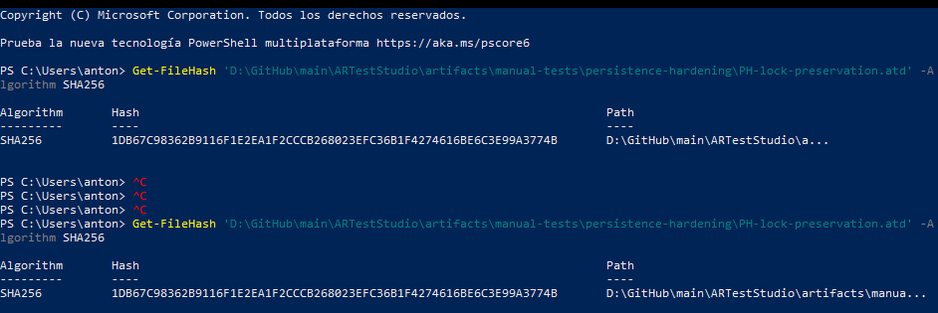  Hash SHA256:  1DB67C98362B9116F1E2EA1F2CCCB268023EFC36B1F4274616BE6C3E99A3774B | Re-generate Hash SHA256 value. Get expected value successfully. The same value of step 1.
 | [2026-08-28T01:17:12.553] [WARNING] [STORAGE] [STORAGE_13] guardar | No se pudo reemplazar el documento anterior; su contenido se conservo. | Detail: Ruta: D:\GitHub\main\ARTestStudio\artifacts\manual-tests\persistence-hardening\PH-lock-preservation.atd | Windows reporto el codigo 5. | Error description saved successfully on Log file with expected description.
Pagina reservada para las capturas del error de reemplazo, hashes SHA256 antes/despues y verificacion del diagrama conservado.

TC-PH-007 - Recover normal saving after a replacement failure
Prioridad | High
Tipo | Recovery / continuity
Requisitos | PH-REQ-003, PH-REQ-004, PH-REQ-006
Cobertura automatica | Partial - successful save after failure paths

Objetivo
Confirm that releasing the external lock is sufficient for the next save and that the application requires no restart or manual cleanup.

Precondiciones y datos
Previous case | TC-PH-006 completed and the file lock is released.
Open document | PH-lock-preservation.atd is open with its original two-block baseline.
Temporary state | PH-lock-preservation.atd.tmp does not exist.

Procedimiento de ejecucion
Paso | Accion exacta | Resultado esperado
1 | Add one third block to the reopened baseline. | The document is marked modified and shows three blocks.
2 | Press Ctrl+S. | Save completes without an error dialog and the modified flag clears.
3 | Close and reopen PH-lock-preservation.atd. | All three blocks are present.
4 | Refresh File Explorer and inspect the directory. | No PH-lock-preservation.atd.tmp file remains.
5 | Review ARTestStudio.log around the prior failure. | The earlier STORAGE_13 entry remains available; no new Storage warning corresponds to the successful save.

Registro de ejecucion
Estado | [X ] PASS [ ] FAIL [ ] BLOCKED [ ] NOT RUN
Ejecutor | Juan Antonio Roman
Fecha / hora | 28/08/2026 – 11:25
Resultado real
Defecto asociado | ID: ____________________ Severidad: ____________________

Evidencia
Evidencia ID | Archivo / captura | Descripcion y punto verificado
EV-TC-PH-007-01 | 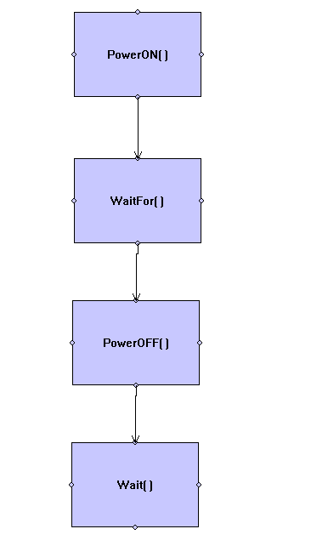 | Diagram before save.
EV-TC-PH-007-02 | 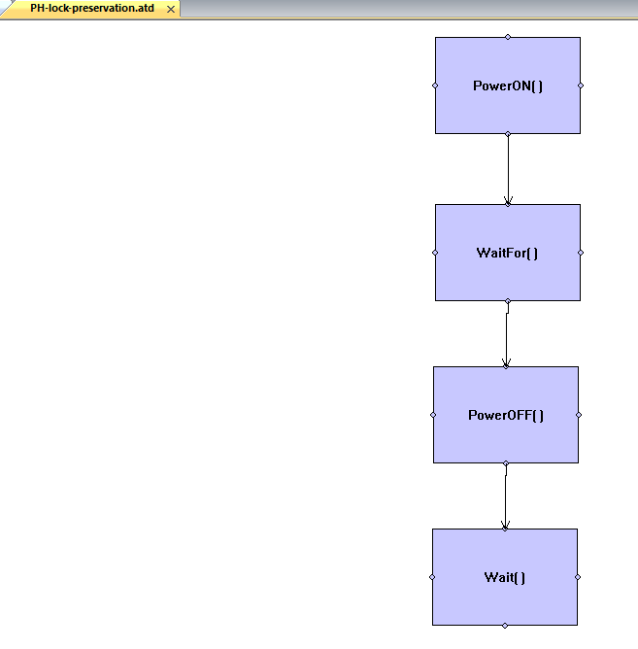 | Diagram after save.
EV-TC-PH-007-03

Final approval
Closure decision
Mark APPROVED only when TC-PH-001 through TC-PH-007 are PASS and all evidence references resolve.

Overall result | [ ] APPROVED [ ] REJECTED [ ] CONDITIONAL
Open defects | ____________________________________________________________
QA executor | Name: ____________________ Signature: ____________________
Technical reviewer | Name: ____________________ Signature: ____________________
Approval date | ____________________
Comments

