Esempi

Visitor Pattern
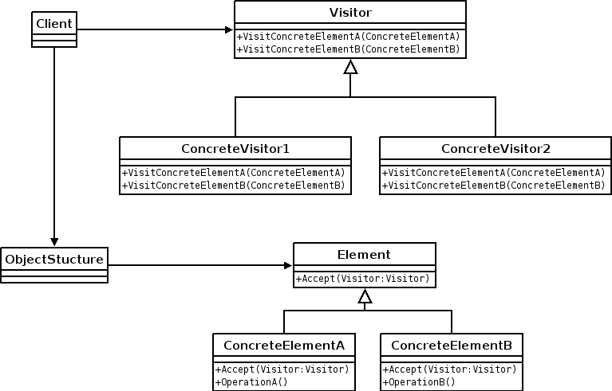
diagram uml "visitor pattern"{
class Client{
relations{
use Visitor,ObjectStructure
}
}
class Visitor{
public VisitConcreteElementA{
ConcreteElementA
}
public VisitConcreteElementB{
ConcreteElementB
}
}
class ConcreteVisitor1{
relations{
extend Visitor
}
public VisitConcreteElementA{
ConcreteElementA
}
public VisitConcreteElementB{
ConcreteElementB
}
}
class ConcreteVisitor2{
relations{
extend Visitor
}
public VisitConcreteElementA{
ConcreteElementA
}
public VisitConcreteElementB{
ConcreteElementB
}
}
class ObjectStructure{
relations{
use Element
}
}
class Element{
public Accept{
Visitor Visitor
}
}
class ConcreteElementA{
relations{
extend Element
}
public Accept{
Visitor Visitor
}
public OperationA{
}
}
class ConcreteElementB{
relations{
extend Element
}
public Accept{
Visitor Visitor
}
public OperationB{
}
}
}

Composite Pattern
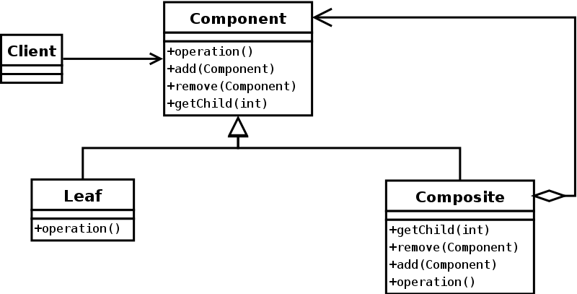
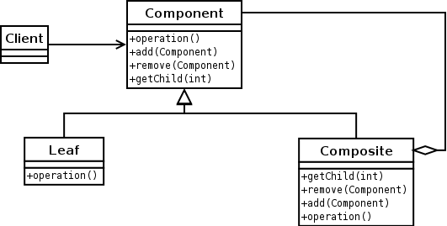

diagram uml “composite pattern” {
class Client{
relations{
use Component
}
}
interface Component{
public operation{
}
public add{
Component
}
public remove{
Component
}
public getChild{
int
}
}
class Leaf{
relations{
implement Component
}
public operation{
}
}
class Composite{
relations{
implement Component
}
public operation{
}
public add{
Component
}
public remove{
Component
}
public getChild{
int
}
}
}

Façade Pattern
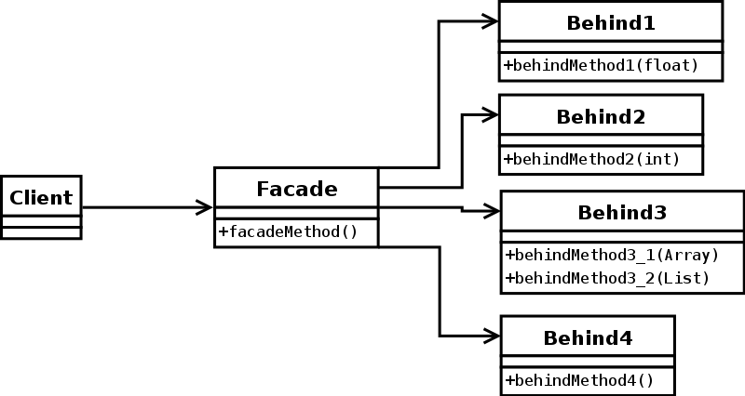

diagram uml “facade pattern”{
class Client{
relations{
use Facade
}
}
class Facade{
relations{
use Behind1, Behind2, Behind3, Behind4
}
public facadeMethod{
}
}
class Behind1{
public behindMethod1{
float
}
}
class Behind2{
public behindMethod2{
int
}
}
class Behind3{
public behindMethod3_1{
Array
}
public behindMethod3_2{
List
}
}
class Behind4{
public behindMethod1{
}
}
}

