9. Individual Writeup:

1. What is the critical path on your WBS? How long will it take to complete?

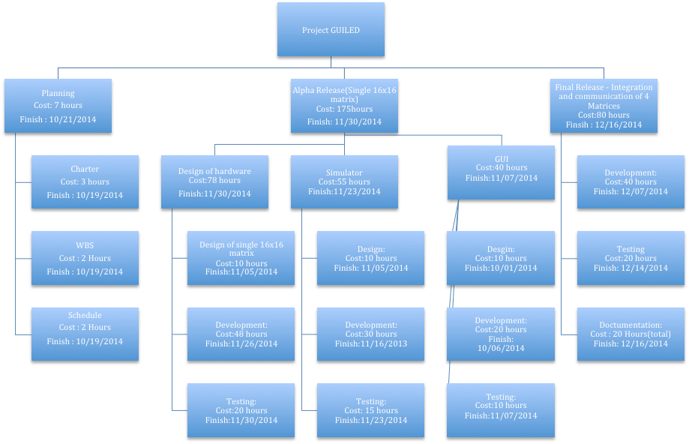

In the WBS, the hours is the total time spent by the entire team on each step. As we can see from the above WBS, the critical path is the design and implementation to get a single 16x16 LED matrix up and running. It will take close to 80 hours to finish it.

1. What are the amounts time you have allotted to:
   1. Design: 30 hours.
   2. Development (i.e. new stuff being written): 98 hours.
   3. Debugging: 65 hours
   4. Other tasks : 20 hours.
2. How have you designed your schedule adjust for unforeseen delays or early completions?
   1. We first analysed the scope of our proposed project, and designated certain deliverable as “stretch”. These are features we would like to have, but are not crucial or mandatory to the essence of the project. We will develop these added features as per time constraints.
3. When have you regularly scheduled to meet with your mentor?
   1. We have chose Antonio to be our mentor. We will be meeting him on: