Supplementary Materials for Manuscript
Antonios G Dougalis, 2026, Interpretable Electrophysiological Features of Resting-State EEG Capture Cortical Network Dynamics in Parkinson’s Disease, BiorXiv

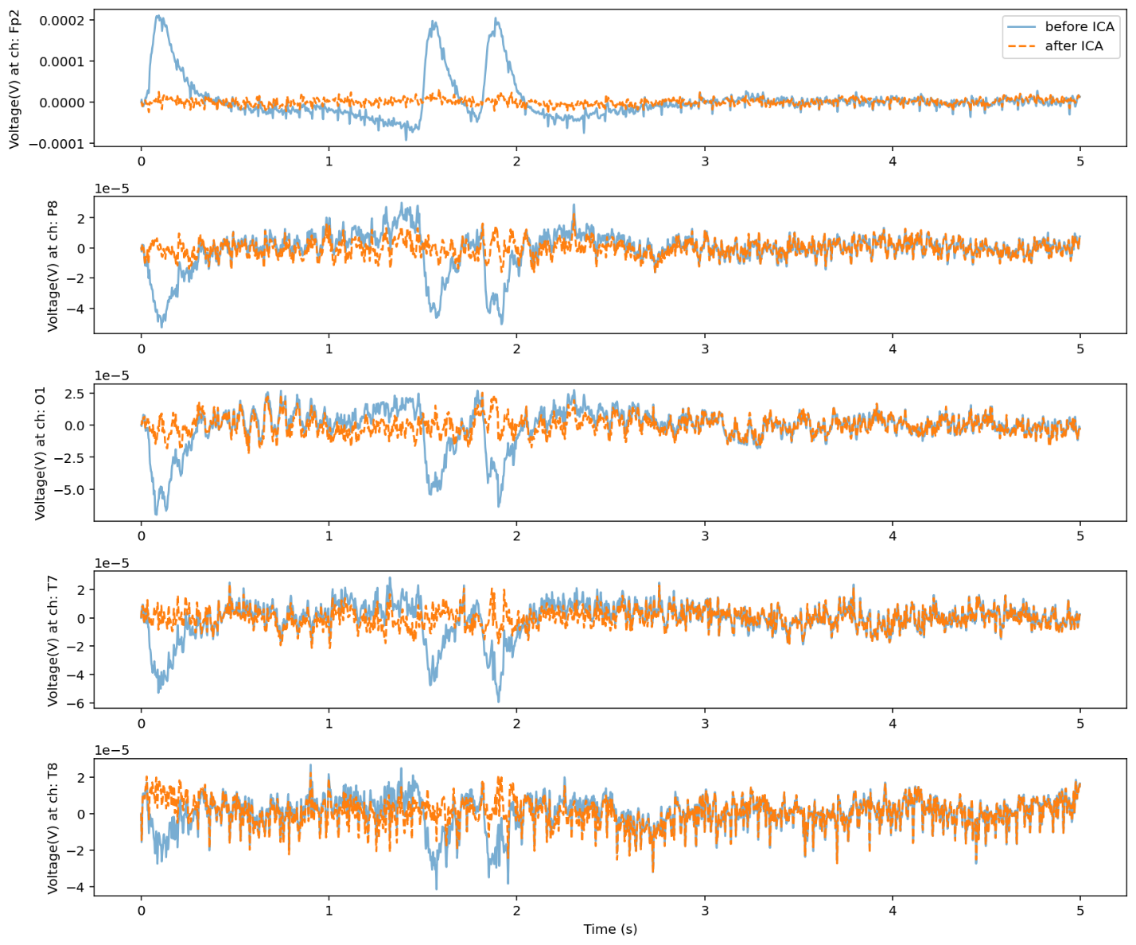
Supplementary Figure S1. Example of filtered EEG traces (1-45 Hz bandpass, blue) taken from five channels showing the resultant signal (orange) after artifact reduction via Independent Component Analysis (ICA) using a combined triple criterion based on percentile-based thresholds of the component projection power & kurtosis and on a fixed high frequency muscle spectral power ratio (25-45Hz over 1-15Hz) to unmix neuronal and muscular sources. The component projection and kurtosis thresholds were set at the 95th percentile and the muscle spectral ratio threshold at three.

Supplementary Figure S2. Topographical voltage maps (top, plotted time point at 0.5s) and z-scored voltage time series (bottom) from a representative electrode (P8) before (left) and after Laplacian(right) spatial filtering of EEG data according to the method of Perrin (Perrin et al., 1989) to remove any volume conduction artifacts before connectivity analysis.

 | Cliff’s delta or rank-biserial corr, CI[low, high], p-val FDR-corrected
Laplacian Corrected Connectivity Metric | CN vs PDoff | CN vs PDon | PDoff vs PDon
Delta PLV | -0.517 [-1.65, -0.42],  0.0357 | -0.575 [-2.01, -0.32],  0.0160 | -0.143 [-0.57, 0.59],  0.9250
Theta PLV | -0.692 [-2.7, -0.64],  0.0050 | -0.658 [-2.59, -0.68],  0.0090 | -0.429 [-0.23, 0.19],  0.9250
Alpha PLV | -0.217 [-1.1, 0.61],  0.3041 | -0.225 [-0.98, 0.61],  0.2859 | -0.143 [-0.29, 0.43],  0.9250
Beta PLV | -0.308 [-1.4, 0.33],  0.1795 | -0.3 [-1.33, 0.27],  0.1934 | -0.286 [-0.23, 0.27],  0.9250
Gamma PLV | -0.375 [-1.52, 0.22],  0.1255 | -0.408 [-1.62, 0.07],  0.0880 | 0.286 [-0.48, 0.47],  0.9250
Delta PLI | -0.233 [-1.18, 0.05],  0.6353 | -0.3 [-1.26, -0.07],  0.3867 | -0.429 [-0.31, 0.06],  0.7005
Theta PLI | -0.125 [-0.79, 0.42],  0.6353 | -0.192 [-0.9, 0.22],  0.6055 | -0.286 [-0.53, 0.17],  0.7210
Alpha PLI | 0.183 [-0.49, 1.17],  0.6353 | 0.108 [-0.33, 1.04],  0.6637 | 0.0 [-0.38, 0.39],  0.9750
Beta PLI | 0.408 [0.09, 1.37],  0.2640 | 0.358 [0.16, 1.27],  0.3867 | -0.286 [-0.52, 0.26],  0.7210
Gamma PLI | -0.1 [-1.05, 0.65],  0.6353 | -0.092 [-1.07, 0.66],  0.6637 | 0.143 [-0.48, 0.44],  0.9750
Delta wPLI | -0.358 [-1.39, -0.1],  0.2230 | -0.408 [-1.45, -0.19],  0.2640 | -0.286 [-0.25, 0.07],  0.7838
Theta wPLI | -0.192 [-0.85, 0.34],  0.4806 | -0.292 [-0.95, 0.13],  0.2775 | -0.286 [-0.49, 0.15],  0.7838
Alpha wPLI | 0.183 [-0.49, 1.2],  0.4806 | 0.1 [-0.34, 1.06],  0.6353 | 0.0 [-0.38, 0.38],  0.9250
Beta wPLI | 0.425 [0.07, 1.39],  0.2190 | 0.317 [0.12, 1.27],  0.2775 | -0.286 [-0.55, 0.31],  0.7838
Gamma wPLI | -0.125 [-1.11, 0.64],  0.5532 | -0.108 [-1.12, 0.64],  0.6353 | 0.143 [-0.46, 0.44],  0.9250

Supplementary Table 1. Comparative summary of group-level comparisons using Phase-based connectivity metrics after Laplacian transform of EEG data across diagnostic contrasts. Values represent Cliff’s delta or matched-pairs rank-biserial correlation (unpaired or paired respectively) with 95% confidence intervals and Wilcoxon (rank sum or signed rank sum) FDR-corrected p-values (Benjamini–Hochberg method). PLV, Phase Locking value; PLI, Phase Lag Index; wPLI, weighted Phase Lag Index; CN, Control; PDoff, Parkinson’s patient off medication; PDon, Parkinson’s patient on medication.

References
Perrin, F., Pernier, J., Bertrand, O., and Echallier, J. F. (1989). Spherical splines for scalp potential and current density mapping. Electroencephalogr Clin Neurophysiol 72, 184–187. doi: 10.1016/0013-4694(89)90180-6

