# Lab 2 report: Utilizing Linear Multivariate Regression for Grid Loss Prediction in a 5-Bus "Kite" Network

## Introduction

In the domain of power systems, accurately predicting grid losses is crucial for efficient energy management. Grid losses occur due to various factors including resistance in transmission lines, transformer inefficiencies, and other network-related losses. In this report, we focus on a 5-bus "kite" network and aim to discover a grid loss function using linear multivariate regression techniques.

Problem Description

Consider a grid comprising N buses where generators and loads are connected. The objective is to develop a grid loss function based on M per-bus power injection readings and the corresponding M total grid loss measurements. Despite the availability of analytical solutions, we opt to explore the effectiveness of linear multivariate regression in solving this problem.

## Methodology

Synthetic data for the 5-bus network is generated including per-bus power injection readings and total grid loss measurements. Noise data is also introduced to simulate real-world scenarios. Various linear regression models are trained using the generated data. Different combinations of features are considered to capture the relationship between per-bus power injections and total grid losses.

## Results

Looking at the results of the regression with the training data and no noise, we get a very small error rate of around 1e-5.

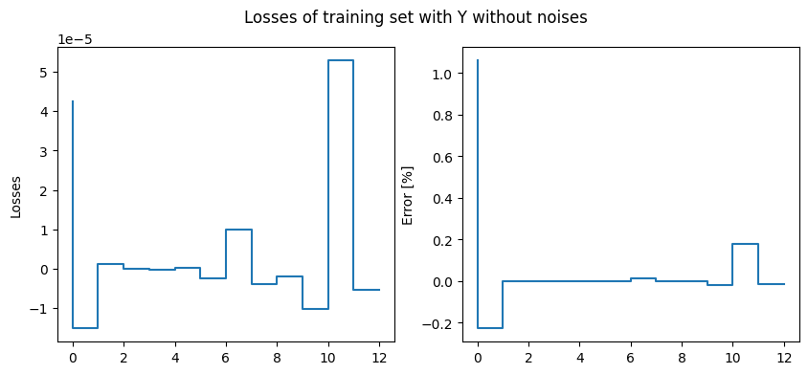

The test data can be replicated in this case, with an average error of 0.049.

This time we introduce gaussian noise ($$μ= 0 and σ =0.0025$$) to our Y test set. Figure below shows the losses between Y and our prediction.

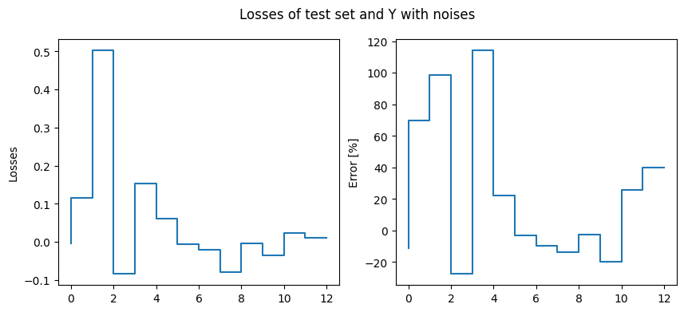

We also used the training set to implement different approaches to this problem. First, the matrix X considering the network structure. Second approach, we reduced dimensionality considering only the squared injections. And lastly, reducing the dimensionality of X by summing electrically close bus injections before using them as explanatory variables of losses. The figure below shows the actual Y with noise and the predictions of all approaches.

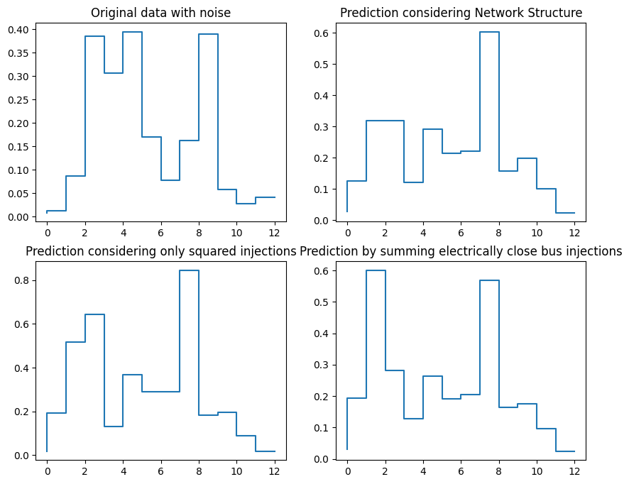

Conclusion

Results from the experiments conducted on the 5-bus kite network indicate the following:

* Linear regression models trained on clean data provide reasonable predictions of grid losses, with low error metrics.
* Models trained with noise data exhibit slightly higher errors compared to clean data models, highlighting the impact of noise on prediction accuracy.
* Feature selection plays a crucial role in model performance, with certain combinations of input features yielding better predictions than others.

## Discussion

In this report, we explored the use of linear multivariate regression for predicting grid losses in a 5-bus "kite" network. Our findings suggest that while linear regression models can provide reasonably accurate predictions, the inclusion of noise data and careful selection of input features are critical for improving model performance.