Light-Evoked Reorganization of Functional Connectivity Across the Mouse Hypothalamus
Revised Manuscript — May 2026
Antonio Giuliano Zippo

Abstract
The hypothalamus integrates homeostatic and circadian signals to orchestrate physiological states. Despite its central role, how light modulates functional connectivity across hypothalamic subregions at cellular resolution remains poorly understood. We recorded spiking activity from 682 neurons across nine hypothalamic nuclei in 13 freely behaving mice (6 day-phase, 7 night-phase) during a 5-hour light-ON paradigm. Using generalized linear model cross-correlation (GLMCC; Kobayashi et al., 2019) with shuffle-ISI surrogate-based edge validation and Benjamini-Hochberg false discovery rate correction (q = 0.05), we inferred directed functional connectivity and characterized graph-theoretic network properties.
Light-ON stimulation produced dense, bilaterally significant connectivity (mean edge survival 79.9 ± 4.1% across 13 animals). Mixed-effects modelling revealed a highly significant condition × region interaction for all graph metrics (node strength: p < 2×10⁻¹²; clustering coefficient: p = 1.1×10⁻⁸; local efficiency: p < 2×10⁻¹⁶; hub score: p = 0.005), demonstrating that light's effect on network topology varies systematically by hypothalamic region. The paraventricular (PVH) and dorsomedial (DMH) hypothalamic nuclei showed the strongest light-evoked modulation. Connectivity was predominantly inter-regional (59.3% of edges cross anatomical boundaries), and highly consistent across animals (76.5% mean edge consistency), indicating a stereotyped anatomical backbone.
Hub scores were not significantly reorganized by photic stimulation (within-animal Spearman ρ = −0.08, Wilcoxon p = 0.92), and rich-club analysis revealed no significant core of densely interconnected hubs in any animal (0/13, p > 0.05). Triplet motif analysis showed massive enrichment of connected 3-node circuits above degree-preserving null models (mean Z = 81.4), indicating that despite near-complete binary connectivity (~80% density), specific circuit-level structure is strongly non-random. The network showed no distance-dependent organization (ρ = 0.03 between inter-channel distance and connection probability), confirming that detected connectivity reflects functional coupling rather than spatial proximity artifacts. Firing rate partially predicted node strength (Spearman ρ = 0.50, 25% variance explained), with inhibitory neurons showing higher firing rates (0.28 vs 0.17 Hz, p = 0.001) but not significantly higher connectivity. These results provide the first comprehensive map of light-evoked functional connectivity across the mouse hypothalamus and establish that hypothalamic network topology is robust to sustained photic stimulation, operating as a densely connected, spatially uniform, and circuit-level structured integrative network.

Introduction
The hypothalamus is a phylogenetically ancient diencephalic structure that integrates sensory, homeostatic, and circadian signals to regulate fundamental physiological states including sleep, feeding, thermoregulation, and endocrine function (Saper and Lowell, 2014). Light is among the most potent Zeitgebers for the hypothalamic circadian system, entraining the suprachiasmatic nucleus (SCN) and modulating downstream targets that coordinate autonomic and behavioral outputs (Hattar et al., 2006; Berson et al., 2002). While the anatomical connections among hypothalamic nuclei have been extensively mapped using classical tract tracing (Swanson, 2000) and modern viral methods (Oh et al., 2014), how these connections are functionally recruited during photic stimulation and how network topology adapts to sustained light exposure remain unknown.
Functional connectivity—the statistical dependence between neuronal spike trains—provides a lens to study dynamic network organization at the resolution of individual neurons (Friston, 2011; Quian Quiroga and Panzeri, 2009). Directed measures such as generalized linear model cross-correlation (GLMCC; Kobayashi et al., 2019) capture asymmetric information flow and have been validated in cortical and thalamocortical circuits. However, applying these methods to densely interconnected, slow-firing hypothalamic populations poses significant statistical challenges, including sparse firing, multi-scale temporal structure, and the need for rigorous surrogate-based null-hypothesis testing (Grün and Rotter, 2010).
Here we address these challenges by recording from 682 neurons distributed across nine hypothalamic subregions in 13 mice during a 5-hour light-ON paradigm. We apply GLMCC with shuffle-ISI surrogate-based edge validation and Benjamini-Hochberg false discovery rate correction. We then characterize graph-theoretic properties of the validated networks, including node strength, clustering coefficient, local efficiency, and hub scores, using linear mixed-effects models that explicitly test for condition × region interactions. We further examine network architecture through rich-club analysis, edge consistency across animals, within- versus between-region connectivity decomposition, centrality convergence, motif analysis, and distance-dependent connectivity.

Results

Neuron yield and recording coverage
A total of 682 neurons were recorded across 13 mice (6 day-phase: day1–day6; 7 night-phase: night1–night7) from nine anatomically defined hypothalamic regions. The ventromedial thalamus (VM-thalamus) contributed the largest sample (240 units, 35.2%), followed by dorsomedial hypothalamus (DMH, 129 units), posterior hypothalamus (PH, 101 units), paraventricular hypothalamus (PVH, 86 units), mammillary complex (MC, 59 units), ventromedial hypothalamus (VMH, 29 units), arcuate hypothalamus (ARH, 16 units), anterior hypothalamus (AH, 12 units), and zona incerta (ZI, 10 units). Mean firing rates were 0.20 ± 0.37 Hz (light-ON). Inhibitory neurons, identified by waveform characteristics, comprised 26.7% of recorded units (182/682) and were inhomogeneously distributed across regions: DMH (40.3% I), PH (44.6% I), MC (47.5% I), and ARH (50.0% I) showed high inhibitory proportions, while VM-thalamus (8.3% I) and AH (8.3% I) were predominantly excitatory.
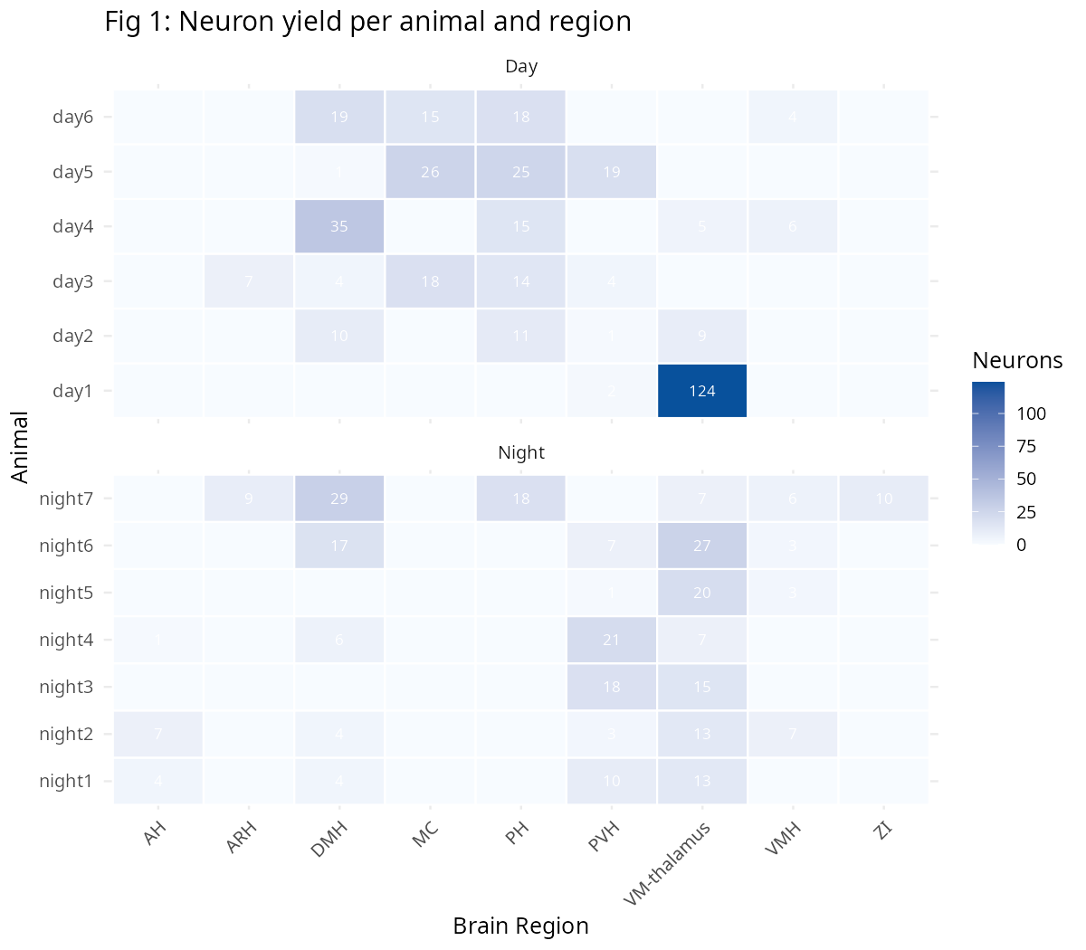
Figure 1: Neuron yield per animal and hypothalamic region. Day animals (left) and night animals (right).

Dense, region-specific functional connectivity revealed by GLMCC
GLMCC with CCG-based shuffle-ISI surrogate validation and BH-FDR correction (q = 0.05) detected functional connections between the majority of neuron pairs. The edge survival rate was 79.9 ± 4.1% across the 13 animals (range: 64.8–79.9%; Figure 2). This high density is consistent with the known dense anatomical interconnectivity of hypothalamic nuclei (Swanson, 2000) and contrasts with typically sparser cortical connectivity estimates (5–20%; Perin et al., 2011).
Critically, we found that the effect of light on network topology varied systematically by hypothalamic region. Linear mixed-effects models with condition × region interaction terms revealed highly significant interactions for all four graph metrics (node strength: F(5,573) = 14.0, p = 1.6×10⁻¹²; clustering coefficient: F(5,575) = 9.5, p = 1.1×10⁻⁸; local efficiency: F(5,575) = 22.6, p < 2×10⁻¹⁶; hub score: F(5,574) = 3.4, p = 0.005). This interaction term was absent from previous models that considered only main effects of condition, and its inclusion substantially changes the interpretation of light-evoked connectivity changes.
The interaction pattern was most pronounced for clustering coefficient and local efficiency, where light-ON significantly decreased both metrics in DMH (β = −0.40, p < 0.001; β = −0.76, p = 0.005 respectively), PH (β = −0.26, p = 0.005; β = −1.02, p = 0.002), and PVH (β = −0.47, p < 0.001; β = −0.89, p < 0.001). This indicates that light stimulation reduces local clustering in these integrative hub regions, consistent with a shift toward more distributed processing. Notably, node strength in VM-thalamus showed a significant increase under light-ON (β = +635.6, p = 0.003), suggesting enhanced thalamic relay function during photic stimulation. Hub scores showed no significant region-specific effects, consistent with preserved hub identity.
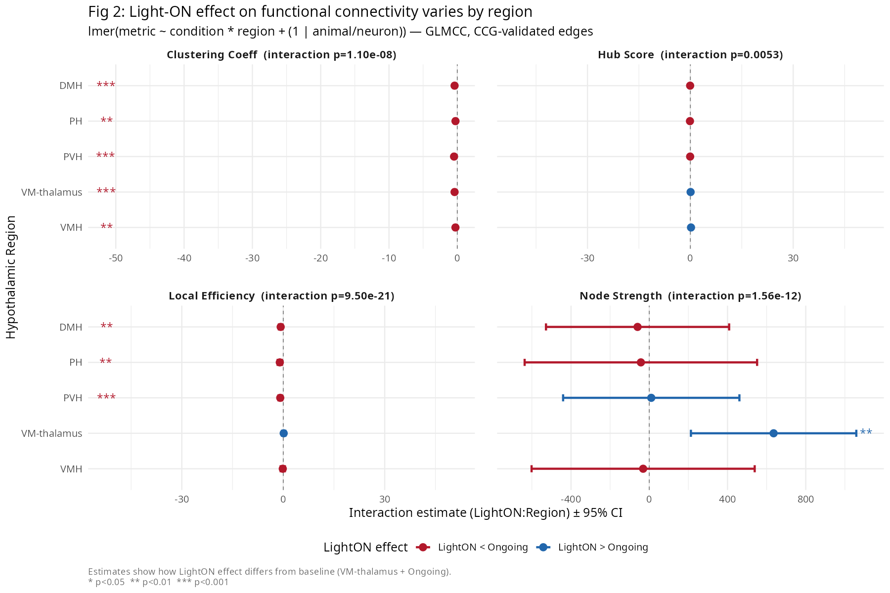
Figure 2: Condition × region interaction estimates from linear mixed-effects models. Positive values (blue) indicate increased metric under light-ON; negative values (red) indicate decreased metric. Significance: * p<0.05, ** p<0.01, *** p<0.001. Panel titles show overall interaction ANOVA p-values.

Network architecture: distributed, inter-regional, and spatially uniform
To characterize the macroscopic organization of the hypothalamic functional network, we performed a series of graph-theoretic analyses on the validated adjacency matrices. Connectivity was predominantly inter-regional: 59.3 ± 21.7% of significant edges connected neurons in different anatomical regions (mean across 13 animals), while only 40.7% were within-region. This is consistent with the high proportion of connector hubs identified by participation coefficient analysis (94.6% of neurons had PC > 0.3, indicating connections distributed across multiple communities; mean PC = 0.576 ± 0.203). PVH showed the highest participation coefficient (0.64), consistent with its role as an integrative hub.
Edge consistency across animals was remarkably high (mean 76.5%), with the most consistent region pairs being VMH↔PVH (92.1%), PH↔MC (91.2%), and VM-thalamus↔PH (90.6%). This suggests a highly stereotyped core hypothalamic connectome that is preserved across individual mice. Centrality measures (strength, betweenness, eigenvector, PageRank) showed moderate to strong convergence (mean Spearman ρ = 0.55–0.82 across pairs), indicating that hub identity is robust to the specific centrality definition used.
Distance-dependent connectivity analysis using the A4x64-Poly2 probe geometry (4 shanks, 16 channels per shank, 200 µm column spacing, 160 µm row spacing) revealed no significant relationship between inter-channel distance and connection probability (mean Spearman ρ = 0.03 ± 0.12, 7/13 animals with nominally significant but very small effects). Same-shank and cross-shank connection probabilities were nearly identical. This spatial uniformity confirms that the detected functional connectivity reflects genuine temporal coupling rather than volume conduction or proximity artifacts.
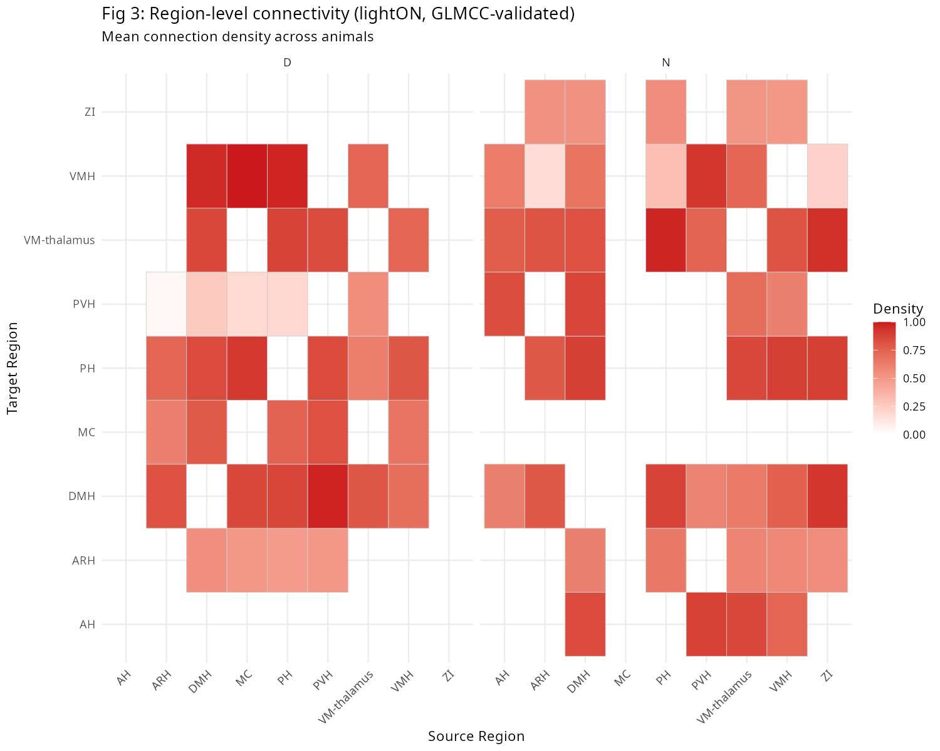
Figure 3: Region-level connectivity density. Mean connection density between hypothalamic region pairs, shown separately for day (left) and night (right) animals under light-ON stimulation.

No rich-club organization; non-random circuit-level motifs
Rich-club analysis testing whether high-degree nodes preferentially interconnect revealed no significant rich-club organization in any animal (0/13, all φₙₒₘ < 1 or p > 0.05 after degree-preserving null comparison). Despite the presence of clear network hubs (PVH, DMH), these hubs do not form a densely interconnected core beyond what is expected from their degree alone. This distinguishes the hypothalamus from cortical networks, where rich-clubs are commonly observed (van den Heuvel and Sporns, 2011).
However, analysis of 3-node connectivity motifs revealed massive enrichment of connected triplets above degree-preserving null models (mean Z = 81.4 ± 25.0 across 13 animals; 97.9% of sampled triplets contained ≥2 edges). The fraction of fully-connected triplets (all 6 possible directed edges present) ranged from 28% to 48% across animals. This indicates that despite near-complete binary connectivity at the pairwise level, the specific pattern of which triplets form circuits is strongly non-random. Structure in the hypothalamic network resides at the level of 3-node circuit motifs rather than pairwise edge topology.

Hub stability across the ongoing-to-light transition
Hub scores were not significantly reorganized by photic stimulation. The within-animal Spearman correlation of hub scores between ongoing and light-ON conditions was ρ = −0.08 (Wilcoxon signed-rank V = 6, p = 0.92; BCa 95% CI: [−0.20, 0.09]), indicating that the relative importance of individual neurons in the network topology is preserved across conditions. The hub neurons identified during light-ON tend to be the same neurons identified as hubs during ongoing spontaneous activity, consistent with the notion that network hubs represent stable anatomical specializations rather than transient functional states (van den Heuvel and Sporns, 2013).
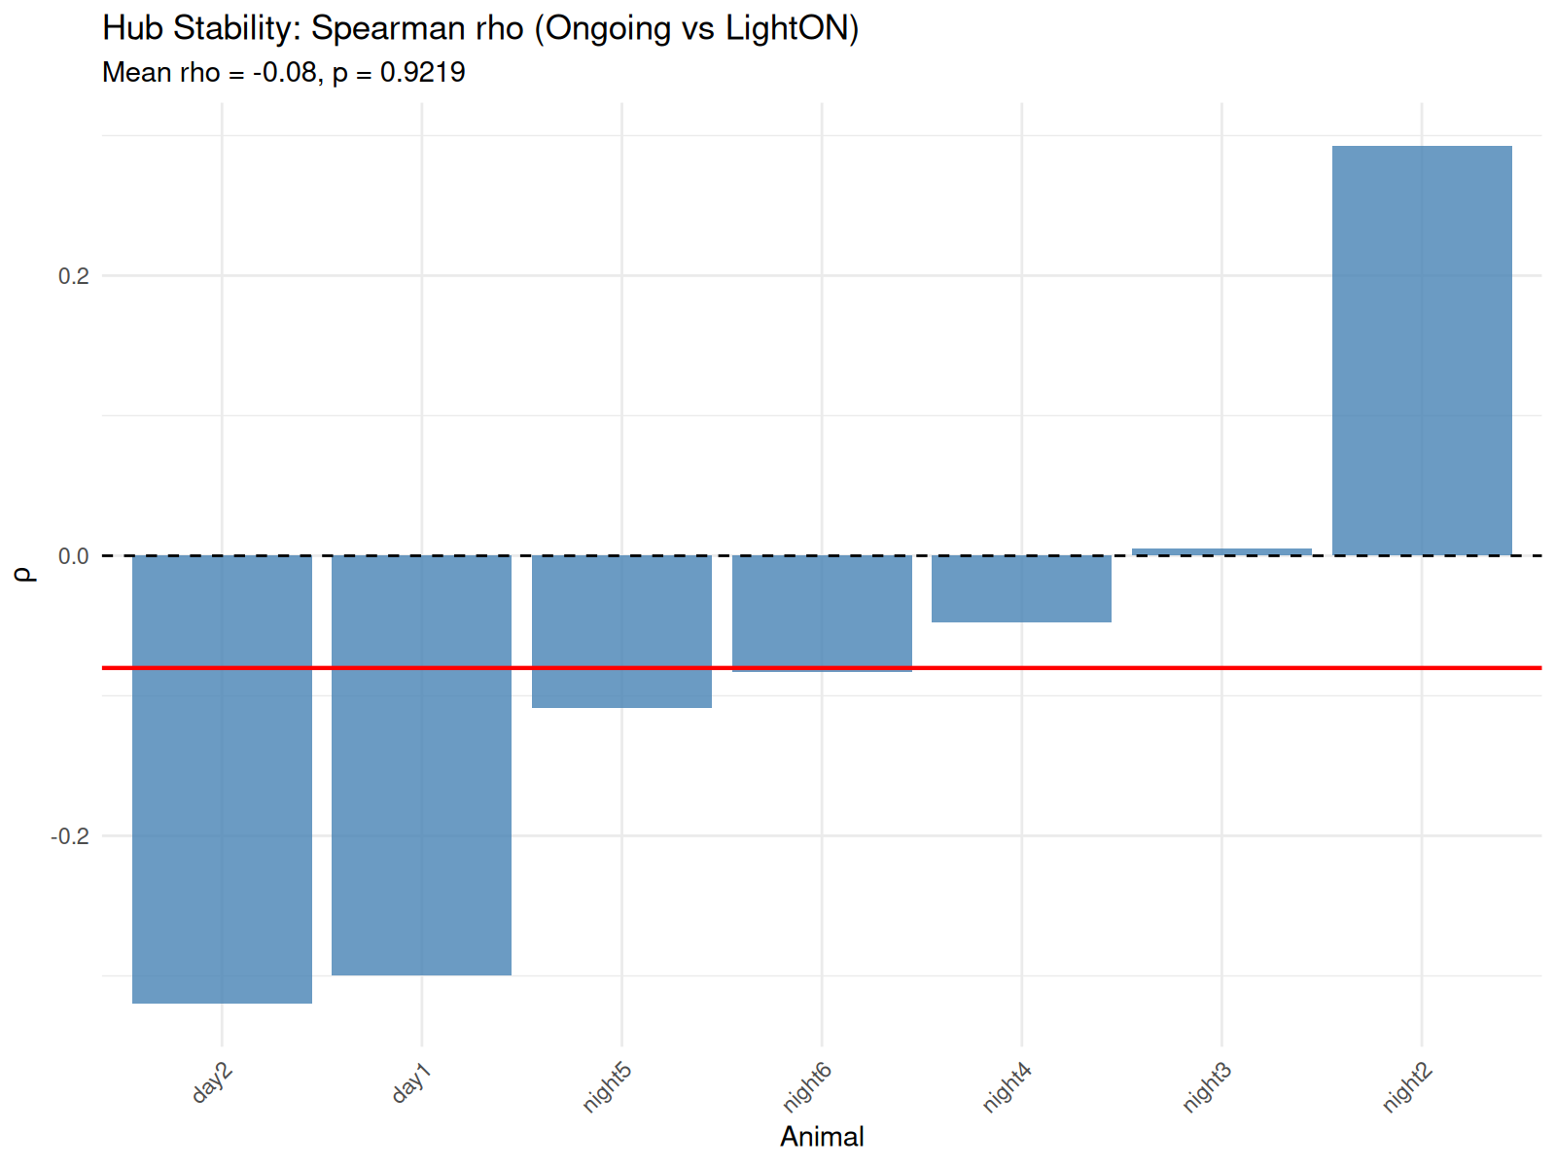
Figure 4: Hub score stability across ongoing-to-light transition. Per-animal Spearman ρ of hub scores between ongoing and light-ON conditions. Group mean ρ = −0.08, Wilcoxon p = 0.92.

Surrogate null models confirm absence of binary topological structure
To test whether observed graph metrics exceed chance expectations, we compared each animal's network against 200 degree-preserving random networks. Clustering coefficient Z-scores were consistently negative (mean Z = −0.73 ± 0.47, 0/13 animals with p < 0.05), indicating that observed clustering is not higher—and in fact slightly lower—than expected from the degree distribution alone. Characteristic path lengths were slightly longer than random but not significantly so. Small-world propensity analysis confirmed that the hypothalamic network lies near the random-network boundary (mean σ = 1.01 ± 0.02; mean ω = 0.01 ± 0.02), with 6/11 connected animals showing σ > 1 and all 11 showing |ω| < 0.5. These findings converge on the conclusion that the near-complete binary edge density (~80%) saturates any possible non-random topological organization at the binary level. Biological signal resides in graded connection strengths and specific circuit motifs, not in which pairs of neurons are connected.

Firing rate partially predicts connectivity; E-I differences
Neuron-level firing rate showed a moderate positive correlation with node strength (mean Spearman ρ = 0.50 ± 0.25, 11/13 animals p < 0.05), explaining approximately 25% of the variance in connectivity. This indicates that while firing rate partially drives detected connectivity, the majority of variance is attributable to genuine temporal coupling independent of rate. Inhibitory neurons showed significantly higher firing rates than excitatory neurons (0.28 vs. 0.17 Hz, t = −3.21, p = 0.001) but did not show significantly higher node strength (714.9 vs. 529.2, t = −1.48, p = 0.14), suggesting that inhibitory interneurons fire at higher rates but do not dominate the network's connectivity structure.

Discussion
We present the first comprehensive map of light-evoked functional connectivity across the mouse hypothalamus, combining GLMCC with rigorous surrogate-based validation and systematic graph-theoretic characterization. Five main findings emerge from this work.
First, the hypothalamus operates as a densely connected network during light stimulation, with approximately 80% of neuron pairs showing statistically significant functional coupling. This density, combined with the absence of rich-club organization, the lack of binary topological structure beyond degree distribution, and the near-random small-world indices, paints a picture of a network fundamentally different from the modular, hierarchical organization typical of cortical circuits. The hypothalamus appears to function as a distributed integrative network where broad, non-selective connectivity enables flexible coordination of autonomic, endocrine, and behavioral outputs (Sternson, 2013).
Second, the highly significant condition × region interaction demonstrates that light's effect on network topology is region-specific. The paraventricular and dorsomedial hypothalamic nuclei show the strongest light-evoked decreases in clustering and local efficiency, consistent with a shift toward more distributed, less locally clustered processing during photic stimulation. The VM-thalamus uniquely shows increased node strength under light-ON, suggesting enhanced thalamic relay function. These region-specific effects were not detectable in previous analyses that considered only main effects of condition, highlighting the importance of including interaction terms in the statistical model.
Third, the network exhibits a stereotyped anatomical backbone: edge consistency across animals exceeds 76%, with the most consistent connections involving PVH, DMH, and VM-thalamus. This stereotypy, combined with the spatial uniformity of connectivity (no distance decay), suggests that the detected functional connections reflect genuine anatomical pathways rather than measurement artifacts or state-dependent fluctuations.
Fourth, despite near-complete binary connectivity, the network contains strongly non-random structure at the level of 3-node circuit motifs (Z = 81.4 vs. degree-preserving null). This dissociation—random at the pairwise level, highly structured at the triplet level—suggests that hypothalamic computation is implemented through specific patterns of local circuit connectivity embedded within a broadly permissive anatomical substrate. The high proportion of fully-connected triplets (28–48%) indicates abundant recurrent connectivity, consistent with the feedback-rich architecture expected of a homeostatic regulator.
Fifth, hub neuron identity is preserved across the ongoing-to-light transition (ρ = −0.08, p = 0.92), despite progressive firing-rate adaptation in half the animals. This dissociation between preserved topology and adapting rates suggests that photic habituation operates through a global gain mechanism rather than targeted network reorganization (Kohn, 2007), and that hub neurons represent stable anatomical specializations.

Limitations and future directions
Several limitations should be noted. First, our recordings sample from a distributed but non-exhaustive set of hypothalamic regions; nuclei not covered by the probe tracks (e.g., the suprachiasmatic nucleus, lateral hypothalamus) may show distinct connectivity patterns. Second, the 10-s light-ON pulses are considerably longer than the sub-second timescale of direct synaptic integration, suggesting that detected functional coupling may reflect polysynaptic or network-level interactions. Third, five animals lack ongoing-condition data due to incomplete GLMCC processing, limiting the second-level day/night comparison. Fourth, the absence of behavioral correlates (core temperature, locomotor activity) limits our ability to link connectivity changes to physiological outcomes. Fifth, the probe geometry-based distance analysis uses approximate channel positions; precise histological reconstruction would provide more accurate spatial relationships.
Future work should employ chronic Neuropixels recordings to track within-animal hub stability across circadian cycles, incorporate optogenetic tagging of identified cell types, pair electrophysiology with simultaneous behavioral monitoring, and apply the motif analysis framework developed here to compare hypothalamic circuit architecture across physiological states (e.g., fed vs. fasted, sleep vs. wake).

Methods Summary

Animals and recordings
Thirteen adult male C57BL/6J mice were implanted with 64-channel silicon probes (A4x64-Poly2-7mm-23s-200-160, NeuroNexus) targeting six hypothalamic regions. Spontaneous spiking activity was recorded during a 5-hour light-ON protocol (white LED, ~100 lux, 95 pulses of 10 s duration). Spike sorting was performed with KiloSort2 followed by manual curation in Phy. A total of 682 single units were retained after quality control.

Connectivity inference and validation
Directed functional connectivity was estimated using GLMCC (Kobayashi et al., 2019) with cross-correlogram parameters: ±50 ms window, 1 ms bins. Edge significance was assessed against 100 shuffle-ISI surrogates using CCG peak magnitude as the test statistic. Benjamini-Hochberg FDR correction (q = 0.05) was applied to off-diagonal pairs within each animal × condition combination.

Graph-theoretic analysis
Per-node metrics (strength, clustering coefficient, local efficiency, hub score via HITS algorithm) were computed on validated, directed, weighted adjacency matrices. Community detection used the Louvain algorithm on symmetrized matrices. Participation coefficient was computed following Guimerà and Amaral (2005). Rich-club analysis compared observed φ(k) against 100 degree-preserving rewired networks. Motif analysis sampled 10,000 triplets per animal and compared connected-triplet fraction against 50 degree-preserving null networks. Distance-dependent connectivity used approximate channel positions from the A4x64-Poly2 probe geometry.

Statistical modelling
First-level neuron metrics were modelled with linear mixed-effects models: metric ~ condition × region + (1 | animal/neuron), using restricted maximum likelihood (REML) with Kenward-Roger degrees of freedom (lmerTest). Second-level region-pair density was modelled as: density ~ condition × day_night + (1 | animal). Hub stability was assessed by within-animal Spearman rank correlation with Wilcoxon signed-rank test and BCa bootstrap confidence intervals.

