**Ntuaflix**

**Software Requirements Specification**

Version 1.0

# Revision History

|  |  |  |  |
| --- | --- | --- | --- |
| **Date** | **Version** | **Description** | **Authors** |
| **<16/12/2023>** | 1.0 | Final Composition of SRS Document | Antonios Alexiadis  Nikolaos Bothos  Chrisostomos Kopitas  Charidimos Papadakis |

# Table of Contents

Revision History 2

Table of Contents 2

Introduction 4

Purpose 5

Scope 5

Definition, Acronyms and Abbreviations 5

Acronyms 5

References 6

Overall Description 6

Problem Statement 6

Background 7

Objectives 8

Constraints 8

Functional Requirements 9

Use Cases 10

Use Case Diagram 10

Requirements 12

Requirement Diagram 12

User Requirements 14

Technical Requirements 15

Performance 15

Scalability 15

Security 15

Maintainability 15

Usability 15

Localization Support 15

Auditing and Logging 16

Availability 16

Hardware Requirements 16

Network 16

Client Computers 16

Deployment Requirements 17

Deployment Diagram 17

Nodes 18

Component Diagram 19

Components 20

# Introduction

This SRS document is structured to provide a clear and organized presentation of all system requirements. It is divided into the following main sections:

* **Overall Description**: This section provides a general overview of the software, including its functionality, user demographics, and the problem it aims to solve.
* **System Features**: A detailed description of each system feature, its utility, and how it interacts within the broader system architecture.
* **Use Cases**: Narrative and diagrammatic representations of user interactions with the system, detailing the main success scenarios and possible extensions.
* Requirements:
  1. **Functional Requirements:** Specific functionalities that the software must perform, derived from the use cases and additional stakeholder input.
  2. **Non-Functional Requirements:** The standards, performance metrics, and quality attributes that the system must adhere to and any additional constraints or compliance requirements, including regulatory and data privacy considerations.
  3. **User Requirements:** What end-users expect from the system. The needs, goals, and tasks of the user, including accessibility, user interface preferences, and specific functionalities users want to perform with the system.
  4. **Technical Requirements:** The requirements that collectively ensure the system is performant, secure, maintainable, usable, and able to operate in the designated environments while meeting all regulatory and compliance needs.
  5. **Hardware Requirements:** The physical components necessary to support the operation of the system. This includes the servers that host the system, network infrastructure for connectivity, and client devices like computers and smartphones that access the system.
  6. **Deployment Requirements:** The conditions necessary to successfully deploy the software in a live environment.

The main focuses of this document are to:

* Provide clear and precise descriptions of the functional behavior of the system.
* Outline the performance and quality standards the system must meet.
* Serve as a reference to ensure mutual understanding between the stakeholders and the development team.
* Act as a foundational agreement that specific system functionalities are designed, developed, and tested appropriately.

## Purpose

The purpose of this Software Requirements Specification (SRS) document is to provide a detailed outline of the functional and non-functional requirements for the development of a film information repository and recommendation platform, herein referred to as “Ntuaflix". This document is intended to be a comprehensive guide for the stakeholders involved in the design, development, testing, and maintenance of Ntuaflix.

## Scope

Ntuaflix will serve as an interactive platform that aggregates and presents metadata about films and television series. It is designed to cater to cinephiles and industry professionals who seek detailed information, such as synopses, cast and crew lists, genre classifications, ratings, reviews, and personalized recommendations. This platform is designed not to host film content directly, but rather to offer extensive metadata and personalized recommendations that enhance users' exploration and discovery of cinema. Its focus is on enriching the cinematic experience through detailed information and tailored suggestions.

## Definition, Acronyms and Abbreviations

This section provides definitions, acronyms, and abbreviations for terms used throughout this SRS to ensure clarity and prevent misunderstandings.

|  |  |
| --- | --- |
| **Term** | Definition |
| **Film Information Repository** | A system that aggregates and presents detailed metadata about movies and television series without hosting or streaming the actual media content. |
| **Metadata** | Data that provides information about other data. In the context of this system, it refers to details such as film titles, release dates, cast and crew information, synopses, ratings, and reviews. |
| **Recommendation Engine** | A component of the system that analyzes user data and metadata to suggest films and TV series to users. |
| **API(Application Programming Interface)** | A set of protocols and tools for building software applications, which in this context, allows for interaction with the Ntuaflix platform by third-party developers or applications. |

## Acronyms

**SRS:** Software Requirements Specification

**UI:** User Interface

**UX:** User Experience

**DB:** Database

**GDPR:** General Data Protection Regulation

**SEO:** Search Engine Optimization

**API:** Application Programming Interface

## References

The following reference materials were utilized to guide the development of this Software Requirements Specification:

* **IEEE Guide to Software Requirements Specifications (IEEE 29148:2011):** A guideline that establishes a set of best practices for writing software requirements specifications.
* **ISO/IEC 25010:2011 Systems and software engineering — Systems and software Quality Requirements and Evaluation (SQuaRE) — System and software quality models:** An international standard defining the quality attributes required for software design and testing.
* **General Data Protection Regulation (GDPR):** The regulation in EU law on data protection and privacy in the European Union and the European Economic Area.

# Overall Description

## Problem Statement

The vast and ever-growing cinematic landscape presents a paradox of choice for film enthusiasts: an abundance of options that leads to overwhelm rather than empowerment. Current market solutions face significant challenges that hinder effective interaction with film content:

**1. Limited Personalization**: Existing platforms lack sophisticated personalization options, leading to generic and often irrelevant recommendations. Users struggle to navigate through the noise to find content that aligns with their tastes and preferences.

**2. Inadequate Search Capabilities**: The current systems offer basic search functionalities that do not cater to the nuanced needs of cinephiles who wish to search using a combination of attributes such as genre, release year, cast, and ratings.

**3. Content Discovery:** Users seeking to explore new content based on specific contributors (actors, directors, etc.) find it challenging due to the lack of intuitive linkages and exploration tools.

Ntuaflix aims to address these issues by developing a robust, intuitive, and comprehensive Film Information Repository. The platform is designed to enhance the ability of users to discover and explore movie content, fostering a more informed and connected film community.

## Background

The current challenges in the cinematic landscape, as outlined in the Problem Statement, are largely attributable to a combination of rapid technological advancements, evolving user behaviors, and a dynamic entertainment industry.

**Technological Constraints**: Existing platforms were often developed during a time when the digital landscape was less complex. As technology has advanced, these systems have struggled to adapt to the high volume and diversity of content, leading to limitations in personalization and search capabilities. Moreover, the infrastructures of these systems were not originally designed to handle the massive, concurrent user loads we see today, contributing to performance issues.

**User Behavior Trends:** Modern users seek high levels of personalization in their online experiences. Legacy platforms were not built with these expectations, leading to a gap between user expectations and platform capabilities, particularly in personalized content discovery.

**Industry Evolution:** The film industry itself has undergone significant changes. There has been a proliferation of independent films and a surge in the number of streaming platforms, each hosting their exclusive content. This expansion has made the discovery process more fragmented and complex for users who are fans of specific actors or filmmakers but are confronted with inadequate tools to track their careers across different platforms.

**Business Environment Changes:** With the rise of mobile computing and increased internet accessibility, users are consuming content in fundamentally different ways than they did even a decade ago. The business environment has had to adapt rapidly, often outpacing the ability of existing platforms to keep up. This has led to a disjointed experience where users might have to use multiple services to fulfill all their movie-related needs.

Ntuaflix recognizes these issues and aims to address them by leveraging the latest technological developments to build a system that can scale efficiently, offer advanced personalization and search features, foster a vibrant community, and provide intuitive content discovery tools. By doing so, Ntuaflix will enable a seamless, enriched film exploration experience for a diverse, global user base.

## Objectives

Ntuaflix is committed to transforming the way users interact with film metadata by creating an advanced Film Information Repository. The system will achieve the following objectives:

**1. Enhanced Recommendation:** Develop a sophisticated recommendation system that takes into account user behavior and interactions to deliver accurate content suggestions.

**2. Robust Search Functionality:** Implement a multifaceted search feature allowing users to discover movies and TV shows based on a wide range of criteria, such as genre, release year, cast, crew, and user ratings, with rapid response times and high accuracy.

**3. Intuitive Content Exploration:** Provide users with tools that make it easy to follow their favorite actors, directors, and industry contributors, ensuring they can effortlessly track filmographies, upcoming projects, and related news.

**4. Seamless User Experience:** Ensure that the platform is intuitive, responsive, and accessible across all devices, providing a seamless experience whether users are at home or on the go.

**5. Data Privacy and Security:** Prioritize user privacy and data security by employing best practices in data management, adhering to regulations such as GDPR, and allowing users to have control over their data and how it is used.

**6. Adaptability and Scalability:** Design a system architecture that is both flexible and scalable, capable of evolving with technological advancements and expanding to accommodate an increasing user base and data volume.

**7. Comprehensive Metadata Management:** Allow for efficient updating and management of movie metadata by contributors and administrators, ensuring the information remains current and accurate.

By meeting these objectives, Ntuaflix aspires to fill the existing gaps in the market and establish a new benchmark for online film information repositories. The platform will serve not just as a vast resource for movie metadata but also as a catalyst for enhancing user engagement and satisfaction through a personalized and intuitive exploration experience.

## Constraints

Ntuaflix's development and operation are subject to the following constraints:

**1. Platform Compatibility:** The initial release of Ntuaflix will be optimized for web browsers on desktop platforms. While the design will be responsive, native app versions for mobile platforms (iOS and Android) may not be available until later development phases.

**2. Data Source Dependence:** The accuracy and comprehensiveness of movie metadata are dependent on third-party data providers. Any inaccuracies or omissions in the provided data could affect the quality of information presented in Ntuaflix.

**3. Regulatory Compliance:** Ntuaflix must adhere to international data protection and privacy laws, which may restrict certain features or the extent of personalization possible, particularly across different regions.

**4. Scalability:** While designed to be scalable, the initial deployment of Ntuaflix may have limitations in handling an unanticipated surge in user traffic, which could necessitate additional development cycles to enhance system infrastructure.

**5. Maintenance Downtime:** Scheduled maintenance and updates will result in periodic downtime. Efforts will be made to minimize disruption by scheduling these during off-peak hours.

**6. Limited Machine Learning Integration:** At its current stage, Ntuaflix does not employ complex machine learning algorithms for movie recommendations. Instead, it relies primarily on user ratings and reviews to suggest movies. This approach may limit the personalization and predictive accuracy compared to systems that use advanced machine learning techniques. Future enhancements may include more sophisticated algorithms for tailored recommendations.

**7. Metadata-Only Repository:** Ntuaflix will not store or stream actual movies or TV shows but will instead focus on the aggregation and presentation of metadata, such as cast details, synopses, user ratings, and reviews. Users seeking full-length content will be redirected to external services where the content is legally hosted.

**8. Internet Dependency:** As a web-based platform, Ntuaflix requires a stable and fast internet connection for optimal performance. Users with limited connectivity may not be able to access all features effectively.

By acknowledging these constraints upfront, Ntuaflix sets realistic expectations for stakeholders and informs the development team of the boundaries within which they must design and build the system.

# Functional Requirements

Ntuaflix is a comprehensive Film Information Repository that aims to enrich the movie-watching experience by offering a suite of interactive and user-focused features. Below is an overview of the core functionalities:

**1. Personalized Recommendations:** Ntuaflix currently employs a user-centric approach to curate personalized movie and TV show recommendations. Instead of using complex machine learning models, the platform relies on a robust system that analyzes user ratings and reviews. This method ensures that recommendations are tailored based on collective user preferences and individual engagement patterns. As Ntuaflix evolves, there are plans to integrate more sophisticated algorithms to enhance the personalization of content suggestions.

**2. Advanced Search Capability:** The platform's advanced search feature extends beyond typical title-based queries. Users can explore films and TV shows using a variety of criteria including genre, release date, and specific keywords. Additionally, Ntuaflix offers a unique functionality where users can search for movies and TV shows by entering names of cast and crew members. This feature also uncovers the intricate network of connections between different movies, shows, and their associated personnel, providing a comprehensive view of the relationships and collaborations in the entertainment industry.

**3. Comprehensive Movie and TV Metadata:** Ntuaflix boasts an extensive database of metadata for each listed movie and TV show. This includes detailed synopses, full cast and crew information, production notes, award histories, and user-generated ratings. The platform serves as a rich repository of information, catering to both casual viewers and film enthusiasts who seek in-depth knowledge about their favorite content.

## Use Cases

### Use Case Diagram

This use case diagram represents the functionality of the Ntuaflix software 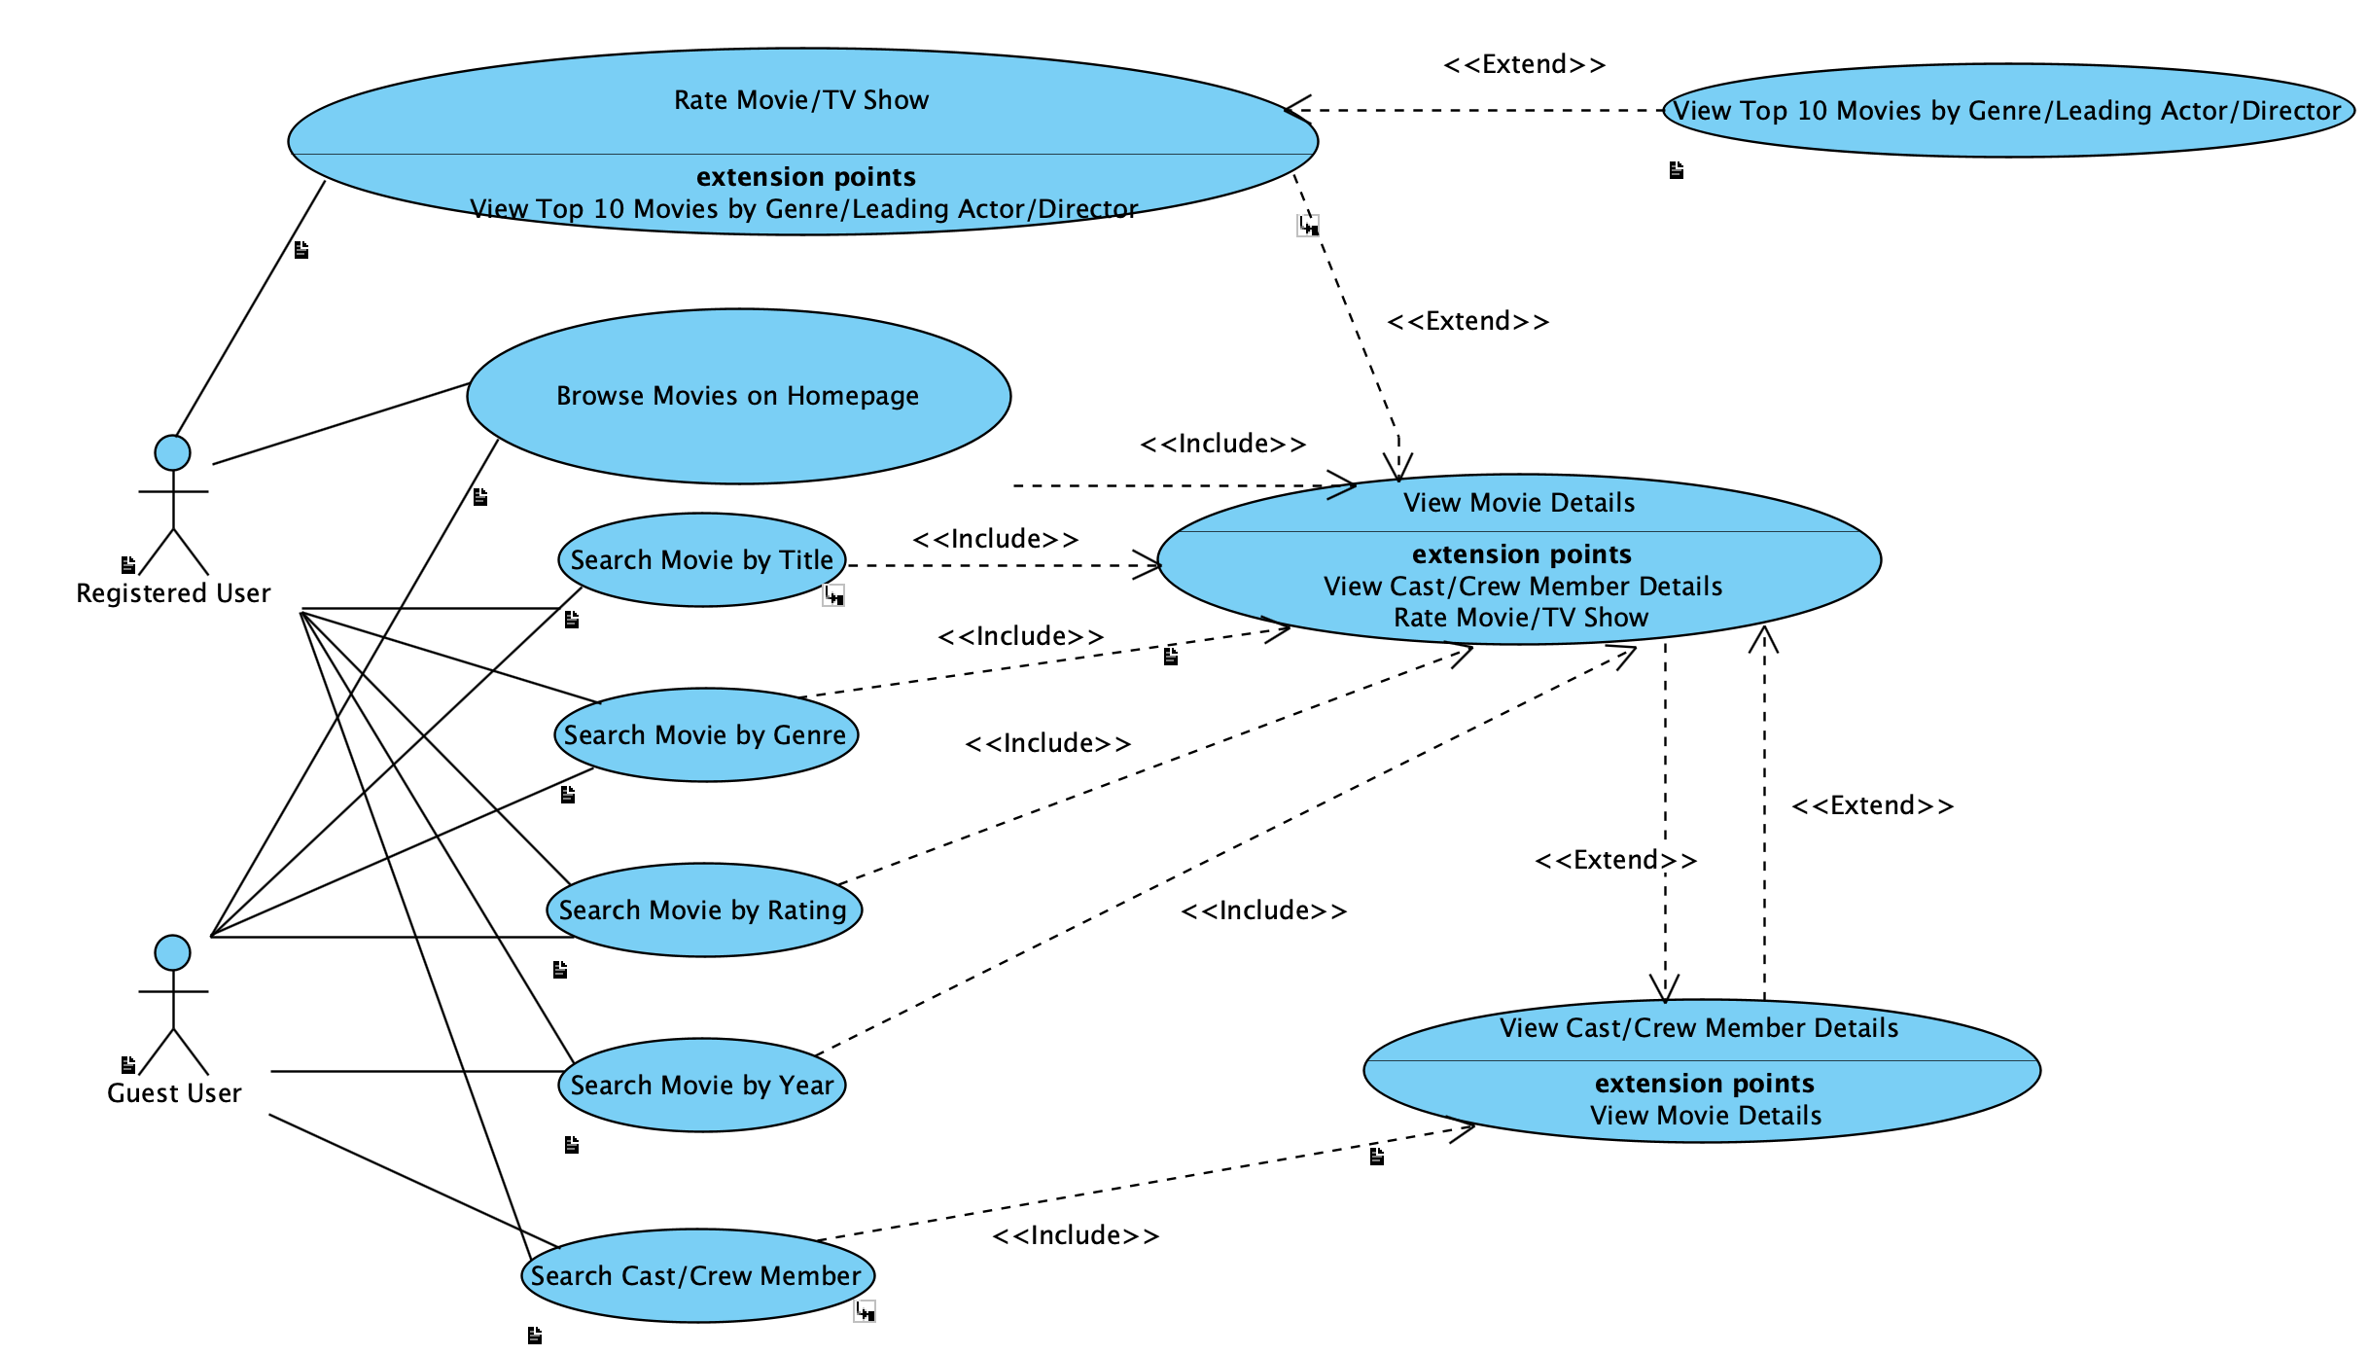system. It outlines the interactions that both registered and guest users can have with the system.

|  |  |
| --- | --- |
| **Use Case** | **Description** |
| **Browse Movies on Homepage** | This use case allows users to browse through a selection of movies displayed on the homepage or a dedicated section. The movies might be categorized or sorted based on different criteria like popularity, new releases, etc. |
| **Rate Movie/TV Show** | This use case enables registered users to rate movies or TV shows on a predefined scale (e.g., 1 to 10 stars). After watching a movie or TV show, users can provide their ratings, which are then aggregated and reflected in the overall rating of the title. This feature includes user authentication, rating submission, and updating the movie's average rating based on user input. |
| **Search Cast/Crew Member** | This use case allows users to search for cast and crew members by name. It enables users to find detailed information about the filmographies, biographies, and other relevant details of these individuals. |
| **Search Movie by Genre** | This use case enables users to filter the movie database based on genre categories like Action, Drama, Comedy, etc. The system should provide an intuitive interface allowing users to select one or multiple genres. Upon selection, the system filters and displays movies that fall under the chosen genre(s). |
| **Search Movie by Rating** | Users can filter and search for movies based on their ratings. This feature helps users find content suitable for their preferences. |
| **Search Movie by Title** | This use case allows both registered and guest users to search for movies by typing in the full or partial movie title. The system then queries the movie database and returns a list of movies that match or closely resemble the search query. The functionality includes handling various forms of movie titles, managing partial inputs, and presenting the results in a user-friendly manner. |
| **Search Movie by Year** | This use case enables users to search for movies released in a particular year or within a range of years. It caters to users interested in recent releases or specific historical periods in film. |
| **View Cast/Crew Member Details** | This use case involves displaying detailed profiles of cast and crew members when selected from a movie's details or searched directly. The profile includes information like their filmography, biography, notable works, and other relevant details. |
| **View Movie Details** | Upon selecting a movie (through search, browsing, or any other means), this use case presents detailed information about the movie. It includes displaying the synopsis, cast and crew details, production information, ratings, reviews, and other relevant data. The interface should be designed for easy reading and navigation. |
| **View Top 10 Movies by Genre/Leading Actor/Director** | Triggered when a user rates a movie highly, this use case generates lists of the top 10 movies either in the same genre or featuring the same leading actor or director. This feature is intended to cater to the user's demonstrated preferences and encourage further exploration within the app. |

## Requirements

### Requirement Diagram

## Screenshot 2023-12-12 at 15.58.18.png

This requirements diagram provides a structured visual representation of the system's requirements. It outlines the specific functionalities, constraints, and goals that the system is designed to fulfill.

|  |  |
| --- | --- |
| **Requirement** | **Description** |
| **Browse Movies on Homepage** | When users access the web page, they should be presented with a browsable selection of movies. This could include new releases, popular titles etc. |
| **Cast/Crew Career Overview** | Provide an overview of a cast/crew member’s career, including filmography, awards, and biography. |
| **Cast/Crew Search Function** | This function enables users to search for cast and crew members associated with movies and TV shows. The search should be robust enough to handle partial names and common variations or misspellings. Additionally, the system should present the results with essential information like name, known roles, and a link to a detailed profile containing their filmography, biography, and other relevant details. |
| **Cross-Linking Movie and Cast/Crew Profiles** | Establish links between movies and their cast/crew members. Clicking on a cast/crew member's name in a movie's details should redirect to their profile, and vice versa. |
| **Data Accuracy and Integrity** | Ensure the accuracy and integrity of all data presented, including movie details, ratings, and cast/crew information. |
| **Detailed Movie Information Display** | Once a movie is selected, the system displays detailed information including synopsis, cast/crew, ratings, genre, and production details. |
| **Movie Genre Filter** | This feature allows users to filter movies based on genre. It should support multiple genre selections simultaneously, enabling users to refine their searches effectively. The system must be updated with a comprehensive list of genres and ensure that each movie in the database is tagged appropriately to facilitate accurate filtering. |
| **Movie Title Search Function** | This function enables users to search the database for movies by entering titles. It should accommodate partial matches, case insensitivity, and common typos. The search algorithm must be optimized for quick, accurate results, minimizing the response time. |
| **Personalized Recommendations** | When a user rates a movie highly in a specific genre or featuring a particular actor, the system automatically suggests the top 10 movies of that genre or with that actor. This feature requires analyzing user preferences and leveraging data on movies and ratings to generate relevant recommendations. |
| **Scalability** | The system architecture should be scalable to handle increasing amounts of data and user traffic efficiently. |
| **Search Movie by Rating** | Allows users to filter movies based on their ratings. |
| **Search Movie by Year** | Users can search for movies by specifying the year of release. The function should support searches for a specific year and ranges. |
| **Security and Privacy** | Implement robust security measures to protect user data and privacy, including secure data transmission and storage. |
| **System Performance** | The system should maintain optimal performance, with rapid loading times and efficient handling of multiple simultaneous user queries. |
| **User Interface Design** | The user interface should be intuitive and easy to navigate, with a clean design that enhances user experience. |
| **User Rating Submission** | Users can rate movies/TV shows. The system should update the average rating in real-time post-submission. |
| **User Registration** | This feature allows new users to create an account by providing necessary information like email, username, and password. The system should validate the input to ensure data integrity and uniqueness of the username/email. |

# User Requirements

**Target User Demographics**

Ntuaflix is designed to serve a broad audience with varying interests and needs related to film and television content. The system is tailored to the following user groups:

**1. Cinema Enthusiasts:** Individuals with a deep interest in films, seeking comprehensive information and personalized recommendation engine to discover hidden gems and classics aligned with their preferences.

**2. Casual Viewers:** Regular consumers of film and television content looking for a convenient way to discover new releases and receive recommendations tailored to their tastes.

**3. Film Industry Professionals:** Creators, critics, and industry experts who require detailed and accurate metadata for professional purposes, including research, networking, and portfolio management.

**4. Academic Users:** Scholars and students engaged in film studies who need access to a rich database for research, educational content, and academic projects.

**User Environment**

The system will be used in a variety of environments, each with its own set of requirements:

**1. Home Environment:** Users accessing Ntuaflix from the comfort of their homes, likely through personal computers, tablets, or connected smart TVs, primarily for entertainment and information.

**2. Educational Institutions:** Academics utilizing the system within educational settings, often on desktops or library terminals, requiring in-depth access to metadata for teaching and research.

**3. Professional Settings:** Industry professionals using the platform in a work capacity, possibly in production offices or on-set, who may require faster, streamlined access to specific data points.

|  |  |
| --- | --- |
| **Actor** | **Description** |
| **Guest User** | A Guest User is an individual who interacts with the system without creating an account or logging in. This type of user typically has access to a subset of the system's functionalities that do not require personalization or content contribution. |
| **Registered User** | A Registered User is someone who has signed up for the system by providing necessary details such as name, email, and password. This user has a profile within the system and can access a wider range of features compared to a guest user. |

# Technical Requirements

## Performance

**1. TR-001 Response Time:** The system shall process and display search results within 2 seconds for at least 95% of requests under normal load conditions.

**2. TR-002 Data Processing:** The system shall handle batch processing of metadata updates for up to 10,000 records within 1 hour.

## Scalability

**1. TR-003 User Load:** The system shall support concurrent usage by up to 10,000 users without degradation of performance.

**2. TR-004 Data Volume:** The system shall be capable of storing and managing metadata for over 1 million individual film and television titles.

## Security

**1. TR-005 Data Encryption:** All user data shall be encrypted.

**2. TR-006 Authentication:** The system shall implement secure protocols for user authentication.

**3. TR-007 Vulnerability Testing:** The system shall undergo quarterly security vulnerability testing and necessary patches applied within 1 month of identification.

## Maintainability

**1. TR-008 Code Documentation:** The system's source code shall be fully documented following the documentation standards of the IEEE.

**2. TR-009 Update Deployments:** The system shall support updates and maintenance without requiring more than 1 hour of downtime per month.

## Usability

**1. TR-010 User Interface:** The system shall provide a user-friendly interface.

## Localization Support

**1. TR-011 Multilingual Interface:** The system shall provide an interface in at least two languages: English, Greek.

## Auditing and Logging

**1. TR-012 Audit Trails:** The system shall maintain audit logs of all user activities that affect data changes for a minimum of 2 years.

**2. TR-013 Log Analysis**: The system shall provide tools for the analysis of log data to detect unusual patterns that could indicate security breaches.

## Availability

**1. TR-014 System Uptime:** The system shall achieve 99.9% uptime, excluding scheduled maintenance windows.

**2. TR-015 Disaster Recovery:** The system shall have a disaster recovery plan that allows restoration of service within 4 hours in the event of a major outage.

# Hardware Requirements

## Network

**HR-001 Bandwidth and Throughput:** The server hosting Ntuaflix shall be connected to a high-speed internet connection to ensure smooth data transfers.

**HR-002 Latency:** The network infrastructure shall support a maximum latency of 100 ms for users connecting to the service within the same region as the data center.

## Client Computers

**HR-003 Operating System Compatibility:** Ntuaflix shall be compatible with the following operating systems: Windows 10 and above, macOS X 10.15 and above, and popular Linux distributions such as Ubuntu 20.04 and above.

**HR-004 Browser Support:** The client-side shall be accessible through the latest versions of major web browsers, including Google Chrome, Mozilla Firefox, Safari, and Microsoft Edge.

**HR-005 Processor Requirements:** Users' computers shall have at least an Intel i5 processor or equivalent to ensure responsive interactions with the Ntuaflix platform.

**HR-006 Memory Requirements:** A minimum of 8GB RAM is recommended for optimal performance when accessing Ntuaflix.

# Deployment Requirements

## Deployment DiagramScreenshot 2023-12-12 at 16.14.25.png

This diagram illustrates a multi-tier architecture that separates the presentation layer (web server), application logic layer (application server), and data storage layer (database server), which is a common structure for scalable web applications. The system is designed to facilitate secure and efficient communication between the user's interface and the servers providing the application's functionality.

## Nodes

|  |  |
| --- | --- |
| **Name** | **Description** |
| **<<device>> Client Device** | The client layer is represented by the user's device, which primarily uses a web browser to interact with the system. The web browser is responsible for sending requests to the web server and rendering the content received in response. Users may also interact with the system through a command-line interface, which, communicates directly with the application server's API. This direct communication is critical for administrative tasks that require more control and precision than what is typically provided through the web interface. CLI also provides an alternative way of accessing the system's functions. |
| **<<server>> Application Server** | The application server layer contains the back-end logic of the system and is where the API offering resides. It is the nucleus of the application's functionality, processing API requests, executing the necessary business logic, and performing data operations as required. The back-end component is designed to handle complex processes, including data validation, user authentication, and interactions with the database server. |
| **<<server>> Database Server** | Data storage and management are handled by a separate database server running MySQL. This server is dedicated to the secure and efficient storage of application data, and it interacts with the application server's back-end component. SQL queries are generated by the back-end and sent to the MySQL server, which processes these queries and returns the required data. |
| **<<server>> Web Server** | On the server side, the Apache web server acts as the gateway for all HTTP requests from the client's web browser. It is configured to serve static content directly to the client, which includes files such as HTML, CSS, and client-side JavaScript. This content constitutes the front-end of the application, which users interact with via their web browser. In addition to handling static content, the Apache server is equipped with a proxy module that forwards dynamic content requests to the application server via the API. This module ensures that the web server can delegate tasks that require server-side processing, thereby acting as a reverse proxy. |
| **System's Console** | The node system's console is the command-line environment where system administrators and authorized users access the backend of the Ntuaflix software system. It provides a powerful CLI component that offers direct interaction with the system's databases and services without the need for a graphical user interface. The CLI is also integral for performing various tasks that include database maintenance, data entry, batch updates and system diagnostics. |

## Component Diagram

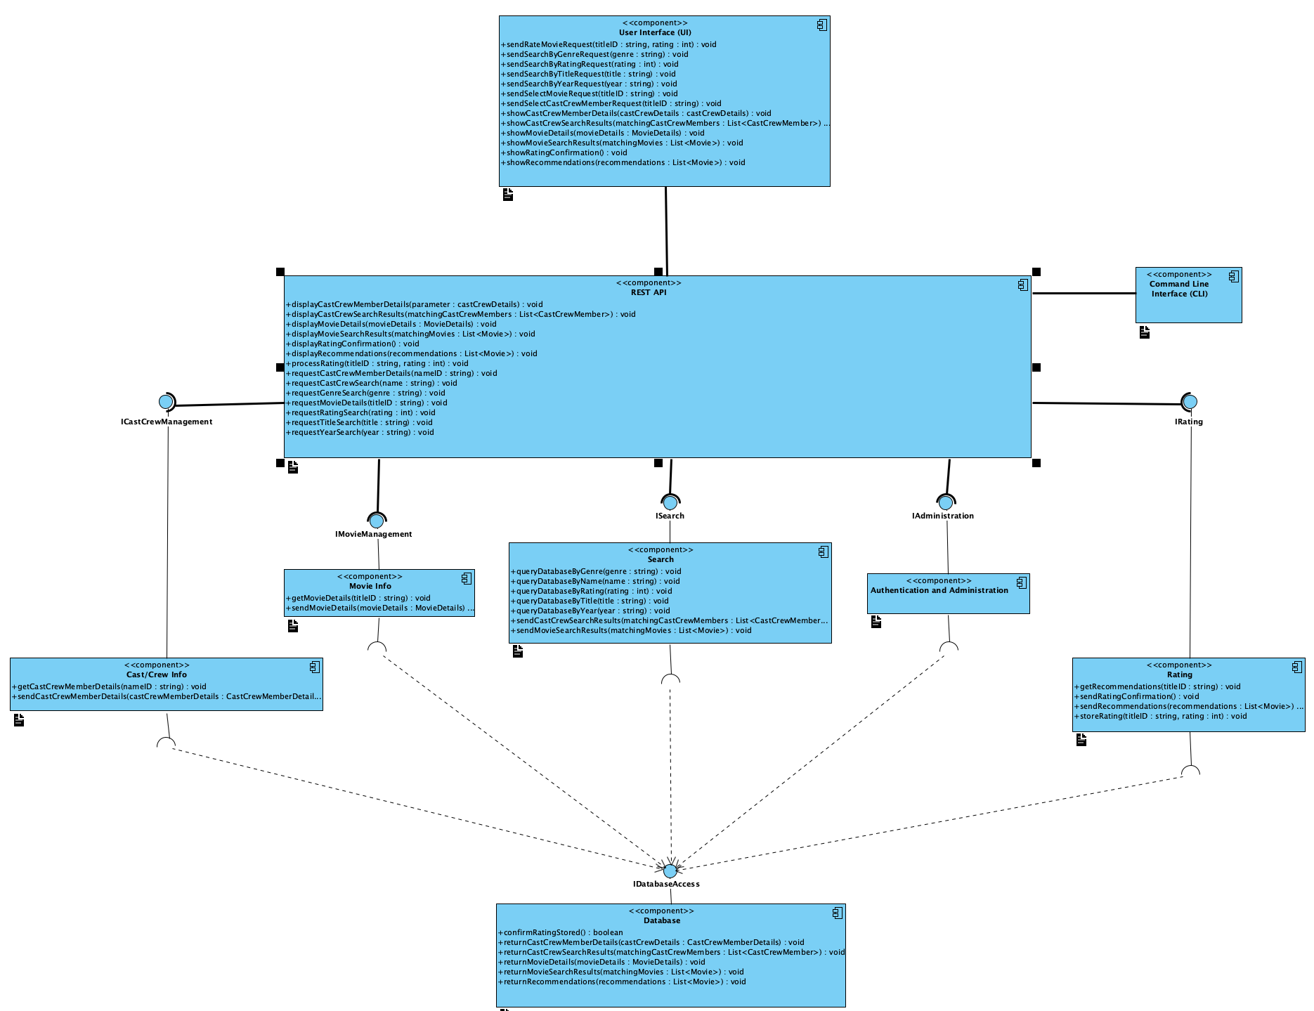

This component diagram represents the internal structure of Ntuaflix software system. It outlines the major components of the system and their interactions, emphasizing modularity and clarity of function.

Core Functionality Components: These are the backbone of the system, encompassing key business logic and data management. They include components like `Movie Info`, `Cast/Crew Info`, `Search`, `Authentication`, and `Rating`. Each of these components is responsible for a specific domain of the system's functionality, such as managing movie data, handling searches, or processing user ratings.

User Interface (UI) Component: Acts as the front-facing part of the system, interacting with the users. It collects user inputs, sends them to the appropriate back-end components for processing, and then displays the results back to the users.

Interfaces: The diagram shows interfaces between components, which define the methods that the components expose and consume. These interfaces represent contracts that ensure components can communicate with each other without needing to know the internal workings of their counterparts.

Database Access Component: Serves as the access layer to the database, providing an abstraction over the data storage mechanism. It offers CRUD operations that other components use to persist and retrieve data.

REST API and CLI Components: These components provide alternative ways for users and external systems to interact with the software system. The REST API exposes endpoints for web-based communication, while the CLI offers command-line access for more direct control or scripting purposes.

Inter-component Communication: The diagram depicts how the components communicate with each other primarily through interfaces. This communication is vital for the operation of the system, allowing user actions to translate into queries and updates within the system.

## Components

|  |  |
| --- | --- |
| **Name** | **Description** |
| **Authentication** | Handles user authentication processes, including login, logout, and session management and also verifies user credentials and maintains secure user sessions. |
| **Cast/Crew Info** | This component is dedicated to storing and providing detailed information about cast and crew members. It interacts with the database to retrieve data such as biographies, filmographies, and other related attributes. It also responds to updates from administrative users who might add new information or modify existing records. |
| **Command Line Interface (CLI)** | The CLI Component provides a command-line interface for system interaction, primarily used for administrative tasks or by users who prefer a command-line experience. It parses user-entered commands and maps them to actions within the system. The CLI interacts directly with the REST API in order to implement its functions. |
| **Database Access** | Acting as the data access layer, this component handles all direct interactions with the system's database. It provides a unified interface for database operations, abstracting the complexities of direct database manipulation from other components. It ensures data integrity and provides a consistent mechanism for other components to store and retrieve data. |
| **Movie Info** | The Movie Info Component is the central repository of detailed movie information. It provides comprehensive data, including synopses, genres, release dates, and ratings. This component works in close conjunction with the Rating Component to update and serve the latest rating information. It ensures that data is consistent and up to date, reflecting any changes in real-time. |
| **Rating** | The Rating Component allows users to express their opinions on movies and TV shows through a rating system. It aggregates user ratings to compute an average score for each title. This component ensures that ratings are recorded accurately and that users can see the most up-to-date ratings for all items. |
| **REST API** | This component exposes a set of RESTful endpoints to external clients, allowing for programmatic access to the system's functionalities. It defines the structure of requests and expected responses, adhering to stateless operations principles. The REST API Component translates HTTP requests into actions that are processed by backend components, returning the results in a structured JSON format. |
| **Search** | This component is responsible for implementing the system's search logic. It processes complex search queries and interacts with the database to return relevant results. The Search Component handles various filters and sorting options to ensure users can find the content they are looking for efficiently. |
| **User Interface (UI)** | This component is the primary interaction layer for end-users. It is responsible for capturing user inputs, processing user actions, and rendering the data returned from various backend services. The UI component translates user activities into requests that are sent to backend components via their respective interfaces. It is designed to provide an intuitive and responsive experience across various devices and platforms. |