**Generator control Board using Telegram**

**V1.2**

Features:1. More safe with relays PCB pin anti-climb design.  
2. With ESP8266 Wifi module,4-layers board design.  
3. One output status indicator, one input status indicator.  
4. 220V 10A relay, one normally open, one normally closed.  
5. One way optocoupler isolation input, TVS input protection.  
6. Access control server via TCP CLIENT mode Via HTTP protocol control.High-current terminals.  
7. Input overvoltage protection, input with TVS, when voltage exceeds 33V, automatic protection will operate.

8. Remote Control via mobile Phone using Telegram

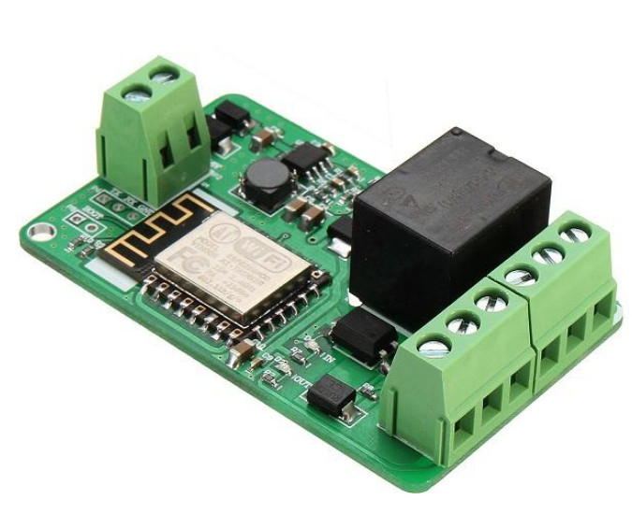

**Board Connection details.**

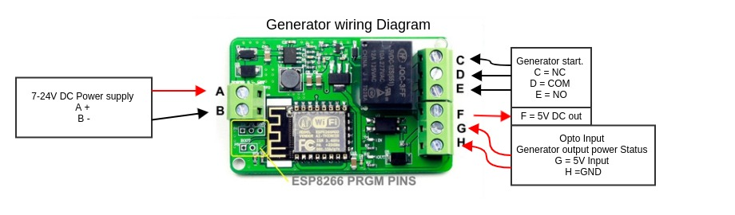 **Wire Diagram**

**1) Supply 12V DC to A and B**

**2) Connect D and E to Generator Key or button of Generator.**

**3) Connect Generator output to a 220v Relay and then connect the rely COM and NO contacts between G and H**

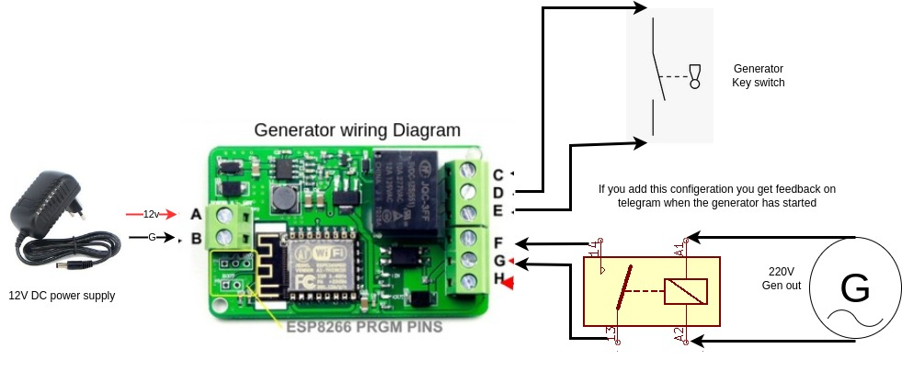

**Wifi Connection configuration**

#### **How It Works**

* When the device starts, it tries to connect to a saved Wi-Fi network.
* If no known network is found, it creates an access point (e.g., ESP32_CONFIG_AP). There is no password

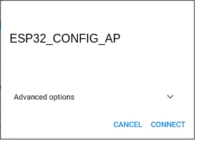

* Users can connect to this AP using their phone or computer and navigate to 192.168.4.1.
* A web portal appears where they can select and configure their Wi-Fi credentials.
* Once configured, the device will automatically connect to the selected network and store the credentials in flash memory.

#### 5. Connecting to Wi-Fi

1. Power on the device.
2. If not already connected, find the Wi-Fi network named ESP32_CONFIG_AP on your phone/computer.

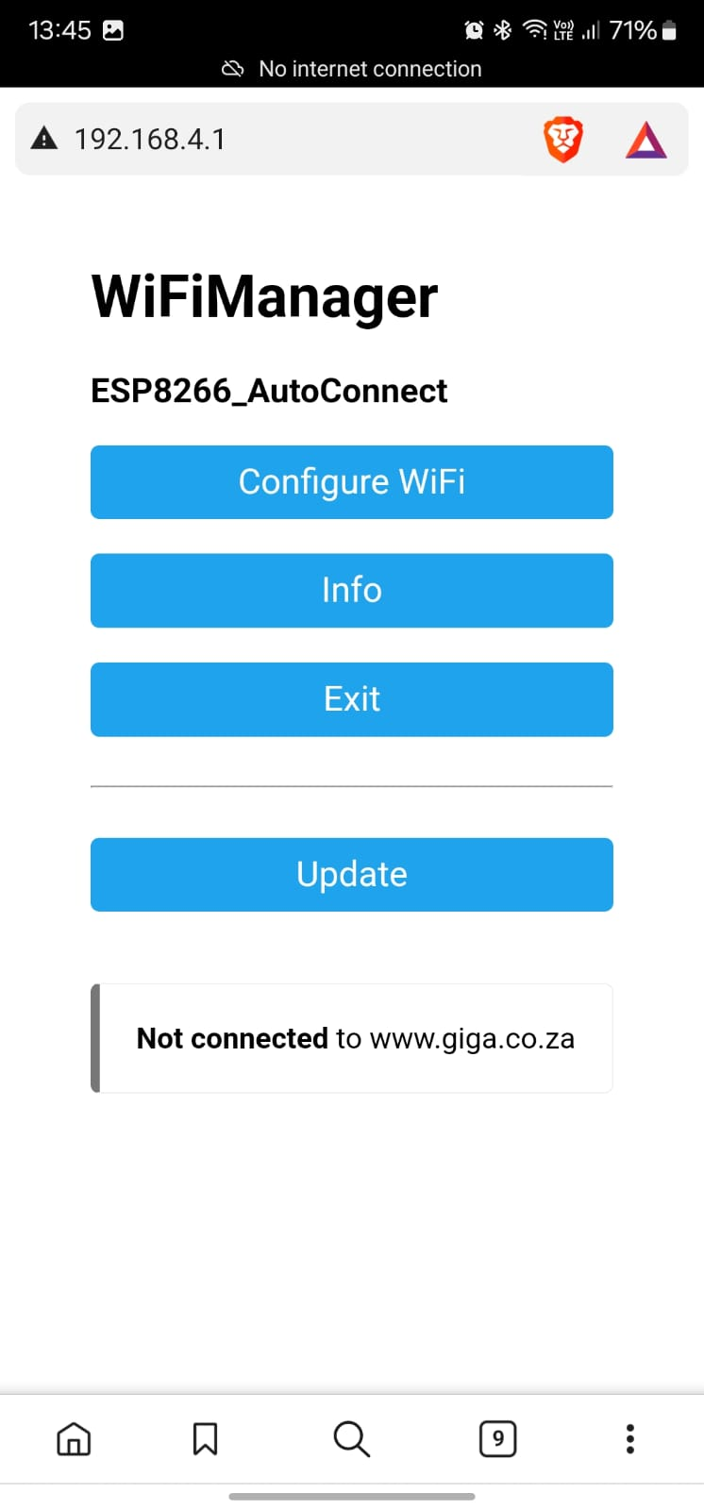

1. Connect and open a web browser.
2. Navigate to 192.168.4.1.

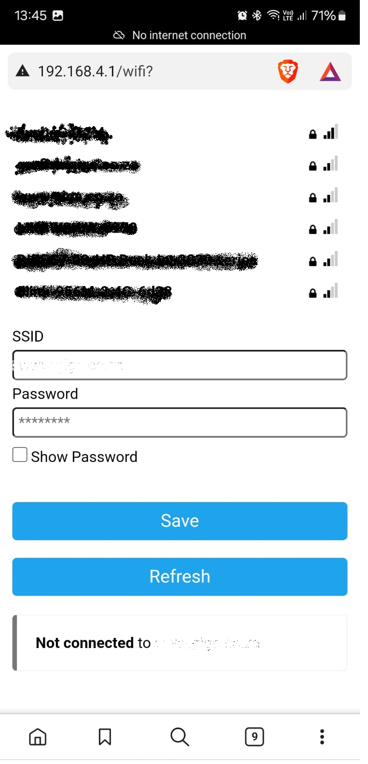

1. Choose your Wi-Fi network and enter the password.
2. Click "Save" and let the device reboot. It can take up to 5 minutes to restart.
3. The device will now connect automatically in the future.

### Setting up your telegram

#### Open Your Telegram App on your mobile phone.

Goto your telegram app and searcher for Generator_control_app

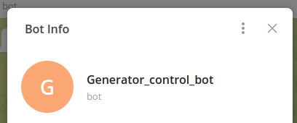

Enter the command /help

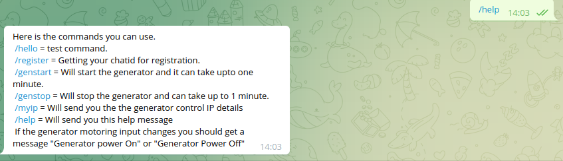

You should get a menu as above.

Enter the command /regester

you will get a register ID like below

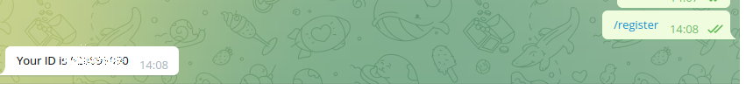

**You then need to send us this ID and we will enable this mobile phone to control the generator.**

We will send you a message on telegram when its enabled.

Now you can start and stop the Generator

using the command /genstart and /genstop

you should get a message Generator will be started.



and Generator will be stopped.



If the input to G and H change from relay you should get the following message.

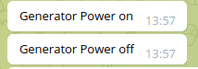

### Troubleshooting

* Can't find the AP? Reset the board and retry.
* Search on your wifi connected network with mobile phone app fing to get the ip of your Generator control.
* Can't connect to the captive portal? Clear your browser cache or try another device.

