RF Noise Monitoring System Remote Monitoring System.

Version 2.0 (Made on Raspberry Pi 4)

# Index

1. Download the Raspberry Pi img and create your 16Gb SD cart for the Raspberry Pi.
2. Register your Station on the Master server <http://rfnoise.amsatsa.org.za/register_station.php>
3. Configure your (password key) and GPS cordionates on the Raspberry Station
4. Setup Your WIFI / Ethernet on your Raspberry Pi to connect to the internet.
5. Setup your time and date on the Raspberry PI using terminal.
6. Connect your SDR dongle to your (External Antenna)

## Download the Raspberry Pi img and create your SD cart.

Download the rfnoise_remote_station_V2.img from here.

### Preperation on Linux.

Insert the emty SD cart into your Linux pc /laptop

Run the command df -k

You should see something like this (Remove the parts in red)

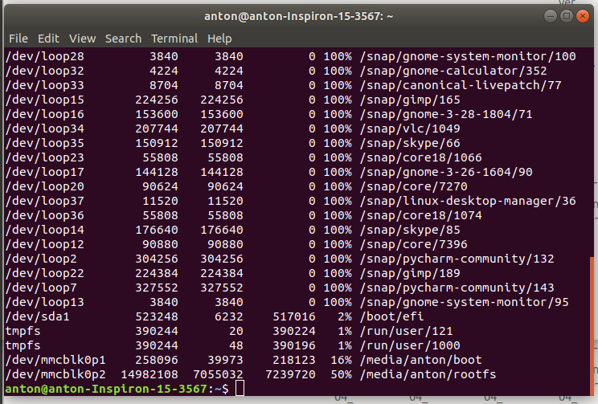/dev/mmcblk0p1

/dev/mmcblk0p2

look for your SD cart by adding it and removing it and see witch device show up.

If = input image file and of = output file

sudo dd if=rfnoise_remote_station_V2.img of=/dev/mmcblk0 bs=4M

Then run the command sync

Remove the the SD cart and install on Raspberry Pi

Boot up thr Raspberry.

You can now login in to your Raspberry using the user hfnoise:[password] will be send to you by SMS when you resgister your Station on the master server.

### Preperation on Windows.

## Register your Station on the Master server.

After registration you will receve a SMS message on your Mobile with the Password Key and Raspberry PI username and password.

Here is the registration Page <http://rfnoise.amsatsa.org.za/register_station.php>

Here is an screenshot of the registration Page.

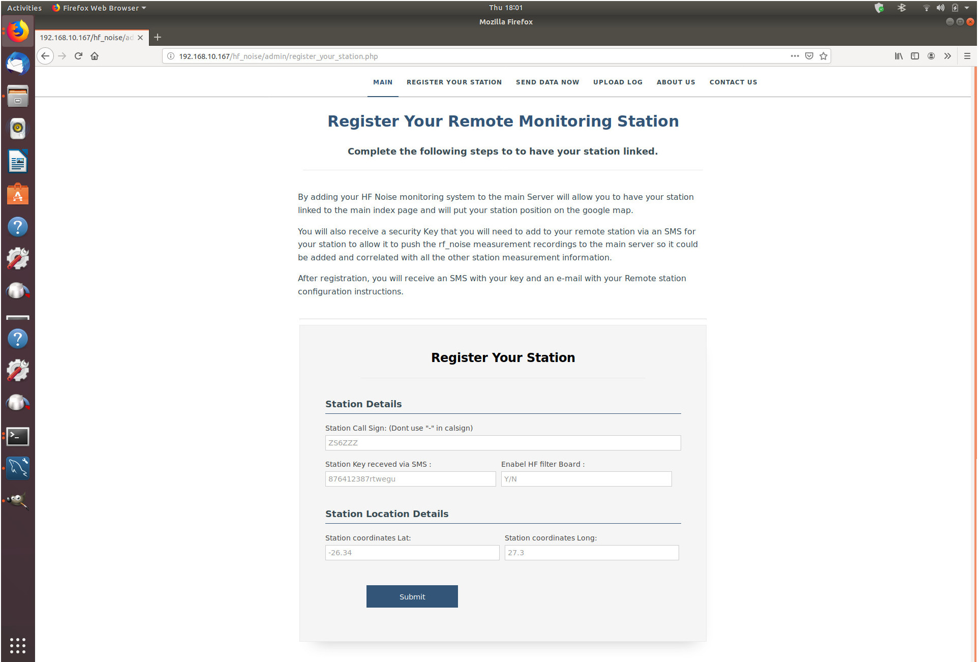

## Configure your (password key) and GPS cordionates on the Raspberry Station.

Login with the username and password you have receved via the SMS on your Mobile.

Then use the browser and go to your to the following adress.

<http://localhost/hf_noise/admin>

You will be asked for username and password

it is the Admin and the same password u used to loginto the raspberry pi.

You should see the following screenshot showing your exsiting configuration.

Then click on register your station.

Enter Your Callsign and Key receved by SMS

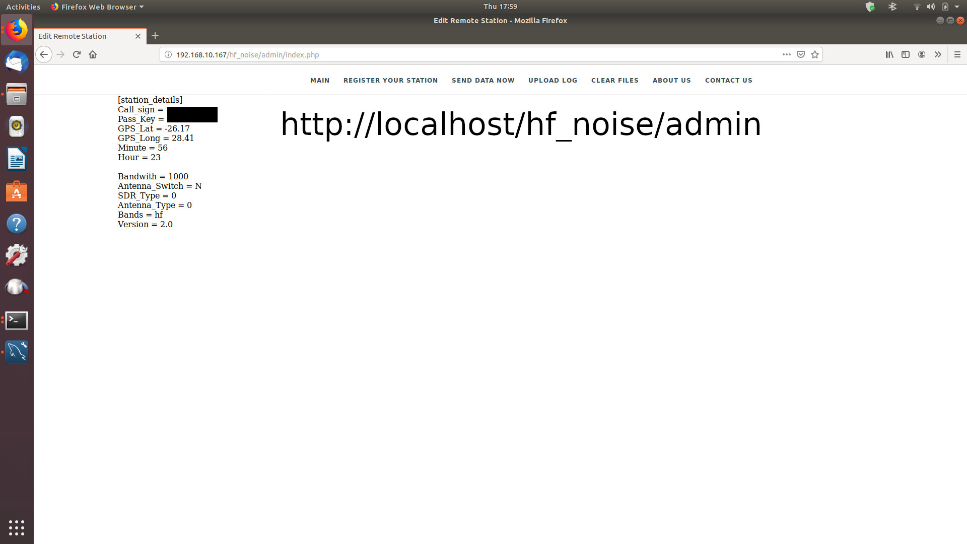

### Register your station



## Setup Your WIFI / Ethernet on your Raspberry Pi to connect to the internet.

Right click on the Wifi Icon on the right hand side and select your wifi from the list and enter your wifi password.

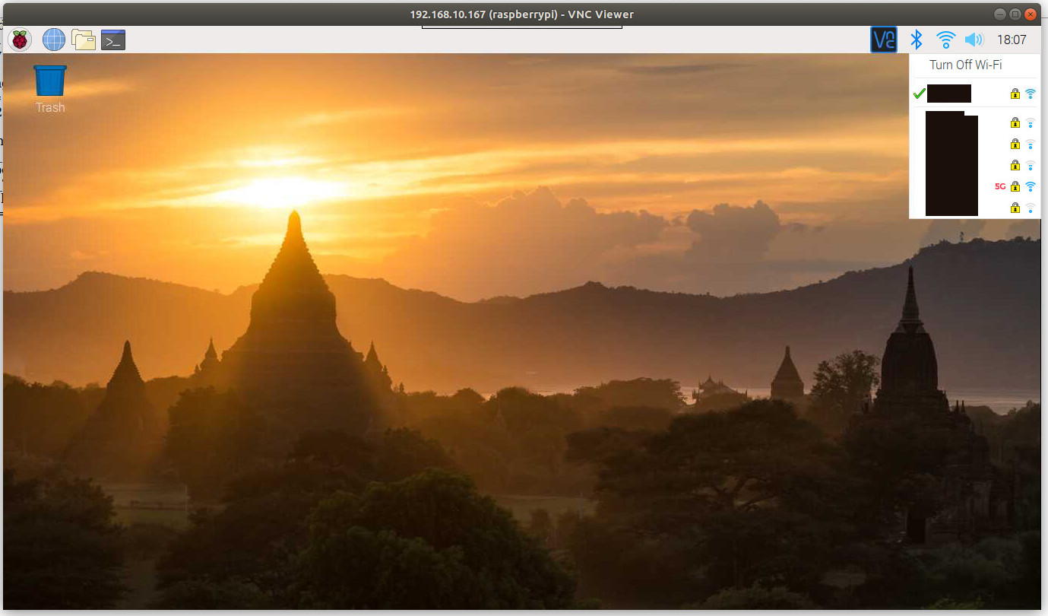

Password menu

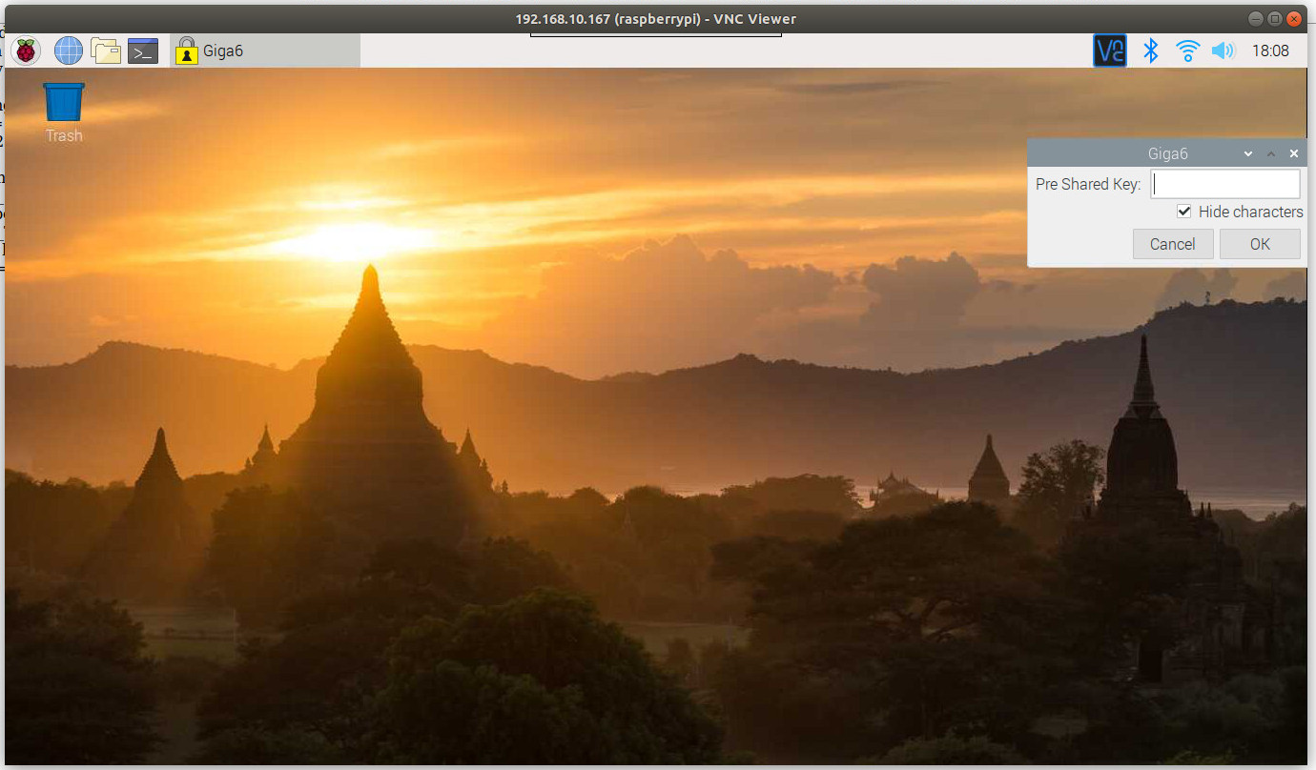

## Setup your time and date on the Raspberry PI using terminal.

## Connect your SDR dongle to your (External Antenna)