# NEW RF Noise monitoring System Version 2.0

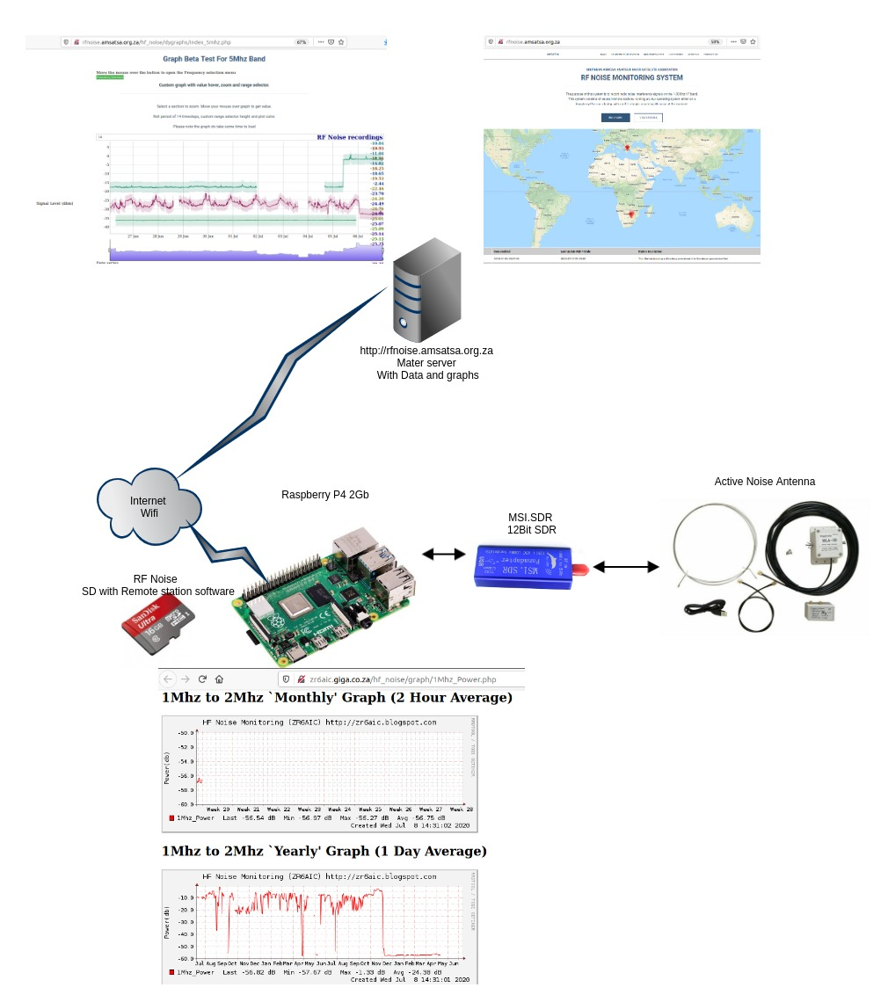

The following is planned for the new RF noise monitoring system.

1. Make the remote station configurable to use 8Bit 12Bit and 14Bit SDR dongles (not complete yet)
2. Make the remote station to Automatic Register it self to the HF noise server no manual intervention required. ( not complete yet)
3. Time interval configuration and average sampling configuration managed by Master server.
4. New Remote Station configured is done via Admin console.
5. New Master server add on Signal Calibration of SDR linear curve and Antenna Linear curve (Calibration can be applied to Row data.)
6. New Master Server add on Graph enhancements. 1 Year historical graph and 4 Month Historical Graph.
7. New Sampling interval configurable 1 – 60Minutes
8. New sample bandwidth selectable from 10hz to 5Khz
9. New Channel sampling frequency selectable up to 4096 channels.
10. New SDR channel sampling resolution selectable from 8Bit to 14Bit (rtlsdr = 8bit) (msi.sdr =12bit)
11. New Antenna Calibration Table to adjust for none Linear Antenna curve.
12. New SDR Calibration Table to adjust For none Linear A/D.

# Pre Configured Raspberry Pi SD

1) Sd Cart is complete with all software you only need to configure your Wifi or #g dongle and your station to the master server. Your local graphs will start working mediately. Master server data the next day. The system upload every hour the existing data.

# V2 Remote Station hardware.

1) Raspberry Pi 4 with 2Gb memory and Power supply.

2) MSI.SDR SDR dongle.

3) HF Antenna Loop antenna.

4) Enclosure for Raspberry PI.

5)optional hardware 3G GSM dongle if you done have local Wifi Access.

# Master RF Noise monitoring system.

Link to mater noise monitoring system. http://rfnoise.amsatsa.org.za/

The V2 master server software will allow you to use 8 to 14Bit SDR units with the calibrated SDR and Antenna information.

Data can the be exported with pre calculated calibration data or in the row format.

The V2 Graph system will allow you to view data up to last 2 years.