Hotspot Setup for LoRa Receiver

WiFi name: Free Wifi
Password: 2222!2222

once the rasp-pi-lora-base connects to the hotspot check the IP of the Pi.
The IP address may be different based on the hotpsot
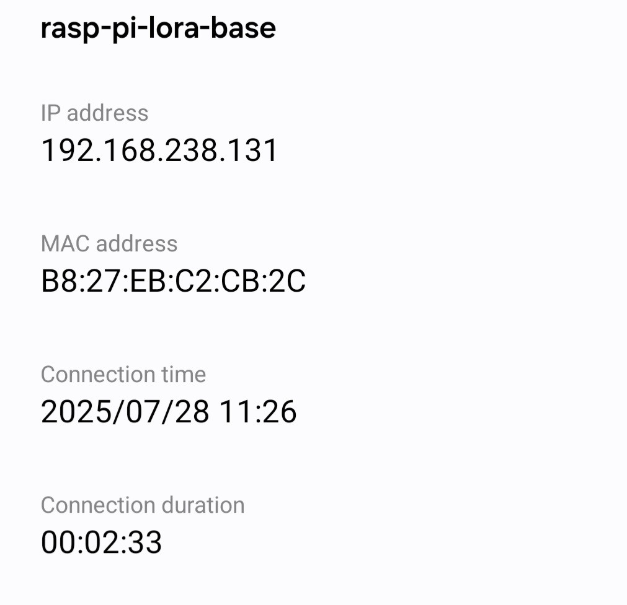

once you have the IP address while on the same hotspot go to your browser and enter the IP plus :5000 to access the port for example: 192.168.238.131:5000

this should bring up this screen
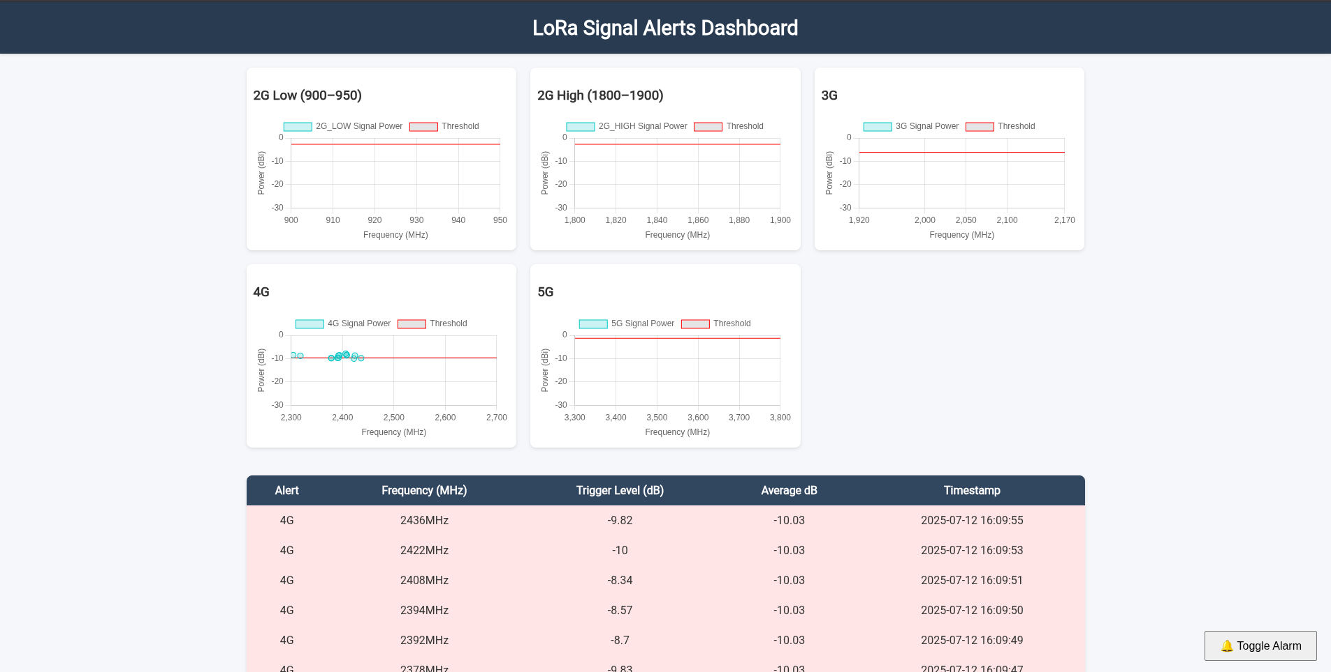

How to configure LoRa Receiver WiFi

1. Connect the PI through Ethernet to a WiFi or connect it to a display through the mini HDMI connector on the Pi( if connected to a display skip to step 5).

2. Use any type of VNC software e.g. TigerVNC

3. In TigerVNC connect the Pi’s IP

4. When asked for the Username and Password use pi and zr6aic respectively
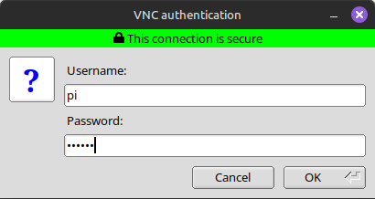

5. Once the Pi screen appears, go to the WiFi icon on the top right corner. Hover over advanced options and select “Edit Connections”.

6. Once the new screen appears in the bottom left click on the Plus symbol to create a new connection.

7. In the choose type select “Wireless”.

8. In Connection name, enter whatever you want for example My WiFi, then select the General tab.

9. In the General tab make sure “Connect automatically with priority” is selected, then go to the Wireless tab.

10. Once in the Wireless tab enter the WiFi name in the SSID, then go to the Wireless Security tab.

11. Once there in the Security drop down select WPA/WPA2/WPA3 Personal and enter the password for the WiFi in the password section.

12. Once done click on Save to close the window and then click the X in the top right to close the Network Connections.

13. You can now restart the Pi to use the new Wifi connection, it may take some time for the Pi to connect to the WiFi.

LoRa Sender Web Server

1. Once the Sender Pi has been powered on, after some time it will activate its Hotspot called PiWebServer, connect using the password 12345678. Make sure your device is set to connect even though there is no internet.
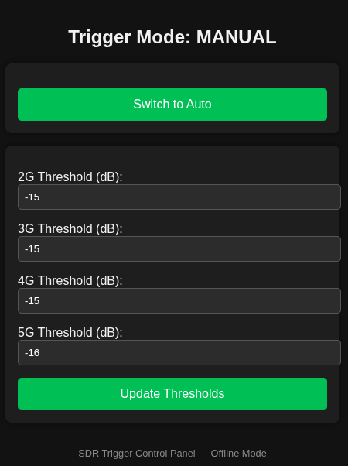
2. Once connected go to your Web Browser and type in the IP 10.42.0.1:8080 to access the configuration Webpage.

