1. Встановіть на своїй домашній робочій станції гіпервізор ІІ типу – Virtual Box, VMWare Workstation, Hyper-V (або інший на Ваш вибір).

2. Опишіть набір базових дій в встановленому Вами гіпервізорі:

- Створення нової віртуальної машини;

To create a new virtual machine, you need to start VirtualBox. On the host where you installed Oracle VDI and VirtualBox, select the Applications menu on the desktop, then the System Tools menu, and then Oracle VM VirtualBox. Alternatively, you can run the VirtualBox command in a terminal. The Oracle VM VirtualBox Manager is displayed

In the toolbar, click the New button. The New Virtual Machine Wizard is displayed in a new window

1. 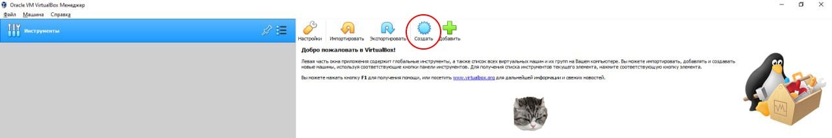
2. 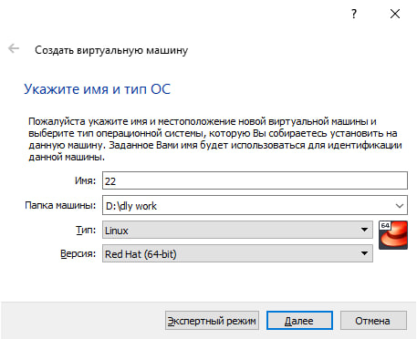

Click the Next button to move though the various steps of the wizard. The wizard enables you to configure the basic details of the virtual machine. On the VM Name and OS Type step, enter a descriptive name for the virtual machine in the Name field and select the operating system and version that you are going to install from the drop-down lists. It is important to select the correct operating system and version as this determines the default settings for VirtualBox uses for the virtual machine. You can change the settings later after you have created the virtual machine.

On the Memory step, you can simply accept the default. This is the amount of host memory (RAM) that VirtualBox assigns to the virtual machine when it runs. You can change the settings of the virtual machine later, when you import the template into Oracle VDI.

3. 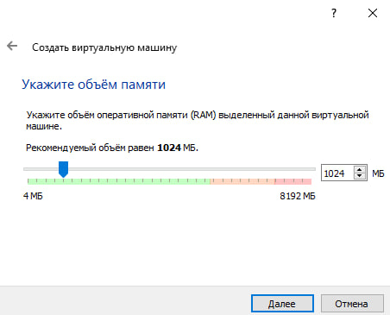

On the Virtual Hard Disk step, ensure Start-up Disk is selected , select Create new hard disk and click Next. The Virtual Disk Creation Wizard is displayed in a new window so you can create the new virtual disk.

On the following steps, select VDI (VirtualBox Disk Image) as the file type, Dynamically allocated as the storage details, and accept the defaults for the virtual disk file location and size, and then click Create to create the virtual disk.

4. 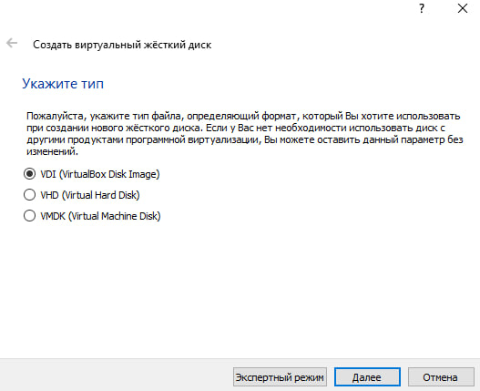

When the virtual disk is created, the Virtual Disk Creation Wizard is closed and you are returned to the Summary step of the New Virtual Machine Wizard. Click Create to create the virtual machine. The wizard is closed and the newly-created virtual machine is listed in Oracle VM VirtualBox Manager.

Since you want to install an operating system in the virtual machine, you need to make sure the virtual machine can access the installation media. To do this, you edit the virtual machine settings. In Oracle VM VirtualBox Manager, select the virtual machine and then in the toolbar click the Settings button. The Settings window is displayed. In the navigation on the left, select Storage

In the Storage Tree section, select Empty below the IDE Controller. The CD/DVD Drive attributes are displayed. Click the CD/DVD icon next to the CD/DVD Drive drop-down list and select the location of the installation media

Click OK to apply the storage settings. The Settings window is closed. If you connected the virtual machine's CD/DVD drive to the host's physical CD/DVD drive, insert the installation media in the host's CD/DVD drive now. You are now ready to start the virtual machine and install the operating system.

5.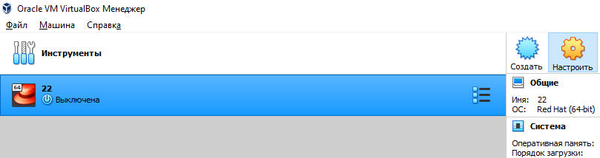

6. 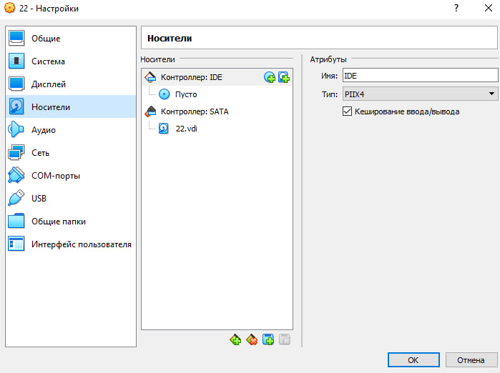

7. 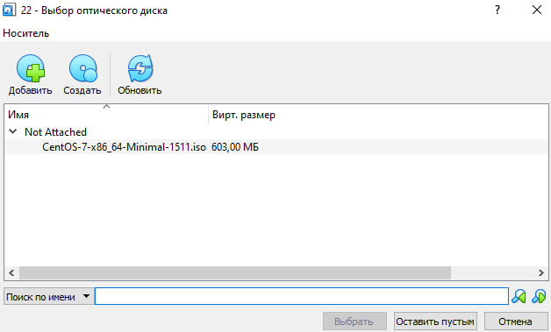

In Oracle VM VirtualBox Manager, select the virtual machine and click the Start button in the toolbar. A new window is displayed, which shows the virtual machine booting up. Depending on the operating system and the configuration of the virtual machine, VirtualBox might display some warnings first. It is safe to ignore these warnings. The virtual machine should boot from the installation media.

8.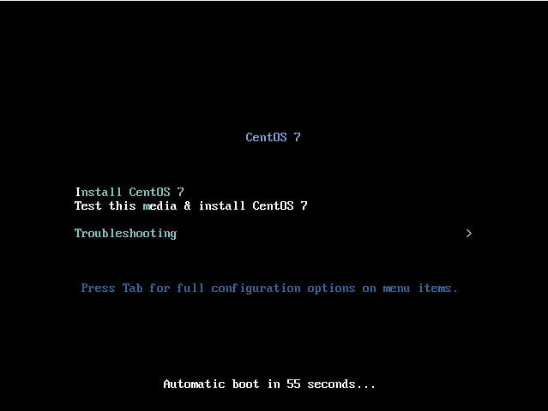

- Вибір/додавання доступного для віртуальної машини обладнання;

You can use virtual machine hardware settings to add hardware to an existing virtual machine.

To add hardware to a selected virtual machine, select VM > Settings, click the Hardware tab, and click Add.

The Add Hardware wizard prompts you to select the type of device that you want to add and to specify device-specific configuration settings. You can modify many of the configuration settings after the device is created by changing virtual machine hardware settings.

You can add the following types of devices to a virtual machine:

Virtual hard disks;

CD-ROM and DVD drives;

Floppy drives;

Network adapters;

USB controller;

Sound card;

Parallel (LPT) ports;

Serial (COM) ports;

Printers.

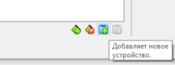

- Налаштування мережі та підключення до точок Wi-Fi;

To configure your virtual machine to access the Internet through WiFi:

1.Choose Configure from the Virtual Machine menu to open the 2.Virtual Machine Configuration dialog.

3.Select Network Adapter in the Hardware list.

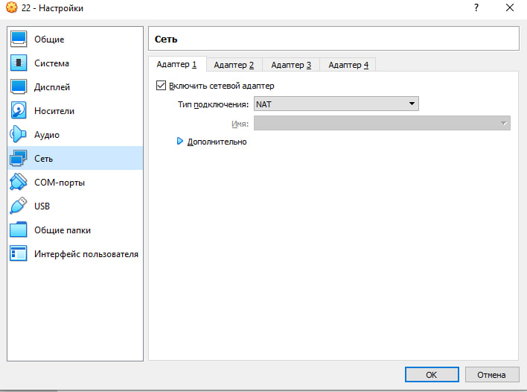

5.In the Network Adapter pane, make sure that the Enabled.

6.Connected and Bridged Ethernet options are selected.

7.In the Bridged Ethernet drop-down list, choose AirPort.

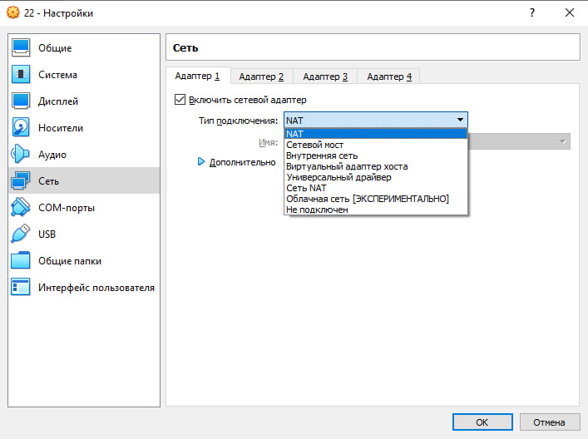

8.Click OK.

- Можливість роботи з зовнішніми носіями (flash-пам’ять).

Process to connect USB hard drive to Linux Virtual Machine:

1.Plug the external USB hard drive into the USB port of your physical machine.

2.Launch VMware Workstation.

3.Start your virtual machine.

4.Click VM > Removable device > external_hard_drive_name, then click Connect.

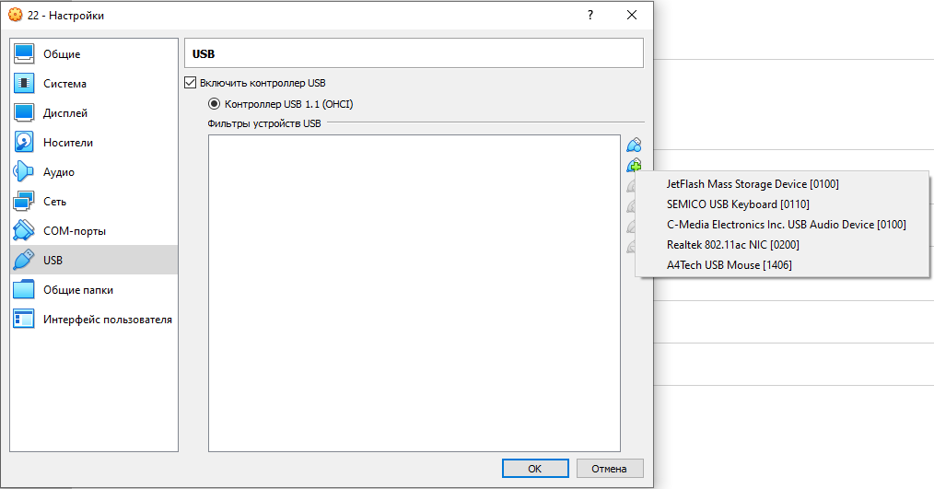

5.Click the KickOff Application Launcher icon in the bottom left corner of the screen.

6.Type File Manager, and click the application name to open it. The hard drive appears on the left side of the File Manager window under Places.

3. Встановіть в вашому гіпервізорі операційну систему GNU/Linux CentOS (або інший зручний Вам дистрибутив) у базовій конфігурації з графічною оболонкою.

To install the GNU/Linux CentOS operating system in your hypervisor with a graphical shell, you can follow these basic steps:

1. Download the CentOS ISO image file from the official CentOS website.
2. Open your hypervisor software VirtualBox and create a new virtual machine.
3. During the creation of the virtual machine, select the option to install the operating system from an ISO image file and specify the location of the CentOS ISO image file that you downloaded in step 1.
4. Configure the virtual machine with the following basic settings
5. Start the virtual machine and follow the CentOS installation wizard. Here are some tips for configuring the installation:

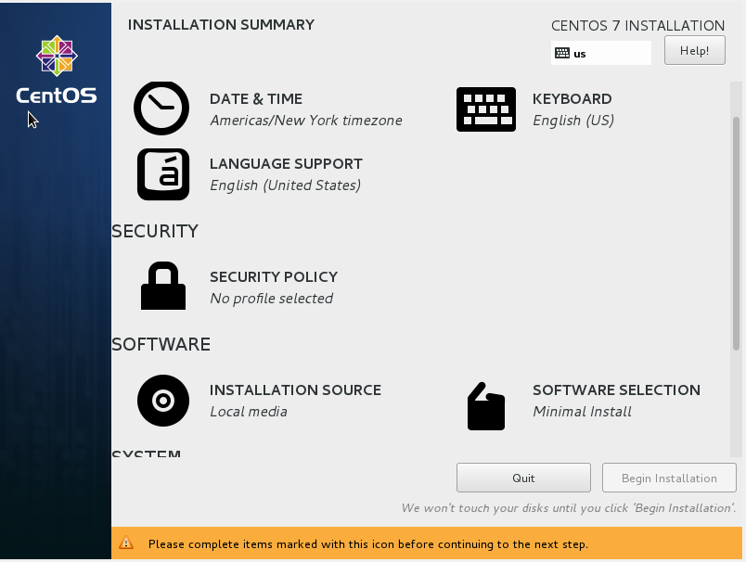

* Select the graphical installation option for the installation process.
* Choose your preferred language and keyboard layout.
* Configure your network settings (e.g., DHCP, static IP address).
* Partition your disk according to your needs. If you're unsure, you can use the default partitioning scheme.
* Choose the software packages that you want to install. If you want a graphical shell, make sure to select the Desktop Environment package group.
* Create a user account with administrative privileges.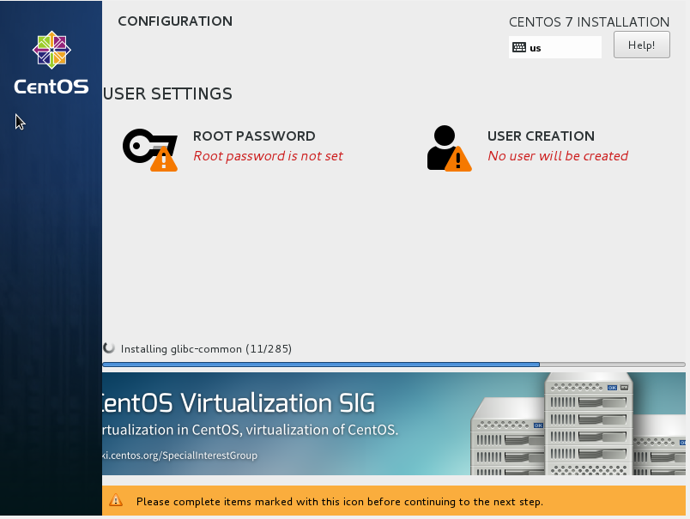

1. After the installation is complete, restart the virtual machine and log in with the user account that you created.

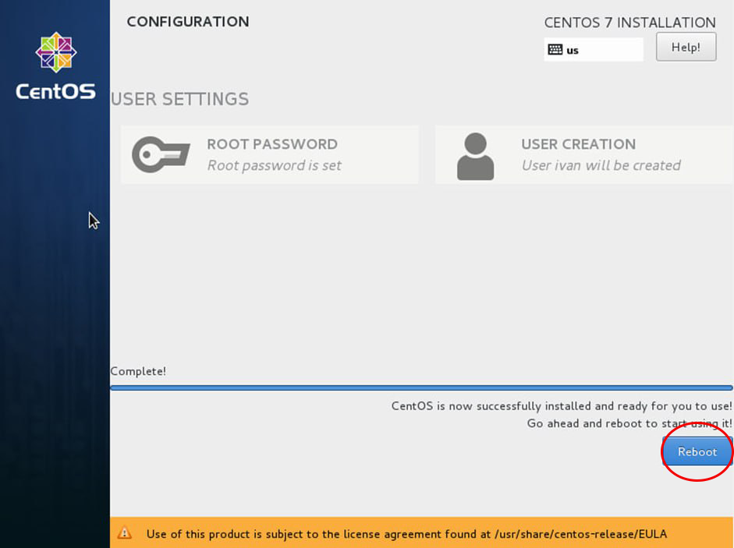

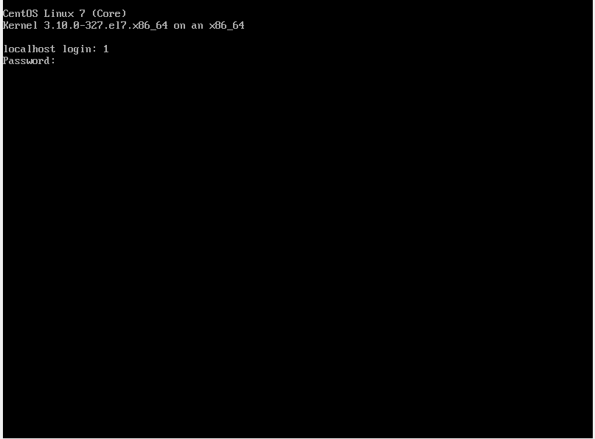

4. Створіть другу віртуальну машину та виконайте для неї наступні дії:

- Встановіть у мінімальній конфігурації з термінальним вводом-виводом без графічного інтерфейсу операційну систему GNU/Linux CentOS ;

- Встановіть графічну оболонку GNOME поверх встановленої в попередньому пункті ОС;

- Встановіть додатково ще другу графічну оболонку (їх можливий перелік можна знайти в лабораторній роботі №1) та порівняйте її можливості з GNOME.

VirtualBox and GNOME are two very different software packages that serve different purposes, so it's difficult to compare them directly in terms of opportunities.

VirtualBox is a virtualization tool that allows you to run multiple operating systems on your computer simultaneously. It's commonly used by developers and IT professionals to test software on different platforms or to create isolated environments for testing and experimentation. Some of the opportunities provided by VirtualBox include:

* Running multiple virtual machines (VMs) simultaneously, each with their own operating system and configurations
* Easy management and configuration of VMs through a user-friendly interface
* Integration with other virtualization tools, such as Vagrant, for streamlined development workflows
* Compatibility with a wide range of operating systems and hardware configurations

On the other hand, GNOME is a desktop environment for Linux-based operating systems. It provides a graphical user interface (GUI) that makes it easy to interact with the operating system and its applications. Some of the opportunities provided by GNOME include:

* A modern and intuitive desktop interface with support for multiple workspaces
* Integration with a wide range of applications and tools for productivity, media consumption, and other tasks
* Customization options to personalize the desktop experience to your liking
* Support for touchscreens and other input devices, making it suitable for use on tablets and other mobile devices

Overall, the opportunities provided by VirtualBox and GNOME are quite different and reflect their respective roles in the software ecosystem. VirtualBox is primarily used for virtualization and testing, while GNOME provides a desktop environment for Linux-based operating systems.

The work was done by Khomenko Anton, Novikov Ivan and Oleksiy Yakovenko