Compiling wxWidgets with Cmake
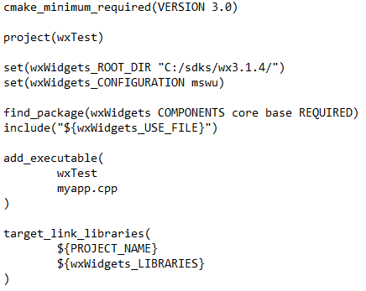
set(wxWidgets_ROOT_DIR “C:/sdks/wx3.1.4”)
- Locating and setting the wxWidgets directory
set(wxWidgets_CONFIGURATION mswu)
- Setting the build type for wxWidgets, mswu means release
- mswud means debug, self-explanatory
find_package(wxWidgets COMPONENTS core base REQUIRED)
- Once again asserting our wxWidgets path, find_package handles a lot of stuff for us
include(“${wxWidgets_USE_FILE}”)
- Self explanatory as well, this is to be able to use “#include <wx/wx.h>” and such
target_link_libraries(...)
- “Specify libraries or flags to use when linking a given target and/or its dependents“

Compiling our program
(Windows) Once we’re in our project’s directory, we may execute:
cmake -G “MinGW Makefiles” -S ./ -B ./build/
-G “MinGW Makefiles” ~ Compile with MinGW Makefiles
-S ./ ~ Source folder (./)
-B ./build/ ~ Build folder

If you’re on linux, run cmake -G “Unix Makefiles” -S ./ -B ./build/

