Writing Your First (Proper) wxWidgets Application
Instructions Used
Writing a wxWidgets (with file source & header file seperation) contains at minimum 2 files:
- One source file to initialize and contain our main function
- One header file to make our wxApp and wxFrame classes

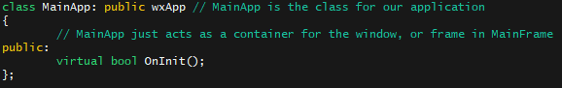
base.h, MainApp
MainApp/wxApp
- MainApp, or the wxWidget’s class wxApp is the class that handles the properties of our application
- What wxApp does
  - Checks for events
  - Handles the properties of our application
  - Container for the window, or frame in MainFrame

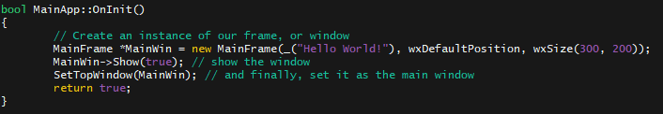
base.cpp, OnInit() implementation
MainApp onInit()
- onInit() is the intialization function for our MainApp class
- We create our actual window here.

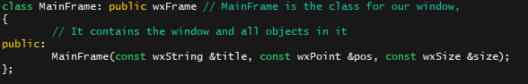
base.h, MainFrame
MainFrame/wxFrame
- MainFrame, or wxFrame is the class that represents a window
  - It’s what you see, and the contents of our application on launch
- What wxFrame does
  - Controls style and objects
  - Window size

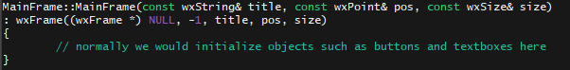
base.cpp, MainFrame Constructor Implementation

MainFrame Constructor
- The constructor is where all of our objects (like buttons and such) will be placed.
- Constructor arguments
  - const wxString& title: Title of the frame
  - const wxPoint& pos: Where the window will be positioned on our screen
    - If we wanted a custom size, we could use the wxPoint(int x, int y) function
  - const wxSize& size: Size of our window

