. The Sub-Sequence Milestone Rules

to be clear - due to many variables the flag system was designed to be highly flexible. I would like the race officer to be able to drag the flag order and class order into the event block and the timer is independent of the flag type/colour. For version 1 – once the race starts with the Start time no further edits will take place until the final count down is finished
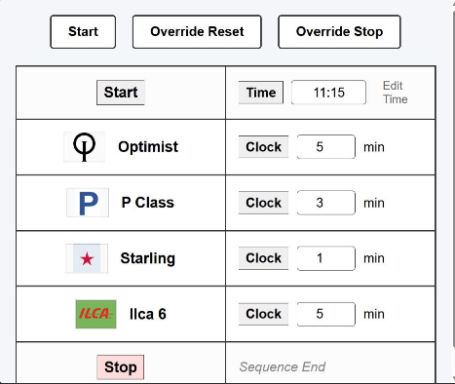
be running
The timers are daisy chained and run one after each other. Timers are independent of the image file on the left side of the event box
Event box/row 1
Event box 2

In standard racing systems, flags are displayed and removed at precise minute marks within a single class's countdown block. For a standard 5-minute event (like Ilca 6), does your sequence follow this pattern: - we would like to flex and allow the race officer to place the flags and classes in the sequence – flags are independent of the counter

Below is a typical flow,

5 Minutes Remaining: Class Flag goes UP (Warning signal)

4 Minutes Remaining: P Flag goes UP (Preparatory signal)

1 Minute Remaining: P Flag comes DOWN (1-minute notification)

0 Minutes (Start): Class Flag comes DOWN (Race Start / Gun)

If yes, how do these milestones compress for your shorter classes? For instance, your data model contains a 3-minute class (Starling) and a 1-minute class (P Class). When do their respective Class, P, and D flags trigger? At our club atypical sequence is as the Ilcal fleet starts (after 5 mins) – starling flag goes up – 3 minutes to start, at 2 minutes the P (blue peter flag goes up) 1 minute P goes down, on start Starling flag down, next class immediately up – this is the typical order and the app we build will allow the race officer to get it set-up with the sequence he want for the days wind conditions, class handicaps etc. as the time and flag are independent the race officer sets the order and how long to count down

2. The Scope of the "D Flag"
How does the D Flag behave relative to the active sequence clock? – let igonr the D flag for now

Is it a global flag? (e.g., Raised once at the beginning of the entire regatta to signal "boats can leave the beach/harbor", remaining visible across all classes?) – yes this is a signal that w=the conditions are ok and get out onto the water – its not implicitly connected to the timing of the start – let ignore E flag

3. UI Display Layout
Our current backend data model assigns exactly one unique flag_image string per boat class row. To display multiple flags (Class flag, P flag, D flag) simultaneously as the clock ticks down, how would you like them arranged on screen? – make a library on a new left column, then race officer drags the ones he wants into the event grid

Option 1 (Single Dynamic Box): A single large flag preview frame per row that swaps its image automatically based on the active milestone (e.g., shows the Class flag at 5m, swaps to show the P flag at 4m, etc.).

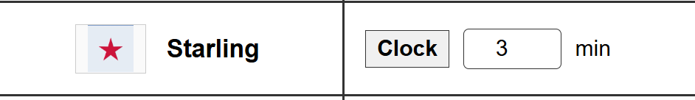
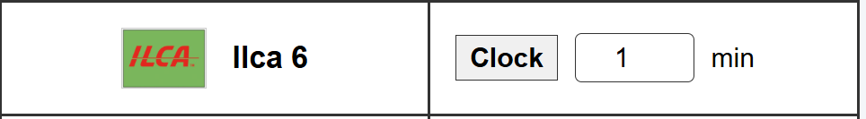
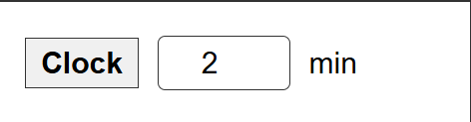

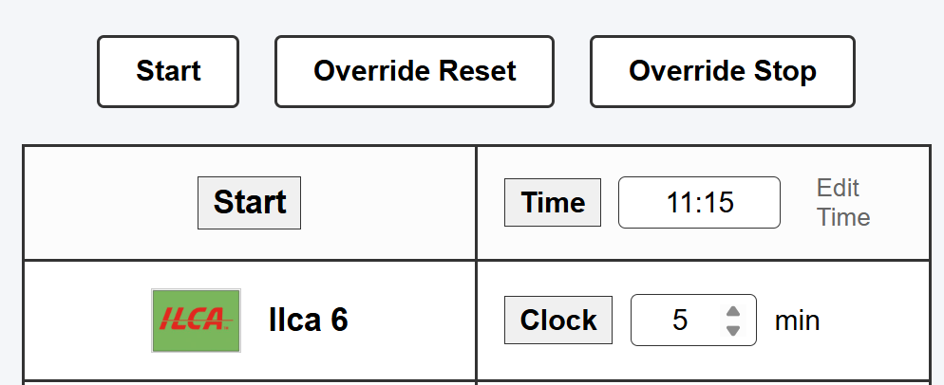
Hidden – the ilca race start – the flag goes down and the Starling goes up

P (blue peter – 2 minutes
Starling - 1 minute
(0 mins race starts and the sequence for next class)
In this version make a red o

