Code is present on Github at: https://github.com/antonoden/Java-Parser
It is written in Java and tested in the following environment:
IDE: VS Code -> Run Java
openjdk 21.0.7 2025-04-15 LTS
OpenJDK Runtime Environment Temurin-21.0.7+6 (build 21.0.7+6-LTS)
OpenJDK 64-Bit Server VM Temurin-21.0.7+6 (build 21.0.7+6-LTS, mixed mode, sharing)
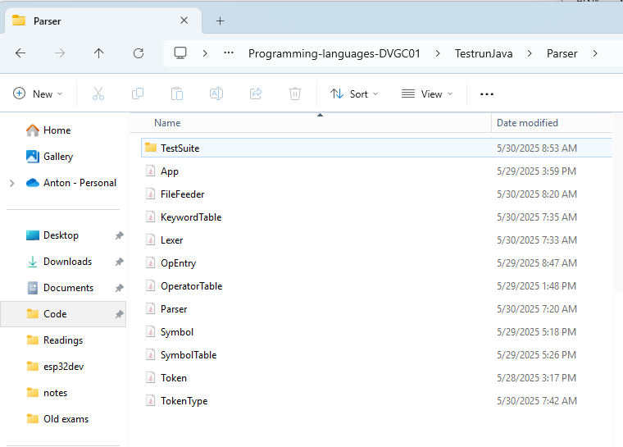
When Running Java in VS code on windows system call is made. I’ve added > output.out to add the prints to a file. The file directories are ofc different on another computer.
c:; cd 'c:\Users\anton\Code\Karlstad-University\Programming-languages-DVGC01\Lab4-Java-Parser'; & 'C:\Program Files\Eclipse Adoptium\jdk-21.0.7.6-hotspot\bin\java.exe' '-XX:+ShowCodeDetailsInExceptionMessages' '-cp' 'C:\Users\anton\AppData\Roaming\Code\User\workspaceStorage\22a1f594de400bf2344ae5e0b47a6fe0\redhat.java\jdt_ws\Lab4-Java-Parser_691e4c5c\bin' 'App' > output.out

Compared to the implementation in C this laboration contains more objects. For example SymbolTable is an object that makes a list of the object Symbol.
OperatorTable is an object that makes a list of the object OpEntry.
Token is the most used object as every time the parser tries to match a Token with what the grammar assumes it to be a new Token is created.

Class explanation

App
Initialize the program. Fetches files via FileFeeder. Then creates and parse the files fetched one at a time via Parser.

FileFeeder
Assumes that the pascalfiles to test is in filefolder Parser/TestSuite/ and that the sourcefiles also are in the Parser/
Saves all filePaths in a list and feed these filePaths one at a time via function getNextFile

Parser
Does all of printing. First off sends the filepath to the Lexer. Then fetches Tokens from the lexer one at a time to check that the program syntax is correct according to rules set up in Parser.

SymbolTable
Handles a list of symbols. First initialize some predefined symbols. Lets user add symbols in variant variable or program. Only handles one program. So multiple functions are not possible. Let user set type of all not yet defined variables. Feeds back the symboltable as a string upon request, then filter out predefined symbols.
A symbol contains name, role, type, size and address. As the symboltable is constructed today the only symbols added has the role .PROGRAM and .VAR inheritated from TokenType.

OperatorTable
Contains rules in a list of OPEntrys. OPEntrys contains operator, argument 1, argument 2 and result. The result is handed back to the user depending on the operator and arguments.

Lexer
First off reads in the file into Strings from the filepath was handed to lexer constructor. Then reads the file character by character to create a list of tokens. Makes use TokenType and KeywordTable. As KeywordTable is not used In many cases I could see benefits of adding a third value to tokentype for example role that would contain for example the role keyword.

Token
Takes in a TokenType. Also differs between ascii values and other Tokentypes. This differs should be removed by refactoring but time is limit.

KeywordTable
Contains a list of specific Keywords. Has some redundancy with TokenType so it should be aimed to be removed or that redundancy is removed.

TokenType
The most used enumeration throughout the code that does also contain a stringname of the enumeration.
