CS795 Vertex AI Assignment 2 Report
Anton Rasmussen
(Link to Colab: link)

Update Since Assignment 1

In Assignment 1, the goal was to train a simple scikit-learn model locally, upload it to Vertex AI Model Registry, and deploy it to a live endpoint for predictions. However, due to limited permissions and missing access to Cloud Logging, the deployment step could not be completed successfully.

Progress in Assignment 2

Since the last report, the deployment pipeline has been successfully completed. The RandomForestClassifier model was retrained on the Iris dataset and uploaded to Vertex AI using the managed scikit-learn prediction container. The following key milestones were achieved in this iteration:
- Model artifacts (model.pkl, sklearn_version.txt, and model directory) were uploaded to the GCS bucket instr-cs795-fall25-hqin-1-arasm002
- The model was registered and versioned in the Vertex AI Model Registry
- A live endpoint (iris-endpoint-20251009-024931) was successfully created and activated in the us-east4 region
- Batch inference and online prediction capabilities were tested through Vertex AI.

Troubleshooting and Error Resolution

During deployment, several errors were encountered due to model serialization format inconsistencies. The Vertex AI Log Explorer indicated an '_pickle.UnpicklingError: invalid load key' issue. This was resolved by ensuring that the model file was saved correctly using the same Python and scikit-learn versions as those in the Vertex AI runtime environment.

Deployment and Monitoring Screenshots
The following screenshots provide evidence of the successful model deployment and endpoint activity:
Active Vertex AI Endpoints
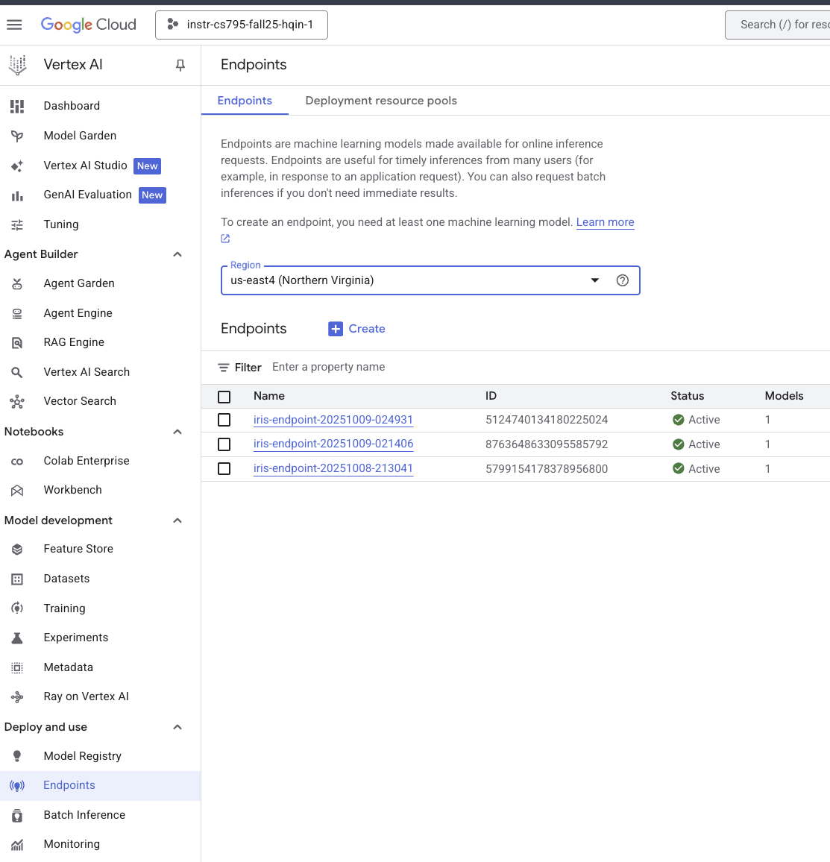

Model artifacts uploaded to GCS bucket
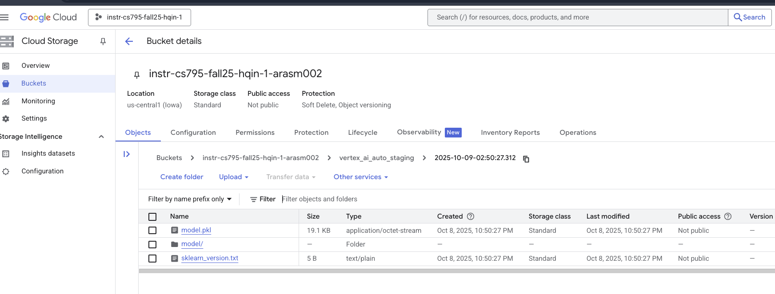
Error trace and Log Explorer output
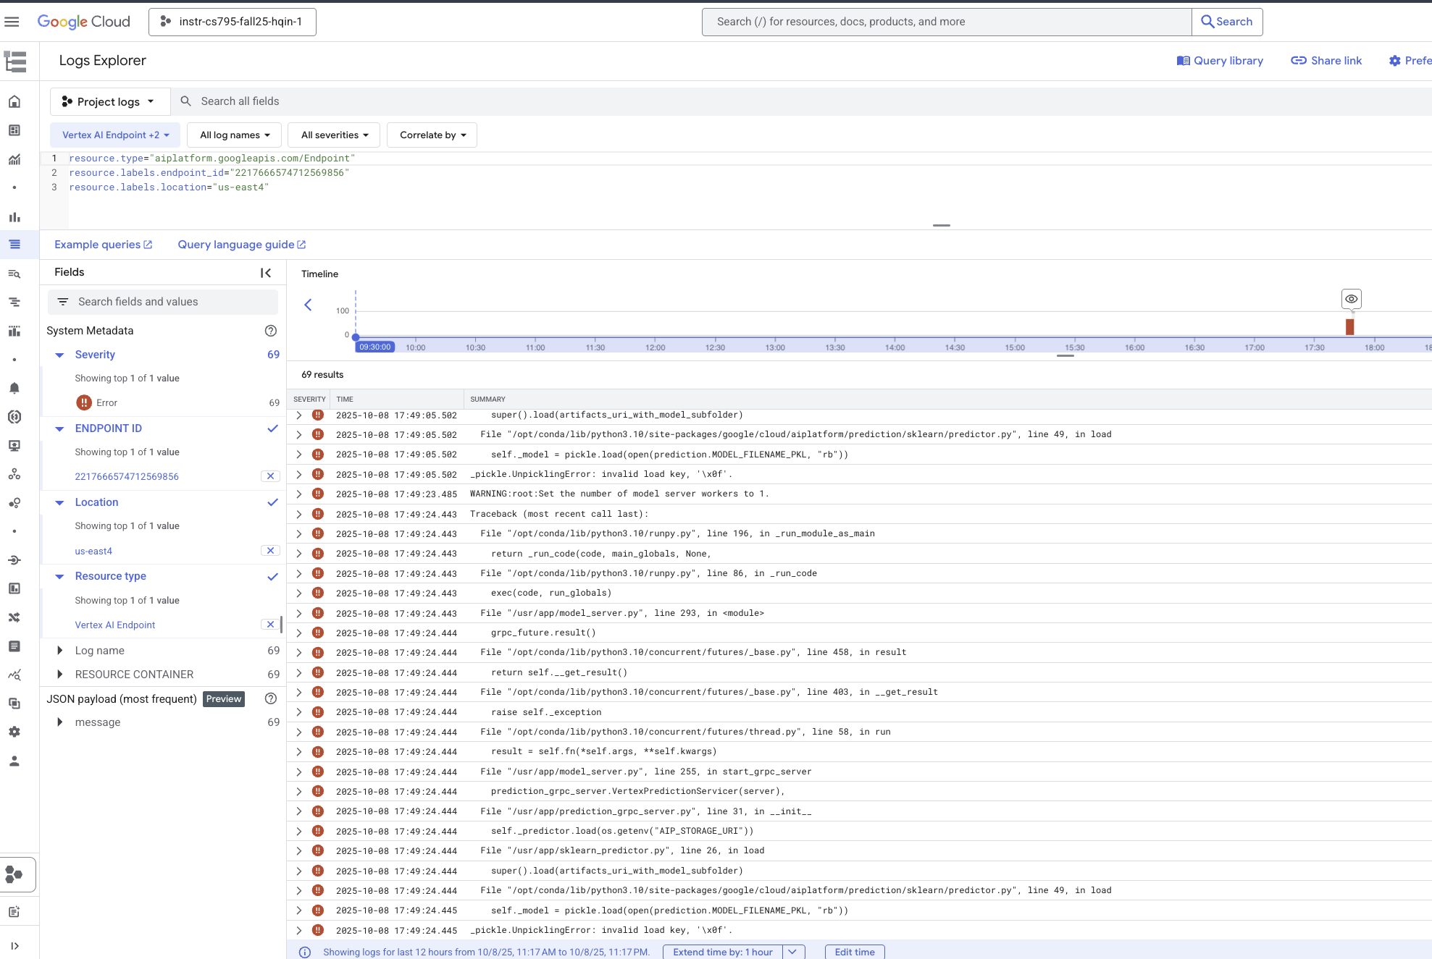

Batch inference job running successfully
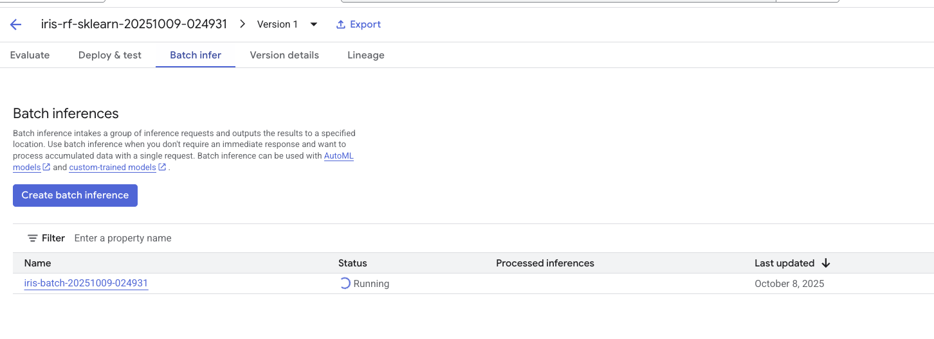
Model deployed to endpoint
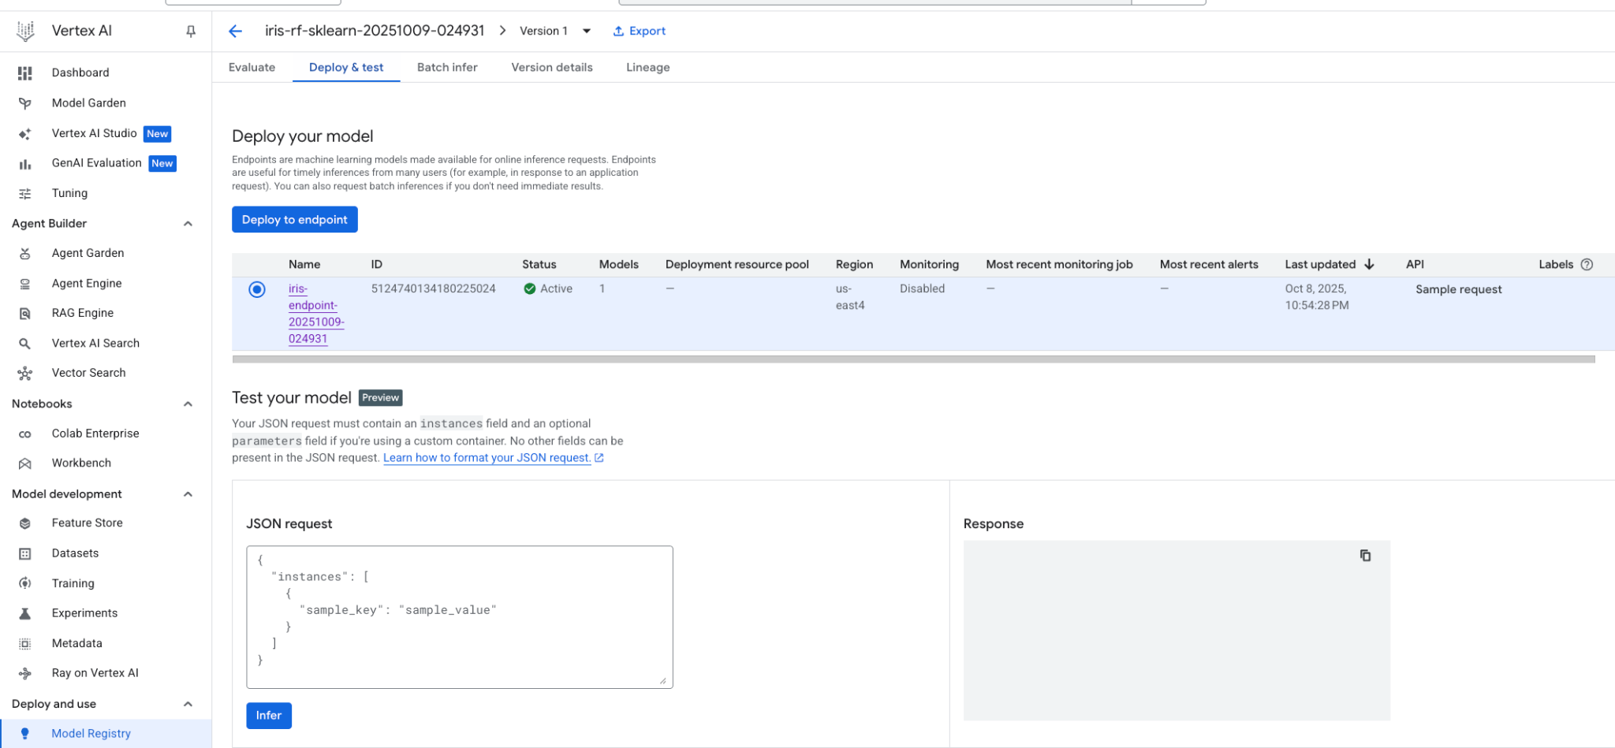
Endpoint showing inference activity metrics
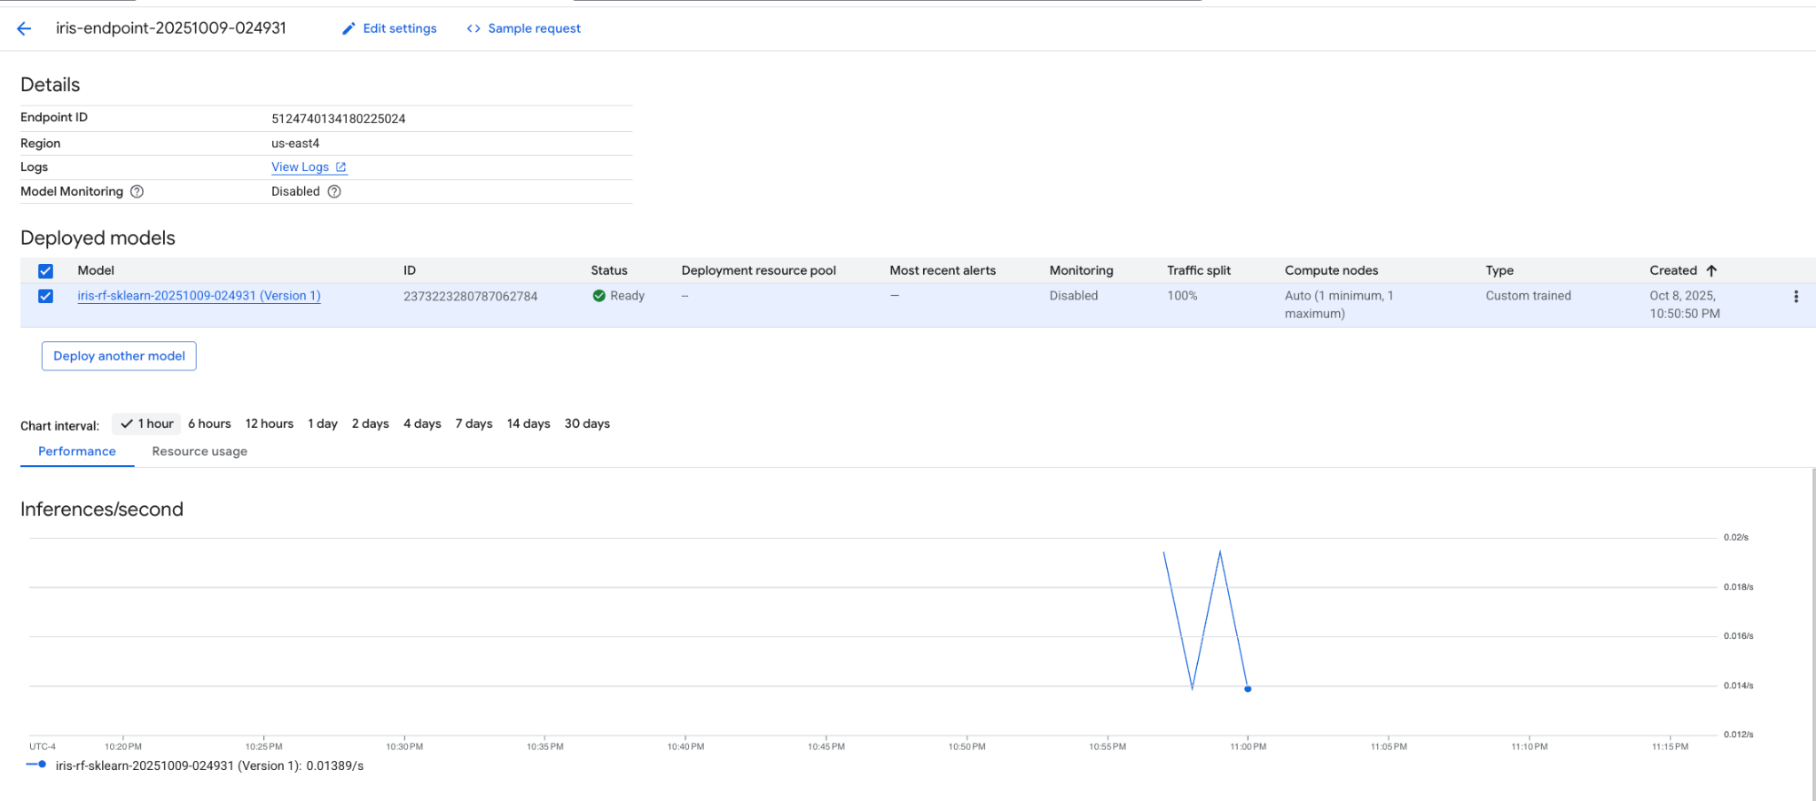

Conclusion

This iteration successfully completed the deployment and testing stages that were pending in Assignment 1. The Vertex AI environment was used to manage model registration, endpoint creation, and inference workloads. The process provided practical experience with end-to-end model operations on Google Cloud Vertex AI.

