Homework Assignment #3 (10 points)
Read chapter 15, 16 and 17 of your textbook.

- Create a webpage about an organization. The layout of this page should be similar to the following Microsoft page by using an outer table and inner tables. Feel free to make up some content for this organizational webpage. Name this page as assignment3.html (4 points).

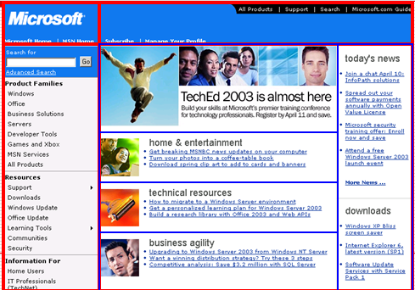

- Create a new webpage named feedback.html with a form exactly like the form below (3 points). A tip: you can make your form neat by formatting it with tables.

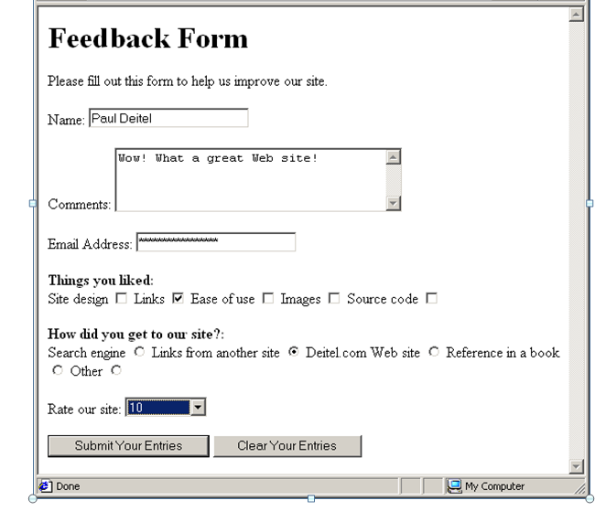

- Image maps are images with clickable areas (sometimes referred to as "hotspots") that usually link to another page. You will need to create an image map on your assignment 3 webpage involves using the <img ...>, <map ...>, and <area ...> tags. Please use the image shapes.jpg in Module>Lecture3 folder on Blackboard to create your image map. You need to add links to the rectangle, the circle, and the polygon. (3 points)

A tip: You may have an image editor Such as Paint on your own computer. You should also be able to find an image editor such as Adobe Photoshop in a computer lab. Most image editors will show you the coordinates of your mouse when you point in the image.

Please provide a link from your homepage to both assignment 3 and feedback web pages.

Assignment due time: 8am, Wednesday, 5/30. If you have any questions, please email me at whe@odu.edu.

