Command Air Intelligence Brief
Hungary-focused air power intelligence · 2026-W45 · UNCLASSIFIED // OSINT
EDITABLE EXPORT — GENERATED FROM AIRCRAFT TRACKER
Editable working copy. The canonical product is the released PDF. Editing this file does not change the report stored in Aircraft Tracker.
Field | Value
Report week | 2026-W45
Reporting window | 2026-10-26 → 2026-11-02
Generated | 2026-11-02 12:55 UTC
Methodology version | v3.0
HU relevance model version | hu-1.1
Template version | 1.0
Brief status | GENERATED · draft rev 0 · NOT APPROVED
Approved by | —
Revision | 2: Command Brief added (methodology v3.1); analytical content unchanged (2026-11-08 12:09 UTC)
Source traceability | 13 original sources (S-xx), hyperlinked in section 5

1. Hungary Air Intelligence Bottom Line

Bottom Line
Of 7 material air-power developments this week, 2 of HIGH relevance to Hungary. Poland FA-50 first 12 aircraft reach full operational capability; assume QRA duties (moderate confidence, effect immediate). [S-01 (official) · S-02 · S-03 · S-04] France to begin Rafale pilot training for Ukraine from November 2026 (moderate confidence, effect horizon not established). [S-05] Outside the region, the most significant changes were China PLA Navy GJ-21 stealth UCAV first deck operations from Type 076 LHA; US Navy MQ-25A Stingray LRIP contract awarded; FQ-42 CCA production partnership announced — globally important, but of low direct relevance to Hungary. [S-06 · S-07 · S-08] In Hungary's immediate and near region, material change was assessed for Poland, Ukraine; no material change was identified for Russia, Romania, Czechia, Lithuania. [S-01 (official) · S-02 · S-03 · S-04 · S-05] Collection gaps remain for Serbia, Belarus, Bosnia and Herzegovina, Austria, Slovakia; absence of reporting there is not evidence of inactivity.
Built from the assessed judgements, developments and coverage audit.

Primary key judgements
Ranked by Hungary relevance → air-power significance → confidence → immediacy. Max 3.

KJ 1 KJ-05 — We assess that Poland has completed the transition of its QRA commitment to the FA-50 for the first twelve-aircraft tranche, eliminating its last operational MiG-29 QRA role and establishing a Western-compatible light combat aircraft on air-defence alert.
HU HIGH · SIG 3/5 · CONF MODERATE · immediate
What changed: Poland fields an operationally ready light fighter/trainer-combat type on QRA, replacing MiG-29s in that role. The FA-50 provides a Western-compatible avionics and logistics baseline.
Assessment: This is the period's only confirmed immediate capability change. The QRA transition completes a logistics and doctrine break from Soviet-era platforms for this tranche, improving sustainment predictability and allied interoperability.
Why Hungary should care: Poland: NATO's largest eastern-flank air force build-up — sets the pace for regional allied capability.
Next observable: Polish Air Force reporting of QRA scrambles conducted by FA-50 in 2026–2027, confirming sustained operational use.
What would make this wrong: All supporting reporting traces to a single evidence chain, so independent confirmation could still overturn it.
Sources: S-01 (official) · S-02 · S-03 · S-04

KJ 2 XS-01 — France to begin Rafale pilot training for Ukraine from November 2026.
HU HIGH · SIG 3/5 · CONF MODERATE · horizon unknown · EXECUTIVE SYNTHESIS
What changed: Pilot training commencement is a necessary precondition for any future Rafale operational capability in the Ukrainian Air Force. It does not itself deliver aircraft or operational sorties.
Assessment: Training start is a credible indicator that the Ukraine Rafale programme is advancing beyond intent; however, without a delivery timeline the operational effect cannot be dated.
Why Hungary should care: Ukraine: neighbouring state at war — air activity and losses close to Hungary's north-eastern border.
Next observable: Confirmation that Ukrainian pilots have commenced Rafale conversion training in France.
What would make this wrong: All supporting reporting traces to a single evidence chain, so independent confirmation could still overturn it.
Sources: S-05

Secondary watch
Globally significant, but of low direct relevance to Hungary.
- China PLA Navy GJ-21 stealth UCAV first deck operations from Type 076 LHA. SIG 5/5 · HU LOW S-06
- US Navy MQ-25A Stingray LRIP contract awarded; FQ-42 CCA production partnership announced. SIG 4/5 · HU MINIMAL S-07 · S-08
- Ethiopia first delivery of Su-35SE fighters from Russia — 2 of 12 received. SIG 4/5 · HU MINIMAL S-09 · S-10

Regional air picture
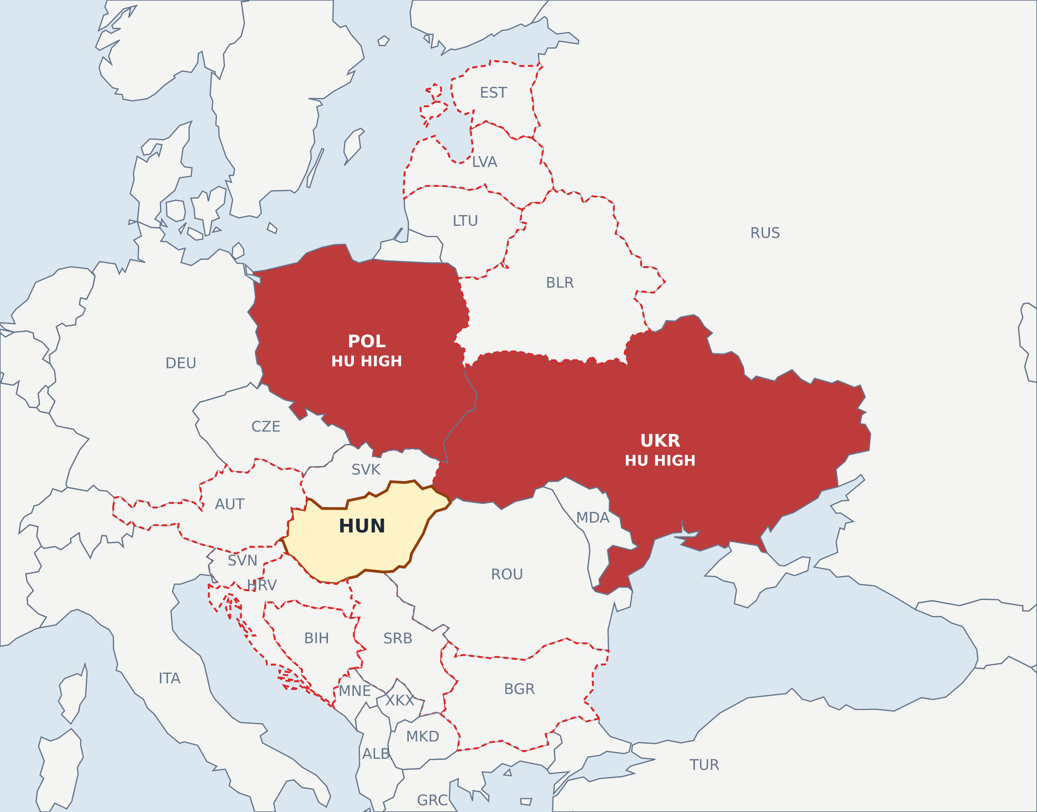
Figure 1 — Central and Eastern Europe — material developments coloured by Hungary relevance (not air-power significance). Dashed outline: collection gap. No hotspot does not mean no activity.

2. Immediate & Near-Regional Air Picture
Non-NATO priority · Hungary's neighbours · extended regional NATO — material changes only.
Country | What changed | Capability / operational effect | HU relevance | SIG | CONF · horizon | Next observable | Sources
Poland | Reporting confirmed on 29 October 2026 that the first 12 South Korean-built FA-50 light fighters delivered to Poland reached full operational readiness in 2026 and have taken over quick-reaction-alert duties previously held by MiG-29s. | Poland fields an operationally ready light fighter/trainer-combat type on QRA, replacing MiG-29s in that role. The FA-50 provides a Western-compatible avionics and logistics baseline. | HU HIGH Poland: NATO's largest eastern-flank air force build-up — sets the pace for regional allied capability. | 3/5 | moderate · <12 months | Delivery pace of the remaining 48 FA-50s on order to Poland. | S-01 (official) · S-02 · S-03 · S-04
Ukraine | France's Armed Forces Minister Catherine Vautrin announced in a parliamentary hearing on 8 October 2026 that France will begin training Ukrainian pilots on the Rafale fighter jet from November 2026. | Pilot training commencement is a necessary precondition for any future Rafale operational capability in the Ukrainian Air Force. It does not itself deliver aircraft or operational sorties. | HU HIGH Ukraine: neighbouring state at war — air activity and losses close to Hungary's north-eastern border. | 3/5 | moderate · horizon unknown | Confirmation that Ukrainian pilots have commenced Rafale conversion training in France. | S-05
No material change identified: Russia (partial) · Romania (partial) · Czechia (partial) · Lithuania (partial)
Collection gap: Serbia · Belarus · Bosnia and Herzegovina · Austria · Slovakia · Croatia · Slovenia · Bulgaria · Estonia · Latvia. Absence of reporting is not evidence of inactivity.
Coverage (60 days): Hungary PARTIAL* · Russia PARTIAL* · Ukraine ADEQUATE* · Serbia GAP* · Belarus GAP* · Bosnia and Herzegovina GAP* · Austria GAP* · Slovakia GAP* · Romania PARTIAL* · Croatia GAP* · Slovenia GAP* · Poland ADEQUATE* · Czechia PARTIAL* · Bulgaria GAP* · Estonia GAP* · Latvia GAP* · Lithuania PARTIAL*
* no official air force / MoD source in collection.

Regional collection requirements
Gap → intelligence question → desired observable.
Country | Status | Collection gap | Question | Observable
Serbia | GAP | No reporting reached the collection in 60 days. | Has Serbia changed its fighter procurement, readiness, basing or exercise activity (Rafale introduction, MiG-29 status)? | Rafale delivery or training milestones, MiG-29 grounding or upgrade news, Serbian Air Force exercise announcements.
Belarus | GAP | No reporting reached the collection in 60 days. | Has Russian aviation basing or deployment in Belarus changed? | Russian combat aircraft or air defence units arriving at or leaving Belarusian air bases; joint exercise announcements.
Bosnia and Herzegovina | GAP | No reporting reached the collection in 60 days. | Is there any change in Bosnia and Herzegovina's air force or EUFOR air activity? | Helicopter procurement or donation news, EUFOR exercise announcements.
Austria | GAP | No reporting reached the collection in 60 days. | Has Austria moved on Eurofighter succession, trainer replacement or Sky Shield integration? | Bundesheer procurement decisions, Sky Shield participation steps, air policing statements.
Slovakia | GAP | No reporting reached the collection in 60 days. | Is Slovakia's F-16 fleet operational for QRA, and who covers its airspace? | Slovak F-16 operational declaration, QRA assumption, end of Allied cover arrangements.
Croatia | GAP | No reporting reached the collection in 60 days. | What is the readiness of Croatia's Rafale fleet and its role in regional air policing? | Rafale FOC or QRA announcements, regional air policing agreements.
Geography sets collection priority, not inclusion: a country appears in the table only if a material development was assessed. 'No material change identified' is stated only where collection was at least PARTIAL; elsewhere it is a collection gap.

3. Extended Air Power Picture

Middle East (coverage partial)
NO MATERIAL CHANGE IDENTIFIED

Africa (coverage partial)
Ethiopia — Ethiopia first delivery of Su-35SE fighters from Russia — 2 of 12 received. (Fighter / strike)
Assessment: The Su-35SE delivery marks Ethiopia's first confirmed acquisition of a Russian fourth-generation-plus fighter and introduces a new high-end air combat capability into the Horn of Africa sub-region; regional air balance implications warrant monitoring, but operationally usable capability cannot be assessed without IOC, pilot readiness, and sustainment data.
HU MINIMAL · SIG 4/5 · CONF MODERATE · <12 months Sources: S-09 · S-10

Wider NATO (coverage partial)
United States — US Navy MQ-25A Stingray LRIP contract awarded; FQ-42 CCA production partnership announced. (Uncrewed / CCA)
Assessment: MQ-25A LRIP is the most concrete near-term step toward restoring organic carrier tanking and extending CVW strike reach; the programme is now in production.
HU MINIMAL · SIG 4/5 · CONF MODERATE · >3 years Sources: S-07 · S-08
Canada — Canada first delivery of 2 F-35A fighters; 88-aircraft programme executing. (Fighter / strike)
Assessment: First deliveries confirm programme execution is under way; IOC in 2030 will close a growing capability gap as legacy Hornets age out.
HU MINIMAL · SIG 4/5 · CONF MODERATE · >3 years Sources: S-11

Capability Maturity Matrix
Development | HU | Intent | Committed | Contracted | Fielding | IOC | FOC
POL FA-50 FOC (12 ac) (Poland) | HIGH | ✓ | ✓ | ✓ | ✓ | ✓ | FOC
UKR Rafale pilot training (Ukraine) | HIGH | ✓ | ✓ | ✓ | ✓ | IOC
PRC GJ-21 deck IOC (China) | LOW | ✓ | ✓ | ✓ | ✓ | IOC
USN MQ-25A / FQ-42 CCA (United States) | MINIMAL | ✓ | ✓ | contract
ETH Su-35SE delivery (Ethiopia) | MINIMAL | ✓ | ✓ | ✓ | delivery
CAN F-35A first delivery (Canada) | MINIMAL | ✓ | ✓ | ✓ | delivery
IND Rafale M trials (India) | MINIMAL | ✓ | ✓ | ✓ | delivery
Capability maturity of this week's material developments: the filled cell is the stage reached as evidenced; earlier cells are implied, not observed. Losses and retirements are shown as withdrawal, outside the introduction chain. ✓ = earlier stage implied, not observed.

Executive Change Table — against 2026-W44 (published)
Priority | Country | Capability | Previous | Current | Change | HU relevance | Confidence
1 | Poland | POL FA-50 FOC (12 ac) | not reported | FOC · moderate | new to the reporting this period | HIGH | moderate
2 | Ukraine | UKR Rafale pilot training | not reported | IOC · moderate | new to the reporting this period | HIGH | moderate
3 | China | PRC GJ-21 deck IOC | not reported | IOC · moderate | new to the reporting this period | LOW | moderate
4 | Ethiopia | ETH Su-35SE delivery | not reported | Delivery · moderate | new to the reporting this period | MINIMAL | moderate
5 | Canada | CAN F-35A first delivery | not reported | Delivery · moderate | new to the reporting this period | MINIMAL | moderate
6 | India | IND Rafale M trials | not reported | Delivery · moderate | new to the reporting this period | MINIMAL | moderate

4. Global Strategic Air Power Watch

Global Strategic
China — China PLA Navy GJ-21 stealth UCAV first deck operations from Type 076 LHA. (Uncrewed / CCA)
Assessment: This is a qualitative milestone: China has joined a very small group of nations to operate fixed-wing unmanned combat aircraft from a warship.
HU LOW · SIG 5/5 · CONF MODERATE · <12 months Sources: S-06
India — India Rafale M carrier trials aboard INS Vikrant; 26-aircraft contract executing. (Fighter / strike)
Assessment: Carrier trials reduce integration risk and keep the delivery schedule credible.
HU MINIMAL · SIG 4/5 · CONF MODERATE · 1-3 years Sources: S-12
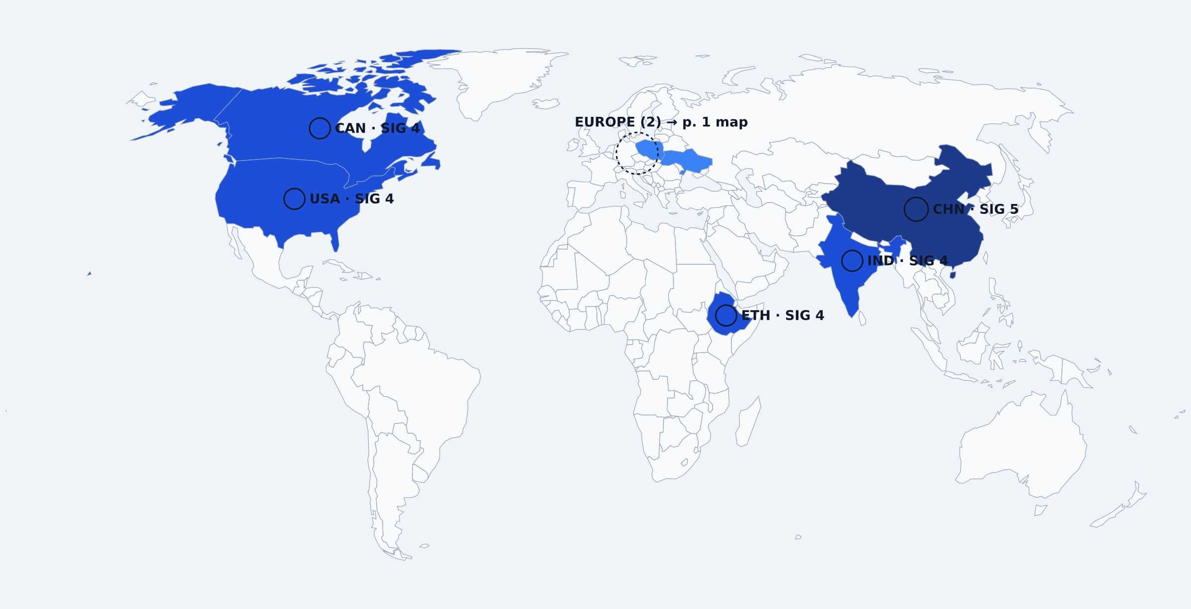
Figure 2 — Global hotspots coloured by air-power significance (1–5) — not by Hungary relevance. An unmarked country is not necessarily quiet.

Priority Intelligence Watch
1. Ukrainian Rafale delivery schedule HU MEDIUM
Why: Training commencement without a confirmed delivery date leaves a material uncertainty in allied air support planning for Ukraine; an unscheduled capability cannot be factored into force employment.
Next observable: French or Ukrainian government announcement of a Rafale delivery date or first aircraft transfer. (horizon quarters, impact high)
2. GJ-21 UCAV operational scaling from Type 076 HU MINIMAL
Why: If the GJ-21 moves from demonstration to embarked squadron operations, PLA Navy amphibious task groups acquire a low-observable strike and ISR vector that fundamentally changes threat calculations for US and allied forces in the Western Pacific.
Next observable: Confirmation of GJ-21 weapons clearance or a second Type 076 hull deploying with GJ-21 embarked. (horizon quarters, impact high)
3. Ethiopian Su-35SE IOC declaration and pilot readiness HU MINIMAL
Why: A BVR-capable fourth-generation-plus fighter becoming operationally available in the Horn of Africa would alter sub-regional air balance and create planning requirements for neighbouring states and partners.
Next observable: Ethiopian Air Force announcement of Su-35SE type IOC or evidence of operational pilot qualification. (horizon months, impact medium)
4. Indian Navy Rafale M IOC date HU MINIMAL
Why: The gap between carrier trial confirmation and IOC declaration determines how long India's carrier strike capability remains below fourth-generation BVR standard, with direct implications for Indian Ocean regional balance.
Next observable: Indian Ministry of Defence announcement of a Rafale M IOC date or confirmation of first delivery in late 2028. (horizon quarters, impact medium)
5. MQ-25A LRIP delivery and IOC progress HU MINIMAL
Why: Carrier air wing strike radius planning remains constrained until MQ-25A achieves an operationally declared organic tanking capability; LRIP delivery confirmation in 2029 is the next concrete programme gate.
Next observable: Boeing delivery of first MQ-25A LRIP aircraft to the US Navy. (horizon quarters, impact medium)

Intelligence Gaps
- GJ-21 UCAV: Fleet size, weapons integration status, sensor suite, sortie generation rate, and operator pipeline for the GJ-21 programme remain entirely unreported; the IOC declaration cannot be net-assessed without these data.
- Ethiopian Su-35SE: Pilot training pipeline location and duration, sustainment arrangements with Russian industry, and the confirmed delivery status of the remaining ten of twelve contracted airframes are not established in available reporting.
- Ukrainian Rafale programme: No delivery date, IOC timeline, or weapons clearance schedule for Ukraine's 32-aircraft Rafale order has been reported; training commencement alone provides no basis for dating operational capability.
- Indian Navy Rafale M: No IOC date, carrier deck certification schedule, or weapons clearance timeline for the 26-aircraft programme has been reported; the operational gap between first delivery (stated late 2028) and combat-ready sorties cannot be bounded.
- No reporting reached the collection on Serbia, Belarus, Bosnia and Herzegovina, Austria, Slovakia, Croatia in 60 days, so quiet cannot be told from unobserved there. (coverage audit)

Outlook & Expected Observables — next 7–30 days
- POL FA-50 FOC (12 ac) (Poland) — Delivery pace of the remaining 48 FA-50s on order to Poland. S-01 (official) · S-02 · S-03 · S-04
- UKR Rafale pilot training (Ukraine) — Confirmation that Ukrainian pilots have commenced Rafale conversion training in France. S-05
- PRC GJ-21 deck IOC (China) — Further GJ-21 operational sorties or weapons release tests from Type 076 Sichuan. S-06
- USN MQ-25A / FQ-42 CCA (United States) — Award of MQ-25A Lot 2 contract and confirmation of 2029 first delivery. S-07 · S-08
- ETH Su-35SE delivery (Ethiopia) — Confirmation of remaining 10 Su-35SE deliveries to Ethiopia and basing location. S-09 · S-10
Expected observables for the next 7–30 days: what would confirm, move or disprove this week's assessments. An intelligence outlook, not an event calendar.

5. Sources & Legend

Source register — evidence behind each judgement
ID | Source · tier | Title (original language) | Published | Evidence role | Country · lang | Lineage | Evidence for | Context for
S-01 | Polish Minister of National Defence (official X account) · T1 official | Statement by Minister of National Defence W. Kosiniak-Kamysz on X: FA-50GF light fighters have entered combat duty — Primary official statement. The minister refers to 'dyżur bojowy' (combat alert duty); the term 'QRA' appears only in secondary reporting. | 2026-10-02 (analyst-verified) | Primary (official) | Poland · pl | L-01 | KJ-05, p.2 Poland, p.4 outlook | —
S-02 | Defence24.pl · T3 | FA-50GF weszły w dyżur bojowy. Polskie samoloty wzmocnią ochronę wschodniej granicy — Reports and quotes the minister's statement. | 2026-10-03 (analyst-verified) | Corroborating | Poland · pl | L-01 | KJ-05, p.2 Poland, p.4 outlook | —
S-03 | Militarnyi · T3 | Polish FA-50s Have Begun Combat Duty — Reports the minister's statement and links the official post. | 2026-10-03 (analyst-verified) | Corroborating | Poland · en | L-01 | KJ-05, p.2 Poland, p.4 outlook | —
S-04 | Aviation Week · T3 | FA-50s Begin Polish Air Protection Duties — States that the minister declared the 12 FA-50GF operational on 2 October 2026 (paywalled). | 2026-10-05 (analyst-verified) | Corroborating | Poland · en | L-01 | KJ-05, p.2 Poland, p.4 outlook | —
S-05 | Defense News · T3 | France to start training Ukrainian pilots on Rafale warplanes in November, minister says | 2026-10-08 | Corroborating | Ukraine · en | L-02 | XS-01, p.2 Ukraine, p.4 outlook | —
S-06 | The Aviationist · T3 | China Claims GJ-21 Naval UCAV has Flown from Type 076 Sichuan LHD | 2026-10-30 | Corroborating | China · en | L-03 | p.1 watch, p.4 China, p.4 outlook | —
S-07 | The Aviationist · T3 | Boeing Moves Second MQ-25A Stingray Airframe to Illinois for Final Assembly | 2026-10-27 | Corroborating | United States · en | L-04 | p.1 watch, p.3 United States, p.4 outlook | —
S-08 | Airforce Technology · T3 | GA-ASI selects Spirit Defense for FQ-42 combat aircraft fuselage work | 2026-10-26 | Corroborating | United States · en | L-05 | p.1 watch, p.3 United States, p.4 outlook | —
S-09 | The Aviationist · T3 | Ethiopia Receives First Russian Su-35 Fighters in Moscow | 2026-10-30 | Corroborating | Ethiopia · en | L-06 | p.1 watch, p.3 Ethiopia, p.4 outlook | —
S-10 | Airforce Technology · T3 | Ethiopia receives 12 Su-35 jets from Russia, S-400 systems to follow | 2026-10-30 | Corroborating | Ethiopia · en | L-07 | p.1 watch, p.3 Ethiopia, p.4 outlook | —
S-11 | Overt Defense · T3 | Canada Receives its First Two F-35 fighters | 2026-10-27 | Corroborating | Canada · en | L-08 | p.3 Canada | —
S-12 | The Aviationist · T3 | Rafale M Conducts Trials Aboard Indian Navy’s INS Vikrant Aircraft Carrier | 2026-10-31 | Corroborating | India · en | L-09 | p.4 India | —
S-13 | Defence Blog · T3 | Poland hands Ukraine two more MiG-29 fighter jets | 2026-10-29 | Context only — not evidence | Poland · en | — | — | KJ-05, p.2 Poland, p.4 outlook
Each S-xx links to the publication it names; titles are shown in their original language. Items cite only sources that directly report their subject: an official (Tier 1) source comes first where one exists, specialist media follow as corroboration. 'Context' sources are listed for audit but are not cited as evidence. 'Published' is the article's own publication date (from the feed or the article URL) — never an event, contract or milestone date; blank means not recorded. Lineage groups publications restating one evidence chain; state-controlled sources are attributed statements, not independent confirmation.

Legend

Hungary relevance (HU)
HIGH — Directly affects Hungary, its airspace, MH capability planning or NATO's Central/Eastern European air posture.
MEDIUM — Affects the regional air picture or Allied posture around Hungary, but not Hungary directly.
LOW — A weak or indirect tie (distant actor, supplier link, doctrinal interest).
MINIMAL — No direct link to Hungary, MH or NATO Central/Eastern Europe identified.

Air-power significance (SIG)
1/5 — Routine; no capability effect.
2/5 — Minor or administrative change.
3/5 — A real but limited capability change.
4/5 — A major national capability change.
5/5 — A change with regional or global strategic weight.

Analytic confidence (CONF)
LOW — First indication; thin or single-source reporting.
MODERATE — Credible reporting; not independently confirmed, or a single evidence lineage.
HIGH — Multiple independent lineages or authoritative primary evidence.

Effect horizon
immediate — The effect exists now.
<12 months — Earliest operational effect within a year.
1–3 years — Earliest operational effect in one to three years.
>3 years — No near-term operational effect.
unknown — Timing is not established in reporting.

Collection status
ADEQUATE — At least 4 events from at least 2 sources in 60 days.
PARTIAL — Some reporting, below the adequate threshold.
GAP — No reporting reached the collection in 60 days; absence of reporting is not evidence of inactivity.
NO MATERIAL CHANGE IDENTIFIED — Collection was at least PARTIAL and nothing material was assessed.

Analytical terminology
FACT — What the source states, attributed.
ASSESSMENT — Our judgement of what the fact means.
CAPABILITY DELTA — What changes in capability terms.
POLICY / INTENT — A stated plan or requirement; no commitment.
FIELDING — Aircraft or systems are being delivered to units.
IOC — Initial operational capability: a first unit can conduct the mission.
FOC — Full operational capability at planned scale.
OPERATIONAL — Employed in its role (IOC or beyond).
NEXT OBSERVABLE — The next concrete, checkable sign that would confirm or move the assessment.
INTELLIGENCE GAP — A question collection could not answer that would change the assessment.

Analytical discipline
- significance ≠ confidence: how much it matters is not how sure we are.
- procurement ≠ operational capability: a contract or delivery is not combat power.
- delivery ≠ IOC: aircraft handed over are not a declared operational unit.
- multiple articles ≠ independent evidence lineage: outlets restating one release are one lineage.
- official statement ≠ independent confirmation: state-controlled sources count as one lineage and are always attributed.

