BLUEPRINT SISTEM
Property Management System – Odoo 19 Community
Arsitektur • Katalog Modul • Manual Instalasi • Konfigurasi Sistem

Dokumen | System Blueprint, Installation & Configuration Manual
Platform | Odoo 19 Community Edition
Basis | addon rental_management v3.3.9 (TechKhedut)
Lingkup | 26 modul companion + integrasi modul standar Odoo
Disusun oleh | System Analyst / Functional & Odoo Developer
Tanggal | 20 Juni 2026

1. Ringkasan Eksekutif & Arsitektur
Sistem ini adalah Property Management System (PMS) komprehensif yang dibangun di atas addon pihak ketiga rental_management (TechKhedut) untuk Odoo 19 Community. Fungsionalitas diperluas melalui 26 modul companion yang masing-masing bersifat opsional (decoupled) dan terintegrasi dengan modul standar Odoo: Accounting, Analytic, Purchase, Project, CRM, Portal, Maintenance, Product, Website, Mail.

1.1 Prinsip Arsitektur
- Non-invasif: Companion, bukan fork: addon berlisensi tidak ditambal; semua ekstensi via modul terpisah.
- Decoupled: Tiap modul mengecek keberadaan field/model sebelum memakainya → dapat diinstal mandiri.
- Terintegrasi: Semua transaksi keuangan ditautkan ke properti & otomatis ter-tag analytic saat posting.
- Standar Odoo: Mengandalkan account.move / analytic / portal standar Odoo, bukan ledger paralel.

1.2 Lapisan Sistem
Lapisan | Komponen
Operasional Leasing | Kontrak, CRM, Casual Leasing, Handover, GTO, Meter, Parking, Vacancy, Lease Expiry, Guarantee, Insurance, Access/Visitor, E-sign, PPM
Keuangan & Akuntansi | Owners Statement (9 laporan), Trust Accounting, Owner Remittance (multi-currency), Budget (+approval), Security Deposit, CAM, Rent Escalation, Dunning, Fixed Asset+Revaluation, Valuation, Procurement, CORETAX, Analytic
Self-Service | Tenant Portal, Owner Portal
Analitik | KPI Dashboard, Analytic Accounting, laporan standar Odoo
Dokumen | Documents (Enterprise) / Documents CE (Community)

1.3 Diagram Arsitektur
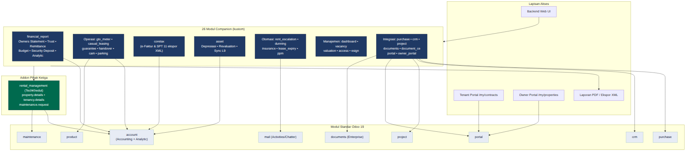
Gambar 1. Arsitektur sistem berlapis: Lapisan Akses → 26 modul companion → addon rental_management → modul standar Odoo 19.
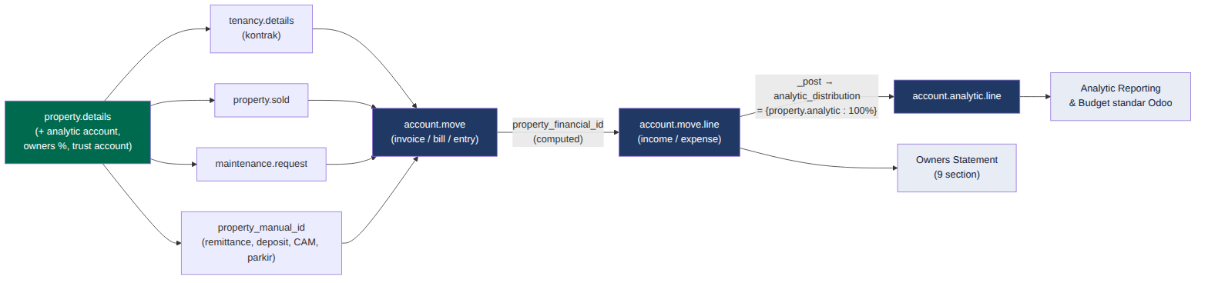
Gambar 2. Arsitektur data — rantai atribusi properti hingga analytic & Owners Statement.
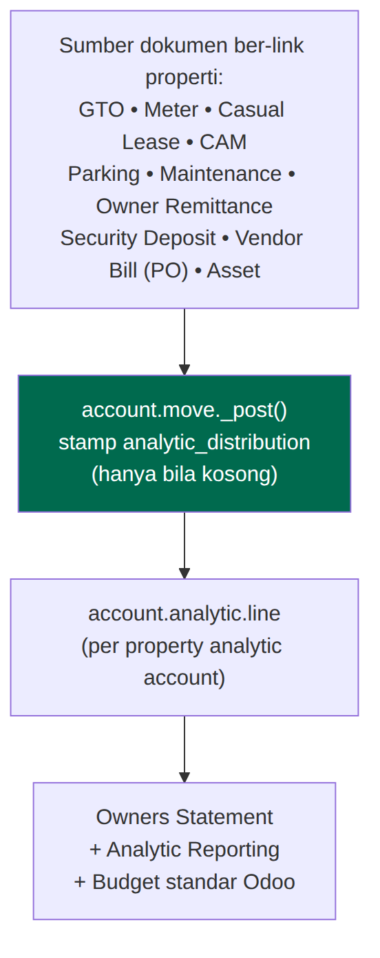
Gambar 3. Integrasi cross-cutting: override account.move._post mencap analytic seluruh dokumen.

2. Katalog Modul (26)
Modul | Area | Fitur Utama | Menu | Konfigurasi Kunci
rental_management_financial_report | Keuangan | Owners Statement 9 laporan, Trust, Remittance, Budget+approval, Deposit, Analytic stamping | Properties → Financial Reports | CoA→Report Category, Trust/Deposit accounts & journals, owners %
rental_management_gto_meter | Leasing | GTO/Revenue sharing, Meter & utility recharge | Properties → Leasing Operations | GTO % di kontrak, produk GTO/utility, tarif meter
rental_management_guarantee | Risiko | Bank/Insurance guarantee + alert expiry | Properties → Tenant Guarantees | reminder lead days; cron aktif
rental_management_casual_leasing | Leasing | Sewa jangka pendek (booth/kios) | Properties → Casual Leases | produk Casual Leasing
rental_management_handover | Operasional | Move-in/Fit-out/Move-out + checklist | Properties → Handovers | —
rental_management_portal | Self-Service | Tenant portal /my/contracts | /my | grant portal access ke tenant
rental_management_coretax | Pajak | e-Faktur & SPT CORETAX (11 ekspor XML) | Properties → CORETAX | TIN/IDTKU company & partner, kode produk
rental_management_purchase | Procurement | PO↔properti/kontrak/maintenance → bill | Properties → Property Purchase Orders | aktifkan app Purchase
rental_management_crm | Sales | Pipeline leasing, Create Lease Contract | CRM | team Property Leasing
rental_management_project | Operasional | Fit-out → Project & Task | form Handover (Fit-out) | aktifkan app Project
rental_management_documents | Dokumen | Folder Documents per properti | form Properti (Documents) | Enterprise; app Documents
rental_management_asset | Aset | Fixed asset, depreciation, revaluation, sync L9 | Properties → Fixed Assets | akun aset/akumulasi/beban/reserve & journal
rental_management_document_ce | Dokumen | Lampiran properti via ir.attachment (Community) | form Properti (Files) | —
rental_management_owner_portal | Self-Service | Owner portal /my/properties + remittance | /my | grant portal access ke owner
rental_management_cam | Keuangan | CAM/Service charge: budget vs actual + apportion | Properties → CAM / Service Charge | produk Service Charge, total area, area tenant
rental_management_rent_escalation | Leasing | Kenaikan sewa berkala otomatis (cron) | tab kontrak + Rent Escalation Log | tipe/nilai/frekuensi/next date di kontrak; cron
rental_management_dashboard | Analitik | KPI: NOI, arrears, collection, WALE | Properties → KPI Dashboard | —
rental_management_dunning | Keuangan | Tangga dunning + late fee (cron) | Properties → Dunning Levels | level (hari), template email, produk late fee; cron
rental_management_insurance | Risiko | Polis asuransi bangunan + alert expiry | Properties → Insurance Policies | reminder lead; cron
rental_management_lease_expiry | Leasing | Daftar lease berakhir + reminder perpanjangan | Properties → Lease Expiry | reminder days; cron
rental_management_vacancy | Leasing | Papan vacancy/availability per status | Properties → Vacancy / Availability | —
rental_management_ppm | Maintenance | PPM otomatis generate maintenance request (cron) | Properties → Preventive Maintenance | frekuensi/next date/SLA; cron
rental_management_parking | Operasional | Bay parkir, alokasi & invoice | Properties → Parking | produk Parking, tarif
rental_management_valuation | Aset | Valuasi pasar berkala | Properties → Property Valuations | —
rental_management_access | Operasional | Access/parking card + visitor log | Properties → Access & Visitors | —
rental_management_esign | Operasional | Tracking permintaan tanda tangan kontrak | Properties → Signature Requests | —

3. Arsitektur Data & Integrasi
Rantai atribusi properti yang menyatukan seluruh transaksi keuangan:
tenancy_id / sold_id / maintenance_request_id / property_manual_id → account.move.property_financial_id (stored) → Owners Statement (filter) + Analytic stamping pada account.move._post()
- Pendapatan: sewa, GTO, meter, casual lease, CAM, parking → out_invoice ber-tag properti.
- Beban: maintenance, vendor bill dari PO, penyusutan aset, late fee → ber-tag properti.
- Trust/Owner: owner remittance & security deposit posting account.move.
- Saat posting, baris income/expense otomatis dicap analytic account properti → laporan Analytic & Budget standar Odoo.
Semua invoice yang dibuat modul-modul ini diberi tenancy_id atau property_manual_id, sehingga muncul otomatis di Owners Statement (Payment Details, Income & Expenditure) dan analytic per properti.
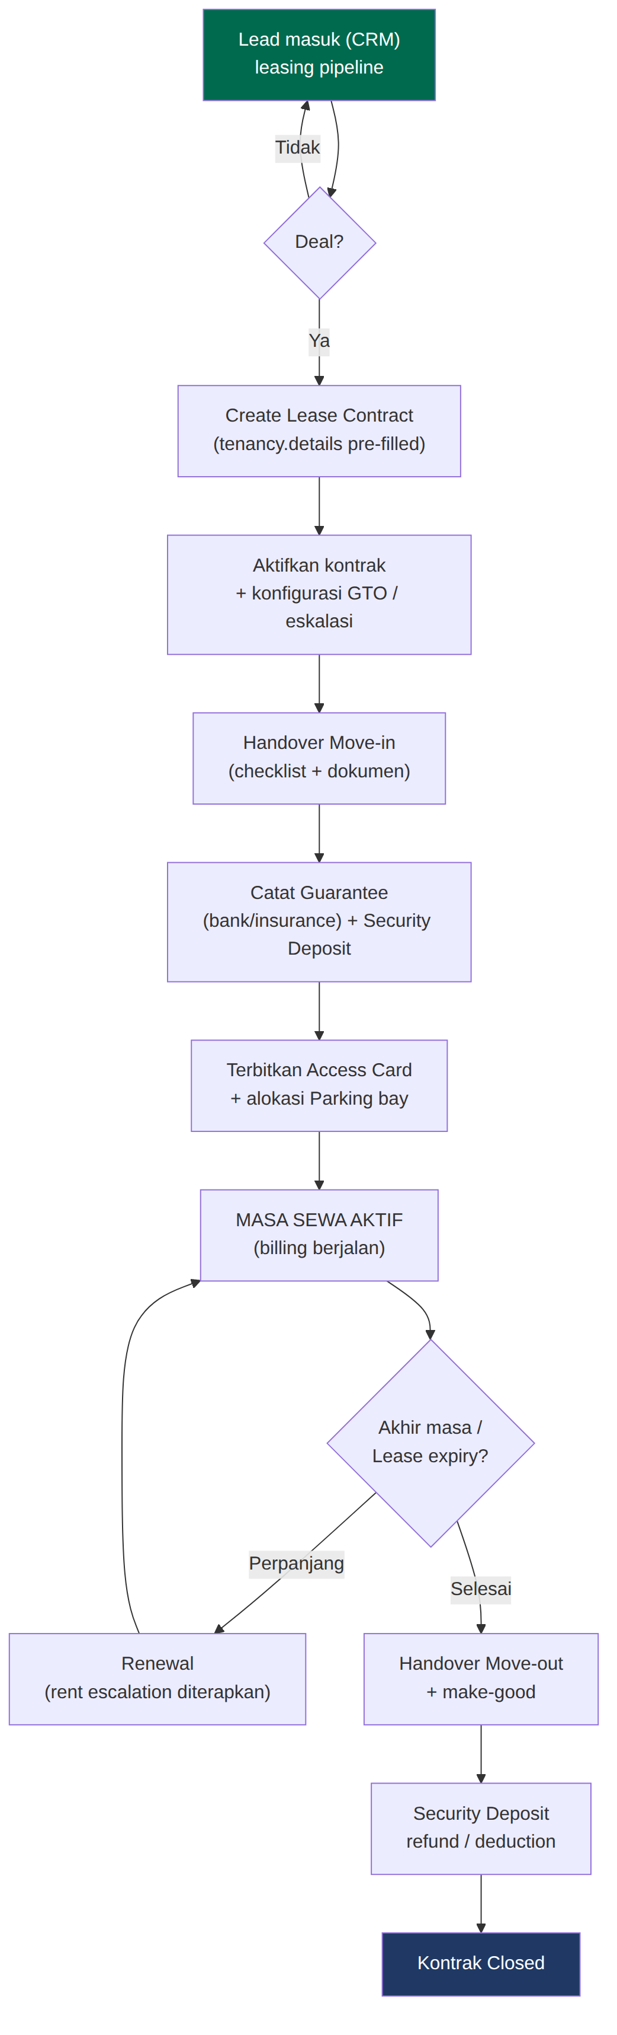
Gambar 4. Siklus hidup tenant end-to-end (lead → aktivasi → billing → move-out).

4. Manual Instalasi

4.1 Prasyarat
- Platform: Odoo 19 Community Edition (server berjalan, akses admin).
- Database: PostgreSQL 14+; Python 3.11+ dengan dependensi Odoo standar.
- Base addon: Addon dasar rental_management (TechKhedut) v3.3.9 — wajib (lisensi OPL-1/berbayar).
- Apps Odoo: Modul standar diaktifkan: Accounting, Purchase, Project, CRM, Portal, Maintenance, Website.
- Enterprise: Opsional Enterprise: app Documents (hanya untuk rental_management_documents; gunakan rental_management_document_ce di Community).
- Infra: Worker cron Odoo aktif (untuk escalation, dunning, PPM, expiry alerts) & outgoing mail server (untuk dunning).

4.2 Langkah Instalasi
- Salin folder addon dasar rental_management dan ke-26 folder rental_management_* ke addons_path Odoo (mis. /opt/odoo/addons atau path kustom).
- Pastikan addons_path di odoo.conf memuat lokasi tersebut; restart service Odoo.
- Aktifkan Developer Mode (Settings → Developer Tools) lalu Apps → Update Apps List.
- Install modul standar Odoo terlebih dahulu: Accounting, Purchase, Project, CRM, Portal, Maintenance.
- Install addon dasar: rental_management.
- Install fondasi keuangan: rental_management_financial_report (disarankan lebih dulu karena modul lain memanfaatkan field property_manual_id & analytic).
- Install modul lain sesuai kebutuhan (semua decoupled). Untuk paket lengkap, install seluruh 26 modul.
- Verifikasi tidak ada error pada log saat instalasi; periksa menu Properties bertambah.

4.3 Urutan Dependensi (ringkas)
Grup | Modul | Prasyarat
Inti | rental_management | account, crm, maintenance, website, hr, mail
Fondasi keuangan | rental_management_financial_report | rental_management, account
Keuangan lanjutan | cam, dunning, asset, coretax, parking, casual_leasing, gto_meter, valuation | rental_management (+account)
Operasional | handover → project, ppm, access, esign, guarantee, insurance, lease_expiry, vacancy, rent_escalation | rental_management (+mail/project)
Self-service | portal (tenant), owner_portal | portal (+financial_report)
Dokumen | documents (Enterprise) / document_ce (Community) | documents / rental_management
Analitik | dashboard | rental_management, account

5. Konfigurasi Sistem (Detail)
Bagian ini menjabarkan konfigurasi tingkat-field per area. Ikuti urutan 5.1 → 5.12. Tanda (Wajib) menunjukkan setting yang harus diisi agar laporan/otomasi berfungsi; (Opsional) dapat dilewati bila modul terkait tidak dipakai.

5.1 Perusahaan & Akuntansi Dasar (Wajib)
- Settings → Companies: lengkapi data perusahaan (nama legal, NPWP, alamat, mata uang fungsional).
- Accounting → Configuration → Settings: aktifkan "Analytic Accounting" dan (bila perlu) "Multi-Currencies" serta "Multi-Companies".
- Pastikan Fiscal Localization / Chart of Accounts sudah terpasang sebelum memetakan Report Category.
- Accounting → Configuration → Journals: siapkan jurnal Sales, Purchase, Bank, Miscellaneous; tambahkan jurnal khusus bila perlu (Trust, Remittance, Deposit, Depreciation).

5.2 Pemetaan Akun → Report Category Owners Statement (Wajib)
Owners Statement mengelompokkan baris GL berdasarkan field "Property Report Category" (model property.financial.category) pada tiap akun. Tanpa pemetaan ini, angka tidak masuk section yang benar. Buat kategori di Properties → Financial → Report Categories lalu set pada akun (Accounting → Chart of Accounts → buka akun → field Property Report Category).
Section Laporan | Tipe | Contoh Akun GL | Catatan
Rental Income | Income | 4-xxxx Pendapatan Sewa | sewa pokok kontrak
Tenant Recharge Income | Income | 4-xxxx Recharge Utilitas/CAM | meter, CAM, service charge
Other / GTO Income | Income | 4-xxxx Pendapatan GTO/Parkir | GTO, parkir, casual lease
Property Expenses | Expense | 6-xxxx Beban O&M, utilitas | maintenance, utilitas, kebersihan
Management Fee | Expense | 6-xxxx Management Fee | fee pengelola
Capital Expenditure | Capital | 1-xxxx CWIP / Aset | pengeluaran kapital (di bawah Net Cash)
GST/PPN Control | Tax | 2-xxxx PPN Keluaran/Masukan | untuk GST Reconciliation

- Sub-group: gunakan field parent pada kategori untuk membentuk hierarki section/sub-group (struktur MR-style).
- Akun trust/deposit/remittance TIDAK dipetakan ke Income/Expense (lihat 5.4–5.5) agar tidak terhitung sebagai pendapatan.

5.3 Konfigurasi per Properti (Wajib)
- Buka properti → tab "Owners & Financial".
- Owners: tambahkan baris pemilik + ownership % (total harus 100%). Isi Property Manager, telepon, faks (tampil di kop Owners Statement).
- Klik "Create Analytic Account" → membuat account.analytic.account khusus properti (dipakai stamping otomatis).
- Isi data fisik (luas/area) bila memakai CAM apportionment by area.

5.4 Trust Accounting & Owner Remittance (Wajib bila pakai trust)
Field (per properti) | Tipe Akun | Fungsi
Trust Bank Account | Bank/Asset | rekening penampung dana milik owner
Owners Remittance Account | Liability/Payable | utang ke owner saat remittance
Remittance Journal | Journal (Misc/Bank) | jurnal posting remittance

- Posting: Posting remittance: Dr Owners Remittance / Cr Trust Bank. Multi-currency: pilih Remittance Currency; konversi ke mata uang perusahaan pada kurs tanggal remittance (amount_currency tercatat).
- Aritmetika: Roll-forward: Opening Trust + Net Cash − Remittances = Closing Trust (tampil di Performance Summary Cash & Trust).

5.5 Security Deposit (Wajib bila pakai deposit)
Field (per properti) | Tipe Akun | Fungsi
Deposit Liability Account | Liability | deposit sebagai kewajiban (bukan income)
Forfeiture Income Account | Income | pengakuan deduction/forfeit
Deposit Journal | Journal | jurnal held/refund/deduction

- Alur: Mark as Held (Dr Bank/Cr Deposit Liability) → Deduction (Dr Liability/Cr Forfeiture Income) → Refund (Dr Liability/Cr Bank). Saldo muncul di kolom Sec Dep Bal pada Tenant Balances.

5.6 Produk Layanan (petakan income account-nya)
Produk | Modul | Income Account → Report Category
Percentage / GTO Rent | gto_meter | Other / GTO Income
Utility Recharge | gto_meter | Tenant Recharge Income
Casual Leasing | casual_leasing | Other / GTO Income
Service Charge / CAM | cam | Tenant Recharge Income
Parking Rental | parking | Other / GTO Income
Late Payment Fee | dunning | Other Income

Buka tiap produk (otomatis dibuat saat install) → tab Accounting → set Income Account, lalu pastikan akun tersebut sudah dipetakan ke Property Report Category (5.2).

5.7 GTO / Revenue Sharing & Meter
- GTO: Di kontrak (tenancy) tab GTO: aktifkan GTO, pilih tipe (Higher-of / Base+Overage / Pure %), isi Turnover % dan Breakpoint (untuk Base+Overage), pilih produk GTO.
- Meter: Meter: daftarkan per properti (jenis listrik/air/gas), pilih produk recharge & tarif per unit; reading berikut mengambil previous otomatis.

5.8 CAM / Service Charge
- Set produk Service Charge & income account-nya.
- Isi Total Area properti dan area tiap tenant (untuk apportionment by area).
- Buat pool biaya CAM per periode (budget), masukkan actual; selisih untuk rekonsiliasi.
- Apportion → tinjau alokasi per tenant → Create Invoices.

5.9 Fixed Asset & Depreciation
Field | Fungsi
Asset / Gross Value Account | nilai perolehan aset
Accumulated Depreciation Account | akumulasi penyusutan (Cr)
Depreciation Expense Account | beban penyusutan (Dr)
Revaluation Reserve Account | cadangan revaluasi (naik/turun)
Depreciation Journal | jurnal posting penyusutan & revaluasi
Method / Number / Period | Garis Lurus atau Saldo Menurun; jumlah & panjang periode

- Compute Depreciation → Confirm → Post Due (atau cron). Revaluation: tambah baris +/- → Post Revaluations (board sisa dihitung ulang). Sync CORETAX L9 bila modul coretax aktif.

5.10 CORETAX (Lokalisasi Pajak Indonesia)
- Company & tiap pelanggan (Contacts → tab CORETAX): isi TIN/NPWP (16 digit), ID TKU, NIK bila perlu.
- Produk: set CORETAX Type (A=barang / B=jasa) + Unit Code; sewa = Service/B.
- Invoice pelanggan → tab CORETAX e-Faktur: cek Transaction Code (default 04), Additional Info, Facility Stamp bila ada fasilitas.
- Vendor credit note (retur): isi Original Faktur No. & tanggal untuk Retur PM.
- Register SPT: Properties → CORETAX → SPT Registers untuk L9, L3B, L11A (Uncollectible/NonPerforming/Promosi/Entertainment), L10A — isi per Tax Year.
- Ekspor: CORETAX → e-Faktur / SPT Export → pilih jenis + periode/Tax Year → Export XML.
- WAJIB validasi XML hasil terhadap XSD resmi DJP sebelum diunggah ke portal CORETAX.

5.11 Scheduled Actions (Cron) — aktifkan & atur interval
Settings → Technical → Scheduled Actions. Aktifkan dan sesuaikan interval (umumnya harian, di luar jam sibuk). Pastikan worker cron Odoo berjalan.
Scheduled Action | Modul | Interval saran | Fungsi
Apply Due Rent Escalations | rent_escalation | Harian | naikkan sewa pada tanggal jatuh tempo
Run Dunning | dunning | Harian | kirim reminder + late fee bertingkat
Generate Preventive Maintenance | ppm | Harian | buat maintenance request terjadwal
Guarantee Check Expiry | guarantee | Harian | auto-expire + reminder activity
Insurance Check Expiry | insurance | Harian | auto-expire + reminder activity
Lease Expiry / Renewal Reminder | lease_expiry | Harian | aktivitas perpanjangan 30/90 hari
Post Due Depreciation | asset | Harian/Bulanan | posting baris penyusutan jatuh tempo

- Dunning: Dunning: definisikan level di Properties → Dunning Levels (hari overdue, template email, late fee on/off) sebelum mengaktifkan cron.
- Escalation: Escalation: set tipe (% / amount), nilai, frekuensi, dan Next Escalation Date di kontrak.
- PPM: PPM: set frekuensi, Next Date, dan SLA pada plan; cron membuat request & menggeser Next Date.

5.12 Penomoran, Portal, Email & Multi-Entitas
- Sequence: Penomoran (ir.sequence) terbuat otomatis (Owner Remittance, Security Deposit, dll). Sesuaikan prefix/format di Settings → Technical → Sequences bila perlu.
- Portal: Tenant: Contacts → kontak → Action → Grant portal access. Owner: idem untuk pemilik (muncul di /my/properties).
- Email: Settings → Technical → Outgoing Mail Servers (SMTP) wajib aktif untuk email dunning/reminder; uji kirim test.
- Multi: Aktifkan Multi-Company & Multi-Currency di Settings bila portofolio lintas entitas/mata uang; set kurs di Accounting → Currencies.
- Akses: Atur Hak Akses (Settings → Users): Accounting Manager untuk approval Budget & ekspor CORETAX; Portal untuk tenant/owner.

6. Keamanan & Hak Akses
- Mayoritas model: akses base.group_user (read/write/create/unlink).
- Approval budget & CORETAX manager: account.group_account_manager.
- Portal: base.group_portal dengan record rule (tenant hanya kontraknya; owner hanya propertinya).
- Nama properti diekspos ke portal via stored related agar model properti tidak terbuka penuh.

7. Alur Operasional Inti (End-to-End)
- Akuisisi tenant: Lead (CRM) → Create Lease Contract → aktivasi kontrak → Handover Move-in → catat Guarantee.
- Billing berkala: invoice sewa + GTO turnover + meter recharge + CAM + parking → semua ber-tag properti & analytic.
- Pengeluaran: Maintenance/PPM → Create PO → terima → vendor bill; penyusutan aset via cron.
- Penagihan: cron Dunning mengirim reminder + late fee untuk invoice menunggak.
- Tutup periode: cetak Owners Statement; buat & setujui Budget; Owner Remittance (multi-currency); ekspor CORETAX.
- Akhir sewa: Lease Expiry reminder → perpanjang atau Handover Move-out + make-good + selesaikan Security Deposit.
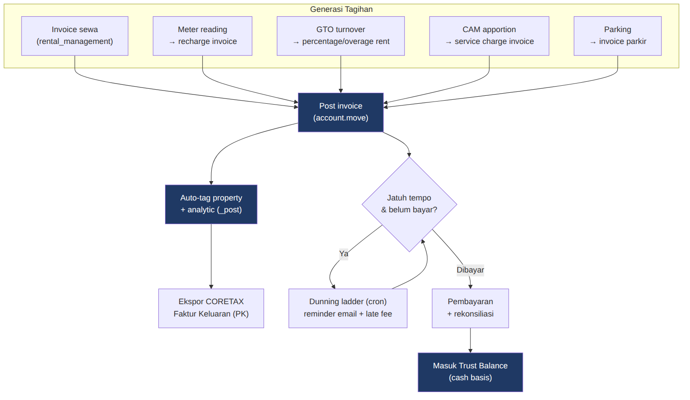
Gambar 5. Alur billing bulanan & penagihan (generasi tagihan → posting → dunning → trust).
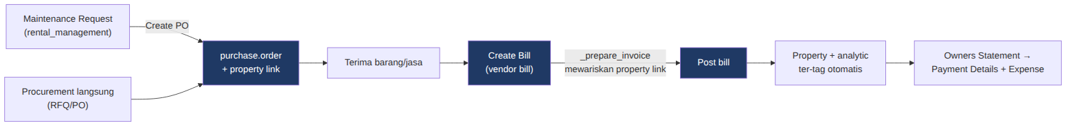
Gambar 6. Alur pengeluaran: procurement & maintenance → vendor bill ber-atribusi properti.
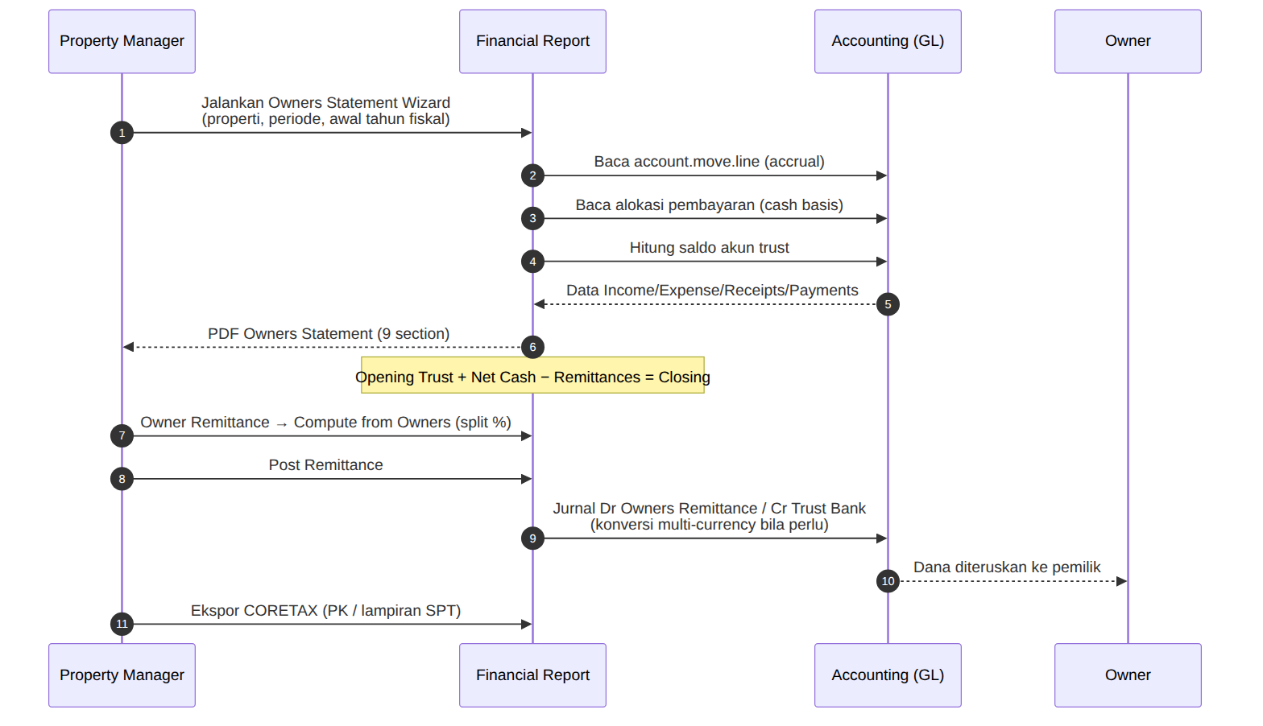
Gambar 7. Alur tutup periode: Owners Statement, rekonsiliasi trust & owner remittance.
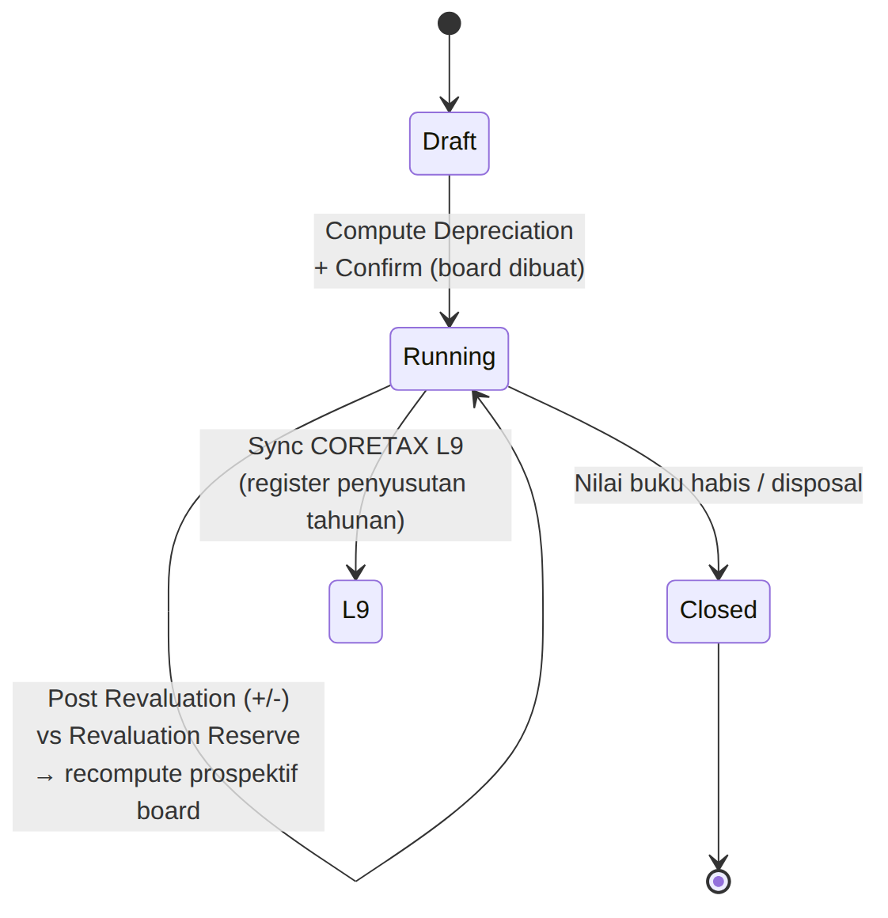
Gambar 8. Alur fixed asset: depresiasi terjadwal & revaluation terhadap reserve.

8. Pemeliharaan, Backup & Go-Live
- Backup: Backup database PostgreSQL & filestore harian (otomatis).
- UAT: Jalankan UAT (lihat UAT Tracker) di staging sebelum produksi; validasi titik API sensitif versi.
- Monitoring: Pantau log cron (escalation/dunning/PPM/depreciation) setelah go-live.
- Migrasi: Migrasi saldo awal: opening tenant balance, deposit, trust balance, budget, aset & penyusutan berjalan.

Catatan: seluruh modul lolos validasi sintaks Python/XML/CSV; WAJIB smoke test pada instance Odoo 19 Community (staging) sebelum produksi.

