|  |  |  |
| --- | --- | --- |
|  | PAIRS OF FIRST-DEGREE RELATIVES  N = 354 | |
| NUMBER OF PAIRS CONCORDANT FOR HOSPITAL (%) | 212 (60%) | |
| NUMBER OF PAIRS CONCORDANT FOR COUNTY (%) | 246 (69%) | |
| NUMBER OF PAIRS CONCORDANT FOR REGION (%) | 268 (76%) | |
|  | | |
|  | PAIRS OF FIRST-DEGREE RELATIVES CONCORDANT FOR PERSISTENCE AT  ONE YEAR  N = 200 (56%) | PAIRS OF FIRST-DEGREE RELATIVES CONCORDANT FOR PERSISTENCE AT  THREE YEARS  N = 210 (59%) |
| NUMBER OF PAIRS CONCORDANT FOR HOSPITAL (%) | 124 (62%) | 126 (60%) |
| NUMBER OF PAIRS CONCORDANT FOR COUNTY (%) | 140 (70%) | 148 (70%) |
| NUMBER OF PAIRS CONCORDANT FOR REGION (%) | 152 (76%) | 158 (75%) |

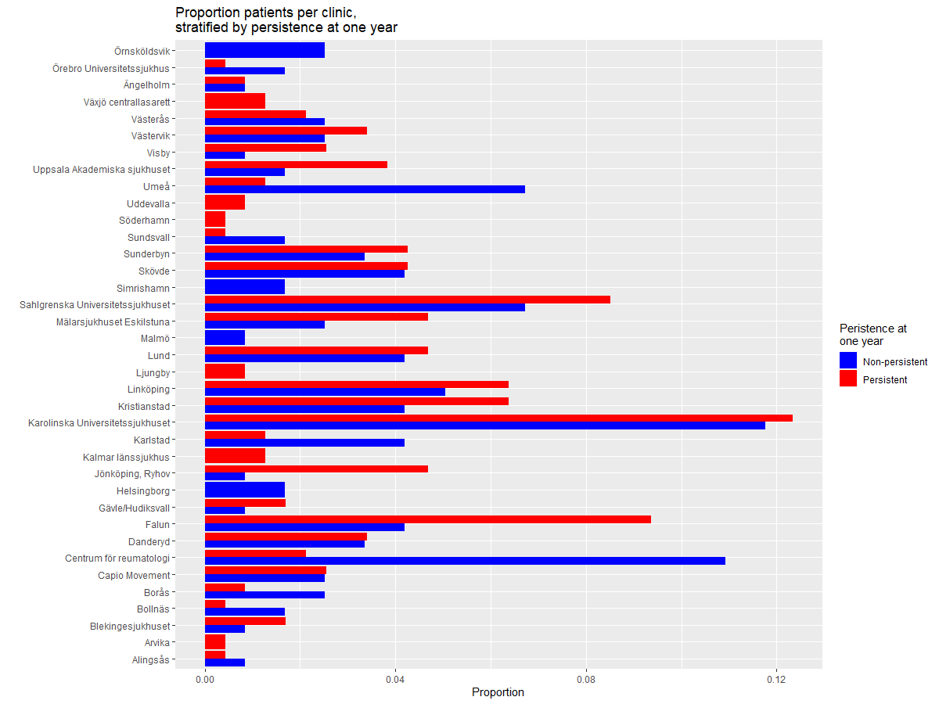

A few things are worth noting:

1. For most clinics, the proportion of patients per clinic is comparable between persistent and non-persistent.

2. A few clinics stand out as having *far more* non-persistent patients than persistent patients. These include the “Umeå” clinic and the “Centrum för reumatologi”.

3. The clinic of Falun stands out as having *far fewer* non-persistent patients than persistent patients.

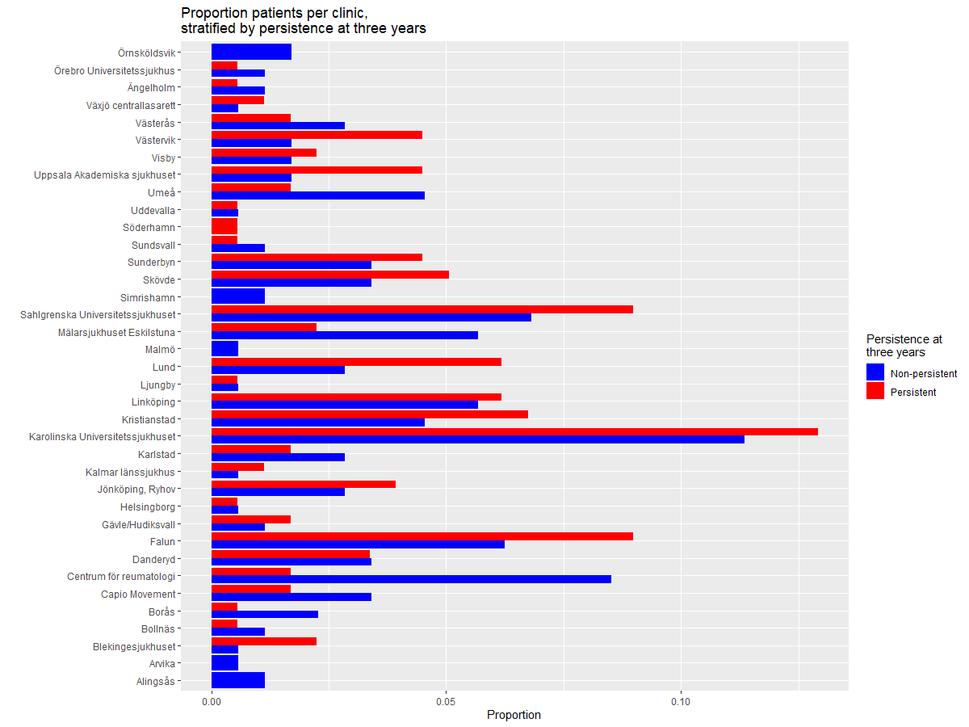

A few things are worth noting:

1. There’s less discrepancy between proportion of patients per clinic across groups of different persistence status.

2. The ‘centrum för reumatologi’ still stands out with its, comparatively, large number of non-persistent patients.

3. Furthermore, “Mälarsjukhuset Eskilstuna” has inverted the relationship, now having twice the amount of non-persistent patients which is the opposite of what we had for persistence at one year.

