The changes will be in the below files of the micro

1. Build.gradle
2. Controller class which is exposed as end points
3. Domain Object Classes

**Build.gradle**

Add the below two lines as part of the dependencies

compile(**'io.springfox:springfox-swagger2:2.6.1'**)  
compile(**'io.springfox:springfox-swagger-ui:2.6.1'**)

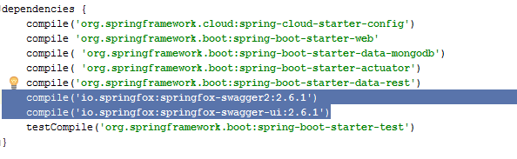

**Controller Class**

1. **Imports:**

**import** io.swagger.annotations.ApiOperation;  
**import** io.swagger.annotations.ApiParam;  
**import** springfox.documentation.swagger2.annotations.EnableSwagger2;

1. **Class Level Annotation:**

@EnableSwagger2

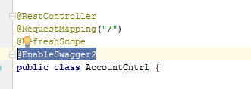

1. **Method Level Annotation:**

@ApiOperation(  
 value = **"Insert Account"**,  
 notes = **"Service to fetch the account details based on the account no"**,  
 response = AccountDO.**class**)  
@ApiResponses(value = {  
 @ApiResponse(code = 200, message = **"Successfully retrieved list"**),  
 @ApiResponse(code = 401, message = **"You are not authorized to view the resource"**),  
 @ApiResponse(code = 403, message = **"Accessing the resource you were trying to reach is forbidden"**),  
 @ApiResponse(code = 404, message = **"The resource you were trying to reach is not found"**)  
})

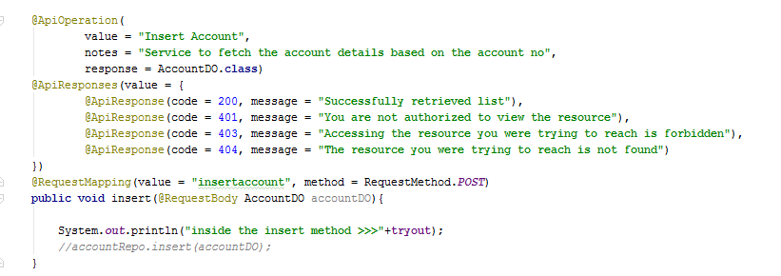

**Input/Output Domain (POJO) Classes of Rest end points**

1. **Imports:**

**import** io.swagger.annotations.ApiModelProperty;

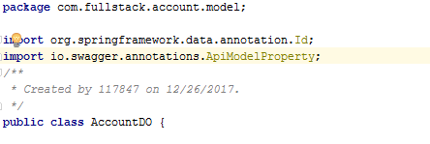

1. **POJO Class Members**

@ApiModelProperty(notes = **"Account ID"**)

