

**DIY ACCOUNTING USER GUIDE**

**2014-15 PAYSLIP GENERATOR**

# Introduction

The DIY Accounting payslip generator is designed for customers who would like a payslip generation facility but use a separate tax calculator such as HMRC’s Basic PAYE Tools. For customers with a DIY Accounting business accounts system such as Company Accounts or Self Employed, the payslip generator feed through into the business accounts via the Wages Interface sheet. A Payment sheet is included to track payments to HMRC.

Complete Employee details below and add calculated tax and wages to the monthly sheets (Apr14, May14, etc…), then switch to the Payslips sheet to generate payslips by selecting W or M (weekly/monthly) and the week or month number.

It is strongly recommended that the payroll package is backed up at least once each week. And ideal solution would be to email the payroll workbook to your personal email address each week. That way the back-up copy is held by your mail server and could be retrieved in the future if required.

# Common problems with Downloading

When downloading the files do not open the files before saving to your DIY Accounting folder.

Opening a file first before saving creates temporary links between the files. If this temporary file is then saved the temporary links are also saved effectively breaking the links to the other files. If this occurs you would receive an error message when trying to open the payroll file stating: EDIT LINKS – This message is an indication of a LINKAGE PROBLEM almost certainly created by opening one or more file first before saving.

**TO AVOID THE PROBLEM. SAVE ALL FILES DIRECTLY TO THE PAYROLL OR ACCOUNTS FOLDER WITHOUT OPENING THE FILES FIRST**

*Copyright. By purchasing this payroll accounting spreadsheet system you are licensed to use the software including making copies as required for your own business only. No part of this system may be reproduced or transmitted by any means to any third party whether for financial gain or otherwise without the express permission of the owner, DIY Accounting Limited. Resellers may be granted a license on application to and at the discretion of the owner.*

[*http://www.diyaccounting.co.uk/*](http://www.diyaccounting.co.uk/)

Contents

Introduction 1

Common problems with Downloading 1

Employee Details Worksheet 3

Weekly / Monthly Worksheets 4

Payslips 5

Revenue Payments 6

Statutory Payments 7

Protection and Parameters 8

Linking Payroll Software to Accounts Software Packages 9

DIY Accounting Contact Information 10

# Employee Details Worksheet

**BUSINESS DETAILS**

A small section located at the top of the employee data sheet. Complete this section with the name and address of your business. These appear on the employee’s payslips.

**EMPLOYEE DETAILS**

The name and National Insurance number appear on the employee’s payslips. The start and end date are used to calculate which employee’s details appear on the monthly tax calculation sheets (Apr14, May14 etc…). The selection of monthly or weekly payments determines where on the monthly tax calculation sheets the employee name appears. The selection of D for directors separate employee wages from Director’ wages when integrating with the DIY Accounting Company Accounts package.

**Entering Employee Data**

The details for each employee are recorded in sections each of which has been pre-allocated a fixed employee number. Do not change this number as the system uses the payroll number to locate the employee details in many areas of the system.

***Employee 01***

***EMPLOYEE DETAILS***

***Cell D15-D20*** Enter employee name

***Cell D24*** Enter 06/04/14 for existing employees at the start of the financial year

Enter the actual starting date for all new employees who join during the year.

The weekly or monthly payroll sheets use this date to determine the appearance of that employee’s name on the payroll list that prompts entry of the gross wages.

***Cell D26*** Enter the leaving date whenan employee leaves

This leaving date controls the appearance of the employee’s name on the payroll and also when completed prompts the completion of the P45.

***Cell D28*** Enter W if this employee is paid on a weekly basis or M if paid monthly.

Always Enter M for Directors to permit the directors payroll costs to be collected for inclusion in the limited company accounts

This box determines whether that employee appears on the weekly or monthly payroll sheet and whether that employee is taxed on a weekly or monthly basis.

***Cell D29*** No Entry Required Employee Payroll Number is preset and fixed.

Do not alter as the payroll sheets use this number is fixed to the employee name and used to identify the employee throughout the payroll spreadsheets.

***Cell D30*** For limited company use only.

Enter D to identify which of the Company employees are directors

Cell D30 may be used to identify a particular department or work location for other employees as required. This box has no effect on the accuracy of the payroll system except to identify Directors.

***Cell H16-H22*** Optional fields in which to record an employee’s bank details for those employers who pay staff through the BACS system.

***NATIONAL INSURANCE***

***Cell M15*** Enter the employees National Insurance number

# Weekly / Monthly Worksheets

The worksheets on which to record the gross pay are in 12 monthly sections from **Apr14 to Mar15.**

Entries are required in each of the white cells and these should be obtained from your tax calculator such as HMRC’s Basic PAYE Tools. Select the month and scroll down to either the week the payment occurs within, or the month (which is the last section on each sheet).

Enter the following:

|  |  |  |
| --- | --- | --- |
| Item | Column | Notes |
| NIC Table | C | A letter code indicating the table used to calculate National Insurance. The most common is A. – Obtain from tax calculator |
| Tax Code | D | The PAYE tax code. For 2014-15 the default tax code is 944L. – Obtain from tax calculator |
| Statutory pay type | G | If sick pay, or any type of maternity pay has been paid, select the applicable code. |
| Statutory pay amount | H | The amount of statutory pay. |
| Basic hours | I | Only needed if the basic wage is calculated from hours worked. |
| Hourly rate | J | Only needed if the basic wage is calculated from hours worked. |
| Basic wages | K | Either calculated from hours * rate or entered directly. |
| Overtime, Bonus or Gratuities | L | Additional pay on top of basic pay including overtime payments, performance bonuses or tips received. |
| Income Tax | N | The PAYE tax deducted from gross wages. – Obtain from tax calculator |
| Employees National Insurance | O | The National Insurance deducted from gross wages. – Obtain from tax calculator |
| Student Loans | P | Any student loans deducted from gross wages – Obtain from tax calculator |
| Other Deductions | Q | Any other deduction from the gross pay. |
| Employer’s National Insurance | T | National Insurance payments the employer is liable for (not deducted from gross wages) – Obtain from tax calculator |

If an employee is employed in a particular week and their name does not appear then check the starting and leaving dates on the employee’s details as it is these details that determine the appearance of an employee.

# Payslips

A single sheet is used to access payslips for each week by entering either W or M in cell F3 and by entering the week or month number in cell F4.

Payslips are automatically updated from the payroll workbook for both weekly paid and monthly paid employees.

Make all changes to payslips by changing the payroll file **not** the payslips file. Changing the payslips directly will overwrite formula be hard coded in the payslip generator template from that point onwards.

Payslips contain all legal requirements including the Employers’ name, Employees’ name and details of all payments and deductions to be made for the pay period and year to date also showing the employees tax code, national insurance table letter.

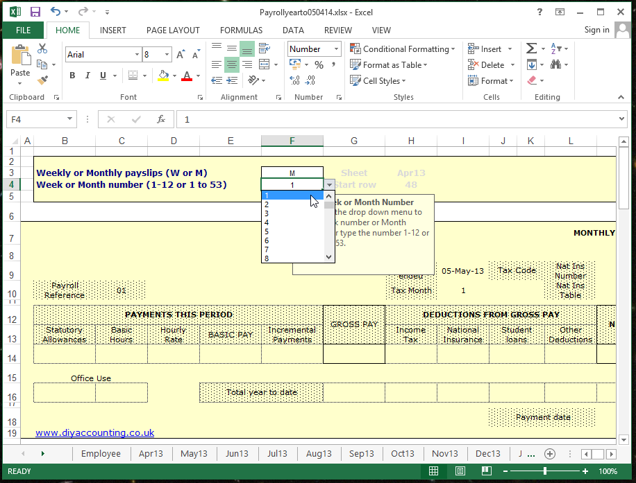

# Revenue Payments

**Update payments made manually**

The revenue returns workbook also contains a payments worksheet that automatically determines the HM Revenue & Customs liability for income tax and national insurance on a month by month basis.

Should statutory payments have been made during the year then these will also be collected and recorded on this record and deducted from the amount to be paid. Employers can reclaim statutory sick pay paid to employees where that SSP amount is over 13% of the National insurance liability for that period. This calculation has been automated.

100 % of Maternity, Paternity and Adoption pay can be recovered plus an additional 4.5% national insurance compensation. These recovered amounts have also been automated and included in the payments sheet.

# Statutory Payments

Statutory payments are not calculated automatically by the program. This is partly due to the additional file sizes that would be required to cover the various calculations that would be required but mainly due to a decision that the amount of information required to be input to enable these calculations can just as easily be input into the HMRC’s Basic PAYE Tools that then calculate the amounts to be paid.

**Statutory Sick Pay**

The weekly rate of Statutory Sick Pay is shown in the Admin file of the payroll workbook for employees with average weekly earnings of at least the lower earnings threshold

SSP is payable from the 4th day of sickness onwards with the 3 waiting days also taken into account when there are connected periods of sickness within 8 weeks. The daily rate to be paid is the weekly rate divided by the qualifying days in the week multiplied by the number of qualifying days of incapacity.

E.g. In a standard 5 day working week the daily rate is the weekly rate divided by 5.

The payroll software collects the amount of SSP paid and automatically calculates any amount that can be recovered which is any SSP over 13% of that months NIC liability. Recovery amounts are included on the Revenue payments worksheet and deducted from the revenue liability that month.

**Statutory Maternity Pay**

Women expecting a baby who satisfy the qualifying conditions are entitled to a maximum of 26 weeks SMP where their average weekly earnings exceed the threshold limit which varies according to when the baby is due on or before 15 July 2006.

The weekly amount payable is 90% of employee’s average weekly earnings for the first 6 weeks and 90% of average weekly earnings thereafter subject to a maximum of limit.

The payroll software collects the amount of SMP paid and automatically calculates the amount that can be recovered which is 100% of the SMP paid plus an additional 4.5% NIC compensation. Recovery amounts are included on the Revenue payments worksheet and deducted from the revenue liability that month.

**Statutory Paternity Pay**

SPP is paid for a maximum of 2 weeks to qualifying employees where their average weekly earnings exceed the threshold level dependent upon when the baby is due on. Amount payable is 90% of average weekly earnings subject to a maximum of limit.

The payroll software collects the amount of SPP paid and automatically calculates the amount that can be recovered which is 100% of the SPP paid plus an additional 4.5% NIC compensation. Recovery amounts are included on the Revenue payments worksheet and deducted from the revenue liability that month.

**Statutory Adoption Pay**

Employees adopting a child are entitled to 26 weeks SAP where their average weekly earnings exceed the threshold levels

The weekly amount payable is 90% of employee’s average weekly earnings subject to a maximum limit

The payroll software collects the amount of SAP paid and automatically calculates the amount that can be recovered which is 100% of the SAP paid plus an additional 4.5% NIC compensation. Recovery amounts are included on the Revenue payments worksheet and deducted from the revenue liability that month,

# Protection and Parameters

**Worksheet Protection**

The payroll data entry spreadsheets have not been protected.

A manual entry in any cell containing a formula will overwrite that formula.

Only enter data in cells that do not contain formulae.

Create a back-up copy of your spreadsheets for use as a test model and also provide a source from which any formula driven cells subsequently overwritten may be replaced.

To restore the formulae overwritten in the active spreadsheet:

Go to the back-up spreadsheet. Highlight the cells to be copied. *Click Edit > copy*

Go to the overwritten spreadsheet. Highlight the same cells to be replaced *Click Edit > paste*

After all the transactions for an individual month have been completed, protect the worksheet.

This avoids inadvertent corruption of the information.

In the case of sales and purchase spreadsheets protection also provides a Vat audit trail.

To protect a sheet, go to the menu bar:

*Click Format > Cells > Protection > Click Locked and Hidden so “ticks” appear > OK*

*Click Tools > Protection > Protect sheet > OK*

*Enter a protection password if you require additional security.*

**Mending Broken Links**

If the links between the spreadsheets become corrupted for any reason these can be automatically corrected by Microsoft Office 2003 Excel.

First unprotect any protected sheets in the workbook.

Then re-open the workbook. You will be asked if you wish to update the sheet.

*Click > Update Click > Edit links*

Highlight in the dialogue box the links to be corrected and click the same file in your accounts folder.

Microsoft Office 2003 then automatically corrects all the links so worksheets update correctly.

**Back up Records**

All financial records should be backed up periodically to preserve the data entered. This is particularly important with payroll and it is recommended that payroll records are backed up by being saved at least once each week. To ensure accuracy please ensure all tax tables and NIC tables are open at the same time as the payroll record or the system cannot update the tax and national insurance correctly.

One simple method of providing an independent back up of the payroll data and software is to email the payroll, payslips and revenue returns to your personal email address once each week. Retain this email in your mail folders until superseded by the next weeks copy. This way if your hard drive is lost you will still be able to recover the current wages information from the mail folder.

# Linking Payroll Software to Accounts Software Packages

The payroll software can be used and stand alone or integrated into either the DIY Accounting Self Employed Accounting Software or the DIY Accounting Limited Company Software.

Each of the Accounting Software packages contain a payroll file.

To integrate the payroll into the Accounting Software which would then automatically update wages costs in the accounting packages simply save the payroll software into the same folder as the DIY Accounting Software overwriting the sample Payroll package provided with each Accounting software package

# DIY Accounting Contact Information

Our website is the first place to look for any information:

**UK product website:** <http://www.diyaccounting.co.uk/>

When new packages are available the “Buy” page will be updated on our website.

For accounting and technical problems please try our forum in the first instance:

**Technical Forum:** <https://forum.diyaccounting.co.uk/>

If no similar query has been posted, you can register and post you own question. We provide technical support through the forum so all members can share the answer.

For technical queries not covered by our forum we have a dedicated email address monitored by our staff and a local rate (when called from land line) number. When calling please use a non-withheld number and leave a message so we can get back to you:

**Technical Support email:** [support@diyaccounting.co.uk](mailto:support@diyaccounting.co.uk)

**Technical Support phone:** 0845 0756015

We have an email address for customer services where you can exchange products, request a VAT invoice and ask about other services we offer.

**Customer services email:** [support@diyaccounting.co.uk](mailto:support@diyaccounting.co.uk)

Please send messages from the email account used for the original purchase through PayPal or quote your PayPal transaction ID so we can trace your original purchase.

We also publish to news feeds and social networking sites where you can follow us:

Facebook: <http://facebook.com/DIY.Accounting.Software>

Twitter: <http://twitter.com/DIYAccounting>

Our company registered office address is:

DIY Accounting Limited,

37 Sutherland Avenue,

Leeds,

LS8 1BY.

**Directors**

Antony Cartwright, Samantha Cartwright, Jane Grundy.

Registered in England and Wales with Company Number: 06846849

We can receive payment for renewals by cheque although we prefer BACS. Please email us before sending a cheque and we’ll send an invoice with an up-to-date price calculation and the details for electronic payment.

