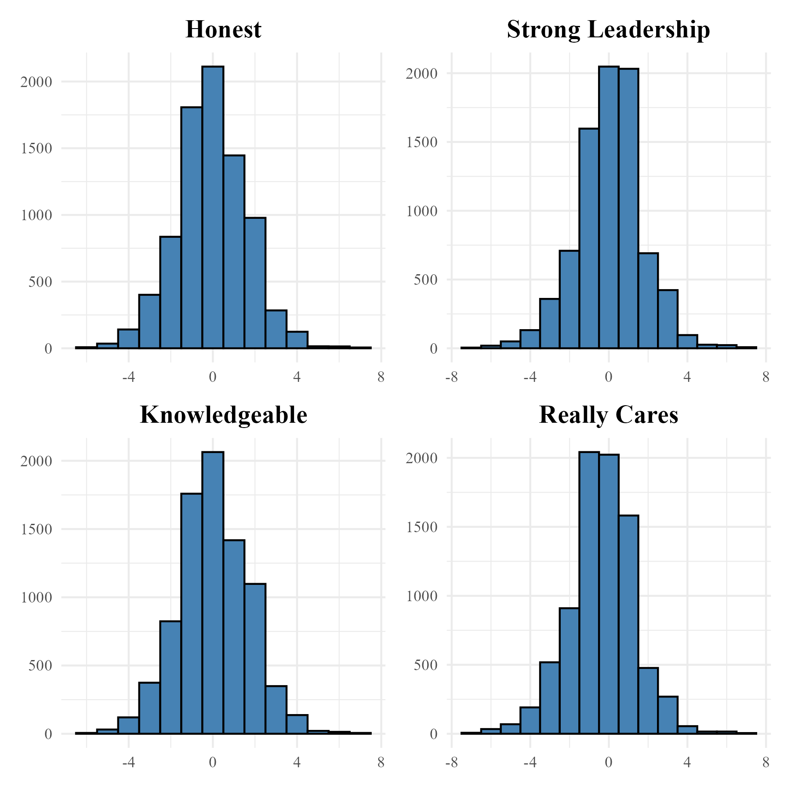

Figure 1. Trait evaluations of candidates (ANES 2020).