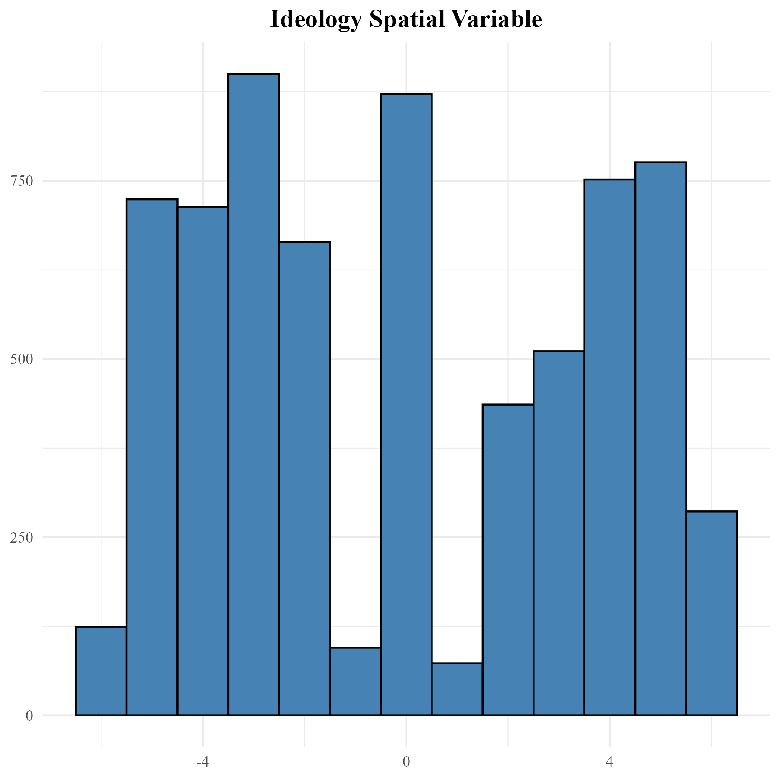

Figure 2. Distribution of ideology spatial variable (ANES 2020).