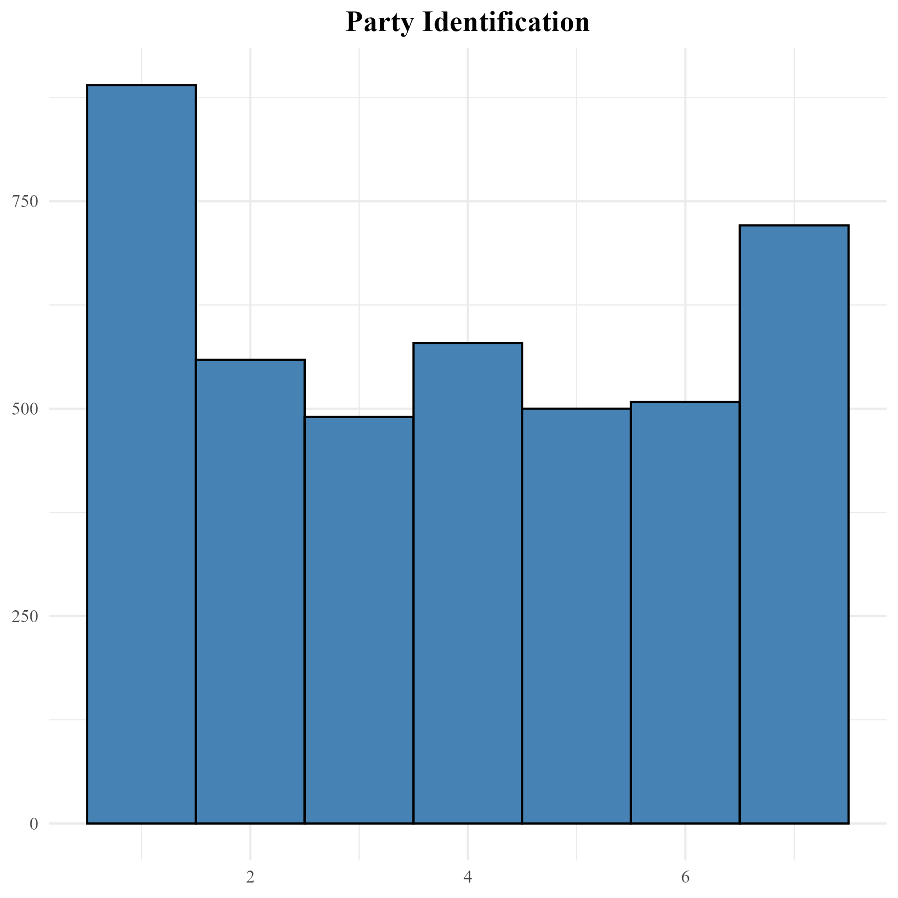

Figure 3. Distribution of party identification (ANES).