Pagnon, Andrew C.

acpagnon@cpp.edu

schematic entry & simulation using cadence orcad, pspice and excel

ece2200 activity

Contents

1. Launching PSpice & creating a new project 3

I. Launch Cadence: 3

i. Open Design Entry CIS 3

II. Create a new project 3

ii. New Project 3

iii. Add Project **path** 3

iv. Enter project **name** 3

v. Select **Analog or Mixed A/D** 3

vi. Click <**OK**> on the “New Project’ pop-up window below 4

vii. **Create blank project** 4

2. Create a Schematic 5

III. Add Libraries 5

viii. Select Place part icon 5

ix. Select the add Library Icon 5

x. Browse for Libraries 6

xi. Select all Libraries 6

xii. Add Libraries 6

IV. Placing parts 6

xiii. **Adding a resistor part and rotating it** 6

xiv. **Adding an NMOS transistor** 7

xv. **Adding a ground**: 8

xvi. **Create the intermediate schematic shown below**: 9

V. Connecting parts with wires 10

xvii. **Adding wires**: 10

xviii. **Drawing wires (shown below)** 10

xix. **Add wires to connect the following circuit** 11

xx. **Naming wires**: 11

VI. Modifying Properties 13

xxi. Select and change Resistor Component value 13

xxii. Select and change Voltage Source value 13

xxiii. Sampling of notations that PSPICE recognizes 13

VII. Save schematic 13

3. DC Bias Simulation 14

VIII. Creating a Variable 14

xxiv. Enter component variable value 14

xxv. Add Variable definition part PARAM 14

xxvi. Exit create variable command 14

xxvii. Enter Variable property name and value in PARAM 14

IX. Placing Current and Voltage Probes 16

xxviii. Place voltage probes to plot voltages or current probes for currents. 16

X. DC sweep with a Nested Parametric sweep simulation 17

xxix. Create a simulation profile 17

xxx. Edit Primary Sweep Parameters 18

xxxi. Edit Parametric Sweep Parameters 19

xxxii. Simulate 20

xxxiii. Netlist Generation 21

xxxiv. Errors – Session Log 21

xxxv. Parametric Sweep options 22

xxxvi. Add simulation traces 22

xxxvii. Simulation waveform window 23

xxxviii. Export simulation data to Excel 23

4. Excel Data Analysis – Plot data 24

XI. Plot excel data 24

xxxix. Format Excel data 24

xl. Plot Data 26

xli. Analyze excel data (Load Line analysis) 28

xlii. Design Bias circuit parameters 28

5. Bias Point Simulation 29

XII. Replace the parametric sweep Voltage source with 2 resistor bias circuit 29

xliii. Modify schematic 29

XIII. Run Bias Point Simulation 30

xliv. Edit Simulation profile 30

xlv. Run Simulation 30

6. Time Domain (Transient) Simulation 32

XIV. Replace 2 resistor bias circuit with AC Voltage Source VSIN/SOURCE 32

xlvi. Modify Schematics 32

XV. Run Time Domain (Transient) Simulation 33

xlvii. Edit Simulation profile 33

xlviii. Run Simulation 34

7. Quiz 7 – May 23th 2018 36

**How to use PSPICE – Schematic design, simulation, analysis**

# Launching PSpice & creating a new project

## Launch Cadence:

### Open Design Entry CIS

Start→ type ‘**cis**’ → click on ‘**Design Entry CIS’ or** ‘**Capture CIS’** → click **OK** on selection below

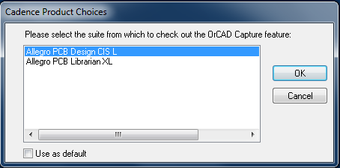

## Create a new project

### New Project

On the top toolbar select: **File->New->Project**

### Add Project **path**

In your student account on the **H: drive**in ‘Location’ click on ‘Browse’

### Enter project **name**

For example ece2200l_m1

### Select **Analog or Mixed A/D**

So you will be able to simulate

### Click <**OK**> on the “New Project’ pop-up window below

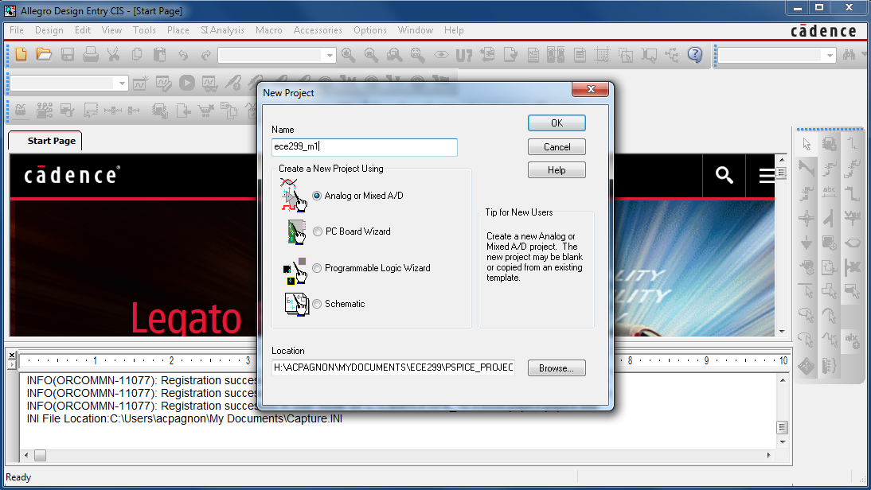

### **Create blank project**

In the pop-up menu select: **Create blank project** then click **<OK>**

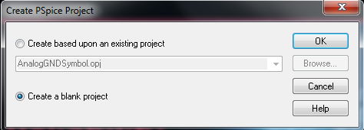

# Create a Schematic

## Add Libraries

### Select Place part icon

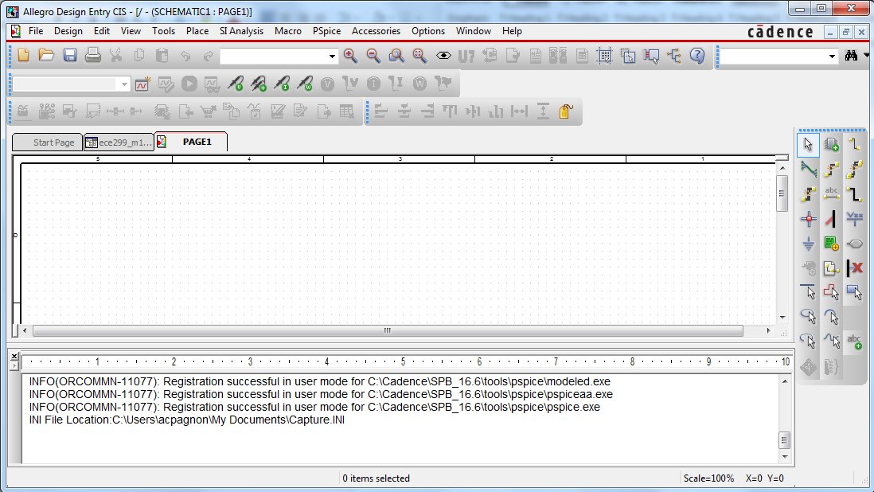

**Place part icon**

### Select the add Library Icon

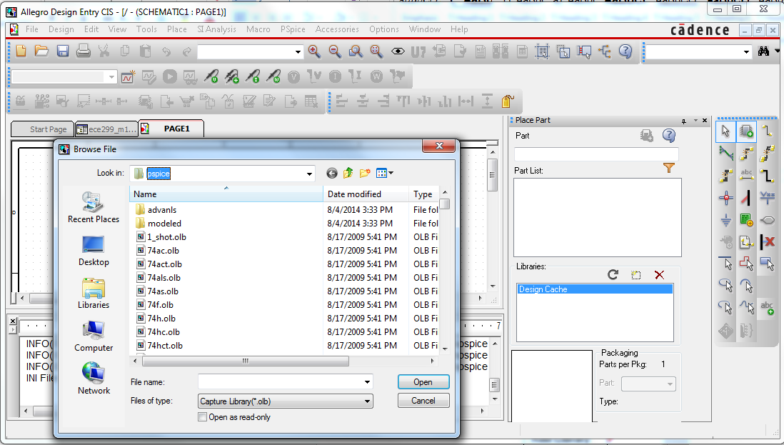

**Add Library icon**

### Browse for Libraries

In the Browse File pop-up menu select ‘Look in’   
Local Disk (C:) Cadence/SPB_17.2/tools/capture/library/pspice

### Select all Libraries

Click on the blank part of the window and hit <ctrl a> to select all the libraries (see below)

### Add Libraries

Select Open to add the selected libraries (see below)

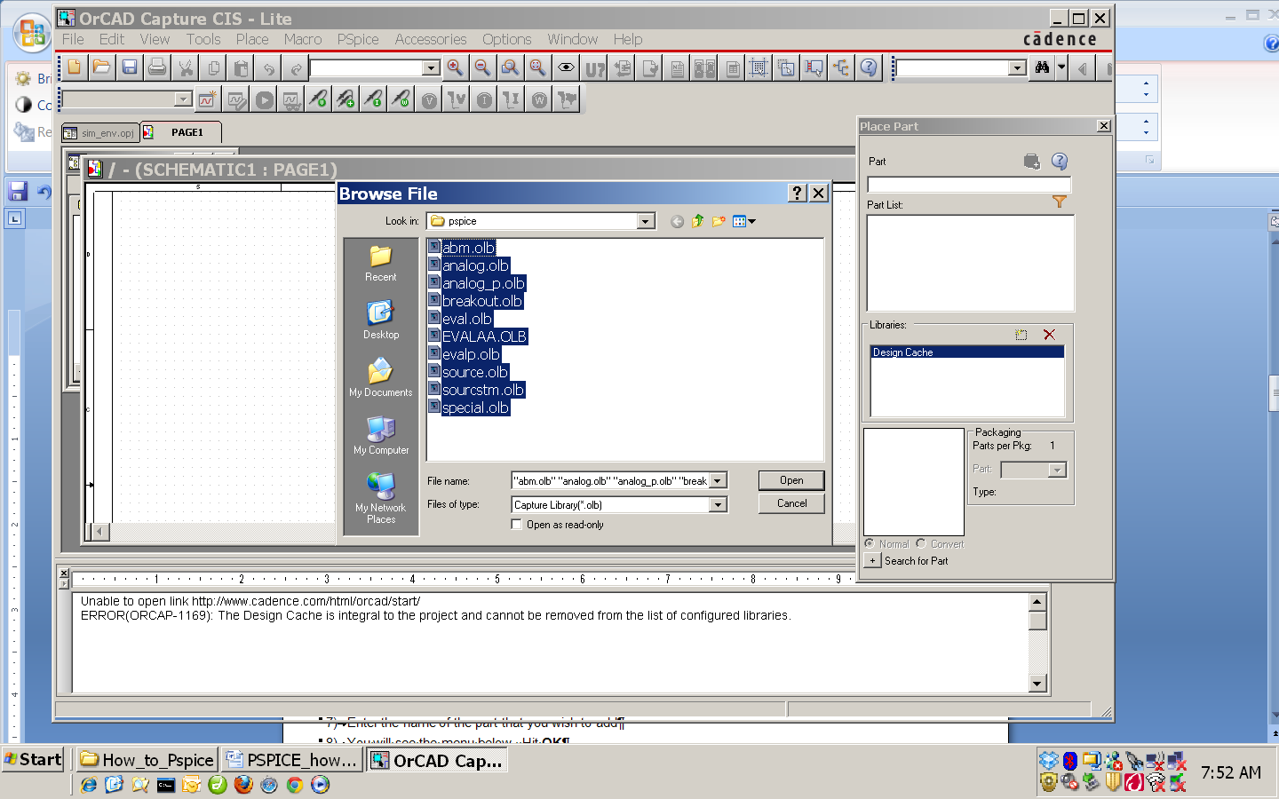

click here and select <**ctrl a>**

**Add path**

## Placing parts

### **Adding a resistor part and rotating it**

#### Search for Part

In the Place part pop-up menu enter the name of the part you wish to add (Here we have entered R)

IMPORTANT: You can find the part R in several libraries. Ensure all libraries are selected

Select the part R from the library Analog. (Notation: R/ANALOG)

#### Add the part

Hit <enter> to add the part

If the part was not in the design cache you will see a pop-up menu.

Hit <yes> If you should get this menu.

Move your cursor on the schematic to where you want to place the part.

Click r to rotate it

Click your mouse on the schematic screen to place the resistor

You will continue to be able to place parts that are of the type that you selected. Hit <esc> to end placing parts.

#### Bindkeys for rotating or flipping

If you wish to rotate or flip a part as you place it use the following bindkeys

##### Rotate r

##### Horizontal flip h

##### Vertical flip v

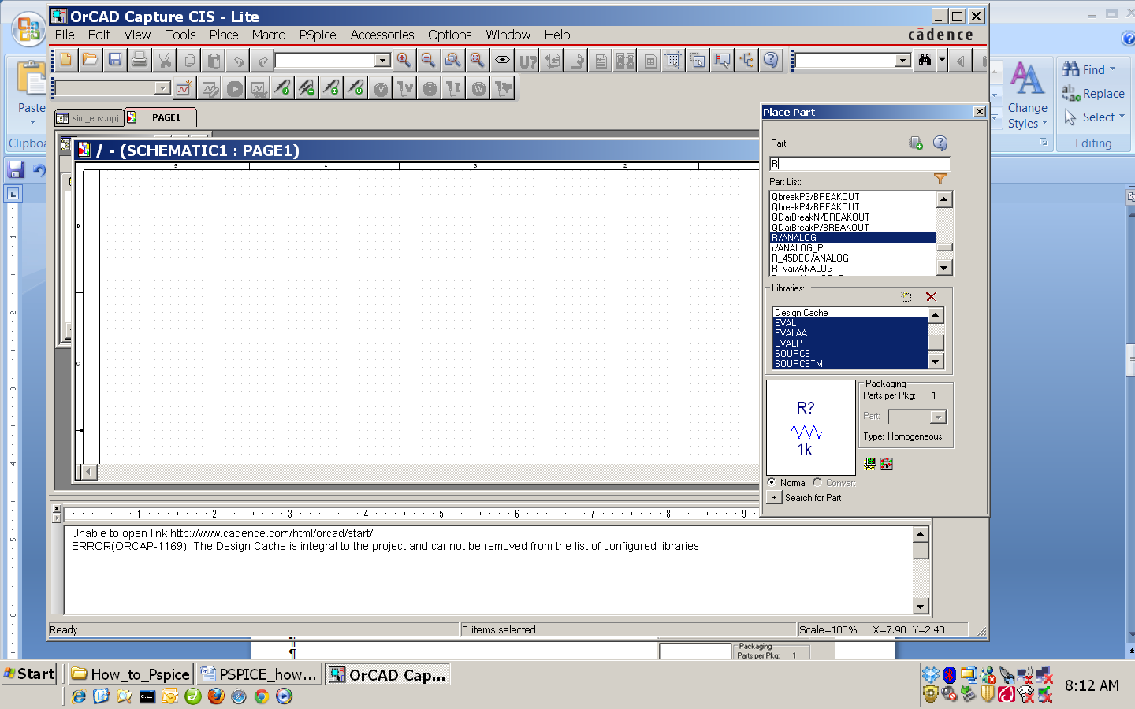

Select the part R from the ANALOG library

### **Adding an NMOS transistor**

#### Search for NMOS transistor

Click **hotkey p** to place part

Select part **MbreakN** from the **BREAKOUT** library

click **<OK>** to close thewindow

#### Place the part

left click with your mouse to position the NMOS in your schematic window

click **<esc>** to stop placing the part

#### Common Editing Commands

**p** Place part **w** Create wire

**^ c** Copy **^ c** cut **^ v** paste

**r** rotate

**v** flip vertically

**h** flip horizontally

**<delete>** delete

Parts can be repositioned by dragging them

### **Adding a ground**:

#### Search for Ground/0

Select **bindkey G** OR **click ground icon**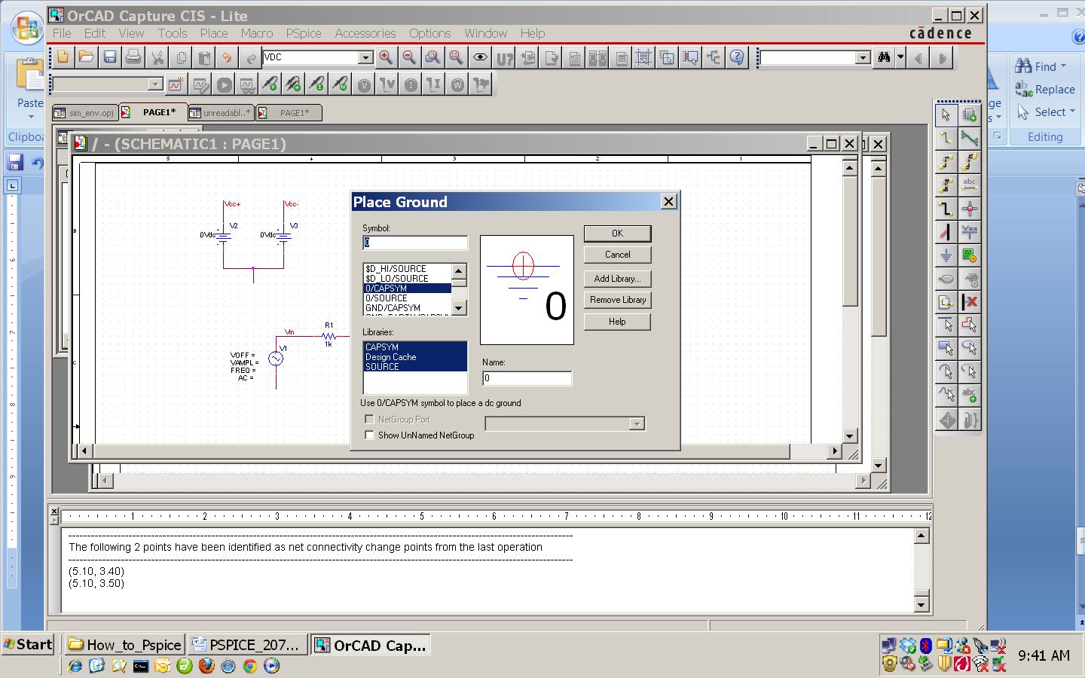

Select: **0/CAPSYM**

#### Place Ground

Hit **<OK>** to start placing the ground

Hit **: <esc>**to end the place ground part command



### **Create the intermediate schematic shown below**:

#### Add 2 resistors R from the library ANALOG (rotated vertical)

#### *Add 2 DC voltage sources* **Vsrc** from the library **SOURCE.**

#### Add 1 NMOS transistor **MbreakN** from the library **BREAKOUT**

#### *Note parts can be repositioned by dragging them.*

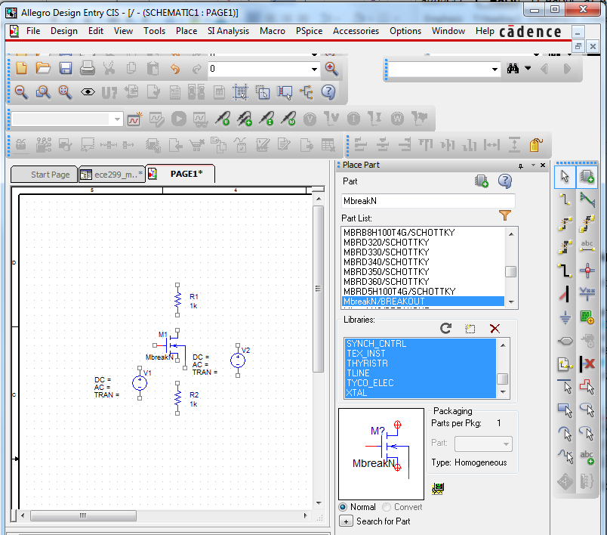

After placing the parts you will need to connect them with wires (also called nets).

## Connecting parts with wires

### **Adding wires**:

**Place wire icon**

#### Select wire tool

Select the **Place wire icon** (toolbar on rhs) OR use **bindkey w**

### **Drawing wires (shown below)**

#### Start wire

Click your mouse at the starting position of your wire

#### Bend wire

Move (do not drag) your mouse to where you want a bend.   
  
Click your mouse. (You may repeat this step for multiple bends)

#### End wire

Move (do not drag) your mouse to the end location click again.

#### Exit wire command

Hit the <esc> key to exit the place wire command.

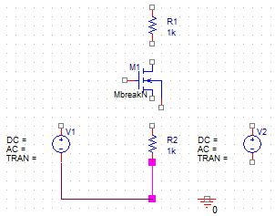

Click mouse (starting point)

Move mouse

Click mouse (bend)

Move mouse

Click mouse (bend)

Move mouse

Click mouse (end point)

Hit <esc> to end command

### **Add wires to connect the following circuit**

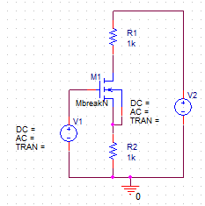

### **Naming wires**:

It is much easier to maintain a design if you name the wires (nets) on your schematic.   
Try to create schematics that are readable and less cluttered with wires

|  |
| --- |
| **Below are two equivalent schematics. Which is more readable/maintainable?** |
| **IMPORTANT ideas**   * **If wires have the same name (net alias) they are viewed as being connected** * **To simulate a PSpice schematic there needs to be a net named 0 (zero)** |

#### **Name a wire (net)**:

##### Create wire Name

Selecting **bindkey n** OR

Selecting the **place net alias** **icon** (right hand side toolbar) OR

Selecting the **Place->net alias** (top toolbar)

In the resulting pop-up menu enter the name (Vin for this example)

##### Place wire name

Click your mouse on the net that you wish to name. (The input of the amplifier.)

Click your mouse again on the wire at the top of one of the two voltage sources

##### End name command

Hit **<esc>** to end the place net alias command

Note: do NOT use the place text icon. PSpice text offers no functionality. It is, however, helpful for annotating schematics with comments.

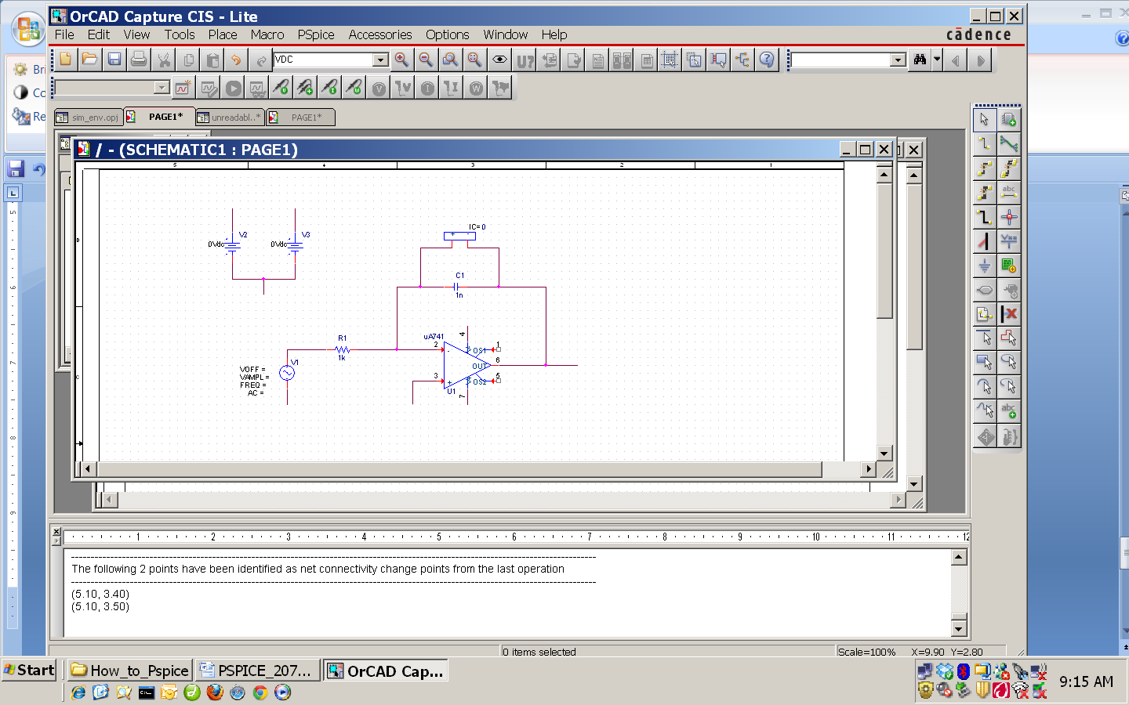

#### Name the wires on your schematic as follows

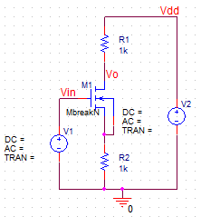

**Place net alias icon**

**Place text icon**

## Modifying Properties

### Select and change Resistor Component value

Double click the value of resistors (1K) R1 and R2.

Change them to 470 and 150

Click <OK> to close the window.

### Select and change Voltage Source value

Double click the DC value of the voltage source (source V2) (DC=)

Change it to be 15V, click <OK> to close the window.

Right Click on M1 a select “Edit Spice Model”

An “AMS Model Editor” window should open. May be minimized.

Type “Kp=9m Vto=0.7V” after “.model Mbreakn NMOS”

Click on “Save Library” icon

#### 

### Sampling of notations that PSPICE recognizes

|  |  |  |  |  |  |  |  |
| --- | --- | --- | --- | --- | --- | --- | --- |
|  | **PSpice Notation** | |  |  |  | **PSpice Notation** | |
| 103 | K | E3 |  |  | **10-3** | m | E-3 |
| 106 | Meg (not M) | E6 |  |  | **10-6** | u | E-6 |
| 109 | G | E9 |  |  | **10-9** | n | E-9 |
|  |  |  |  |  | **10-12** | p (pico) | E-12 |
|  |  |  |  |  | **10-15** | f (femto) | E-15 |

## Save schematic

From the main menu: File->Save

Your schematic is now complete!

# DC Bias Simulation

## Creating a Variable

### Enter component variable value

Double click on the DC= of the voltage source V1

Change it to the equation {ving*1V} (curly brackets are needed)

ving is a variable.

### Add Variable definition part PARAM

Hit bindkey p and add the part PARAM from the library special.

This part defines variables

### Exit create variable command

Click on <OK> to close the window and place the part

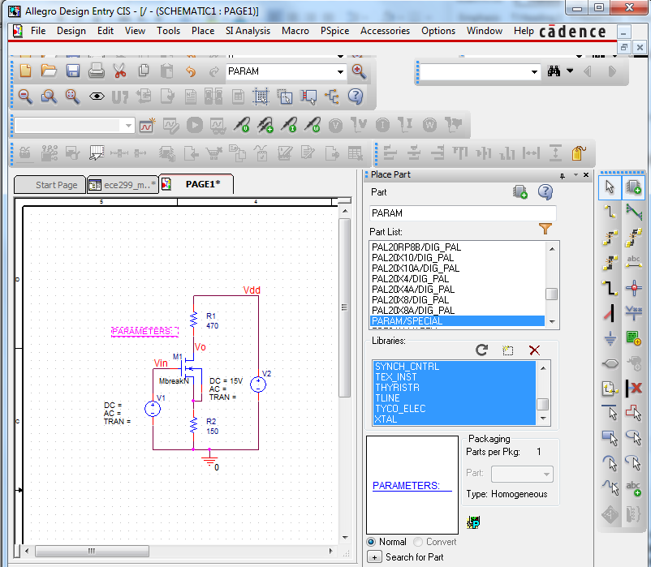

### Enter Variable property name and value in PARAM

On the schematic, double click on the wordPARAMETERS.

You will see the window below.

Click on New Column (or New Row or New Property)  *- It is different for different versions*

If prompted answer yes

In the *Add New Column* window type the variable name

Give it a default value (as shown below)

Click OK to close the *Add New Column* window

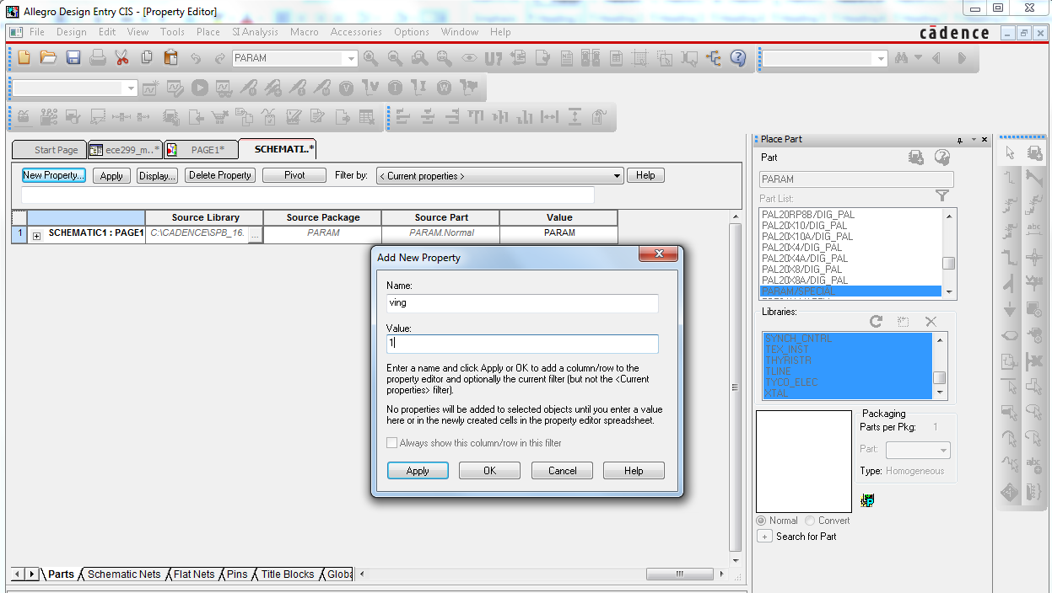

Close window

Close the Property Editor Window (top right)  
**Now you are ready to simulate**

## Placing Current and Voltage Probes

### Place voltage probes to plot voltages or current probes for currents.

Automatically plots results when a simulation is complete

Place a voltage probe at the output of the amplifier as shown below

Place current probe to plot the collector current.

Note current probes must be placed on the pins of devices (the very edge – look for the red/blue transition)

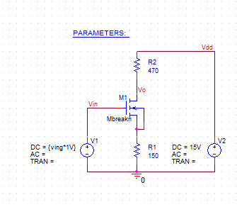

## DC sweep with a Nested Parametric sweep simulation

### Create a simulation profile

Select **Pspice->New Simulation Profile** from the top toolbar

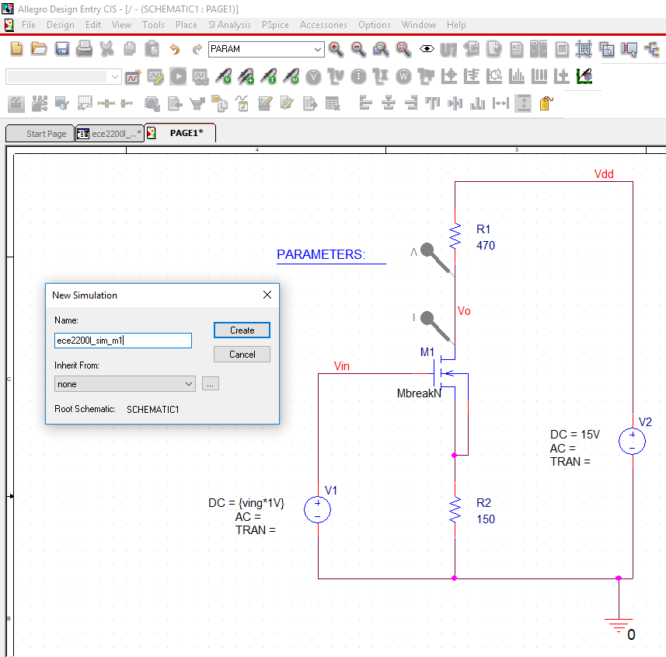

Enter a name (like ece2200l_sim_m1)

Click on **create** to close the window

A *Simulation Settings* window will open (may be minimized)

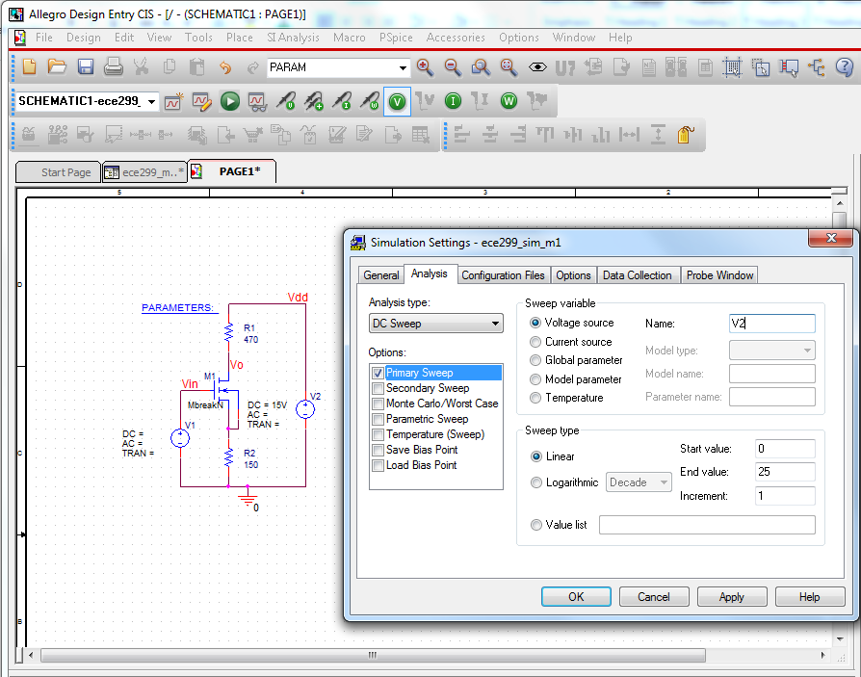

### Edit Primary Sweep Parameters

Select the analysis tab (it should be the default)

Select DC **sweep** analysis

Specify that you wish to sweep a **voltage source**

Specify the voltage source that you wish to sweep (**V2**)  
this one is connected to the output of the amplifier

Specify the Start: 0, stop: 25 voltages as well as the voltage increment: 1

Note: Spice understands m to be 10-3

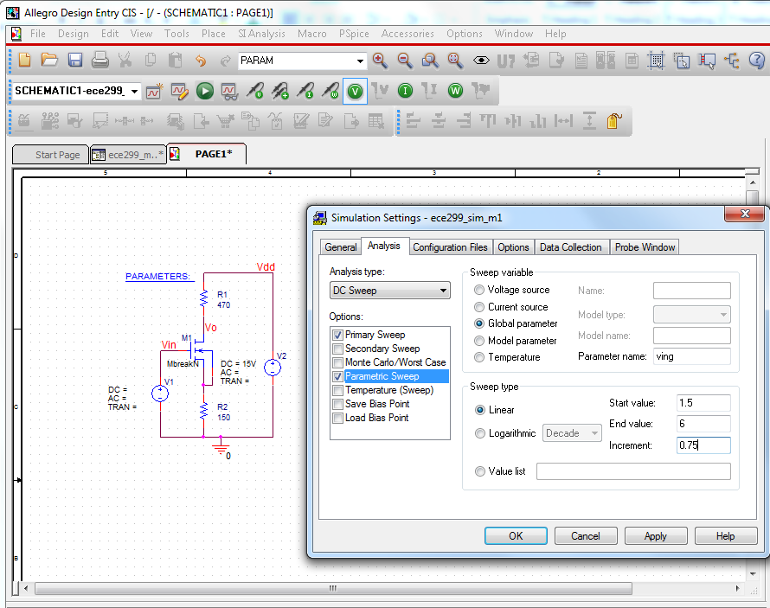

### Edit Parametric Sweep Parameters

Select **Parametric Sweep** (ensure it is checked)

Select **Global Parameter**

Specify the parameter you wish to sweep (**ving**)

Specify the range for ving (start: 1.5, stop: 6, Increment 0.75)

Click on <OK> to close the window

### Simulate

Click on the run Pspice icon at the top of the schematic

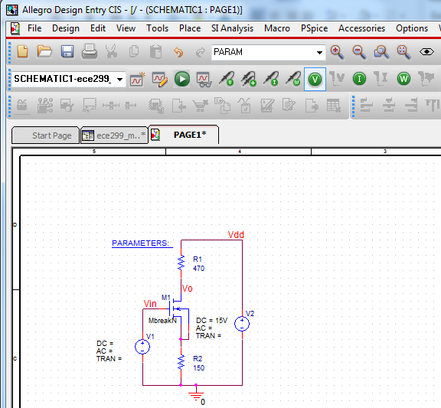

**Run Pspice icon**

### Netlist Generation

Pspice will generate a netlist of the schematic

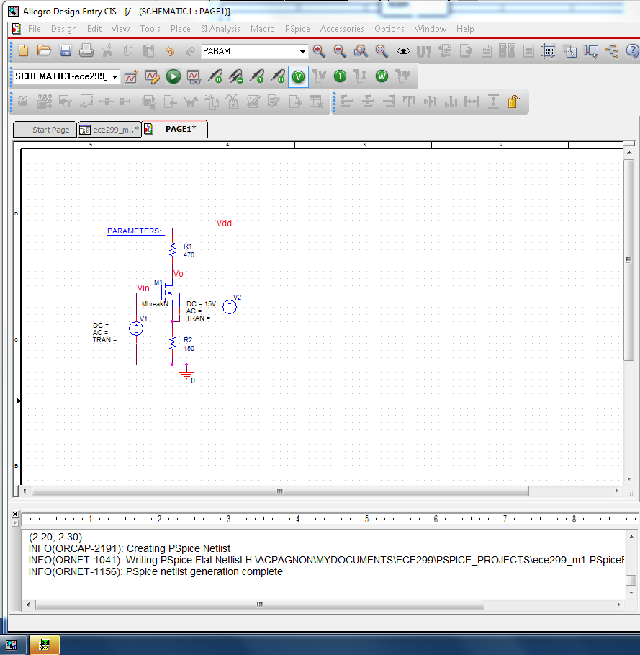

**Simulation window minimized**

### Errors – Session Log

If your simulation fails check for errors:

from top toolbar: **Window->Session Log**

If netlist runs successfully a simulation window will open (may be minimized as above)

### Parametric Sweep options

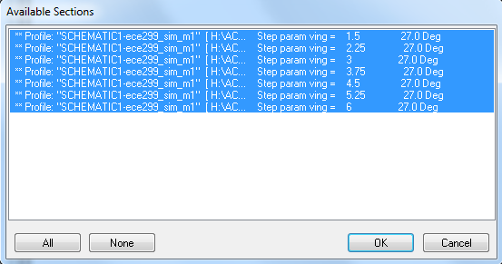

Click on **<OK>** to run all seven parametric sweep simulations

### Add simulation traces

Open the simulation window (if minimized) and right click on waveform screen

Select “add traces” and add the 4 waveforms I(M1:d) VG(M1) VD(M1) VS(M1)

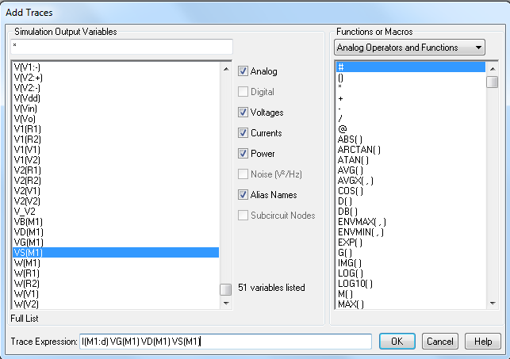

### Simulation waveform window

The simulation waveforms will be displayed as below

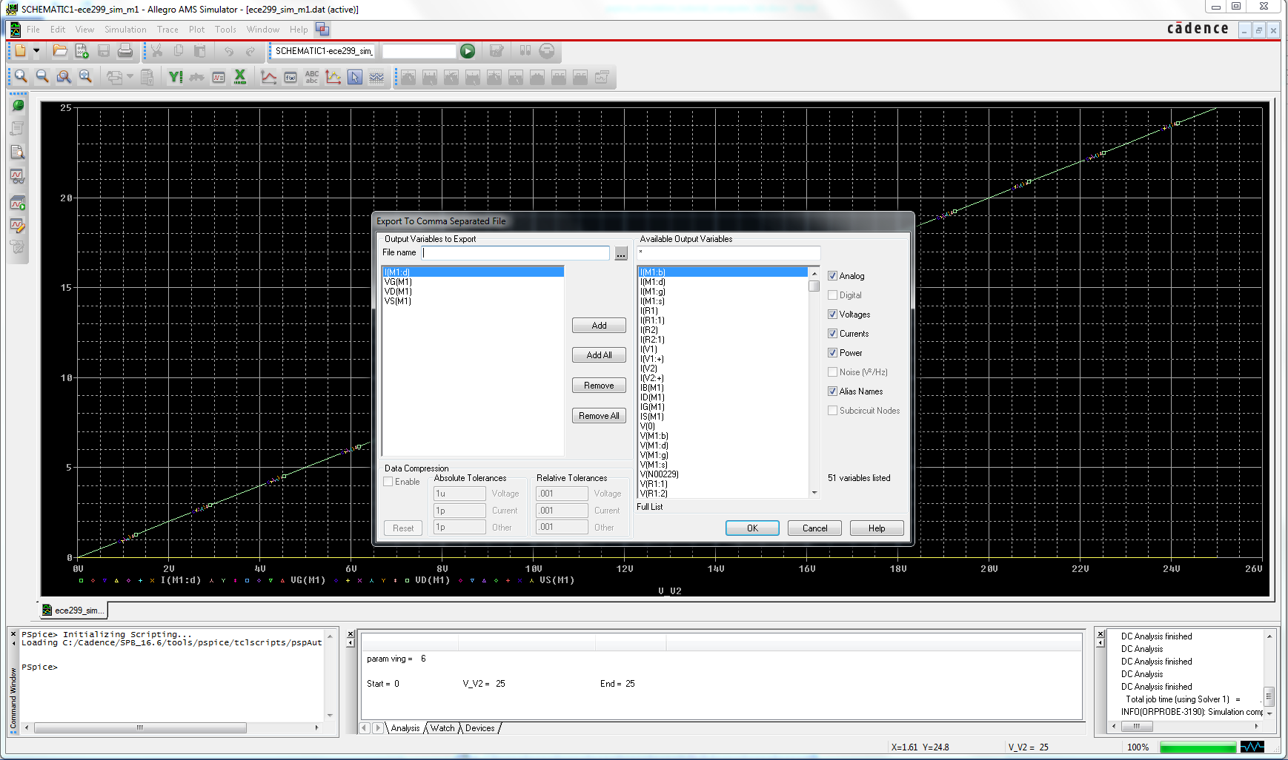

### Export simulation data to Excel

Select File -> Export -> comma-separated values (.csv file) and click ok

Provide a file name (like ece299_sim_m1) and save in your H drive account

# Excel Data Analysis – Plot data

## Plot excel data

### Format Excel data

Open excel csv file

Select all cells (click on top right corner)

Right click on cell area and select “format cells”

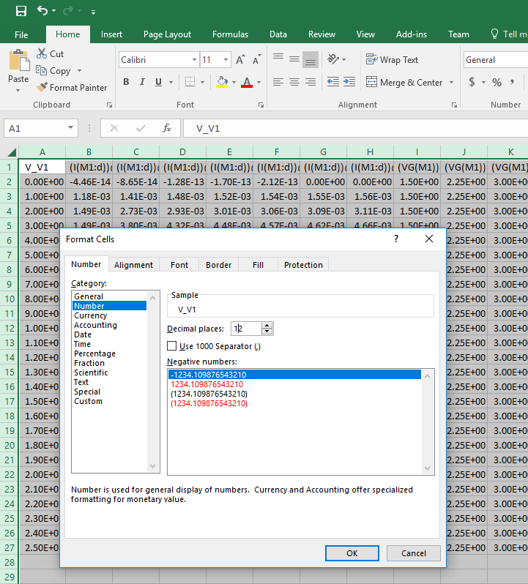

**Double click to format cell width**

**Click to select all cells**

Create columns for Id in mA (multiply Id by 1000) and Vds (Vd-Vs) for each of the 7 Vg values

Create columns for Vgs (Vg-Vs), Vdsat for each of the 7 Vg values

You can do this pretty quickly in Excel. For example for Vds (showing only 2 values below instead of 7)

Find the first free column (H in the example below)

Write Vds1 in the first row

In the second row write “=”, click on the first value from the “(V(M1:d))@1” column, write “-”, click on the first value from the “(V(M1:s))@1” column. Type Enter

Double click on the bottom right corner of the cell (cursor should become a cross). This will autofill the column.

Select all the cells filled in this column (including Vds1 on row 1)

Grab the bottom right corner of this selection and drag it right across 6 empty columns to auto fill them

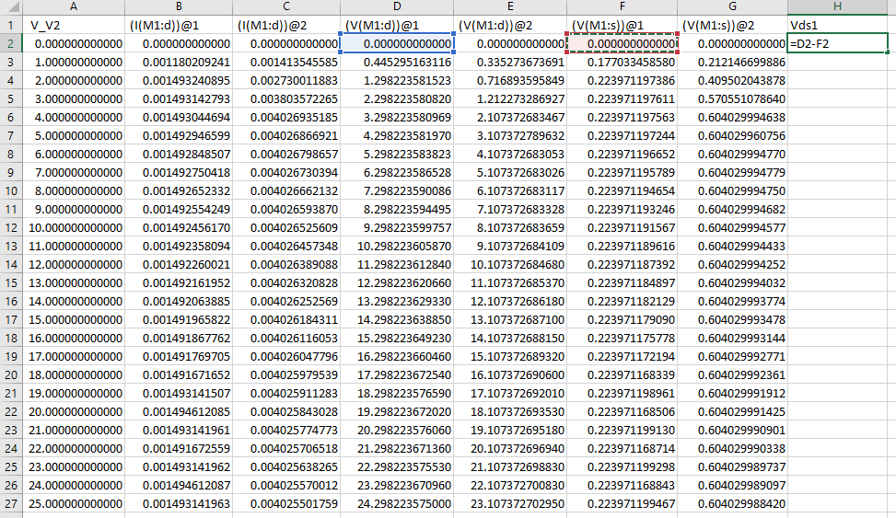

**Double Click to autofill**

**Grab and drag right across 6 empty columns to autofill them**

### Plot Data

Create XY scatter plots for **Id versus Vds** in Excel with these steps:

Select the “Insert” tab and under “Charts” click on “Scatter with straight lines and Markers”

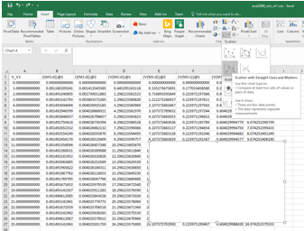

Right click on the new chart area and click on “Select Data”

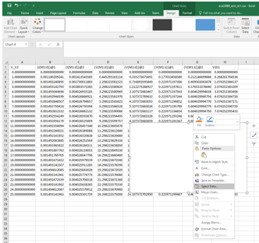

Click on “Add” under “Legend Entries” and fill in the “Series name” (Id1), “Series X Values” by selecting all the Vds1 values (column H in the example below) and “Series Y Values” by selecting the values in Column B below. Hit OK.

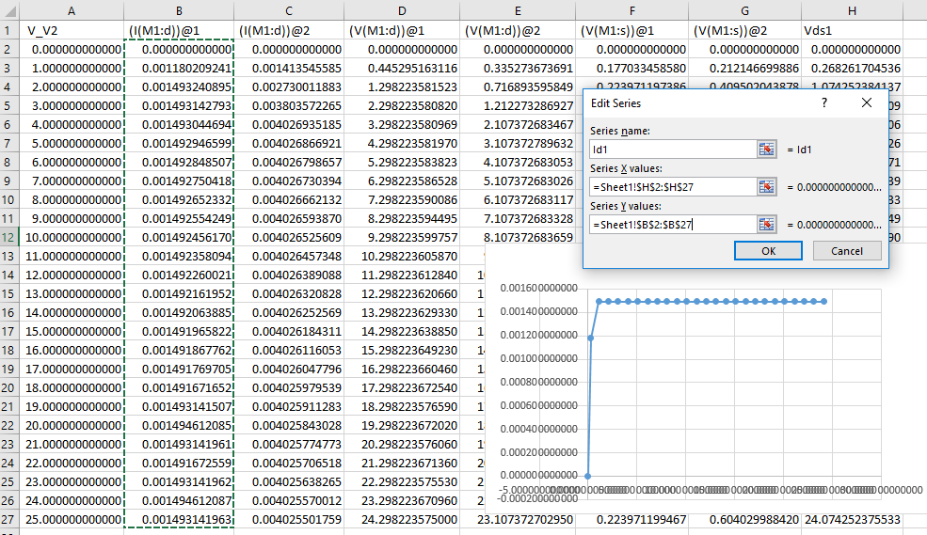

Click “Add” 6 more times to repeat the “Select Data” process for Id2 to Id7

Create XY scatter plots for Id versus Vo (Vd)

### Analyze excel data (Load Line analysis)

Add a load line for Id versus Vo from Vomax (15V) to Vomin (5.26V)

Label 2 free columns as “VLoad” and “ILoad”

In the VLoad column enter the Vomin (5.26V) and Vomax (15V) values

In the Iload column enter the current at Vomin in mA (roughly the highest current with Vg=1.5V, about 20.95mA), and at Vomax (ILoad=0mA)

Add a new series to the Scatter plot with X axis Vload and Y axis ILoad

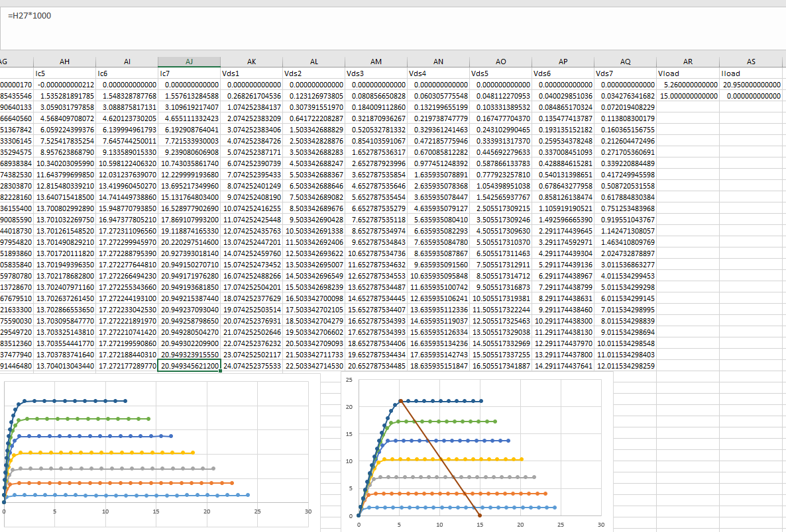

### Design Bias circuit parameters

Graphically determine ideal DC bias point operating input and output parameters

Amplifier output voltage **VOQ** = about 10V

Amplifier output current **IDQ**= about 10mA

Amplifier input Voltage **VINQ** = Vg = about 3.75V

# Bias Point Simulation

## Replace the parametric sweep Voltage source with 2 resistor bias circuit

### Modify schematic

Remove “V1 voltage Source” and “Parameter”

Add 2 resistors (112.5K, 37.5K) for a 2-resistor Vg bias circuit to set Vg to about 3.75V

Note the large resistance values to minimize the impact on the NMOS bias current

Ensure M1 parameters are still **KP**=9m and **VTO**=0.7V

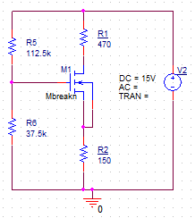

## Run Bias Point Simulation

### Edit Simulation profile

Analysis type = Bias Point

### Run Simulation

#### Enable Bias Voltage Display

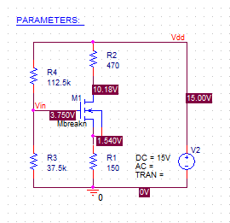

#### Enable Bias Current Display

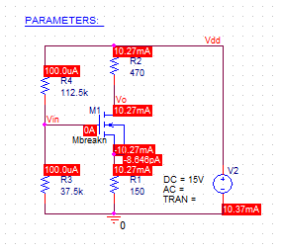

# Time Domain (Transient) Simulation

## Replace 2 resistor bias circuit with AC Voltage Source VSIN/SOURCE

### Modify Schematics

Replace V2 with a VSIN/SOURCE part

Set VSIN parameters

VOFF = 5V (Offset voltage)

VAMPL = 5V (Peak Voltage)

FREQ = 1K (1KHz sinewave)

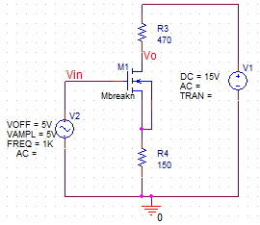

## Run Time Domain (Transient) Simulation

### Edit Simulation profile

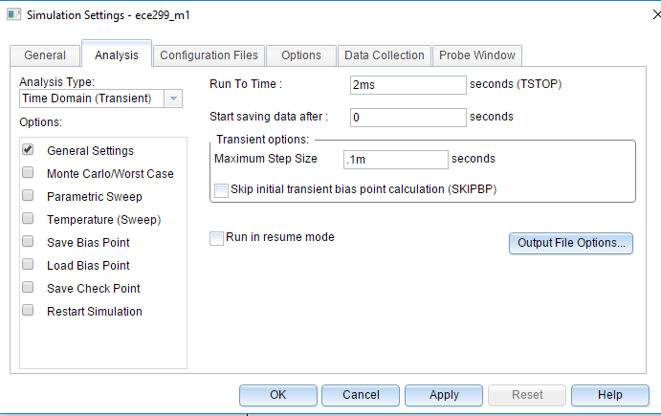

Analysis type = Time Domain (Transient)

Run To Time = 2ms

Maximum Step Size = 0.1m

### Run Simulation

#### Open simulation window, right click and add traces V(Vin) and V(Vo)

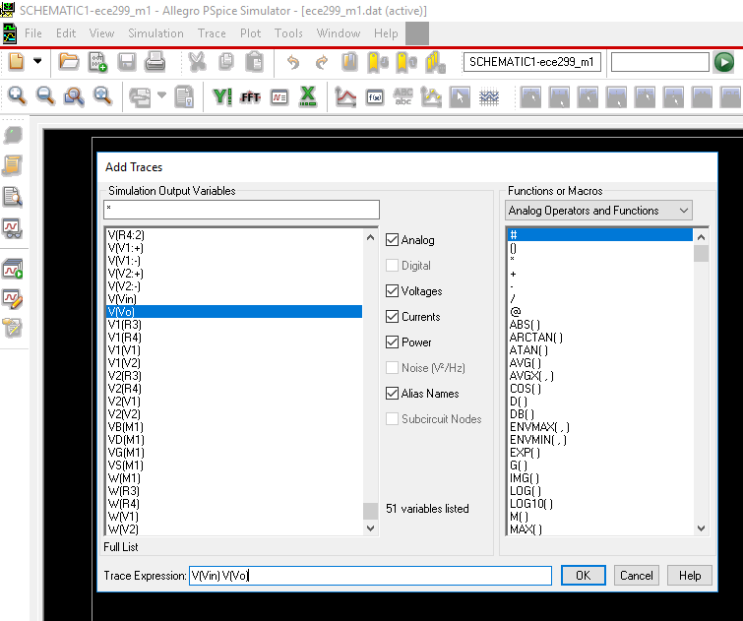

#### Analyze Simulation Results

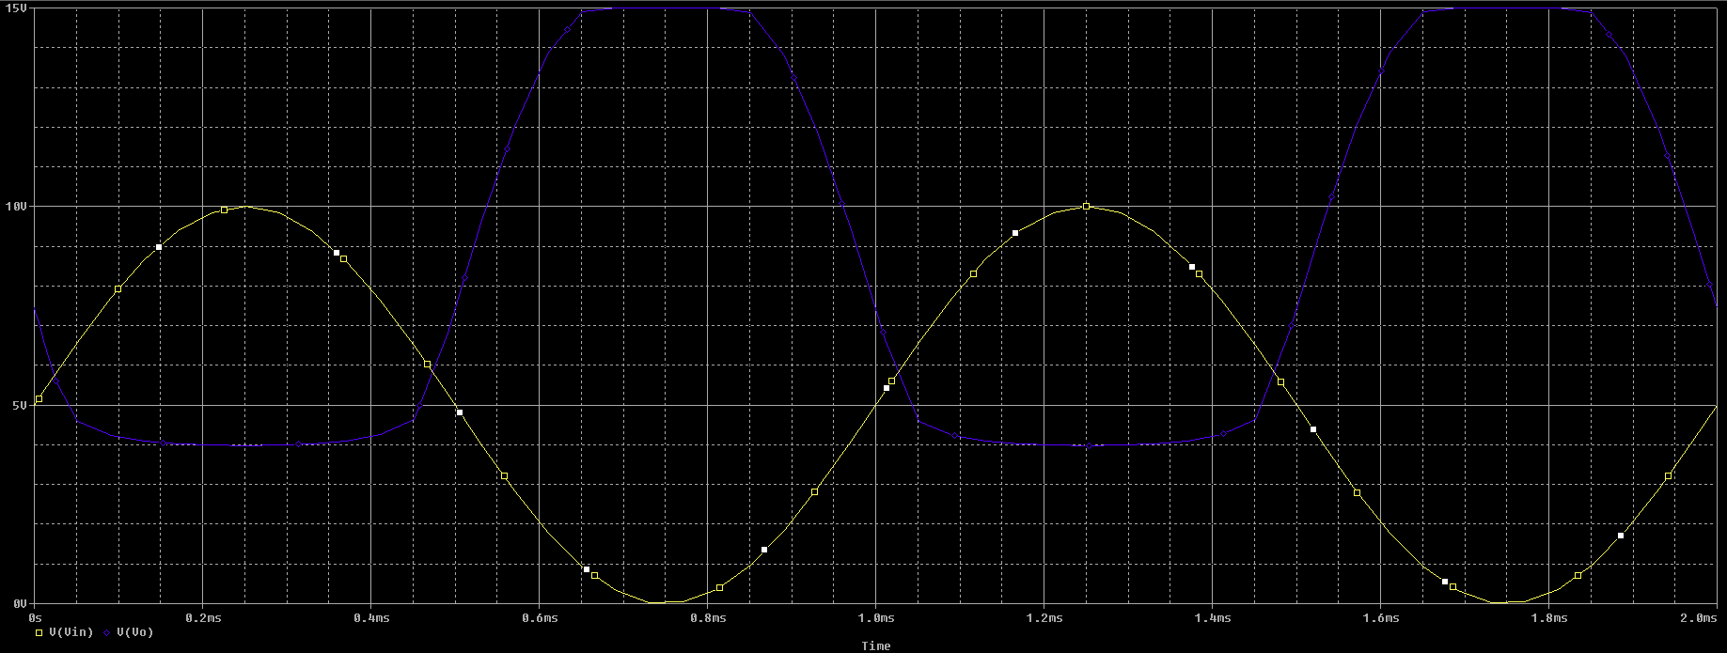

**CutOff**

**Vo=15V (max)**

**Vgs<Vtn=0.7V**

**Linear/Triode**

**Vgs>Vtn**

**Vds<Vdsat**

**Poor gain**

**Saturation**

**Vgs>Vtn**

**Vds>Vdsat**

**Maximum gain**

**VOQ**

**DC Bias Operating Point when VIN=3.75V and VO=10V**

Identify the 3 different NMOS transistor mode regions

Identify DC Bias Operating Point

Identify Amplifier Gain

# Quiz 7 – May 23th 2018

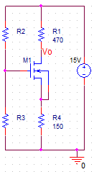

**Assume:**

KN=9mA/V2

VTN=0.7V

**Equations (when MOSFET is in Saturation.):**

**Determine R2 and R3 to bias M1 at midswing Vo**

**Vomax**=15V when M1 is in cutoff and Id=0

**Vomin** at the onset of saturation when Vds=Vdsat

KVL from 15V supply rail to ground through M1

Vdsatmin = -2.5048V or 2.1464V.

Since M1 is on at Vomin, then Vdsatmin = 2.1464V>0V

If **R3=37.726KΩ**, then and R2+R3=150KΩ>>R1+R4