*Answer all questions in complete sentences explaining your answer thoroughly in your own words. Short answers or incomplete sentences will be give zero to partial credit. Please be detailed with your answers.*

*Name: Choi Tim Antony Yung*

[1] (25 pts) You’ve been asked to build a high capacity file storage server with 384 TB of usable space. The hard drives available for purchase are of size 8 TB ($200), 12 TB ($350), and 16 TB ($625). Draw and explain the type of RAID array you would use in the following scenarios:

1. Money is not important, but you are limited to a maximum of 40 drive bays. You want to optimize read/write performance as much as possible.

RAID 0 of 32 12TB disk should be used as it provide stripping with more disk r/w at the same time than 16TB.

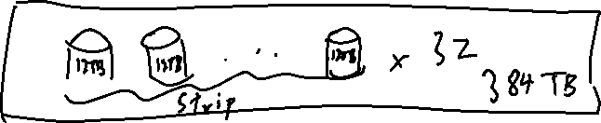

1. You have a limited amount of money and cannot spend a lot of money on hard drives, but redundancy is important.

RAID 1 of 2 sets of 384 TB is needed as it provide mirroring for redundancy.

384TB can either be 48 8TB disks costing $9600, 32 12TB disks costing $11200 or 24 16TB disks costing $15000

RAID 1 array of 2 sets of 48 8TB disks is needed costing a total of $9600.

The 48 8TB can be a RAID 0 array to increase performance as well. (RAID 01)

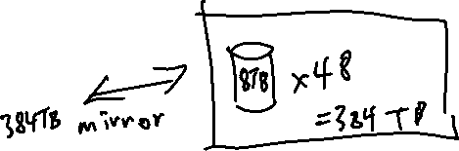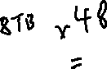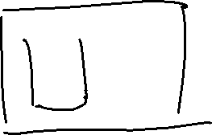

[2] (25 pts) Consider the following page reference string: 7, 4, 3, 1, 5, 7, 2, 2, 6,5, 7, 3, 1, 4, 4, 2, 3, 5, 3, 6, 2, 4

Using the FIFO, LRU, and Optimal page replacement algorithms with 3 frames, show the page load order and number of page faults that would occur.

FIFO: 19 page fault

|  |  |  |  |  |  |  |  |  |  |  |  |  |  |  |  |  |  |  |  |  |  |
| --- | --- | --- | --- | --- | --- | --- | --- | --- | --- | --- | --- | --- | --- | --- | --- | --- | --- | --- | --- | --- | --- |
| 7 | 7 | 7 | 1 | 1 | 1 | 2 | 2 | 2 | 2 | 7 | 7 | 7 | 4 | 4 | 4 | 4 | 5 | 5 | 5 | 5 | 4 |
|  | 4 | 4 | 4 | 5 | 5 | 5 | 5 | 6 | 6 | 6 | 3 | 3 | 3 | 3 | 2 | 2 | 2 | 2 | 6 | 6 | 6 |
|  |  | 3 | 3 | 3 | 7 | 7 | 7 | 7 | 5 | 5 | 5 | 1 | 1 | 1 | 1 | 3 | 3 | 3 | 3 | 2 | 2 |
|  |  |  |  |  |  |  |  |  |  |  |  |  |  |  |  |  |  |  |  |  |  |

LRU: 19 page fault

|  |  |  |  |  |  |  |  |  |  |  |  |  |  |  |  |  |  |  |  |  |  |
| --- | --- | --- | --- | --- | --- | --- | --- | --- | --- | --- | --- | --- | --- | --- | --- | --- | --- | --- | --- | --- | --- |
| 7 | 7 | 7 | 1 | 1 | 1 | 2 | 2 | 2 | 2 | 7 | 7 | 7 | 4 | 4 | 4 | 4 | 5 | 5 | 5 | 2 | 2 |
|  | 4 | 4 | 4 | 5 | 5 | 5 | 5 | 6 | 6 | 6 | 3 | 3 | 3 | 3 | 2 | 2 | 2 | 2 | 6 | 6 | 6 |
|  |  | 3 | 3 | 3 | 7 | 7 | 7 | 7 | 5 | 5 | 5 | 1 | 1 | 1 | 1 | 3 | 3 | 3 | 3 | 3 | 4 |

Optimal: 13 page fault

|  |  |  |  |  |  |  |  |  |  |  |  |  |  |  |  |  |  |  |  |  |  |
| --- | --- | --- | --- | --- | --- | --- | --- | --- | --- | --- | --- | --- | --- | --- | --- | --- | --- | --- | --- | --- | --- |
| 7 | 7 | 7 | 7 | 7 | 7 | 7 | 7 | 7 | 7 | 7 | 3 | 3 | 3 | 3 | 3 | 3 | 3 | 3 | 6 | 6 | 4 |
|  | 4 | 4 | 1 | 5 | 5 | 5 | 5 | 5 | 5 | 5 | 5 | 5 | 5 | 5 | 5 | 5 | 5 | 5 | 5 | 5 | 5 |
|  |  | 3 | 3 | 3 | 3 | 2 | 2 | 6 | 6 | 6 | 6 | 1 | 4 | 4 | 2 | 2 | 2 | 2 | 2 | 2 | 2 |