**Cal Poly Pomona Electrical & Computer Eng.**

**ECE 4810 Project Design Principles and Applications**

**Assignment 7 – Find your vocal range**

# Find your vocal range

Using a “vocal pitch monitor” app find your vocal range and map it to the ranges below

Find the lowest and highest notes you are comfortable with.

Be aware that you can sing notes outside of your range using falsetto notes

* [Soprano](https://en.m.wikipedia.org/wiki/Soprano): the highest female voice, C4 (middle C) to C6 (high C).
* [Mezzo-soprano](https://en.m.wikipedia.org/wiki/Mezzo-soprano): a female voice, A3 (A below middle C) and A5 (two octaves above A3).
* [Contralto](https://en.m.wikipedia.org/wiki/Contralto): the lowest female voice, F3 (F below middle C) to E5.
* [Tenor](https://en.m.wikipedia.org/wiki/Tenor): the highest male voice, B2 (2nd B below middle C) to A4 (A above Middle C).
* [Baritone](https://en.m.wikipedia.org/wiki/Baritone): a male voice, G2 (two Gs below middle C) to F4 (F above middle C).
* [Bass](https://en.m.wikipedia.org/wiki/Bass_(voice_type)): the lowest male voice, E2 (two Es below middle C) to E4 (the E above middle C

<https://play.google.com/store/apps/details?id=com.tadaoyamaoka.vocalpitchmonitor&hl=en_US>

<https://apps.apple.com/us/app/vocal-pitch-monitor/id842218231>

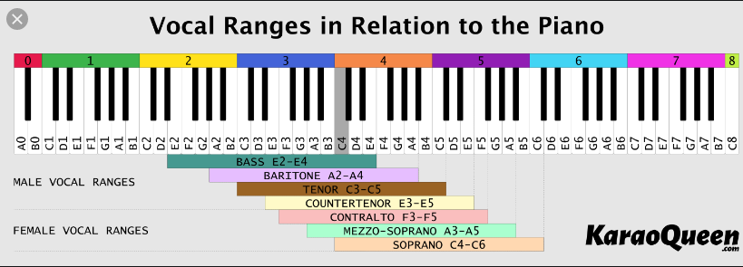

Lowest: E2

Highest: D4