TRADE .NET

Design and Functional Specification

Project Requirements and Architecture

<December 15, 2012>

Owners and List of Contacts

Name | Email | Phone | Role
Antony Drew Developer
Todd Faestel Developer

Signoffs
Phase | Name | Date | Signature
Completed 12/15/2012

Revision History

Date | Reason for change(s) | Author(s)

Table of Contents

Owners and List of Contacts 2
Signoffs 2
Revision History 2
About this Document 4
Purpose and Contents 4
What this specification does 4
What this specification does not do 4
A ‘Living Document’ 4
Assumptions 4
Questions and Comments 4
Software Overview 5
Product description 5
Product functional capabilities 5
User characteristics 5
User operations and practices 5
General constraints 5
Assumptions 5
Other software 5
System Architecture 6
Description 6
Logical View 7
Deployment View 9
Class Diagram 10
Database Diagram 14
Specific Function Description 15
1. Product 15
Description 15
User Interface 16
Inputs 16
Processing 16
Reports 17
Report 1: 17
Actions 18
1. Select 18
2. Update 18
3. Delete 18
4. Calculate 18
Output Screen: 19
Security 20

About this Document

Purpose and Contents

What this specification does
This document describes functionality of the Trade .NET stand-alone application for end-users and owners.

What this specification does not do
This is not a project plan. It is a guide for system architecture and development, not for phasing, timelines or deliverables.

A ‘Living Document’
Finally, this specification will change, continuously, as the project proceeds. We will add details and edit existing information as the database structure and functionality evolve in the course of the project.

Assumptions
The user has some general knowledge about computing overall.

Questions and Comments

If you have questions or comments regarding this document, contact:

Software Overview

Product description
This .NET application is used for trading stocks as well as an overall research tool. This tool helps to explore what happens to stocks at extreme overbought/oversold levels aiming to potentially provide the user with a means to make a profit. Past testing performance does not guarantee future trading success, however. Note that there are effectively 2 model views here: momentum and mean-reversion. So, the user can select between both models and choose a course of action.

Product functional capabilities
This trade product provides historical back-testing and data download capabilities. It also provides reporting metrics allowing the user to further explore various markets facilitating decision-making.

User characteristics
Users will typically be traders or people interested in finance, overall.

User operations and practices
This is a friendly, straightforward application with only a few user inputs. There are also several error-catching (try/catch) routines in case of user error.

General constraints
N/A

Assumptions
Assumptions include transaction costs of 0.08% per trade (8 bps) as well as signal generation on the morning market open and trade execution on the same day’s close. A risk-free rate of 1% is also used to calculate the Sharpe ratio.

Other software
N/A

System Architecture

Description:
The trading system developed encompassed three core projects within the total system, as described in the Logical View, to include the Data Project, HTMLReportEngine Project and Test Project. The architecture of each class within each project focused upon the utilization of various aspects of the .NET Framework. Each aspect was chosen for its suitability to each class’ intent in order to maintain highly cohesive class structure. Of particular note was the attention paid towards the time complexity of the chosen data structures within the .NET Framework in order to maximize runtime efficiency.

The core areas and data structures utilized in the .NET Framework within the trading system include the following:

- ADO.NET
  - Connected layer:
    - SQL Server
      - Table for stored data
      - Stored procedure called locally
    - Entity Framework

  - Disconnected layer:
    - DataSet
    - DataTable

  - LINQ (directly applied within ADO.NET context)
    - SQL Server/Entity Framework queries/updates/deletes
    - DataSet queries
    - DataTable queries

- ASP.NET
  - HTML reporting engine

- Windows Forms
  - GUI

- WebClient
  - Data download request

- General Data Structures Utilized:
  - Arrays
  - SortedList
  - Dictionary
  - DataSet
  - DataTable

Logical View

The architecture is divided into three logical layers in order to maintain highly cohesive projects/classes within the system, increase code reusability/scalability and ease of code maintenance.

- Data Project
The data project is the core area within the system that handles that functionality and logic behind the trading system. Specifically, this project encompasses the following classes:

- BackTest: the class includes all functionality in order to conduct an entire backtest on an individual equity in accordance with the trading system’s rules-based logic. A high degree of cohesion is maintained with the sole purpose of the class is to conduct a backtest.

- DataDownload: the class performs one crucial aspect for the trading system that includes obtaining the data for the desired equity from Yahoo Finance. This class utilizes the WebClient functionality afforded by the .NET Framework.

- DataLayer: the class includes methods that are required in order to allow communication with the SQL Server DB for updates to the stored data.

- MarketTable: the class creates the DataTable for the desired equity market. This class makes extensive use of the disconnected layer afforded by ADO.NET. This data structure is a key aspect of the trading system. The scalability afforded by this data structure is very powerful. For instance, going forward the system could utilize the Merge() method within this structure in order to create a portfolio of DataTables unified into a single in-memory representation of a database. This not only dramatically increases ease of access but also speed of execution.

- MathFunctions: as expected, this class closely resembles the Math class in the .NET Framework. The intent and architecture of the class is to include multiple methods that perform crucial mathematical and statistical calculations for use in the trading system and for further evaluation in the GUI.

- EntityFramework: this is a self-generated ORM for working with the SQL Server database. EF provides very efficient connectivity for certain portions of the trading system when communicating with the database.

- HTML Report Engine Project
HTML Report Engine project is code that we obtained from CodeProject.com and utilized as open source code. The actual code and functionality was altered in our system in order to meet the needs for this class’ intent. The class affords functionality to utilize ASP.NET in order to display via HTML the results from the backtest. The main class utilized in this project is as follows:

- GUI Form: the class allows the user, when clicked on inside the system’s main GUI, to select from a multitude of “check-boxes” to display information relevant to the equity, statistical evaluation and overall performance of the backtest.

- GUI/Test Project
The GUI/Test project is the main testing and presentation project in the system. The project includes the following classes:

- Program: this is a very simple class that has the sole functionality for launching the application within the system’s required Main method.

- Form: the class encompasses all aspects of the Windows Forms GUI for presenting the backtested history for the system. Multiple functionalities are afforded in the GUI in order to allow the user ease of access to the system’s functionalities and intent.

Deployment View

Figure 1 – Main GUI Diagram

Below is the deployed system’s main GUI for the user.

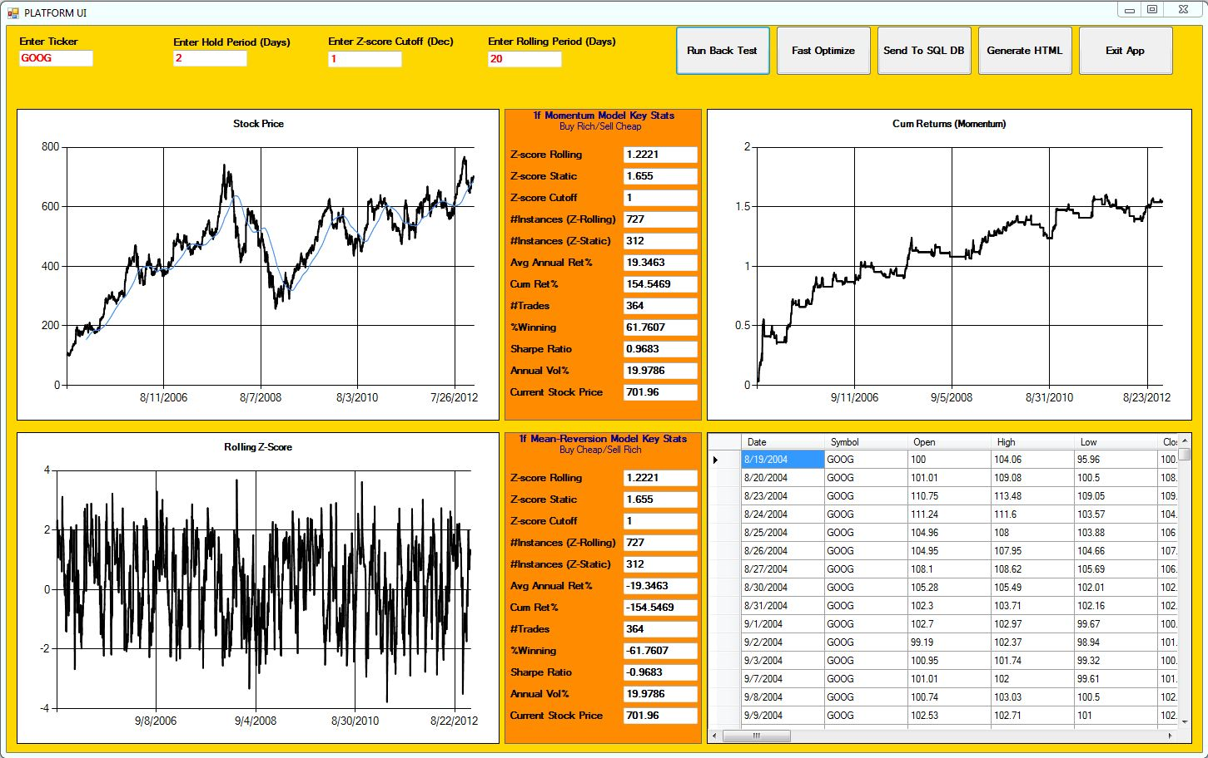

Figure 2 – HTML Report Engine GUI Diagram

Below is the deployed system’s HTML Report Engine GUI for the user that appears within the deployed system’s main GUI.

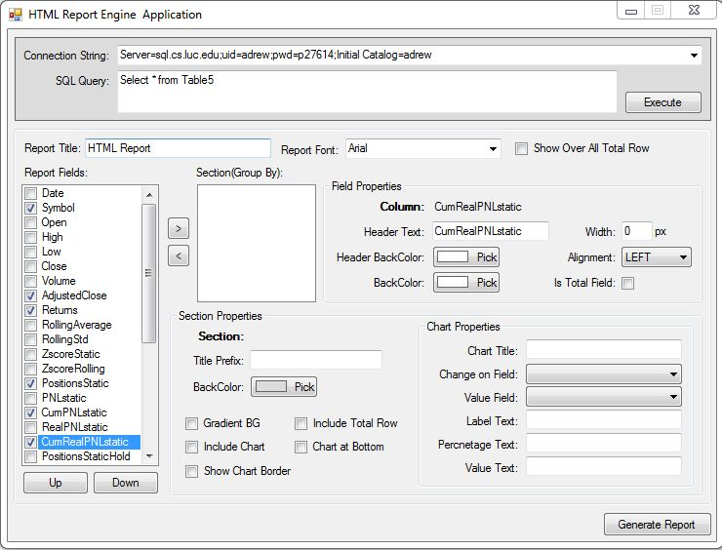

Class Diagrams
Figure 3 – Class Diagrams – Data Project

Below are the class diagrams for the Data Project.

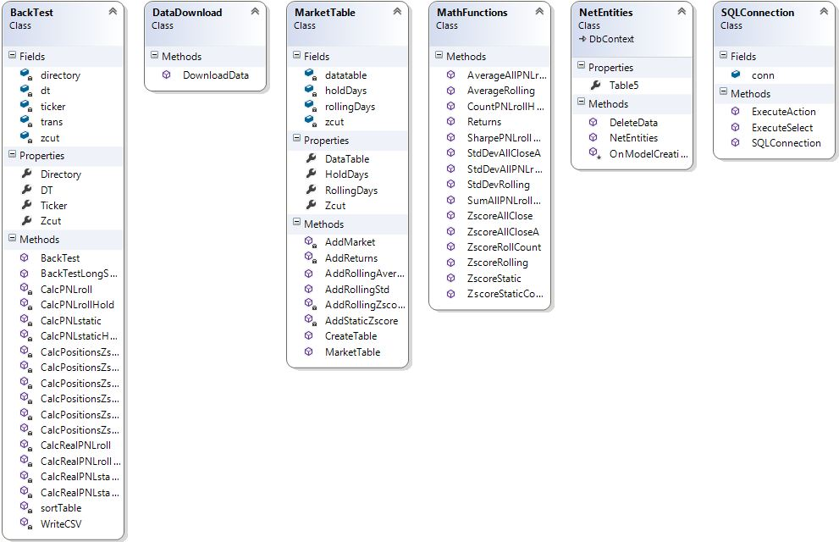

Figure 4 – Class Diagrams – HTML Report Engine Project

Below is the class diagram for the HTML Report Engine Project.

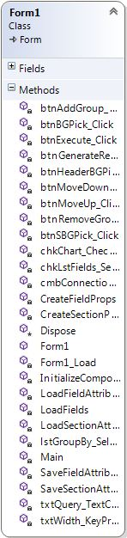

Figure 5 – Class Diagrams – GUI/Test Project

Below is the class diagram for the GUI/Test Project.

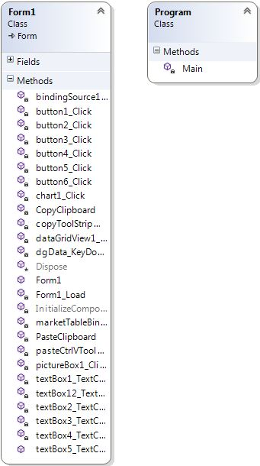

Database Schema
Figure 6 – Database Schema

Below is the database schema for the system’s table.

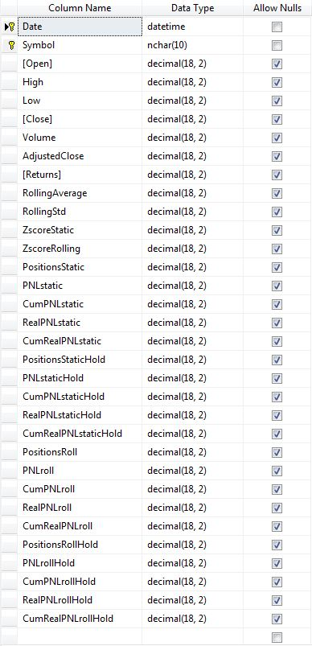

Specific Function Description

1. Product

Description
The general flow of the project can be described by the following flow chart:

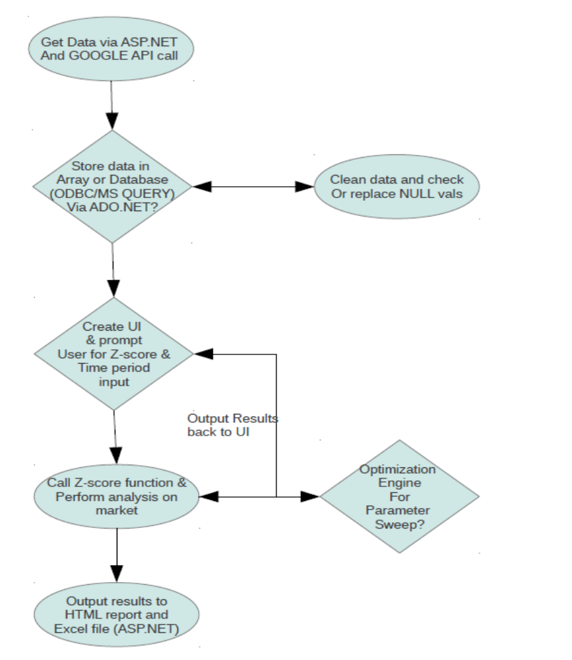

User Interface
When the user clicks the .exe file in the release or debug bin, the application opens along with the main UI opens. The user can click on the any of the 5 action buttons to see trade results:

The 5 buttons are: Run Back Test, Fast Optimize, Send to SQL DB, Generate HTML and Exit APP.

Inputs
All user-adjustable inputs are in RED on the top-left. The user can change any of these 3 input boxes to the desired parameters and then re-run the trade results. The 3 boxes are Hold Days (Int), Z-score Cutoff (Double) and Rolling Days (Int) (see above).

Processing
During processing, the mouse will turn into an hour glass icon so the user knows something is occurring. If there are any errors, a message box will pop-up and alert the user after which the application will effectively reset.

Reports

Report 1:

Reports are customizable and user-generated via Form1 in HTML REPORT project:

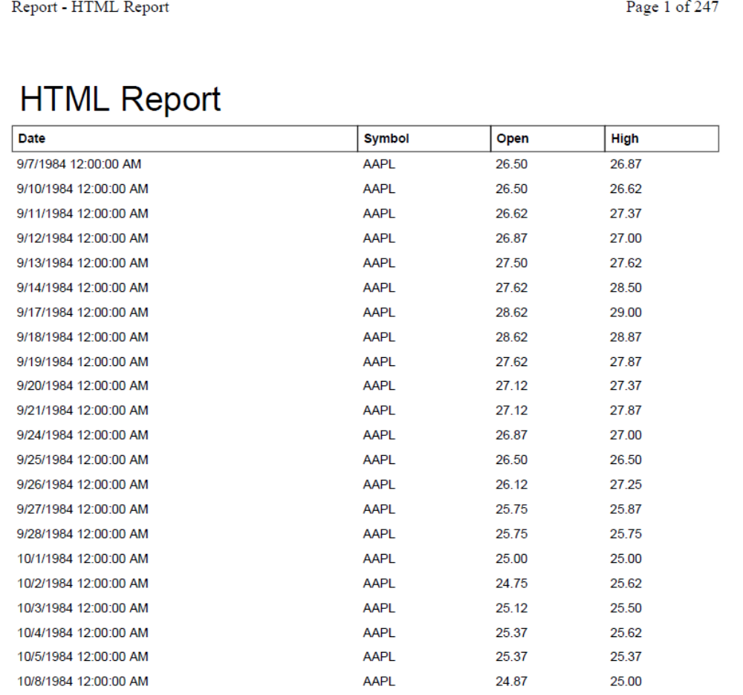

Actions

1. Select

“Select * FROM Table5” is code syntax stored and called in C# Forms1.cs class. It also calls functions in the DataLayer.cs class under the DATA project:

conn.ConnectionString = "Server=sql.cs.luc.edu;uid=adrew;pwd=p27614;" +
"Initial Catalog=adrew";

2. Update

Update of data records is handled by a stored procedure in the SQL SERVER database that is called every time the database [Table 5] is queried.

3. Delete

Delete of data records is handled by a stored procedure in the SQL SERVER database that is called every time the database [Table 5] is queried:

ALTER PROCEDURE dbo.DeleteData(@Symbol nchar(10))
AS
Delete from dbo.Table5
where symbol = @Symbol

4. Calculate

Output Screen:

Security

Security is handled on the SQL SERVER side via user name and password prompts.

