**Music_evaluation (simple, intermediate, advanced)**

**My Dashboard**

**antonyitki@protonmail.com**

**Survey Overview**

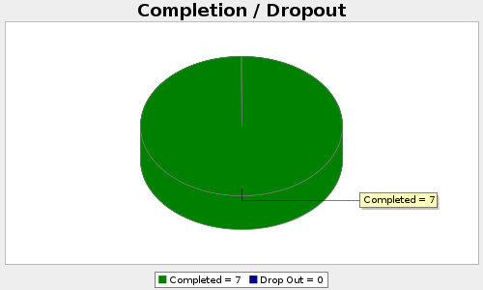

|  |  |  |  |  |  |  |
| --- | --- | --- | --- | --- | --- | --- |
| |  |  |  |  |  |  | | --- | --- | --- | --- | --- | --- | | Viewed  **92** | Started  **7** | Completed  **7** | Completion Rate  **100%** | Drop Outs (After Starting)  **0** | Average Time to Complete Survey  **2 minutes** | |

**Q1. Do you like this song (1E)?**

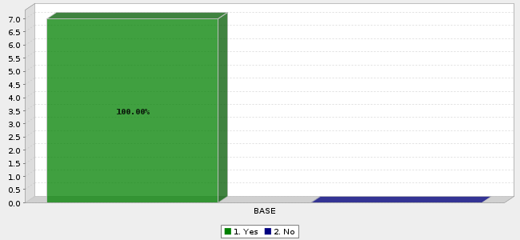

|  |  |  |  |
| --- | --- | --- | --- |
|  | **Answer** | **Count** | **Percent** |
| 1. | Yes | 7 | 100.00% |
| 2. | No | 0 | 0.00% |
|  | Total | 7 | n = 7.0 |

|  |  |  |  |
| --- | --- | --- | --- |
| Mean **:  1.000** | Confidence Interval @ 95% **:   [1.000 - 1.000]** | Standard Deviation **:   0.000** | Standard Error **:  0.000** |

**Q2. Do you like this song (2E)?**

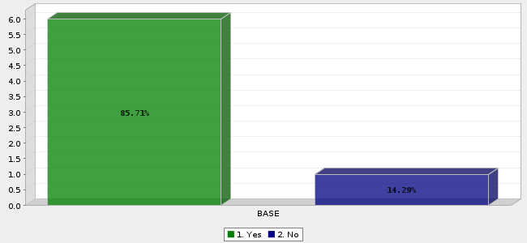

|  |  |  |  |
| --- | --- | --- | --- |
|  | **Answer** | **Count** | **Percent** |
| 1. | Yes | 6 | 85.71% |
| 2. | No | 1 | 14.29% |
|  | Total | 7 | n = 7.0 |

|  |  |  |  |
| --- | --- | --- | --- |
| Mean **:  1.143** | Confidence Interval @ 95% **:   [0.863 - 1.423]** | Standard Deviation **:   0.378** | Standard Error **:  0.143** |

**Q3. Do you like this song (3E)?**

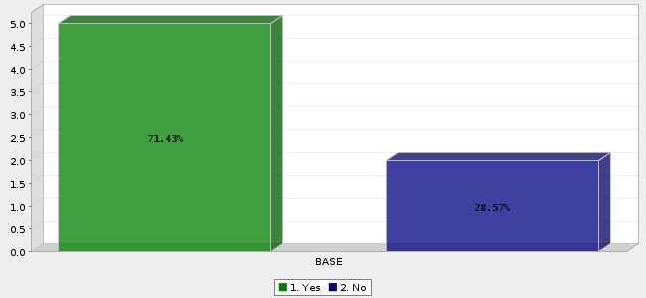

|  |  |  |  |
| --- | --- | --- | --- |
|  | **Answer** | **Count** | **Percent** |
| 1. | Yes | 5 | 71.43% |
| 2. | No | 2 | 28.57% |
|  | Total | 7 | n = 7.0 |

|  |  |  |  |
| --- | --- | --- | --- |
| Mean **:  1.286** | Confidence Interval @ 95% **:   [0.924 - 1.647]** | Standard Deviation **:   0.488** | Standard Error **:  0.184** |

**Q4. Do you like this song (6E)?**



|  |  |  |  |
| --- | --- | --- | --- |
|  | **Answer** | **Count** | **Percent** |
| 1. | Yes | 5 | 71.43% |
| 2. | No | 2 | 28.57% |
|  | Total | 7 | n = 7.0 |

|  |  |  |  |
| --- | --- | --- | --- |
| Mean **:  1.286** | Confidence Interval @ 95% **:   [0.924 - 1.647]** | Standard Deviation **:   0.488** | Standard Error **:  0.184** |

**Q5. Do you like this song (7E)?**



|  |  |  |  |
| --- | --- | --- | --- |
|  | **Answer** | **Count** | **Percent** |
| 1. | Yes | 5 | 71.43% |
| 2. | No | 2 | 28.57% |
|  | Total | 7 | n = 7.0 |

|  |  |  |  |
| --- | --- | --- | --- |
| Mean **:  1.286** | Confidence Interval @ 95% **:   [0.924 - 1.647]** | Standard Deviation **:   0.488** | Standard Error **:  0.184** |

**Q6. Do you like this song (1C)?**



|  |  |  |  |
| --- | --- | --- | --- |
|  | **Answer** | **Count** | **Percent** |
| 1. | Yes | 7 | 100.00% |
| 2. | No | 0 | 0.00% |
|  | Total | 7 | n = 7.0 |

|  |  |  |  |
| --- | --- | --- | --- |
| Mean **:  1.000** | Confidence Interval @ 95% **:   [1.000 - 1.000]** | Standard Deviation **:   0.000** | Standard Error **:  0.000** |

**Q7. Do you like this song (2C)?**



|  |  |  |  |
| --- | --- | --- | --- |
|  | **Answer** | **Count** | **Percent** |
| 1. | Yes | 5 | 71.43% |
| 2. | No | 2 | 28.57% |
|  | Total | 7 | n = 7.0 |

|  |  |  |  |
| --- | --- | --- | --- |
| Mean **:  1.286** | Confidence Interval @ 95% **:   [0.924 - 1.647]** | Standard Deviation **:   0.488** | Standard Error **:  0.184** |

**Q8. Do you like this song (3C)?**



|  |  |  |  |
| --- | --- | --- | --- |
|  | **Answer** | **Count** | **Percent** |
| 1. | Yes | 7 | 100.00% |
| 2. | No | 0 | 0.00% |
|  | Total | 7 | n = 7.0 |

|  |  |  |  |
| --- | --- | --- | --- |
| Mean **:  1.000** | Confidence Interval @ 95% **:   [1.000 - 1.000]** | Standard Deviation **:   0.000** | Standard Error **:  0.000** |

**Q9. Do you like this song (6C)?**



|  |  |  |  |
| --- | --- | --- | --- |
|  | **Answer** | **Count** | **Percent** |
| 1. | Yes | 6 | 85.71% |
| 2. | No | 1 | 14.29% |
|  | Total | 7 | n = 7.0 |

|  |  |  |  |
| --- | --- | --- | --- |
| Mean **:  1.143** | Confidence Interval @ 95% **:   [0.863 - 1.423]** | Standard Deviation **:   0.378** | Standard Error **:  0.143** |

**Q10. Do you like this song (7C)?**



|  |  |  |  |
| --- | --- | --- | --- |
|  | **Answer** | **Count** | **Percent** |
| 1. | Yes | 5 | 71.43% |
| 2. | No | 2 | 28.57% |
|  | Total | 7 | n = 7.0 |

|  |  |  |  |
| --- | --- | --- | --- |
| Mean **:  1.286** | Confidence Interval @ 95% **:   [0.924 - 1.647]** | Standard Deviation **:   0.488** | Standard Error **:  0.184** |

**Q11. Do you like this song (1M)?**



|  |  |  |  |
| --- | --- | --- | --- |
|  | **Answer** | **Count** | **Percent** |
| 1. | Yes | 7 | 100.00% |
| 2. | No | 0 | 0.00% |
|  | Total | 7 | n = 7.0 |

|  |  |  |  |
| --- | --- | --- | --- |
| Mean **:  1.000** | Confidence Interval @ 95% **:   [1.000 - 1.000]** | Standard Deviation **:   0.000** | Standard Error **:  0.000** |

**Q12. Do you like this song (2M)?**



|  |  |  |  |
| --- | --- | --- | --- |
|  | **Answer** | **Count** | **Percent** |
| 1. | Yes | 7 | 100.00% |
| 2. | No | 0 | 0.00% |
|  | Total | 7 | n = 7.0 |

|  |  |  |  |
| --- | --- | --- | --- |
| Mean **:  1.000** | Confidence Interval @ 95% **:   [1.000 - 1.000]** | Standard Deviation **:   0.000** | Standard Error **:  0.000** |

**Q13. Do you like this song (3M)?**



|  |  |  |  |
| --- | --- | --- | --- |
|  | **Answer** | **Count** | **Percent** |
| 1. | Yes | 7 | 100.00% |
| 2. | No | 0 | 0.00% |
|  | Total | 7 | n = 7.0 |

|  |  |  |  |
| --- | --- | --- | --- |
| Mean **:  1.000** | Confidence Interval @ 95% **:   [1.000 - 1.000]** | Standard Deviation **:   0.000** | Standard Error **:  0.000** |

**Q14. Which song did you most liked?**

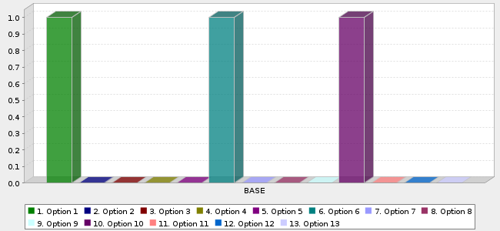

|  |  |  |  |
| --- | --- | --- | --- |
|  | **Answer** | **Count** | **Percent** |
| 1. | Option 1 | 1 | 33.33% |
| 2. | Option 2 | 0 | 0.00% |
| 3. | Option 3 | 0 | 0.00% |
| 4. | Option 4 | 0 | 0.00% |
| 5. | Option 5 | 0 | 0.00% |
| 6. | Option 6 | 1 | 33.33% |
| 7. | Option 7 | 0 | 0.00% |
| 8. | Option 8 | 0 | 0.00% |
| 9. | Option 9 | 0 | 0.00% |
| 10. | Option 10 | 1 | 33.33% |
| 11. | Option 11 | 0 | 0.00% |
| 12. | Option 12 | 0 | 0.00% |
| 13. | Option 13 | 0 | 0.00% |
|  | Total | 3 | 100% |

|  |  |  |  |
| --- | --- | --- | --- |
| Mean **:  5.667** | Confidence Interval @ 95% **:   [0.564 - 10.769]** | Standard Deviation **:   4.509** | Standard Error **:  2.603** |