Natural Numbers N = { 1, 2, 3, 4 ,5, ….}

Whole Numbers W = { 0, 1, 2, 3, 4 , 5, ….}

Integers Z = { -4, -3, -2, -1, 0, 1, 2, 3, 4 }

Rational Number: { -5, -4, 13/4, -1, 0, 1/8, 1, 2/3, 2, 7/3, …}

IRRational Number: 

Real Number:



* The Real Numbers are  Uncountable
* The set of all Java programs is  countable.
* The set of positive integers (Z+) is called  countable. A set that is not countable is uncountable.
* The set of all finite strings over the alphabet of  lowercase letters is countable.
* The set of real numbers R  is an uncountable set.

 the set of positive even integers is  countable set.

Because of one to one or onto relationship.

* The sum of first n even natural numbers can be calculated as

S=2+4+6+.....+(2n)=n(n+1)

* The sum of first n even natural numbers can be calculated as N2

**SET THEORY:-**

**Number of Subsets of a given Set:**

If a set contains ‘n’ elements, then the number of subsets of the set is 2N.

**Number of Proper Subsets of the Set:**

If a set contains ‘n’ elements, then the number of proper subsets of the set is 2n– 1

For Ex: If A = {p, q} the proper subsets of A are [{ }, {p}, {q}]

**Symmetric Difference:-**

Let A and B are two sets. The symmetric difference of two sets A and B is the set (A – B) ∪ (B – A) and is denoted by A △ B.

Thus, A △ B = (A – B) ∪ (B – A) = {x : x ∉ A ∩ B}

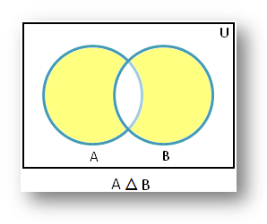

1.R, a relation in a set X, is reflexive if and only if ∀x∈X, xRx.

2.R is symmetric if and only if ∀x,y∈X, xRy => yRx.

3.R is transitive if and only if ∀x,y,z∈X, xRy∧yRz ==> xRz.

4. R is asymmetric if and only if ∀x,y∈X, xRy not=> yRx.

5. R is antisymmetric if and only if ∀x,y∈X, xRy => yRx where x != y

***Which of these are antisymmetric?***

**(i) R = {(1,1),(1,2),(2,1),(2,2),(3,4),(4,1),(4,4)}**

**(ii) R = {(1,1),(1,3),(3,1)}**

**(iii) R = {(1,1),(1,2),(1,4),(2,1),(2,2),(3,3),(4,1),(4,4)}**

***Solution:***

(i) R is not antisymmetric here because of (1,2) ∈ R and (2,1) ∈ R, but 1 ≠ 2.

(ii) R is not antisymmetric here because of (1,3) ∈ R and (3,1) ∈ R, but 1 ≠ 3.

(iii) R is not antisymmetric here because of (1,2) ∈ R and (2,1) ∈ R, but 1 ≠ 2 and also (1,4) ∈ R and (4,1) ∈ R but 1 ≠ 4.

***If A = {1,2,3,4} and R is the relation on set A, then find the antisymmetric relation on set A.***

Solution: The antisymmetric relation on set A = {1,2,3,4} will be;

R = {(1,1), (2,2),(3,3),(4,4)}

**EQUIVALENCE RELATION:-**

An equivalence relation is a relation that is reflexive, symmetric, and transitive.

If two elements are related by some equivalence relation, we will say that they are equivalent (under that relation).

**RECURRENCE RELATIONS:-**

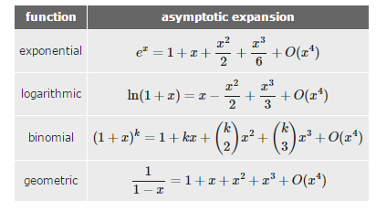

**GRAPH THEORY**

**Regular Graph:-**

A graph is called regular graph if degree of each vertex is equal. A graph is called K regular if degree of each vertex in the graph is K.

Eg:

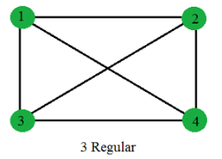

**Complete Graph**

A complete graph has an edge between any two vertices. You can get an edge by picking any two vertices.

So if there are n vertices = n(n−1)/2 Edges

Complete graph of order n and is denoted by Kn. A graph of order n with no edges is called an empty graph and is denoted by Kn with top underline..

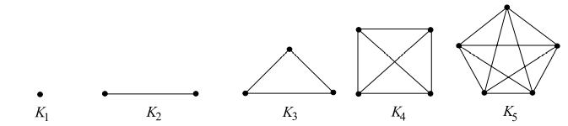

**Connected Graph**

A connected graph is any graph where there's a path between every pair of vertices in the graph.

**Spanning Tree**

A spanning tree is a subset of Graph G, which has all the vertices covered with minimum possible number of edges

How many spanning tree can we derive using n vertices graph.

Ans :According to Cayley formula n pow(n−2).

How many bipartite tree can we derive using n vertices graph.

**Minimum Spanning Tree:-**

A minimum spanning tree is a spanning tree in which the sum of the weight of the edges is as minimum as possible. It is found using the following algorithms: 1. Prim's Algorithm 2. Kruskal's Algorithm

**Bipartite Graphs**

A bipartite graph is a graph whose vertex-set can be split into two sets in such a way that each edge of the graph joins a vertex in first set to a vertex in second set.

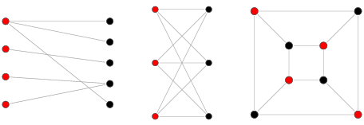

**Complete Bipartite Graph**

A complete bipartite graph is a bipartite graph in which each vertex in the first set is joined to each vertex in the second set by exactly one edge. The complete bipartite graph with r vertices and 3 vertices is denoted by Kr,3.

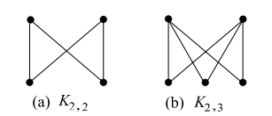

**Hamiltonian Graph:-**

In the mathematical field of graph theory, a Hamiltonian path (or traceable path) is a path in an undirected or directed graph that visits each vertex exactly once. A Hamiltonian cycle (or Hamiltonian circuit) is a Hamiltonian path that is a cycle.

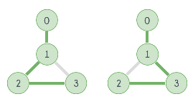

**Euler Graph**

A closed walk in a graph G containing all the edges of G is called an Euler line in G. A graph containing an Euler line is called an Euler graph.

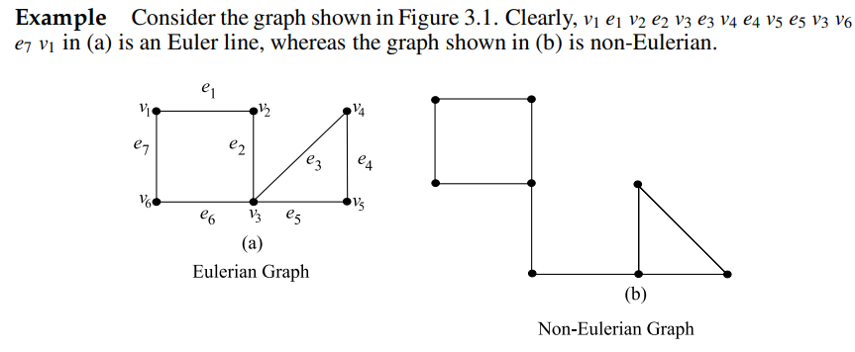

**General Points about Euler and Hamiltonian circuit:-**

*) A connected graph G is an Euler graph if and only if all vertices of G are of even degree. For example Below picture

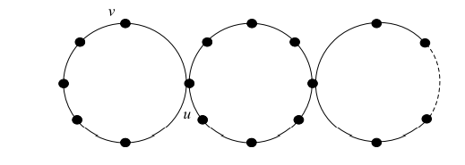

*) A Hamiltonian cycle visits each vertex of the graph exactly once. But Eulerian circuit traverses each edge exactly once without regard to how many times a given vertex is visited. See below fig

*) The complete bipartite graph K2,4 is Eulerian but not Hamiltonian. (see below fig)

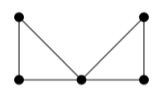

*) It's easy to find an Eulerian circuit, but there is no Hamiltonian cycle because the center vertex is the only way one can get from the left triangle to the right. (In the above graph)

**Planar and Non-Planar Graphs**

Planar graph is 2 dimension representation. Non planar graph is 3 dimensional representation.

If we are able to represent 3D graph into 2D form then that graph is planar graph.

More info refer https://www.youtube.com/watch?v=SFAu52v7owg

A Graph is planar since no link is overlapping with another.

A Graph is non-planar since many links are overlapping.

Also, the links of graph cannot be reconfigured in a manner that would make it planar.

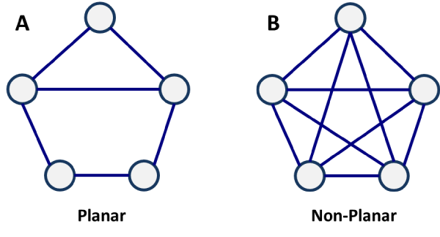

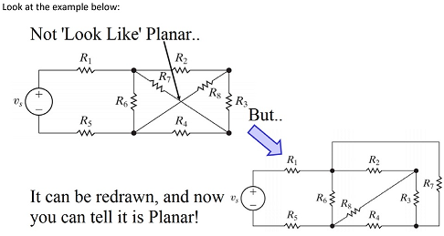

**ISOMORPHIC GRAPH:-**

If two graphs are isomorphic, they must have:

- the same number of vertices

- the same number of edges

- the same degrees for corresponding vertices

- the same number of connected components

- the same number of loops

- the same number of parallel edges.

- both graphs are connected or both graphs are not connected, and

- pairs of connected vertices must have the corresponding pair of vertices connected.

**Example 1 :-**

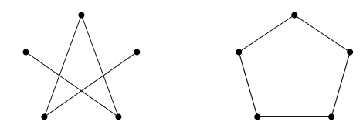

Firstly, label the graphs. It “looks” true, so check all the things we know:

Number of vertices: both 5.

Number of edges: both 5.

Degrees of corresponding vertices: all degree 2.

Connectedness: Each is fully connected.

Number of connected components: Both 1.

Pairs of connected vertices: All correspond.

Number of loops: 0.

Number of parallel edges: 0.

Everything is equal and so the graphs are isomorphic.

**Example2:-**

No. The left-hand graph has 5 edges; the right hand graph has 6 edges.

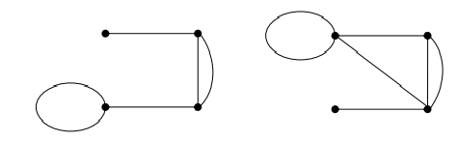

**Euler Circuit in a Directed Graph:-**

[Eulerian Path](http://en.wikipedia.org/wiki/Eulerian_path) is a path in graph that visits every edge exactly once. Eulerian Circuit is an Eulerian Path which starts and ends on the same vertex.

A graph is said to be eulerian if it has eulerian cycle. We have discussed [eulerian circuit for an undirected graph](https://www.geeksforgeeks.org/eulerian-path-and-circuit/). In this post, same is discussed for a directed graph.

For example, the following graph has eulerian cycle as {1, 0, 3, 4, 0, 2, 1}  
[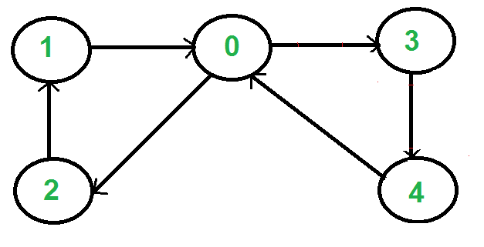](https://www.geeksforgeeks.org/wp-content/uploads/SCC1.png)

How to check if a directed graph is eulerian?

A directed graph has an eulerian cycle if following conditions are true

1) All vertices with non zero degree belong to a single strongly connected component.

2) In degree and out degree of every vertex is same.

**Eccentricity of a Vertex:-**

The maximum distance between a vertex to all other vertices is considered as the eccentricity of vertex.

**Tautology** :-

A tautology is a formula which is "always true" --- that is, it is true for every assignment of truth values to its simple components. You can think of a tautology as a rule of logic.

**Contradiction**:-

The opposite of a tautology is a contradiction, a formula which is "always false". In other words, a contradiction is false for every assignment of truth values to its simple components.

**NOTE:-**

*) A -> B is equivalent to ~A V B now checking option A

**Conjunctive and Disjunctive Normal Forms:-**

A Boolean expression is in disjunctive normal form if it is expressed as the sum (OR) of products (AND).

A Boolean expression is in conjunctive normal form if it is expressed as the product (AND) of sums (OR).

A statement is in conjunctive normal form if it is a conjunction (sequence of ANDs) consisting of one or more conjuncts, each of which is a disjunction (OR) of one or more literals

**Normal Forms :-**

Remember that we also called “or” “disjunction” and “and” “conjunction”.

A clause that contains only ∨ is called a disjunctive clause and only ∧ is called a conjunctive clause.

Negation is allowed, but only directly on variables.

P ∨ ¬q ∨ r: a disjunctive clause

¬p ∧ q ∧ ¬r: a conjunctive clause

¬p ∧ ¬q ∨ r: neither

If we put a bunch of disjunctive clauses together with ∧, it is called conjunctive normal form.

For example: (p∨r)∧(¬q∨¬r)∧q is in conjunctive normal form.

Similarly, putting conjunctive clauses together with ∨, it is called disjunctive normal form.

For example: ( p ∧ ¬q ∧ r ) ∨ ( ¬q ∧ ¬r ) is in disjunctive normal form.

**More examples:**

( p ∧ q ∧ ¬r ∧ s) ∨ ( ¬q ∧ s ) ∨ ( p ∧ s) is in disjunctive normal form.

( p ∨ q ∨ ¬r ∨ s ) ∧ ( ¬q ∨ s ) ∧ ¬s is in conjunctive normal form.

( p ∨ r ) ∧ ( q ∧ ( p ∨ ¬q )) is not in a normal form.

¬p ∨ q ∨ r and ¬p ∧ q ∧ r are in both normal forms.

**Predicate Logic:-** Predicate logic is the general form of all logics that uses predicates, like q(x). Here q is predicate. Predicate logic supports the ability to have variables, and quantifiers. For example, ∀x∃y.p(x,y) means "For all x there exists a y such that the proposition p(x,y) is true".

**Propositional Logic:**- Propositional logic means without ability to do predication. For example, in P ^ Q, both p and q are propositions.

**EXAMPLES:-**

Everyone likes someone

(Ax)(Ey)likes(x,y)

Someone is liked by everyone

(Ey)(Ax)likes(x,y)

Every gardener likes the sun.

(Ax) gardener(x) => likes(x,Sun)

You can fool some of the people all of the time

(Ex)(At) (person(x) ^ time(t)) => can-be-fooled(x,t)

You can fool all of the people some of the time.

(Ax)(Et) (person(x) ^ time(t) => can-be-fooled(x,t)

All purple mushrooms are poisonous.

(Ax) (mushroom(x) ^ purple(x)) =>poisonous(x)

No purple mushroom is poisonous.

~(Ex) purple(x) ^ mushroom(x) ^ poisonous(x)

(Ax) (mushroom(x) ^ purple(x)) => ~poisonous(x)

There are exactly two purple mushrooms.

(Ex)(Ey) mushroom(x) ^ purple(x) ^ mushroom(y) ^ purple(y) ^ ~(x=y) ^ (Az) (mushroom(z) ^ purple(z)) => ((x=z) v (y=z))

Deb is not tall.

~tall(Deb)

**PERMUTATION AND COMBINATION**

Lot of problems available in this link

https://ncert.nic.in/pdf/publication/exemplarproblem/classXI/mathematics/keep207.pdf

https://gradestack.com/CBSE-Class-11th-Science/Permutations-and/Extra-Questions/17571-3565-31187-revise-wtw

**DOMAIN AND RANGE**

The domain is all the x-values, and the range is all the y-values.

For example,

State the domain and range of the following relation?

{(2, –3), (4, 6), (3, –1), (6, 6), (2, 3)}

Ans:- domain: {2, 3, 4, 6} range: {–3, –1, 3, 6}

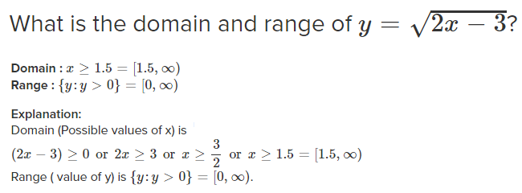

When finding the domain, remember:-

The denominator (bottom) of a fraction cannot be zero

The number under a square root sign must be positive in this section

**GROUP AXIOMS:-**

A group is a set, G, together with an operation • (called the group law of G) that combines any two elementsa and b to form another element, denoted a • b or ab. To qualify as a group, the set and operation, (G, •), must satisfy four requirements known as the group axioms:[5]

**Closure**

For all a, b in G, the result of the operation, a • b, is also in G.b[›]

**Associativity**

For all a, b and c in G, (a • b) • c = a • (b • c).

**Identity element**

There exists an element e in G such that, for every element a in G, the equation e • a = a • e = a holds. Such an element is unique (see below), and thus one speaks of the identity element.

**Inverse element**

For each a in G, there exists an element b in G, commonly denoted a−1 (or −a, if the operation is denoted "+"), such that a • b = b • a = e, where e is the identity element

**Abelian Group added**

Commutativity.a • b = b • a

**LINEAR PROGRAMMING PROBLEM**

**TRANSPORTATION PROBLEM**

1. NORTH WEST CORNER RULE
2. LEAST COST METHOD
3. VOGEL’S APPROXIMATION METHOD

(Ref https://www.youtube.com/watch?v=aNasiGQhnTY&ab_channel=WELCOMEENGINEERS)