**Specialization Hierarchy** – has the constraint that every subclass participates as a subclass in only one class/subclass relationship, i.e. that each subclass has only one parent. This results in a tree structure.

**Specialization Lattice** – has the constraint that a subclass can be a subclass of more than one class/subclass relationship. The figure shown above is a specialization lattice, because Engineering_Manager participates has more than one parent classes.

**Java Class File:-**

Java Class files are identified by the following 4 byte header (in hexadecimal): CA FE BA BE (the first 4 entries in the table below).

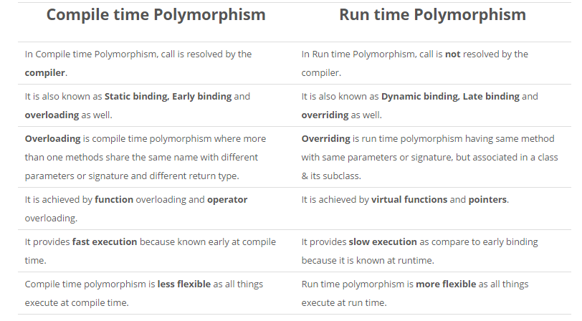

**malloc():-** Allocates requested size of bytes and returns a pointer to the first byte of allocated space.

**calloc():-** Allocates space for an array elements, initializes to zero and then returns a pointer to memory.

**free():-**dellocate the previously allocated space.

**realloc():-**Change the size of previously allocated space

**Array of pointers**

An array of pointers is an array, where the elements are pointers to some memory location.

for eg- it would be something like int* parr[10]; here parr[0],parr[1],etc are pointer variables

**Pointer to an Array**

A pointer to an array is when a pointer is pointing to the starting address of an array.

eg, let int arr[10] be an array. A pointer that points to arr[0], would be a pointer to an array

For eg:- int (*ptr) [10] is ptr is a pointer to an array of 10 integers.

**Class diagram** shows a collection of declarative (static) model elements, such as classes, types, and their contents and relationships.

**Object diagram** encompasses objects and their relationships at a point in time. It may be considered a special case of a class diagram or a collaboration diagram

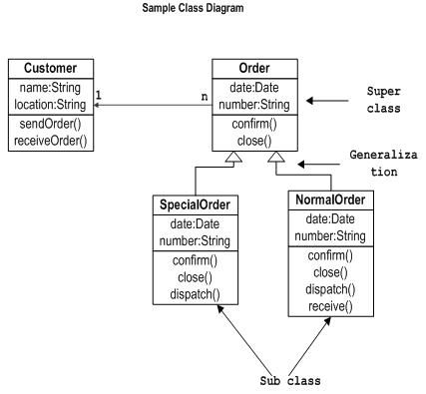

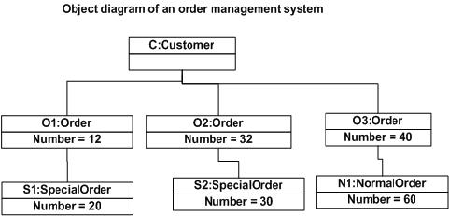

***QUES:- Which diagram provides a formal graphic notation for modelling objects, classes and their relationships to one another ?***

(A) Object diagram (Ans) (B) Class diagram

(C) Instance diagram (D) Analysis diagram

**PARALLEL PROCESSING**

**Amdahl's Law**

Execution time after improvement =

Execution time unaffected +

Execution time affected / Amount of improvement

TI = TU + TA/Improvement

**More About Amdahl's Law :-**

speedup is a function of the fraction of the code that can be parallelized and the number of processors

non-parallel sections do not gain performance

Speedup(N) = 1/((1-p)+p/N)

where p= portion of the code that can be made parallel

N=number of processor. For example:

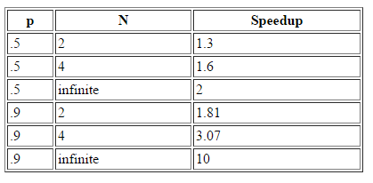

**Amdahl's Law Example**

***1) Suppose a program runs in 100 seconds on a machine, with multiply responsible for 80 seconds of this time. How much do we have to improve the speed of multiplication if we want the program to run 4 times faster?***

Explanation 1:-

100/4 = 20 + 80/n

n = 16

Explanation 2:-

Execution time after improvement= 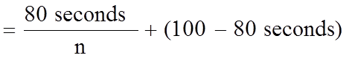

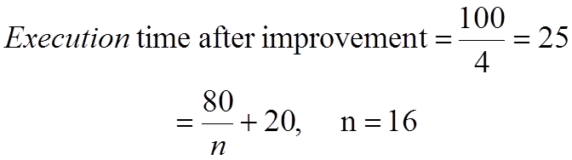

How about 5 times faster?

ans : Not possible

***Ques:- Application execution time is 20sec. 12 seconds are spent performing add operations. If we improve the add operation to run twice as fast, how much faster will the application run?***

***which speedup could be achieved according to amdhal law for infinite number of processor if 5% of the program is sequential and remaining is ideally parallel?***

Ans : 20

**Which speedup could be achieved according to Amdahl’s law if an “infinite number” of processors is available but 4% of a program is sequential and the remaining part is ideally parallel?**

(a) Infinite speedup (b) 4 (c) 25 (d) 50 (e) None of the answers above is correct.

Explanation:-

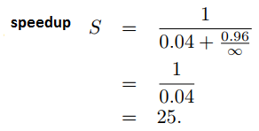

***QUES:- Amdahl’s law states that the maximum speedup S achievable by a parallel computer with ‘p’ processors is given by:***

(A) S≤f+(1 – f)/p

(B) S≤f/p+(1-f)

(C) S≤1/[f+(1 – f)/p]

(D) S≤1/[1 – f+f/p] (yes)

***QUES:- The data type created by the data abstraction process is called***

(A) class (B) structure (C) abstract data type(YES) (D) user defined data type

***QUES:- The implicit return type of a constructor is***

A. void B. A class object in which it is defined.(yes)

C. There is no return type. D. None of the above

***QUES:- Implicit return type of a class constructor is :***

(1) not of class type itself (2) class type itself(yes)

(3) a destructor of class type (4) a destructor not of class type

***QUES:- A multicomputer with 256 CPUs is organized as 16 × 16 grid. What is the worst case delay (in hops) that a message might have to take ?***

(1) 16 (2) 15 (3) 32 (4) 30

**Explanation:-**

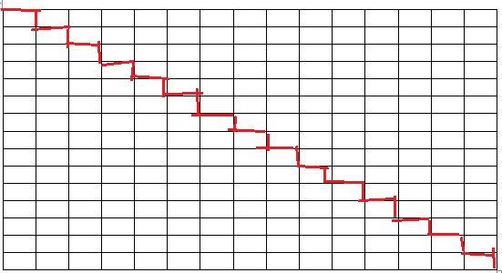

In the 16X16 CPU case, the worst-case delay happens when message passes through longest path which is the diagonal of the upper right corner to lower left corner or upper left corner to lower right corner.

Longest path is indicated in red color.

It passes through 2(N-1) = 2(16-1) = 30 hops

***QUES:- Suppose that the time to do a null remote procedure call (RPC) (i.e. 0 data bytes) is 1.0 msec, with an additional 1.5 msec for every 1K of data. How long does it take to read 32 K from the file server as 32 1K RPCs ?***

(1) 49 msec (2) 80 msec(yes) (3) 48 msec (4) 100 msec

A single 32K RPC takes 1.5*32 + 1.0 = 49.0 msec

32 1K RPCs take 1.5*32 + 1.0*32 = 80.0 msec

***Which of the following differentiates between overloaded functions and overridden functions ?***

(A) Overloading is a dynamic or runtime binding and overridden is a static or compile time binding.

(B) Overloading is a static or compile time binding and overriding is dynamic or runtime binding.(yes)

(C) Redefining a function in a friend class is called overloading, while redefining a function in a derived class is called as overridden function.

(D) Redefining a function in a derived class is called function overloading, while redefining a function in a friend class is called function overriding.

***The goal of operator overloading is***

(A) to help the user of a class(yes) (B) to help the developer of a class

(C) to help define friend function (D) None of the above

***The speed up of a pipeline processing over an equivalent non-pipeline processing is defined by the ratio :***

(A) S = n tn/ (k + n – 1)tp(yes)

(B) S = n tn/ (k + n + 1)tp

(C) S = n tn/ (k – n + 1)tp

(D) S = (k + n – 1)tp/ n tn

Where n → no. of tasks; tn→ time of completion of each task;

k → no. of segments of pipeline; tp→ clock cycle time;

S → speed up ratio;

**Without pipeline** one task needs tn time.

* n tasks need ntn time.

**With pipeline,**

* First task needs  k cycles to finish. So time will be k tp
* Other n-1 tasks needs tp time only to finish.
* Total time = (k+ n -1 ) tp

**Speed up** = T pipeline / T without pipeline = n t n / (k+n-1) t p

***A set of processors P1, P2, ......, Pk can execute in parallel if Bernstein's conditions are satisfied on a pair wise basis; that is P1 || P2 || P3 || ..... || Pk if and only if:***

(A) Pi || Pj for all i ≠ j(yes) (B) Pi || Pj for all i = j+1

(C) Pi || Pj for all i ≤ j (D) Pi || Pj for all i ≥ j

***What is the result of the expression (1&2)+(3/4) ?***

(A) 1 (B) 2 (C) 3 (D) 0(yes)

***When one-dimensional character array of unspecified length is assigned an initial value :***

(A) an arbitrary character is automatically added to the end of the string

(B) ‘o’ is added to the end of the string(yes)

(C) length of the string is added to the end of the string

(D) ‘end’ is added to the end of the string

***The declaration “unsigned u” indicates :***

(A) u is an unsigned character

(B) u is an unsigned integer(yes)

(C) u is a character

(D) u is a string

***The following ‘C’ statement : int * f[ ]( ) ; declares :***

(1) A function returning a pointer to an array of integers.

(2) Array of functions returning pointers to integers.(yes)

(3) A function returning an array of pointers to integers.

(4) An illegal statement.

***The following statement in ‘C’ int (*f())[ ]; declares***

(1) a function returning a pointer to an array of integers.(YES)

(2) a function returning an array of pointers to integers.

(3) array of functions returning pointers to integers.

(4) an illegal statement.

## Calculating Constant Failure Rates

In order to measure failure rates, you need a sample of identical components or systems that can be observed over time. For example, suppose you had five light bulbs connected to an automatic circuit that you could then turn on and off once per hour for 1,000 hours, giving you the following data:

* Bulb 1 burned out after 422 hours.
* Bulb 2 burned out after 744 hours
* Bulb 3 burned out after 803 hours
* Bulb 4 burned out after 678 hours
* Bulb 5 stayed lit for 1000 hours

This gives you 4 failures over a total of 3,647 hours.

To calculate the failure rate, divide the number of failures by the total number of hours, such as 4/3,647 = 0.0011 failures per hour.

In this example, the failure rate per hour is so small that it is almost insignificant. Multiplying the number by 1,000 would make it more meaningful to someone thinking about buying a light bulb, which would be 1.1 failures per 1,000 hours. Since there are 8,760 hours in one year, you can divide 3,647 by 8,760 to get 0.41 failures per year, or about 2 failures every five years.

## Calculating MTBF

Another way to express failure rates is by using the Mean Time Between Failures. MTBF is usually used in high-quality systems where failures are expected to be rare and need to be minimized, like the guidance system on a commercial aircraft or the air bags in a passenger car. Knowing the MTBF allows manufacturers to recommend how often components should be inspected, maintained and replaced.

To calculate the MTBF, you divide the number of hours by the number of failures. In the case of the five light bulbs that were tested, which had a failure rate of 4 per 3,647, you determine the MTF as 3,647/4 = 909. The MTBF is therefore 909 hours.