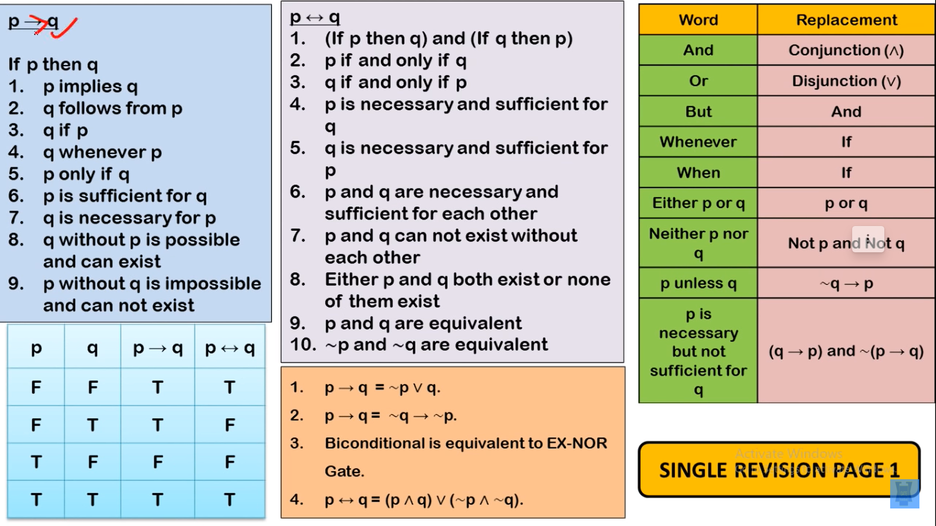

1. Tautology

All the output is true

2. Contradiction

All the output is false

3. Contingency

Output is either true or false

4. Conditional Statement

5. BiConditional Statement

p ↔q = p ->q and q->p

6. Inverse,

p → q is ¬p → ¬q

7.Converse

p → q is q → p.

8. Contra-Positive

p → q is ¬q → ¬p

is logically equivalent to original implication

Ref:- <https://www.youtube.com/watch?v=SAUlS3Qt1ck&ab_channel=BYJU%27SExamPrep%3AUGCNETJRF%26AllSETExams>

Ref:- <https://www.youtube.com/watch?v=aNLb7EkxQxA&ab_channel=GATENoteBook>

Laws:-

----------

The rules for negating quantifiers are:

DEMORGANS LAW FOR QUANTIFIER

¬∀x P(x) ≡ ∃x ¬P(x)

¬∃x P(x) ≡ ∀x ¬P(x)

-------------------------------------------------------------------------

**Precedence of Quantifiers**

Quantifiers ∀ and ∃ have higher precedence then all logical operators.

∀x P(x) ∧ Q(x) means (∀x P(x)) ∧ Q(x). In particular, this expression contains a free variable.

∀x (P(x) ∧ Q(x)) means something different.

------------------------------------------------------------------

Negation

∀x ¬¬S(x) ≡ ∀x S(x).

∼ (∀x ∈ D, p(x)) ≡ ∃x ∈ D, ∼ p(x)

∼ (∃x ∈ D, p(x)) ≡ ∀x ∈ D, ∼ p(x)

--------------------------------------------------------------------

**Universal conditional statements (∀x, p(x) → q(x))**

**Definitions**

Statement: ∀x, if p(x) then q(x)

Contrapositive of the statement is ∀x, if ∼ q(x) then ∼ p(x)

Converse of the statement is ∀x, if q(x) then p(x)

Inverse of the statement is ∀x, if ∼ p(x) then ∼ q(x)

**Identities**

Conditional ≡ Contrapositive B Useful for proofs

Conditional !≡ Converse

Conditional !≡ Inverse

Converse ≡ Inverse

**Formulas**

∀x, p(x) → q(x) ≡ ∀x, ∼ q(x) →∼ p(x) B Useful for proofs

∀x, p(x) → q(x) 6≡ ∀x, q(x) → p(x)

∀x, p(x) → q(x) 6≡ ∀x, ∼ p(x) →∼ q(x)

∀x, q(x) → p(x) ≡ ∀x, ∼ p(x) →∼ q(x)

---------------------------------------------------------------

Determine whether the following two statements are logically equivalent:

¬(P→Q) and P∧¬Q

Are the statements

P→(Q∨R) and (P→Q)∨(P→R) logically equivalent?

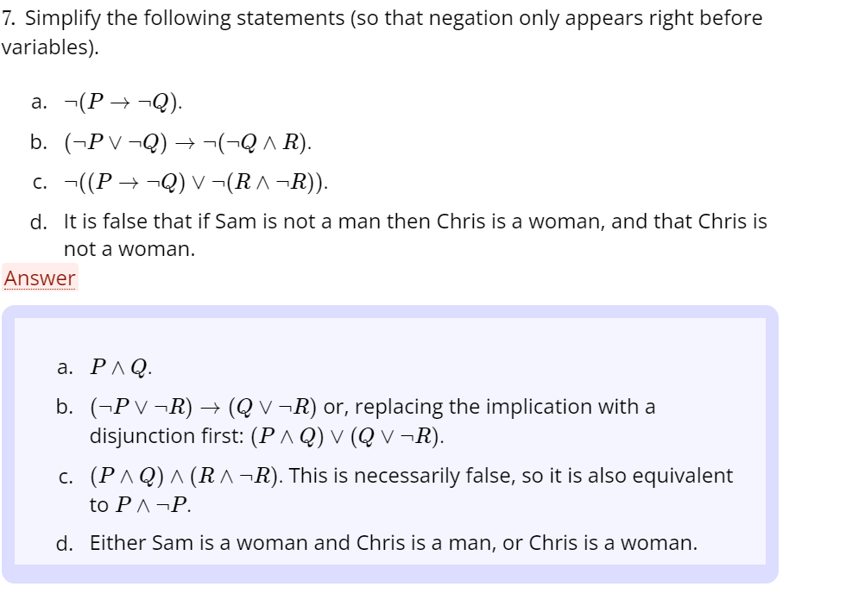

Negation of Quantification

• ‘Not all SCE students study hard’ = ‘There is at

least one SCE student who does not study hard’



• Negation of a universal quantification becomes

an existential quantification.

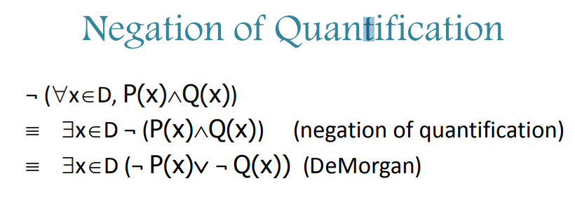

**EXERCISE**

Determine whether each of the following is a tautology, a contradiction or neither:

1. p → (p ∨ q)

2. (p → q) ∧ (¯p ∨ q)

3. (p ∨ q) ↔ (q ∨ p)

4. (p ∧ q) → p

5. (p ∧ q) ∧ (p ∨ q)

6. (p → q) → (p ∧ q)

7. (¯p ∧ q) ∧ (p ∨ q¯)

8. (p → q¯) ∨ (¯r → p)

Ref <http://www.itu.dk/people/jcg/IPDM/solutionLogic.pdf>

**Exercise:-**

4. Show that (p ↔ ¬q) → ¬p is not a tautology. If you use a truth table, you need to be specific about which row of the truth table justifies your answer

**Exercise:-**

Let’s show that (P ∧ (P → Q)) → Q is a tautology.

**COMMON LOGICAL EQUIVALENCES**

¬¬p ≡ p Double negation

¬(p ∧ q) ≡ ¬p ∨ ¬q De Morgan’s law

¬(p ∨ q) ≡ ¬p ∧ ¬q De Morgan’s law

p ∧ q ≡ q ∧ p Commutativity of AND

p ∨ q ≡ q ∨ p Commutativity of OR

p ∧ (q ∧ r) ≡ (p ∧ q) ∧ r Associativity of AND

p ∨ (q ∨ r) ≡ (p ∨ q) ∨ r Associativity of OR

p ∧ (q ∨ r) ≡ (p ∧ q) ∨ (p ∧ r) AND distributes over OR

p ∨ (q ∧ r) ≡ (p ∨ q) ∧ (p ∨ r) OR distributes over AND

p → q ≡ ¬p ∨ q Equivalence of implication and OR

¬p → q ≡ p ∨ q Equivalence of implication and OR

p → q ≡ ¬q → ¬p Contraposition

p ↔ q ≡ (p → q) ∧ (q → p) Expansion of if and only if

p ↔ q ≡ ¬p ↔ ¬q Inverse of if and only f

p ↔ q ≡ q ↔ p Commutativity of if and only if

**OTHERS:-**

P ∧ 0 ≡ 0 P ∨ 0 ≡ P

P ∧ 1 ≡ P P ∨ 1 ≡ 1

P ↔ 0 ≡ ¬P P ⊕ 0 ≡ P

P ↔ 1 ≡ P P ⊕ 1 ≡ ¬P

P → 0 ≡ ¬P 0 → P ≡ 1

P → 1 ≡ 1 1 → P ≡ P

**Prove that** (p → r) ∨ (q → r) ≡ (p ∧ q) → r

(p → r) ∨ (q → r) ≡ (¬p ∨ r) ∨ (¬q ∨ r) [Using p → q ≡ ¬p ∨ q twice]

≡ ¬p ∨ ¬q ∨ r ∨ r [Associativity and commutativity of ∨]

≡ ¬p ∨ ¬q ∨ r [p ≡ p ∨ p]

≡ ¬(p ∧ q) ∨ r [De Morgan’s law]

≡ (p ∧ q) → r. [p → q ≡ ¬p ∨ q]

**Prove that** (P ∧ (P → Q)) → Q is a tautology

(P ∧ (P → Q)) → Q ≡ (P ∧ (¬P ∨ Q)) → Q expand →

≡ ((P ∧ ¬P) ∨ (P ∧ Q)) → Q distribute ∨ over ∧

≡ (0 ∨ (P ∧ Q)) → Q non-contradiction

≡ (P ∧ Q) → Q absorption

≡ ¬(P ∧ Q) ∨ Q expand →

≡ (¬P ∨ ¬Q) ∨ Q De Morgan’s law

≡ ¬P ∨ (¬Q ∨ Q) associativity

≡ ¬P ∨ 1 excluded middle

≡ 1 absorption

**Negation Formula in Logic**

<https://en.wikipedia.org/wiki/Universal_quantification>

<https://www.csm.ornl.gov/~sheldon/ds/sec1.6.html>

<https://www.geeksforgeeks.org/mathematical-logic-propositional-equivalences/#:~:text=Two%20logical%20expressions%20are%20said,of%20the%20original%20compound%20proposition>.

1. **(p ∧ ~q) ≡ ~(p -> q).**

**Definitions:**

**Literal:** A variable or a negation of a variable is called a literal.

**Sum and Product:** A disjunction of literals is called a sum and

a conjunction of literals is called a product.

**Clause:** A disjunction of literals is called a clause.

**Resolvent:** For any two clauses C1 and C2, if there is a literal

L1 in C1 that is complementary to literal L2 in C2, then delete

L1 and L2 from C1 and C2 respectively and construct the

disjunction of the remaining clauses. The constructed clause is

a resolvent of C1 and C2.

C1 = P ∨ Q ∨ R

C2 = ¬P ∨ ¬S ∨ T

What is a resolvent of C1 and C2? Q ∨ R ∨ ¬S ∨ T