**QUESTIONS AND ANSWER**

***Given a simple image of size 10 ×10 whose histogram models the symbol probabilities and is given by***

***p1 p2 p3 p4***

***a b c d***

The first order estimate of image entropy is maximum when

(A) a = 0, b = 0, c = 0, d = 1

(B) a =1/2, b =1/2, c = 0, d = 0

(C) a = 1/3, b = 1/3, c = 1/3, d = 0

(D) a = 1/4, b = 1/4, c = 1/4, d = 1/4

Answer B.

In option D all elements are in class ¼. Hence entropy is least.

In option c,a, 3 elements are in single class and one in other class.

In Option B, maximum diffusion, 2 in each class. Hence max entropy.

***QUES:- What is the bit rate for transmitting uncompressed 800 × 600 pixel colour frames with 8 bits/pixel at 40 frames/second?***

A)2.4 Mbps B)15.36 Mbps C)153.6 Mbps(yes) D)1536 Mbps

**Explanation 1:-** Uncompressed pixel = 800*600

each of 8 bit = 800*600 *8

Bit rate for transmitting = 800*600 *8 *40 =153600000 = 153.6Mbps

**Explanation 2 :-**

1 frame = 800x600 pixels.

1 pixel is represented by 8 bits.

1 frame is represented by 800x600x8 bits.

Total bits in 40 frames 7= 40*800*600*8bits=40*8*100*6*100*8= 40x8x6x8 kb.

=40*2^3*6*2^3kb. Approx 240*2^6kb=2^14KB= 16*kb*kb= 16mb/s

**Explanation 3 :-**

Uncompressed pixel = 800*600

each of 8 bit = 800*600 *8

Bit rate for transmitting = 800*600 *8 *40 =153600000 = 153.6Mbps

***QUES:- A computer vision technique that relies on image templates is:***

A. edge detection B. binocular vision

C. model-based vision(Ans) D. robot vision E. None of the above

***QUES:- Which of the following is used for the boundary representation of an image object ?***

(1) Quad Tree (2) Projections (3) Run length coding (4) Chain codes(yes)

***QUES:- The Mandelbrot set used for the construction of beautiful images is based on the following transformation : C:\Users\antony\Desktop\Untitled.png Here,***

(A) Both x & z are real numbers. (B) Both x & z are complex numbers(yes)

(C) x is real & z is complex. D) x is complex & z is real.

***QUES:- The Z-buffer algorithm is used for Hidden surface removal of objects. The maximum number of objects that can be handled by this algorithm shall***

(i)depend on the application (ii)be arbitrary no. of objects(YES)

(iii)depend on the memory availability (iv)depend on the processor

**Explanation1:-** In Z-buffer algorithm an arbitrary number of objects can be handled because each object is processed one at a time.

**Explanation2:-** Depth Buffer (Z-Buffer) Method

(i)An X x Y matrix is used to store all depth values of screen pixels.

(ii)Take one object. Store its z coordinate value to corresponding pixel.

(iii) If another object also comes in same screen pixel, the pixel closer to observer will be saved. (z-culling)

Lets go through the options

(i) depend on the application : Z buffer algorithm will be same for any application. Not the answer

(ii) be arbitrary no. of objects: as the number of objects heavily increases it will affect the performance. hence the answer

(iii )depend on the memory availability: Only one matrix is needed to handle any number of objects. Wrong option

(iv)depend on the processor: Not related with Z buffer algorithm, Wrong option

***QUES:- You are given four images represented as***

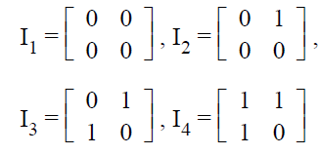

The value of entropy is maximum for image

(A) I1 (B) I2 (C) I3(yes) (D) I4

**Explanation:-**

entropy of image represents the randomness in pixels. in I1 all pixels are same. entropy is 0.

in I3 2 pixels are same other 2 diff.

in i2 i4, 3 are same.

so most random is in I3

***QUES:- The transform which possesses the "multi-resolution" property is***

(A) Fourier transform (B) Short-time-Fourier transform

(C) Wavelet transform(yes) (D) Karhunen-Loere transform

***The transform which possesses the highest ‘energy compaction’ property is***

(A) Slant transform (B) Cosine transform (C) Fourier transform

(D) Karhunen-Loevetransform(yes)

***Scan conversion refers***

(A) conversion of ideal geometric primitives into their best pixel approximations(yes)

(B) conversion of pixel to digital form (C) conversion of digital to pixel form

(D) conversion of row into line

***Consider a rectangle defined by its four vertices (20, 0), (80, 0), (20, 100), (80, 100) is***

***to be enlarged to twice its original size. The four vertices become***

(A) (20, 0) (80, 0) (20, 100) (90, 100)

(B) (40, 0) (80, 0) (40, 100) (160, 100)

(C) (40, 0) (160, 0) (40, 200) (160, 200)(yes)

(D) (40, 0) (160, 0) (40, 100) (160, 100)

***Images tend to be very large collection of data. The size of memory required for a 1024 by 1024 image in which the color of each pixel is represented by a n-bit number, (in an 8 bit machines) is***

Explanation:-

1MB=1024*1024.

Size of image.1024*1024 pixels.

1 pixel takes n bits

1024*1024 pixels takes 1024*1024*n bits.

8 bits make I unit of memory.

1 bit make 1/8 unit of memory.

n MB need n MB/8 unit of memory.

***In Bresenham's algorithm, while generating a circle, it is easy to generate***

1) One octant first and other by successive reflection(yes)

2) One octant first and other by successive rotation

3) One octant first and other by successive translation

4) All octants

***The line 2x-y+4=0, if clipped against this window will connect the points ?***

A) (0, 1) and (3, 3) B) (0, 1) and (2, 3)

C) (1, 2) and (4, 2) D) None of above(yes)

**Explanation:-** I think apply the coordinates to the equation. If it satisfies then the result is that point.

***Which of the following clipping algorithm follows the Divide and Conquer strategy?***

A) 4-bit algorithm B) Midpoint algorithm(yes)

C) Cyrus break algorithm D) Cohen- Sutherland algorithm

***In bresenham's algorithm error term is initialized to ?***

A) 0(yes) B) 1 C) -1/2 D) None of above

***Reflection of a point about x-axis, followed by a counter-clockwise rotation of 900 , is equivalent to reflection about the line?***

A) x = -y B) y = - x C) x = y(yes) D) x + y = 1

***A line with endpoints codes as 0000 and 0100 is?***

A)Partially invisible(yes) B)Completely visible C)Completely invisible D)Trivially invisible

***In an image compression system 16384 bits are used to represent 256 × 256 image with 256 gray levels. What is the compression ratio for this system ?(June-2012-P3)***

(A) 1 (B) 2 (C) 4 (D) 8

**Explanation1:-**

Number of bits required to store a 256 X 256 image with 256 gray levels is 256 gray levels = 28 = 8 bits. Therefore 256 * 256 * 8 = 524,288 bits

The ratio of the original(uncompressed) image to the compressed image is referred to as the Compression Ratio CR.

CR = Uncompressed image size/Compressed image size

Uncompressed image size for the given data above= 524,288 bits

Compressed image size as given in the question = 16384 bits

Therefore, compression ratio = 524,288/16384 = 32

**Explanation2:-**

Number of bits required to store a 256 X 256 image with 256 gray levels is 256 gray levels = 28 = 8 bits. Therefore (256 * 256 * 8)/8 = 65536 bits

The ratio of the original(uncompressed) image to the compressed image is referred to as the Compression Ratio CR.

CR = Uncompressed image size/Compressed image size

Uncompressed image size for the given data above= 65536 bits

Compressed image size as given in the question = 16384 bits

Therefore, compression ratio = 65536/16384 = 4

***A point P(5, 1) is rotated by 90° about a pivot point (2, 2). What is the coordinate of new transformed point P′ ?***

(1) (3, 5) (2) (5, 3) (3) (2, 4) (4) (1, 5)

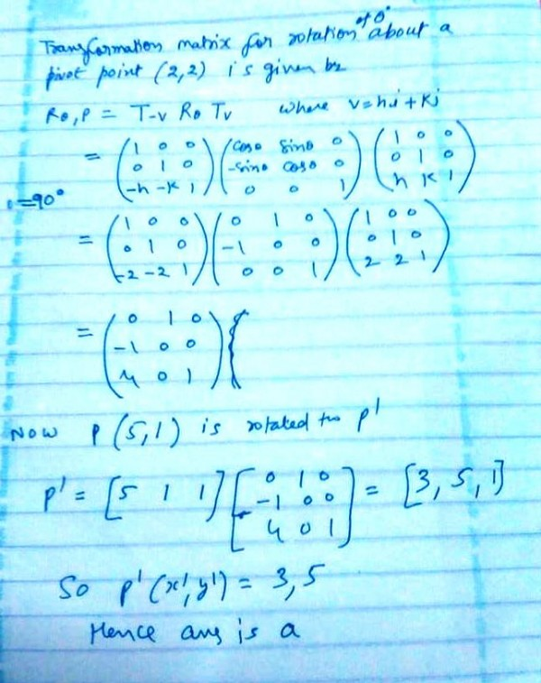

A point P(2, 5) is rotated about a pivot point (1, 2) by 60°. What is the new transformed point P'?

(1) (1, 4) (2) (–1, 4) (3) (1, – 4) (4) (– 4, 1)

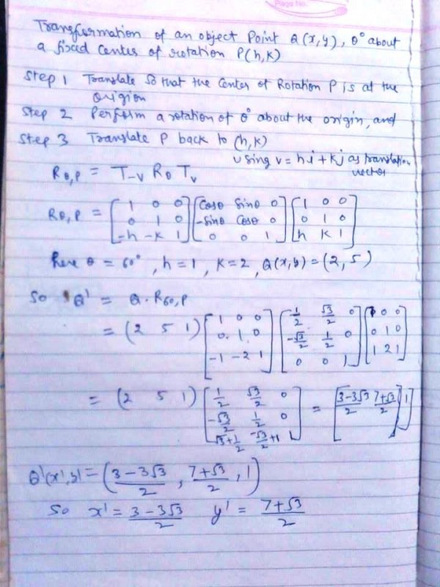

​***In 3D Graphics, which of the following statement/s is/are true ? (ugc – 2018 – Dec)***

P: Back-face culling is an example of an image-precision visible-surface determination.

Q: Z-Buffer is a 16-bit, 32-bit, or 64-bit field associated with each pixel in a frame buffer that can be used to determine the visible surface at each pixel.

(A) P only (B) Q only (C) Neither P nor Q (D) P and Q

Answer: (B)

***How much memory is required to implement z-buffer algorithm for a 512 x 512 x 24 bit-plane image? ( ISRO – 2014 )***

(A) 768 KB (B) 1 MB (C) 1.5 MB (D) 2 MB

**Explanation:** Z-buffer, which is also known as the Depth-buffer method is one of the commonly used method for hidden surface detection. Z-buffer requires 2 type of buffers to be filled: Depth buffer and Frame buffer

Space required by depth buffer = 512 x 512 x 24 = 6291456 bits.

Space required by frame buffer = 512 x 512 x 24 = 6291456 bits.

Total space required = 6291456 + 6291456 bits = 12582912 bits ≈ 1.5 MB

***How much memory is required to implement z-buffer algorithm for a 512 x 512 x 24 bit-plane image? (ISRO - 2014 )***

(A) 768 KB (B) 1 MB (C) 1.5 MB (D) 2 MB

Explanation: Z-buffer, which is also known as the Depth-buffer method is one of the commonly used method for hidden surface detection. Z-buffer requires 2 type of buffers to be filled: Depth buffer and Frame buffer

Space required by depth buffer = 512 x 512 x 24 = 6291456 bits.

Space required by frame buffer = 512 x 512 x 24 = 6291456 bits.

Total space required = 6291456 + 6291456 bits = 12582912 bits ≈ 1.5 MB

**A frame buffer array is addressed in row major order for a monitor with pixel locations starting from (0,0) and ending with (100,100). What is address of the pixel(6,10)? Assume one bit storage per pixel and starting pixel location is at 0.**

a)1016 b)1006 c)610 d)616

Address of pixel (6,10) in row major order is,

= 0 + 1((6 - 0) +101 (10 - 0))

= 1016

(For pixel calculation address in row major order , use logic of how to find address of array element in column major order .)

Column Major System:

The address of a location in Column Major System is calculated using the following formula:

Address of A [ I ][ J ] = B + W * [ ( I – Lr ) + M*( J – Lc ) ]

A[6][10] = 0 + 1[(6-0) +100*10] = 1016

Answer is A

***What is the bit rate of a video terminal unit with 80 characters/line, 8 bits/character and horizontal sweep time of lOOµs (including 20 µs of retrace time)? ISRO - 2011, GATE - 2004***

(A) 8 Mbps (B) 6.4 Mbps(yes) (C) 0.8 Mbps (D) 0.64 Mbps

Explanation

Bit rate of a video terminal unit =80×8 bits/100µs=6.4 Mbps

***Consider a raster system with resolution 640 by 480. What size is frame buffer (in bytes) for this system to store 12 bits per pixel? (NET 2019 - JULY)***

a)450 kilobytes b)500 kilobytes c)350 kilobytes d)400 kilobytes

Resolution = 640*480 pixels

Explanation:-

No. of bits per pixel=12

Frame Buffer size = Resolution* No. of bits per pixel

=640*480*12 bits

=(640*480*12) /8 Bytes (1 bit = 1/8 Bytes)

=(640*480*12) / (8 * 1024) Kilo Bytes (1 Bytes = 1/ 2^10 Kilo Bytes)

= 450 KB

450 KB is the answer

So option A is correct